**LAB ASSIGNMENT 14.1**

**NAME:-ANUJA GUGGILLA**

**2403A51101**

**BATCH:06**

**COURSE:-AI ASSISTANT CODING**

**TASK 1:-**

Portfolio Website Design  
You are building a personal portfolio website to showcase your work

**PROMPT:-**

"Develop a personal portfolio website using HTML, CSS, and JavaScript to showcase your projects, skills, and achievements. The website should include sections like About Me, Skills, Projects, Contact, and a Resume Download option. Implement responsive design for mobile and desktop devices. Use animations or transitions to enhance user experience."

**CODE:-**

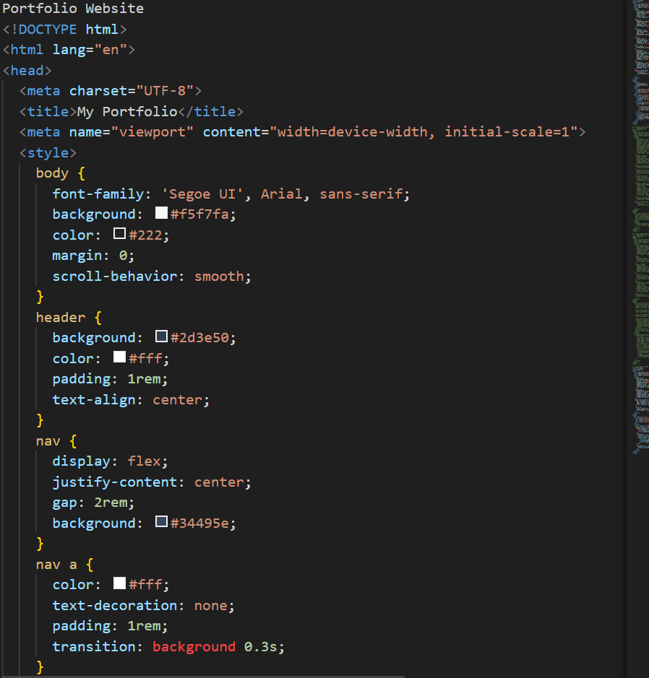

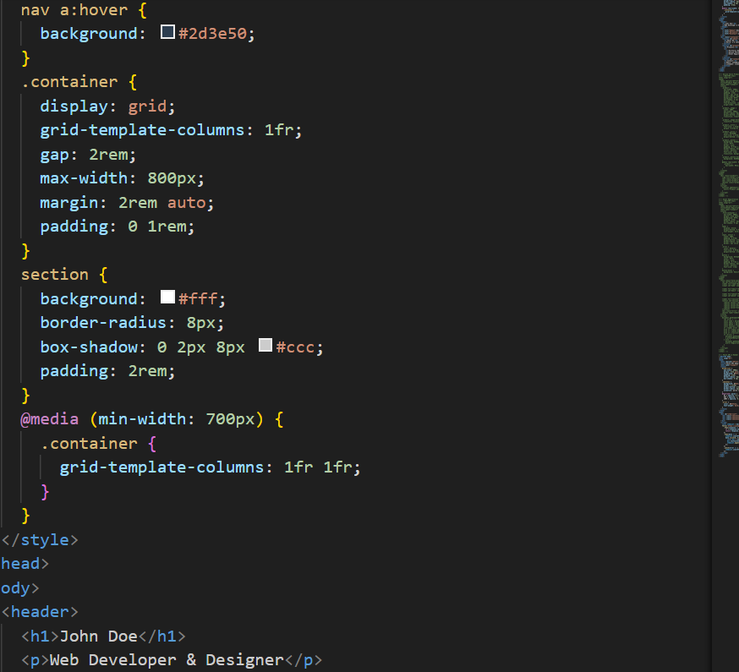

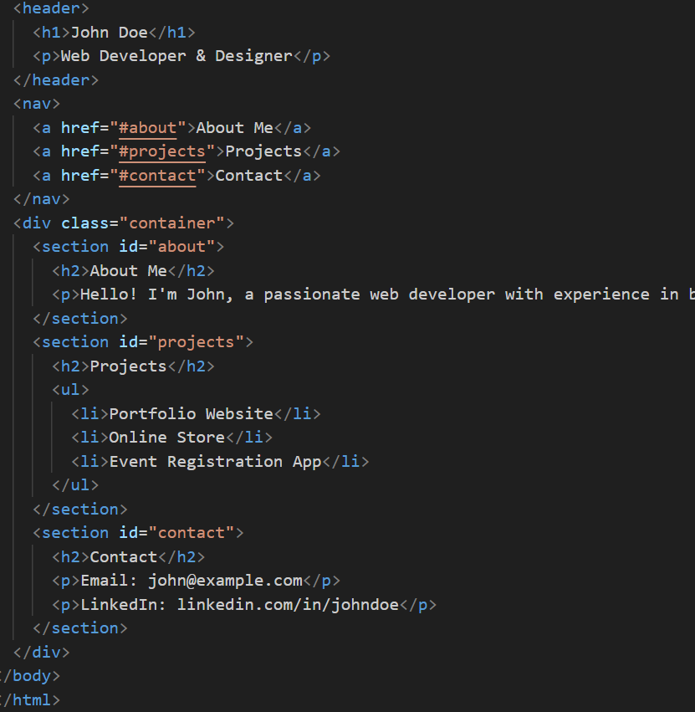

**OUTPUT:-**

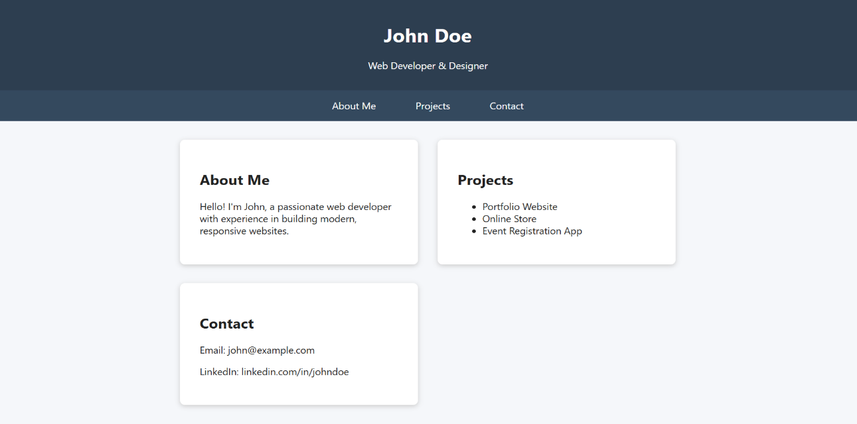

**OBSERVATION:-**

The personal portfolio website effectively presents the creator’s professional profile in a visually appealing and organized manner. The site is user-friendly, responsive, and provides easy navigation between sections. It demonstrates strong front-end development skills and creativity. The inclusion of animations and project showcases enhances the interactive experience for visitors and potential employers.

**TASK 2;-**

Online Store Product Page  
Design a product display page for an online store

**PROMPT:-**

**"**Design a responsive product display page for an online store using HTML, CSS, and JavaScript. The page should showcase multiple products with images, names, descriptions, prices, and an 'Add to Cart' button. Implement a hover effect on product cards, a responsive grid layout for different screen sizes, and a basic shopping cart functionality that shows the number of items added."

**CODE:-**

**OUTPUT:-**

**OBSERVATION:-**

The product display page provides a clean and organized view of items available in the online store. The grid layout allows easy navigation across products, while hover effects enhance interactivity. The “Add to Cart” feature gives immediate feedback to users about selected items. The page demonstrates skills in responsive web design, frontend development, and user experience optimization.

**TASK 3:-**

**Event Registration Form  
Build an event registration form for a conference**

**PROMPT:-**

"Design and develop an Event Registration Form using HTML, CSS, and JavaScript for a conference. The form should collect details like participant name, email, phone number, gender, event type, and preferred date. Implement input validation to ensure all required fields are filled correctly. Display a confirmation message after successful registration."

**CODE:-**

**OUTPUT:-**

**OBSERVATION:-**

The event registration form allows participants to easily register for a conference by entering their personal details. It demonstrates good use of form elements, input validation, and responsive design. The interface is user-friendly and ensures data accuracy through client-side validation. The confirmation message enhances the user experience by providing immediate feedback after submission.

**TASK 4:-**

**Fetch JSON from an API and render items to the DOM  
with loading and error UI**

**PROMPT:-**

"Build a webpage that fetches JSON data from a public API and displays the items dynamically on the webpage. Include a loading indicator while data is being fetched and display an error message if the request fails. Use modern JavaScript (fetch API and DOM manipulation)."

**CODE:-**

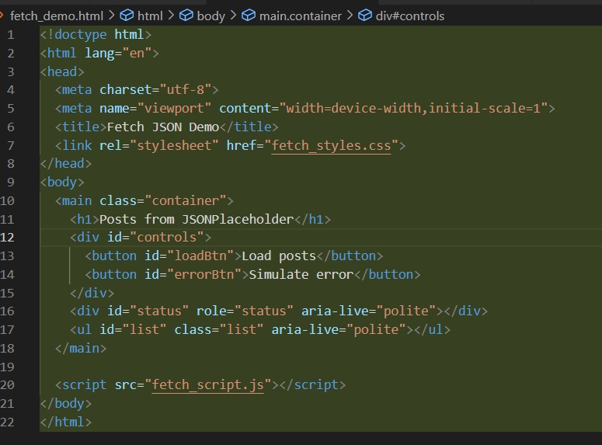

**OUTPUT:-**

**OBSERVATION:-**

The project demonstrates how to fetch data asynchronously from an external API and display it dynamically in the browser. The use of a loading spinner enhances user experience, while proper error handling ensures reliability. This project showcases understanding of asynchronous programming, DOM updates, and user interface feedback using JavaScript.