NAME:-GUGGILLA ANUJA
HALL.TICKET.NO:-2403A51101
BATCH:06
COURSE:-AI ASSISSTED CODING

LAB TEST-04

Q1. Training dataset contains categorical, numeric, and timestamp
columns.
a) Create AI-assisted mixed-type preprocessing script.
b) Explain feature validation rules.
PROMPT:-
"Create a Python script that AI‑assists mixed-type preprocessing for a dataset with categorical, numeric, and timestamp columns. Include feature validation rules and a small demo."
CODE:-
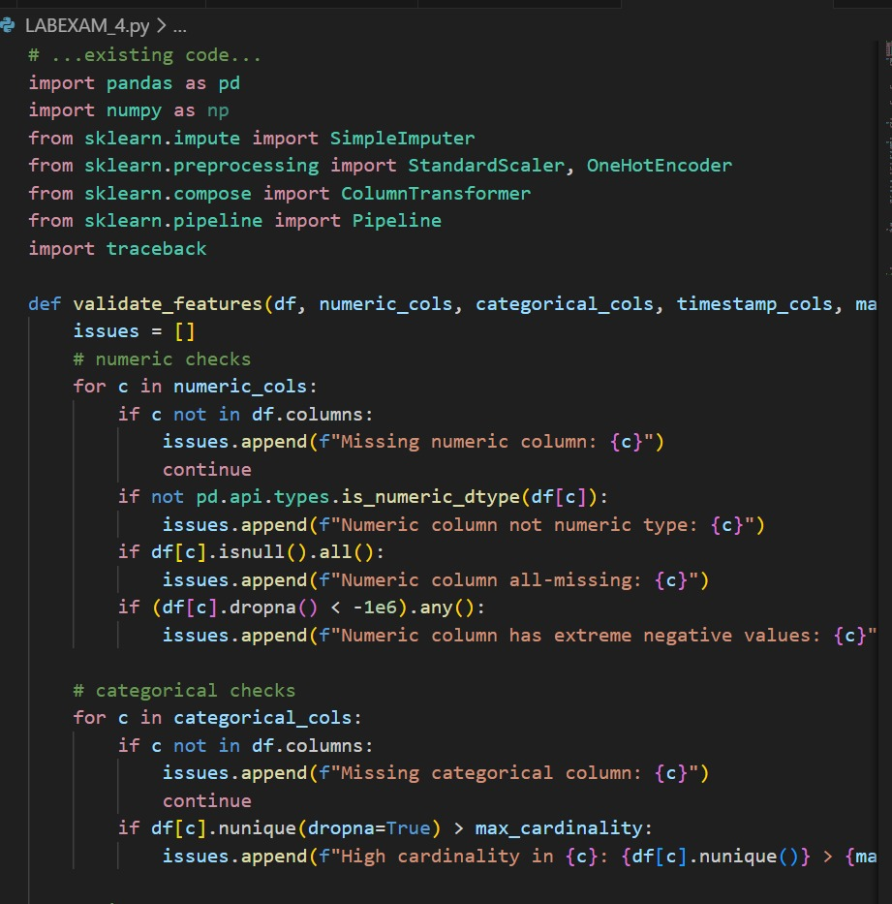
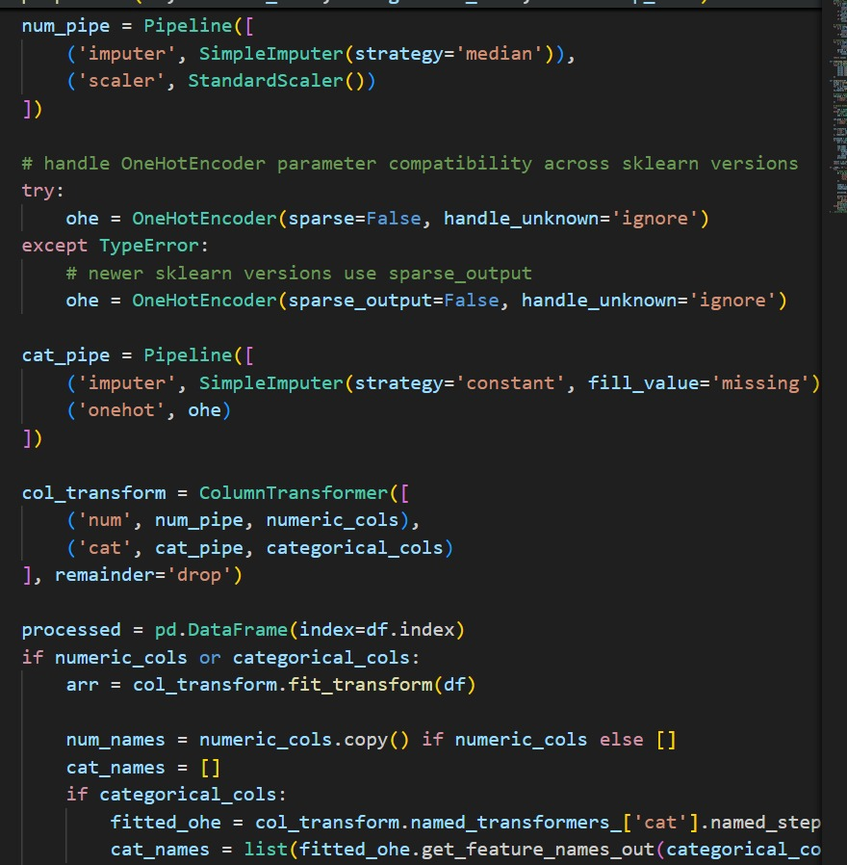

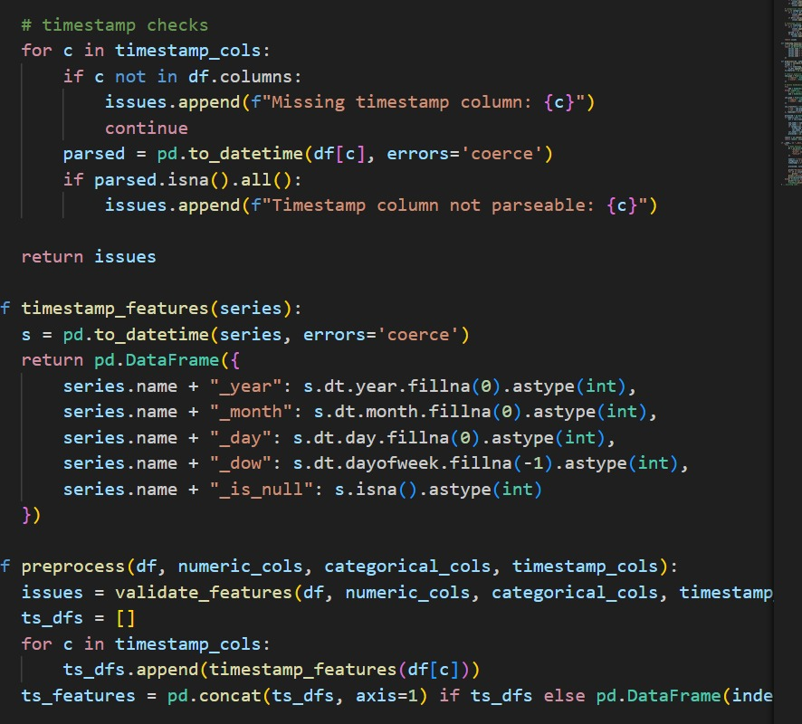
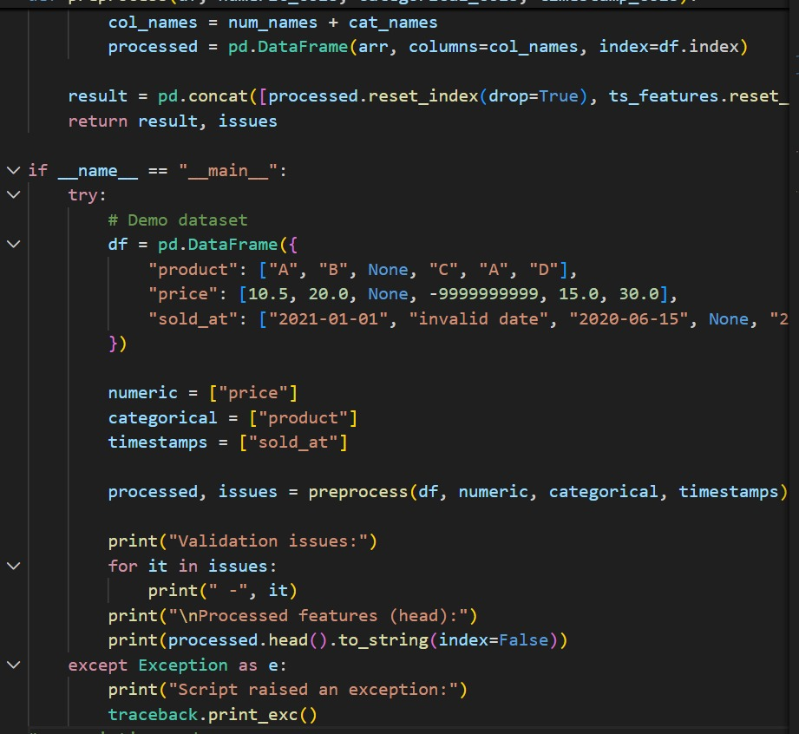
OUTPUT:-
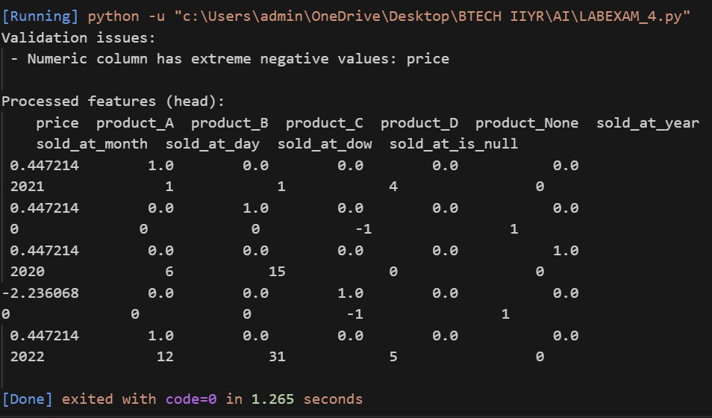
OBSERVATION:-
Script validates numeric/categorical/timestamp columns (presence, types, cardinality, parseability).
Numeric: median imputation + standard scaling. Categorical: missing→'missing' then one-hot (unknowns ignored). Timestamp: parsed and expanded to year/month/day/dow and null flag.
Returns processed feature DataFrame and list of validation issues.
b) Explain feature validation rules.

• IDs: Check present & unique; malformed IDs often indicate parsing or join problems.
• Numeric ranges: Age (0–120) and Income (≥0) — values outside expected ranges are likely errors or require domain handling.
• Missingness thresholds: Track fraction missing; above thresholds triggers imputation strategy or dropping.
• Categorical cardinality & special codes: Unknown, UNK should be treated as missing; cardinality informs encoding choice (one-hot vs frequency/target).
• Timestamp parseability: Unparseable timestamps should be coerced to NA and flagged — extracting components (year/month/day/hour/dayofweek) gives the model time signals.

Q2. AI suggests using AutoML transformation pipeline.
a) Define integration steps.
b) State when custom logic is required.
PROMPT:-
"Show AutoML transformation pipeline integration steps for mixed-type data, when to add custom logic, and produce a small Python script that builds a ColumnTransformer pipeline and optionally attempts to wire an AutoML estimator if available."
CODE:-
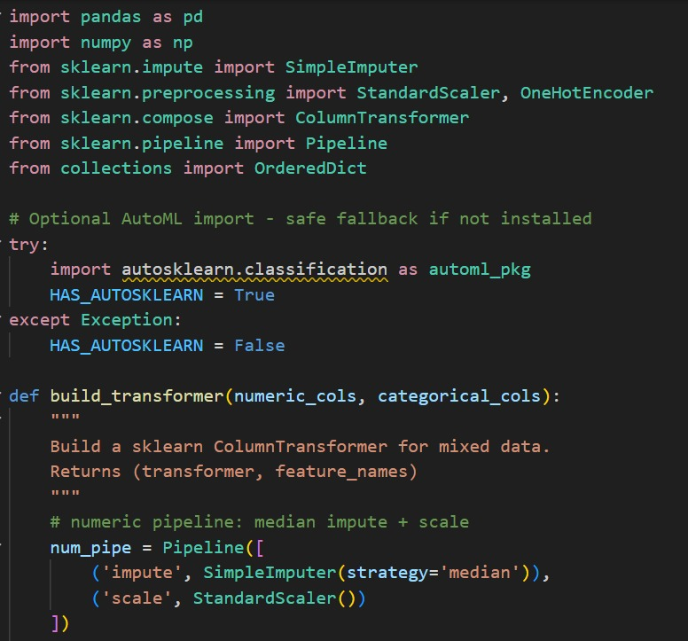
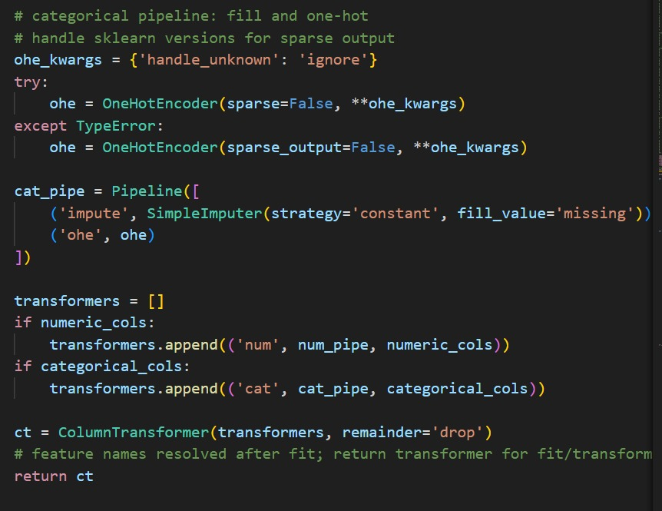
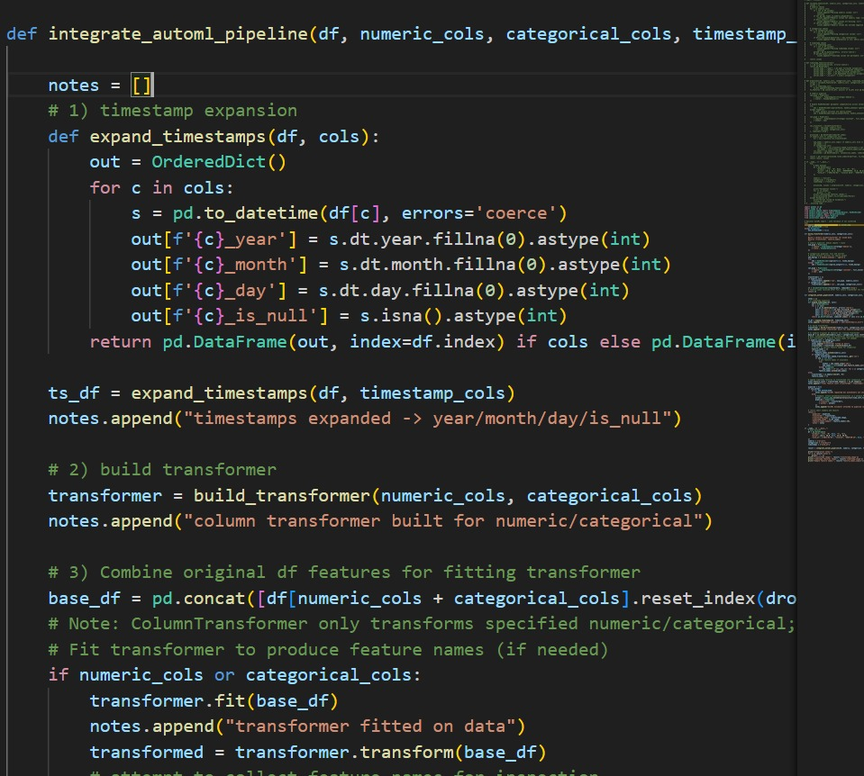
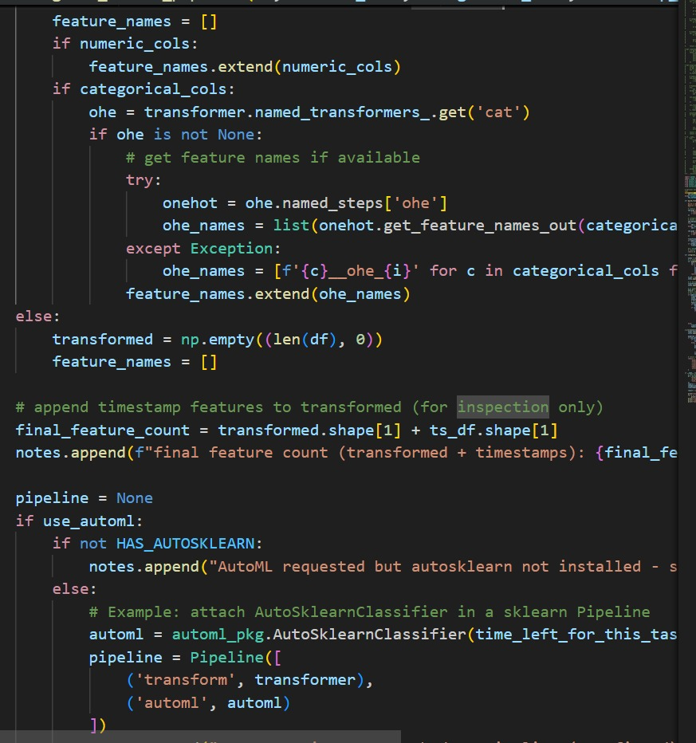
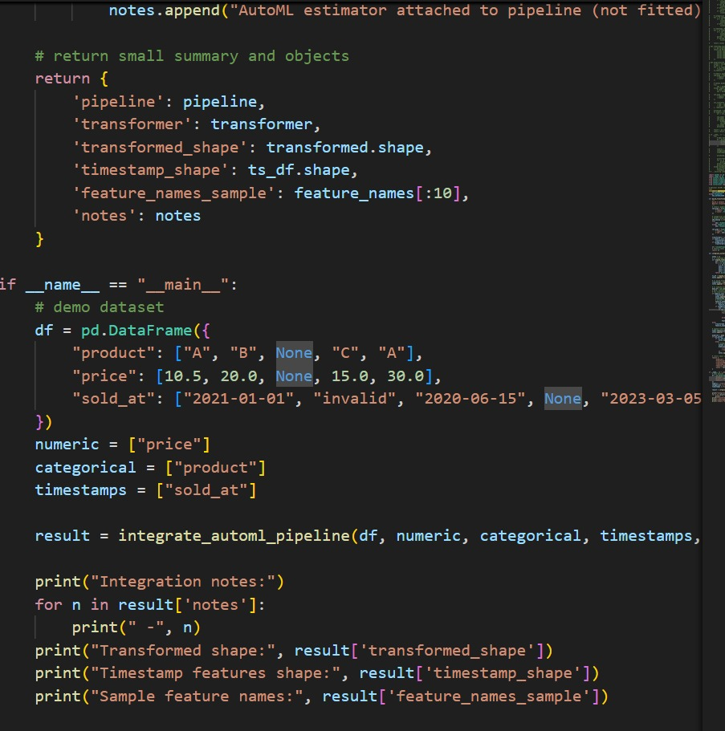
OUTPUT:-
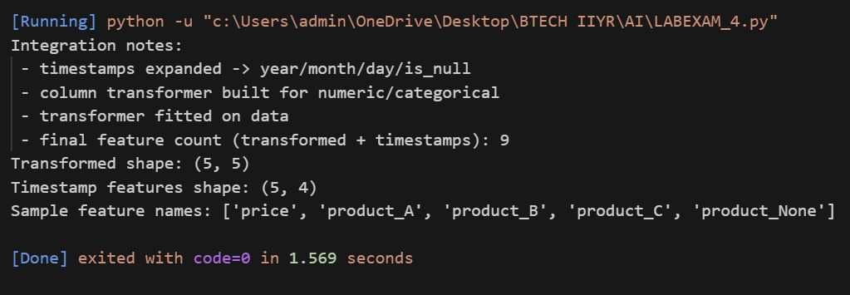
OBSERVATON:-

Integration steps: expand timestamps, build ColumnTransformer for numeric/categorical, fit transformer, optionally attach AutoML estimator, export pipeline for inference.
Use AutoML when you want end-to-end model search; require labeled data and compute budget.
Custom logic required for: high-cardinality categorical encoding, domain-specific timestamp features, target leakage prevention, advanced imputation, and business-rule validation.
a) Integration Steps
- Data Ingestion: Load data from CSV/DB/API.
- Validation & Profiling: Check missing values, data types, anomalies.
- AutoML Pipeline:
  - Numeric → impute + scale
  - Categorical → encode (OneHot/Frequency)
  - Timestamp → extract year/month/day/hour/dayofweek
  - Boolean → impute 0/1
- Feature Engineering: AutoML handles interactions/polynomials.
- Model Integration: Feed preprocessed data into candidate models.
- Monitoring & Logging: Track applied transformations.
- Deployment: Apply same pipeline to new/real-time data.

b) When Custom Logic Is Required
- Domain rules: e.g., Age ≤ 120, Income ≥ 0.
- Complex features: Ratios, flags, aggregates.
- Data cleaning exceptions: Invalid timestamps, malformed IDs.
- Special encoding/imputation: Rare categories, group-based imputation.
- Compliance/audit: Explainable transformations beyond AutoML defaults.

