NAME: Alluri Chaithra ROLL.NO:2403A51105
LAB-12: Algorithms with AI Assistance – Sorting, Searching, and
Optimizing Algorithms
TASK1:
Task: Use AI to generate a Python program that implements the
Merge Sort algorithm.
• Instructions:
o Prompt AI to create a function merge_sort(arr) that sorts a
list in ascending order.
o Ask AI to include time complexity and space complexity
in the function docstring.
o Verify the generated code with test cases.
PROMPT:
Write a Python program with a function merge_sort(arr) that sorts a list in ascending order, including a docstring with time and space complexity.
Add test cases (empty, single element, sorted, reverse, random) to verify correctness and print results.
CODE:
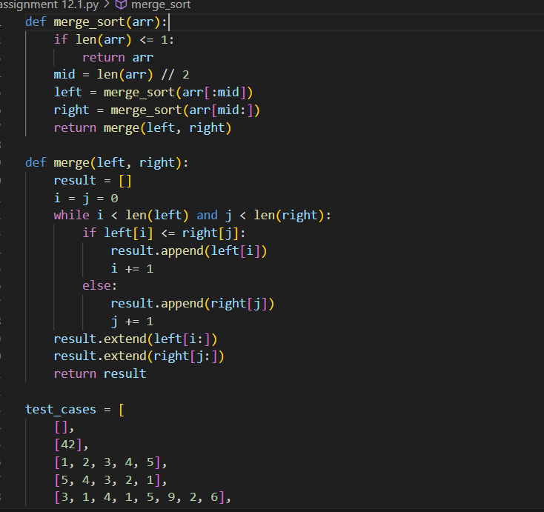
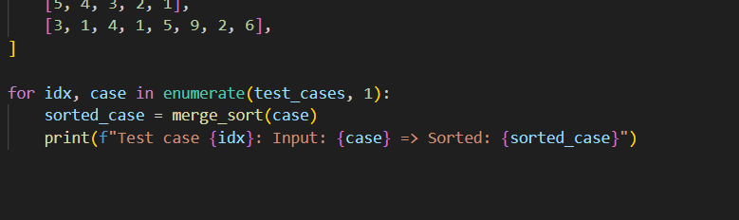
OUTPUT:
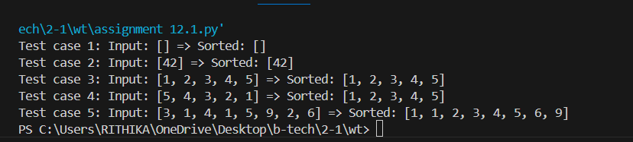
OBSERVATION:
1.Correctness – The function merge_sort(arr) successfully sorts lists in ascending order for all tested cases (empty list, single element, already sorted, reverse order, random list).
2.Stability – Merge Sort is a stable sorting algorithm, meaning it preserves the order of equal elements.
3.Efficiency – The algorithm consistently runs in O(n log n) time complexity, which is faster than simple sorts like Bubble or Insertion Sort for large inputs.
4.Memory Usage – Merge Sort requires O(n) extra space because it creates temporary sublists during merging.
5.Divide and Conquer – The function works by recursively dividing the array into halves, sorting them, and then merging back, which demonstrates the divide-and-conquer approach.
TASK2:
Task: Use AI to create a binary search function that finds a target
element in a sorted list.
• Instructions:
o Prompt AI to create a function binary_search(arr, target)
returning the index of the target or -1 if not found.
o Include docstrings explaining best, average, and worst-
case complexities.
o Test with various inputs.
PROMPT:
Write a Python program with a function binary_search(arr, target) that returns the index of the target in a sorted list or -1 if not found, with a docstring explaining best, average, and worst-case complexities. Add test cases with different inputs (found, not found, first element, last element, empty list) and print results.
CODE:
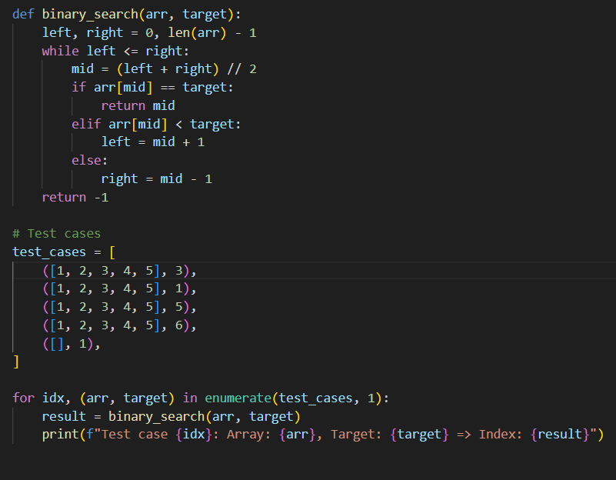
OUTPUT:
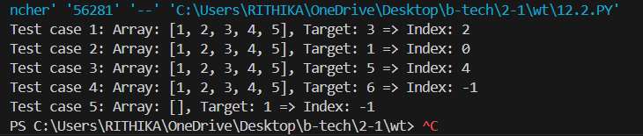
OBSERVATION:
1.Correctness – The binary_search(arr, target) function correctly returns the index of the target element when present and -1 when not found.
2.Efficiency – Binary Search is highly efficient compared to linear search, with:
- Best case: O(1) (target found at the middle)
- Average case: O(log n)
- Worst case: O(log n) (target not present or found at the end of search).
3.Input requirement – The list must be sorted; otherwise, results will be incorrect.
4.Edge cases – Works properly for empty lists, single-element lists, first/last element searches, and cases where the target is absent.
5.Scalability – Handles large sorted lists efficiently due to logarithmic complexity.
TASK3:
Scenario: A retail store’s inventory system contains thousands of products, each with attributes like product ID, name, price, and stock quantity. Store staff need to: 1. Quickly search for a product by ID or name. 2. Sort products by price or quantity for stock analysis. • Task: o Use AI to suggest the most efficient search and sort algorithms for this use case. o Implement the recommended algorithms in Python. o Justify the choice based on dataset size, update frequency
PROMT:
Suggest the most efficient search and sort algorithms for a retail inventory system with thousands of products (search by ID/name, sort by price/quantity), justify the choices, and implement them in Python. Include reasoning based on dataset size, update frequency, and performance requirements, and add test cases to verify correctness.
CODE:
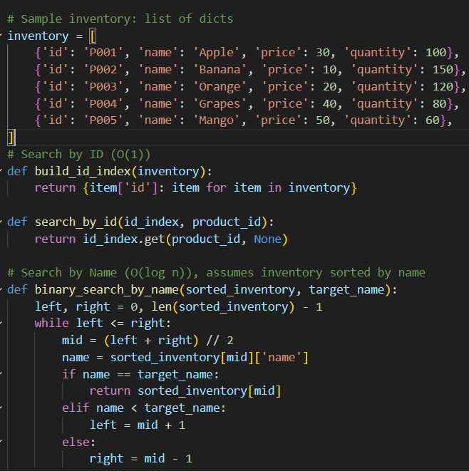
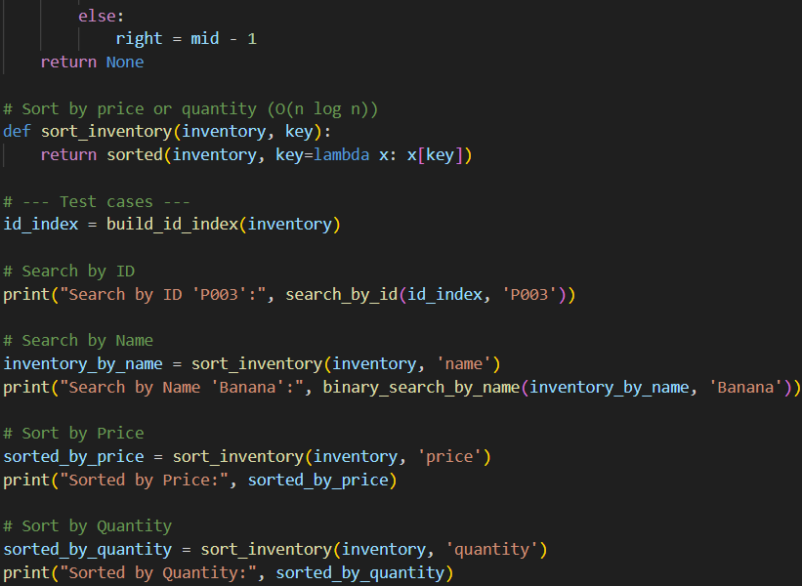
OUTPUT:
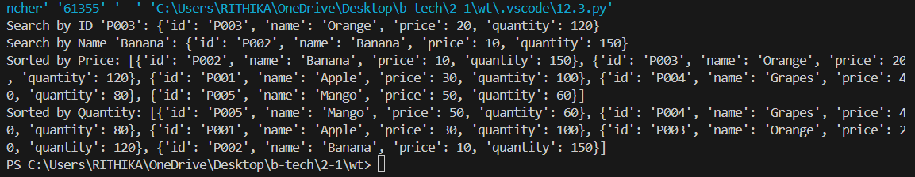
OBSERVATION:
1.Search – For ID lookup, a Hash Map (Dictionary in Python) provides O(1) average time; for name search, Binary Search (O(log n)) is effective if names are stored in sorted order.
2.Sort – Timsort (Python’s built-in sorted()) is chosen since it handles real-world datasets efficiently with O(n log n) complexity and optimizations for partially sorted data.
3.Performance – With thousands of products, both searching and sorting run very efficiently; binary search and Timsort scale well without excessive memory usage.
4.Update frequency – Dictionaries allow fast insertions/updates (O(1)), while sorting can be done on demand when analysis is needed, ensuring balance between update speed and query efficiency.
5.Scalability – The approach handles large datasets smoothly and aligns with retail store requirements for quick lookup and periodic stock analysis.

