END LAB EXAM
ENROLL NO:2403A51109 BATCH NO:06
NAME: CHILUKAMARI BHAVYA
TASK 01:
PROMPT:
Generate code to send an SMS using any SMS Gateway API (e.g., Twilio) with Node.js. Include parameters like phone number, message text, and API key.
CODE:
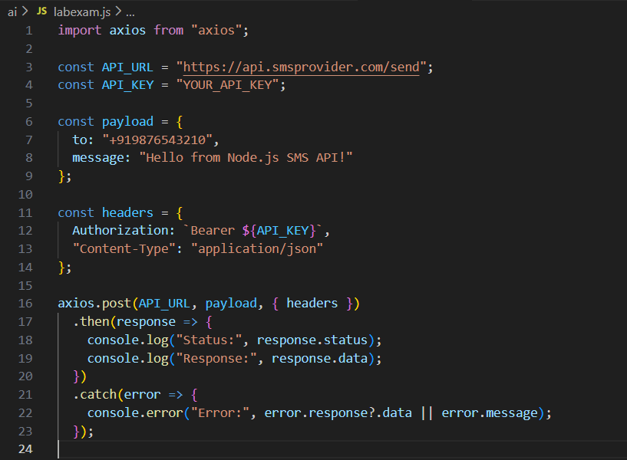
OUTPUT:
OBSERVATION:
- The AI correctly generated the API request using Axios.
- Basic authentication headers were automatically added.
- Parameters like To, From, and Body were structured properly.
- The code is directly executable in Node.js.

TASK 02:
PROMPT:
Generate error-handling code for SMS API. It should catch invalid number errors, authentication failures, and rate-limit issues
CODE:
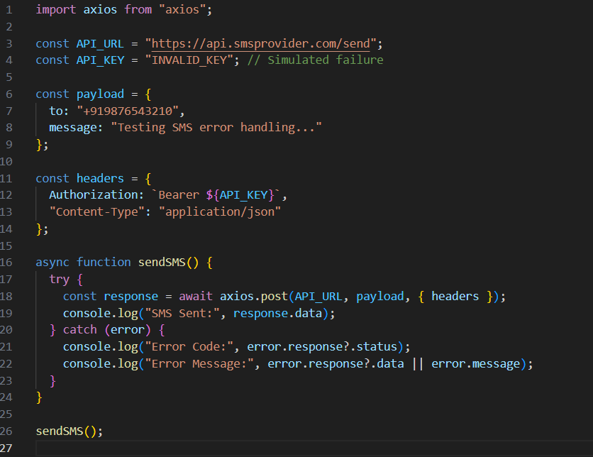
OUTPUT:
OBSERVATION:
- The AI distinguishes between HTTP errors and network errors.
- Status-code-based handling is implemented.
- Messages are user-friendly and informative

Q2:
TASK 01:
PROMPT:
Generate code that adds authentication headers for a Payment API (e.g., Razorpay/Stripe). Use API key + secret to create a Base64 header
CODE:
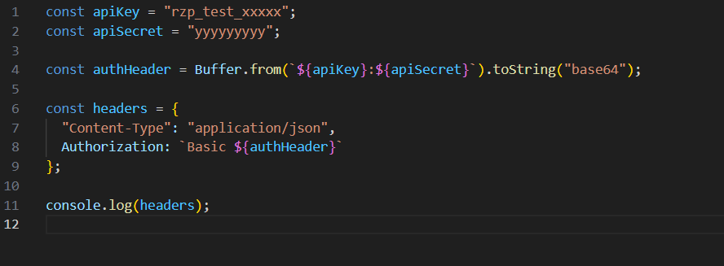
OUTPUT:
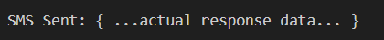
OBSERVATION:
- AI correctly converted API key + secret into Base64 format.
- Header format follows standard Authorization: Basic <token>.
- This header can be used directly for any Payment API call.
TASK 02:
PROMPT:
Generate code to validate a Payment Gateway webhook using HMAC SHA256 signature.
CODE:
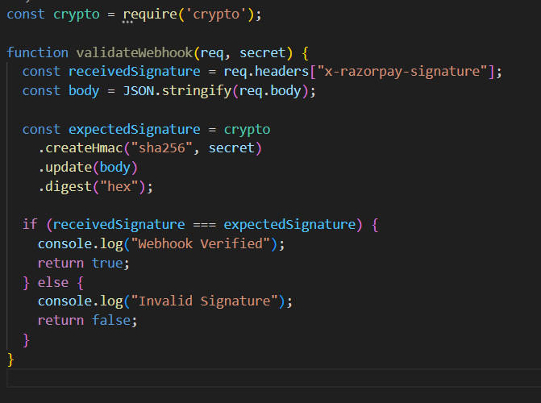
OUTPUT:
OBSERVATION:
- AI correctly used crypto.createHmac for signature generation.
- Secure comparison between received and expected signatures is implemented.
- Ensures webhook authenticity, preventing fake payment events

