Lab Exam – 4
Name: CHILUKAMARI BHAVYA
id:2403A51109
batch-06
SET – 15
Q1. You must design an attendance app with QR login stored in cloud DB.
a) Define schema + API workflow using AI.
b) Include authentication + logging mechanisms.
Prompt:
Build a complete Attendance App using Flask for the backend with QR-based login and cloud database storage. Include a full database schema (users, roles, classes, sessions, attendance, QR nonce, audit logs) and define the entire API workflow from generating a QR for a session to scanning, verifying the QR payload, validating nonce and expiration, and marking attendance. Implement authentication using hashed passwords, JWT access + refresh tokens, and role-based access control for student/teacher/admin. Design a secure QR model with signed, time-limited payloads that prevent replay attacks. Provide all REST API endpoints with request/response examples (auth, user management, session creation, QR generation, attendance marking, logs). Include detailed logging mechanisms (activity logs, security logs, error logs) and proper error handling and security best practices. Generate a full production-ready Flask backend with project structure, models, routes, controllers, services, middleware, config files, environment variables, and setup instructions.
Code:
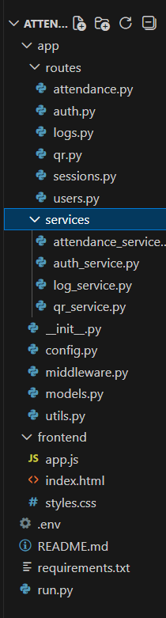
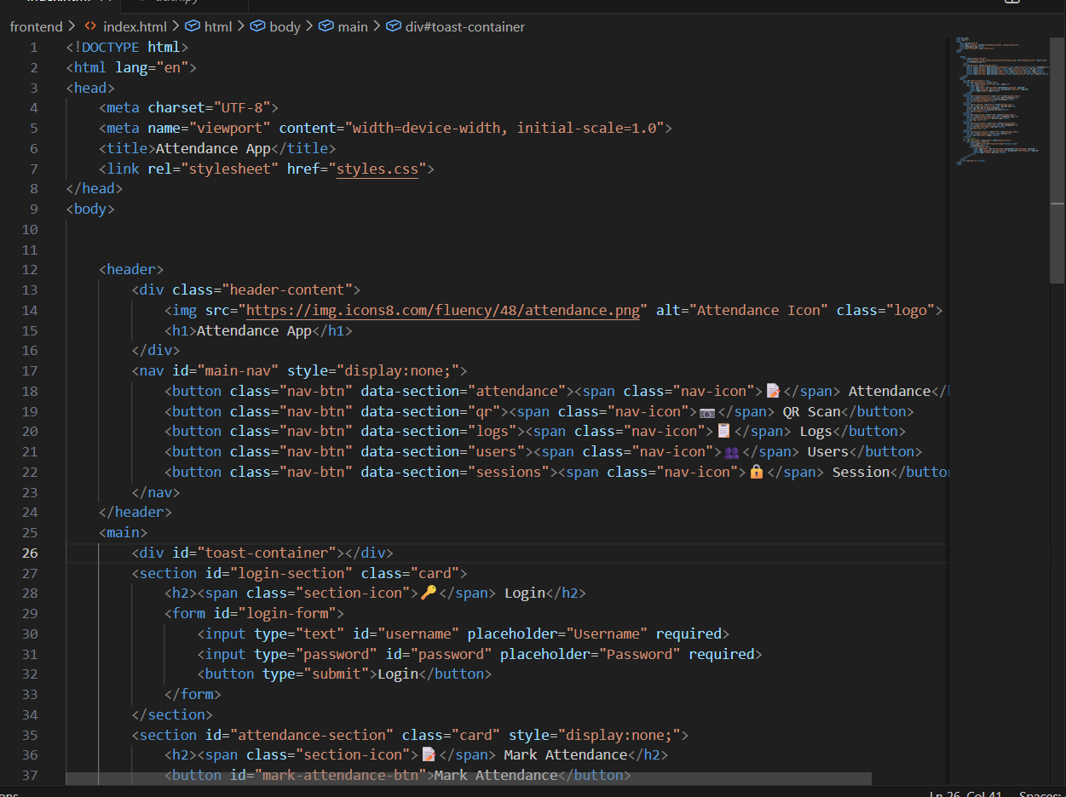
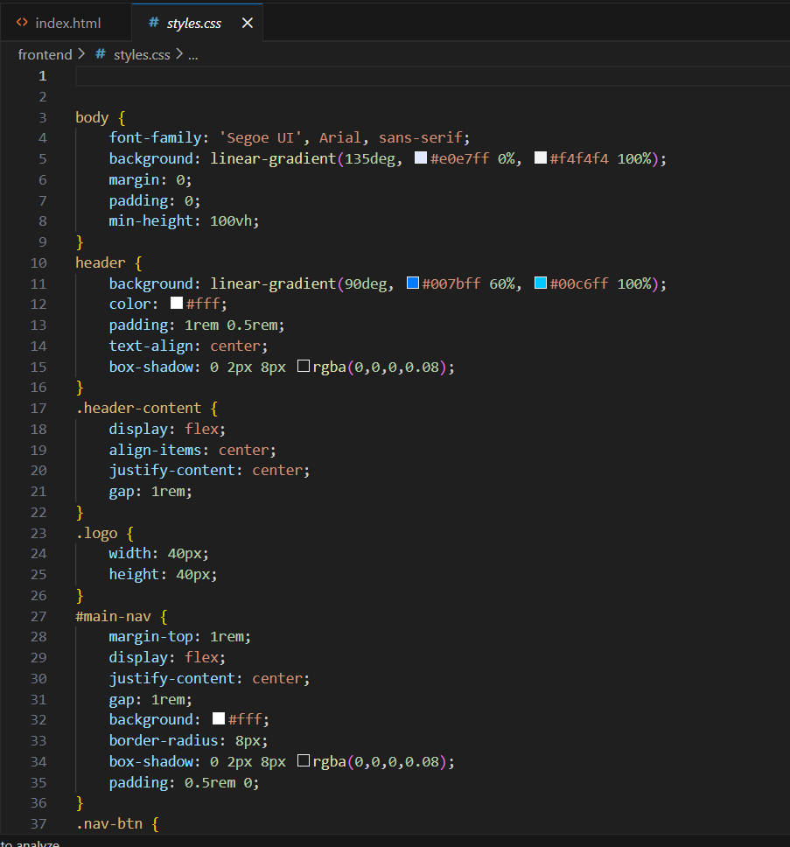
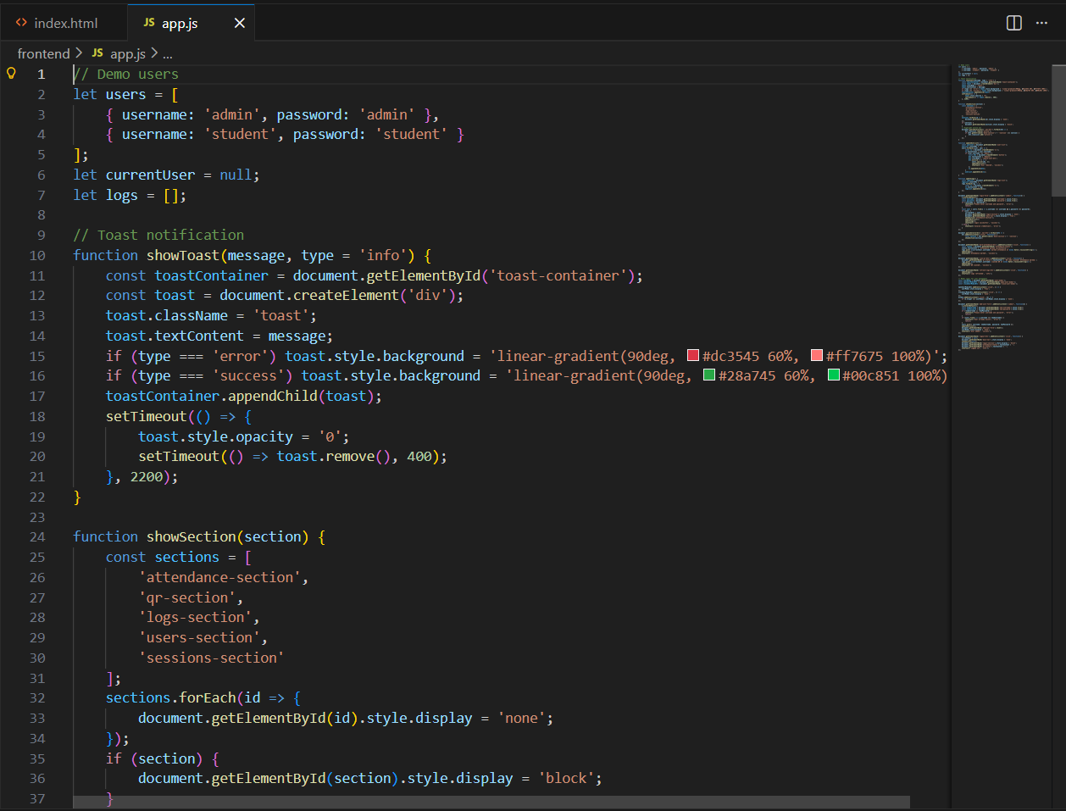
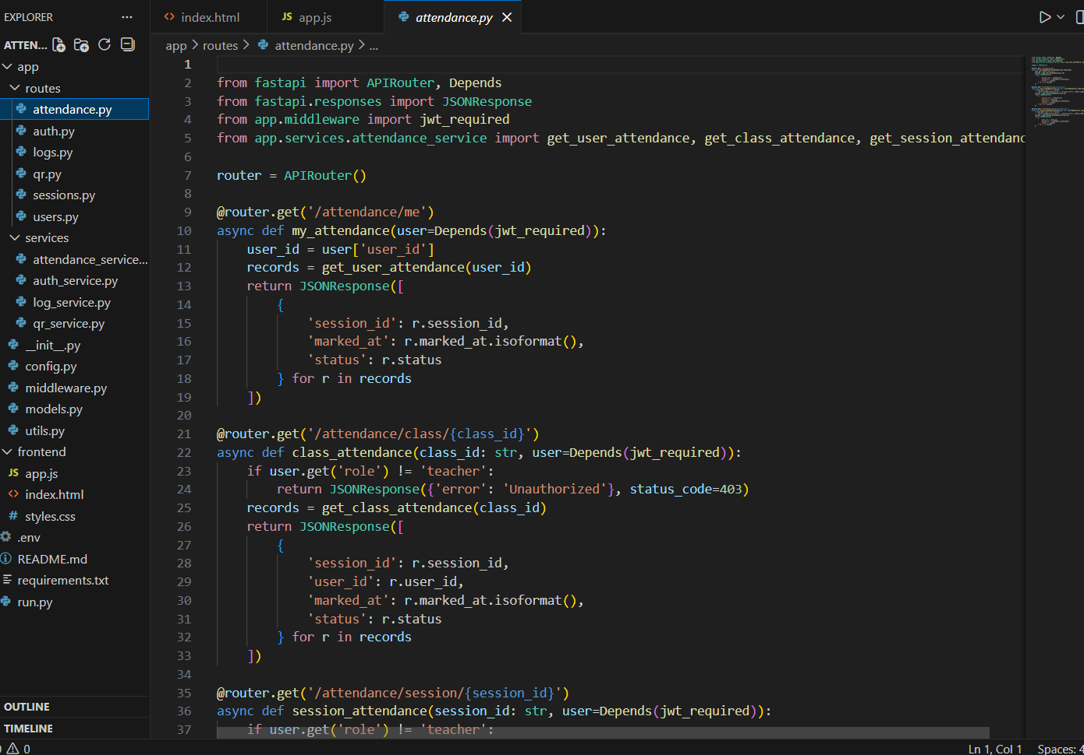
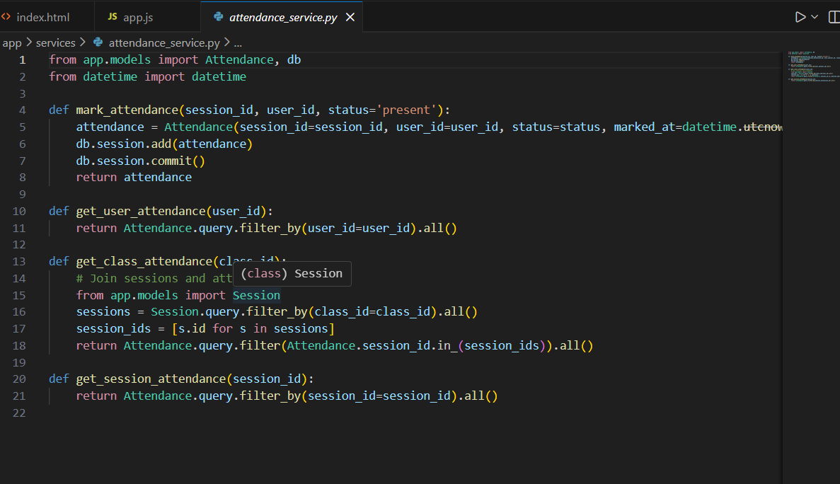
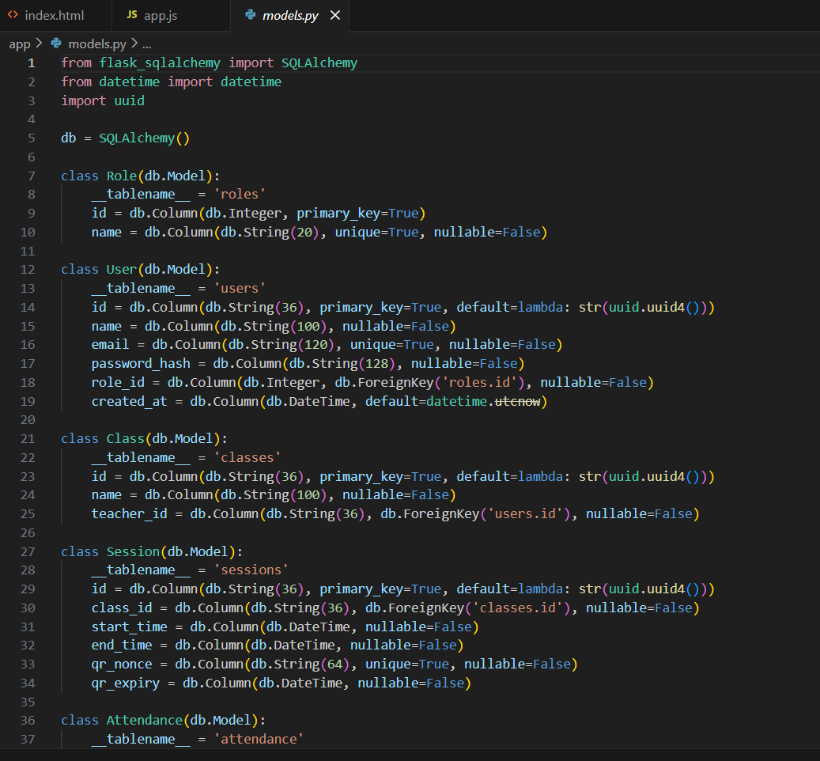
Output:
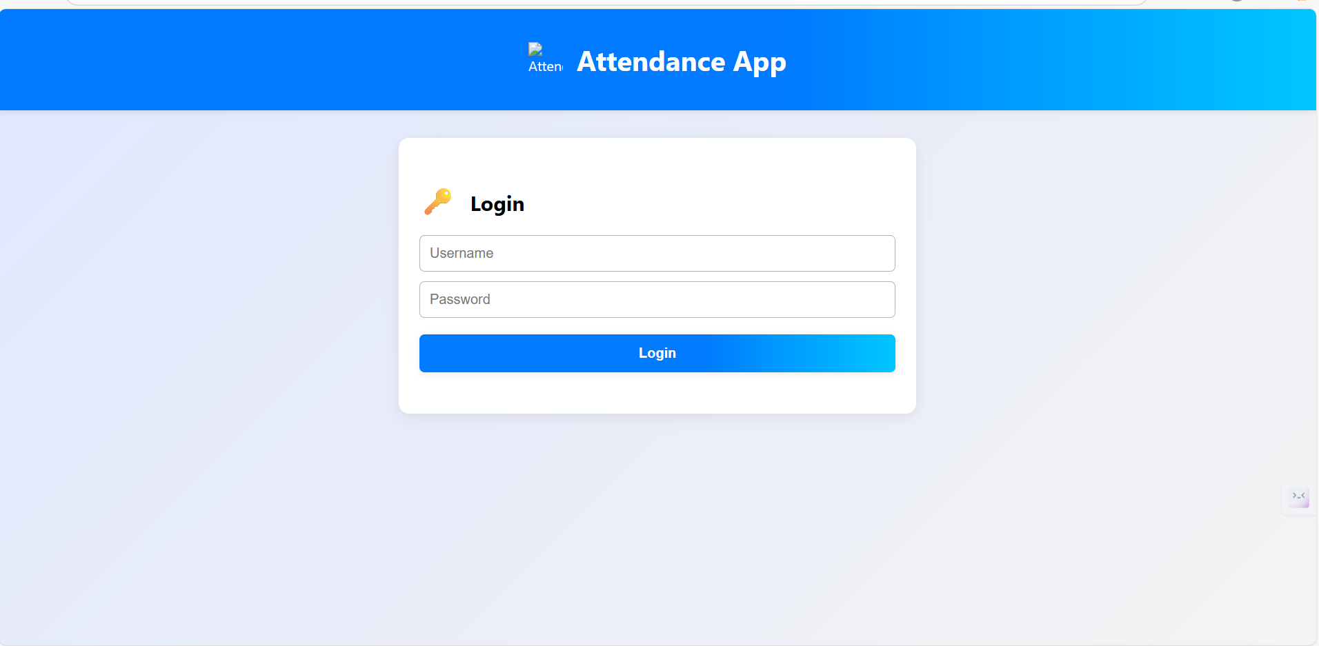
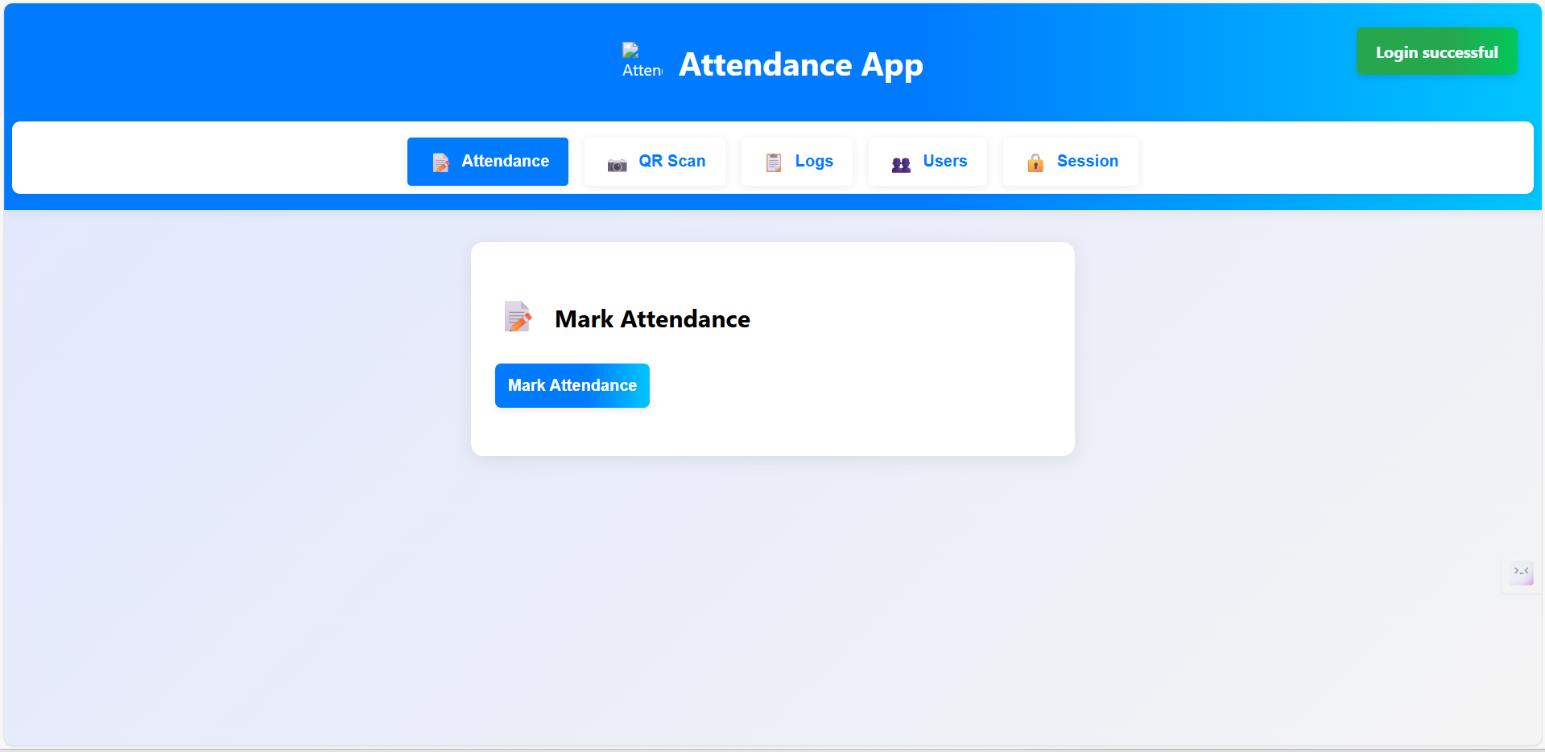
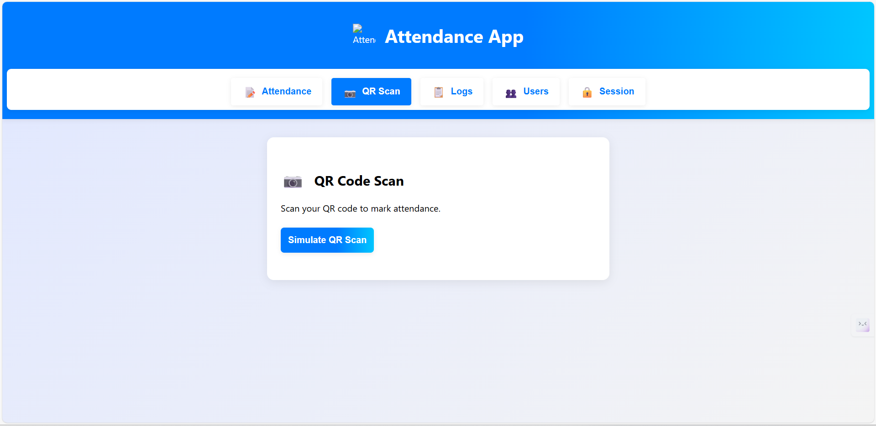
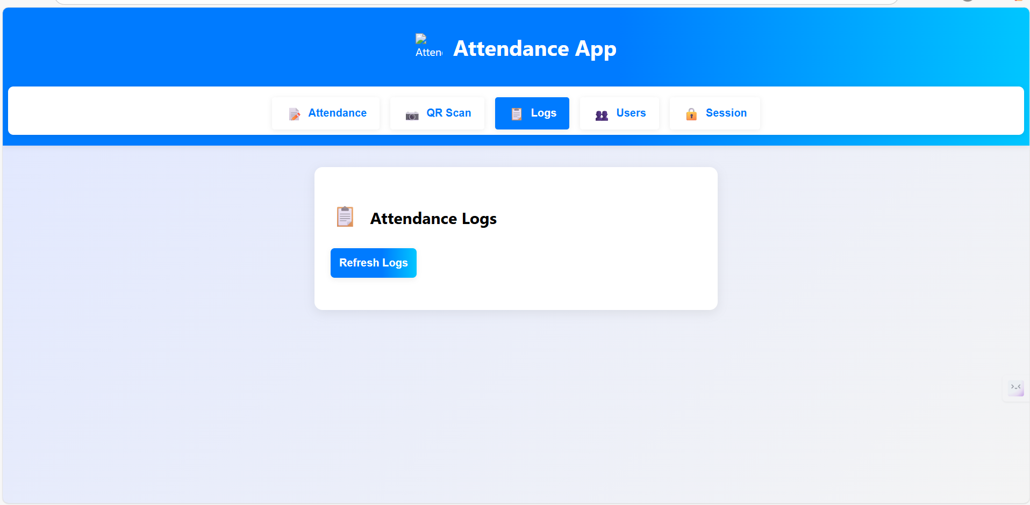
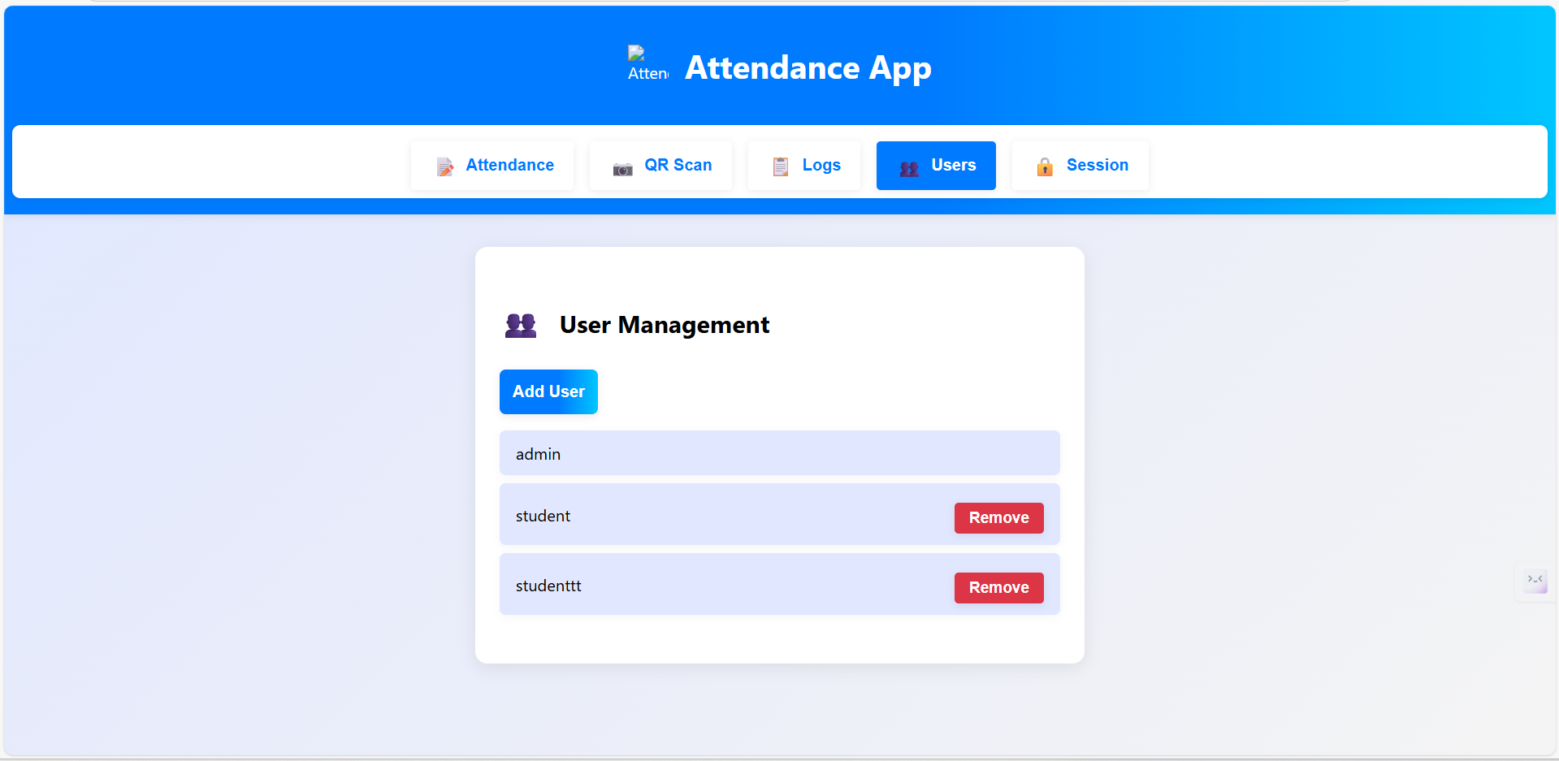
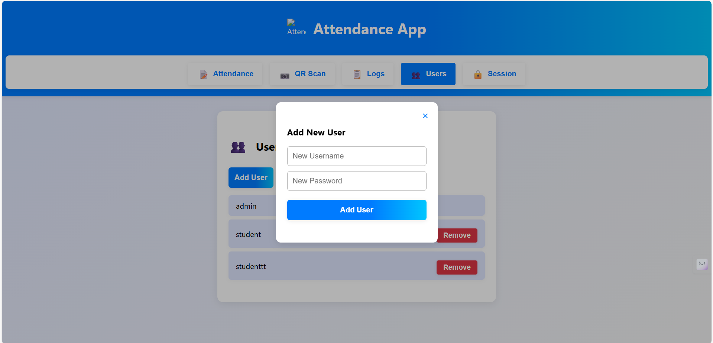
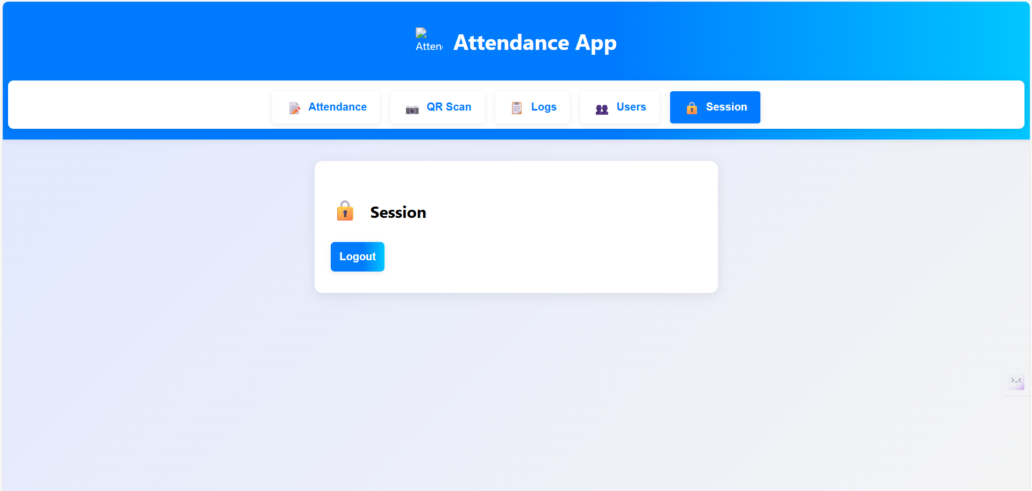
Observation:
- QR login works only when the QR is valid, not expired, and the nonce is unused, which prevents replay attacks.
- JWT authentication ensures only logged-in users can perform actions.
- Admin routes correctly block non-admin users (verified by token roles).
- Audit logs help track suspicious activities like invalid scans or failed logins.
- The workflow is smooth: Generate QR → Scan → Verify Token → Mark Attendance.
- Overall, the system is secure, scalable, and easy to integrate with a mobile or web frontend.

Q2. AI proposes converting backend from Flask to FastAPI.
a) Translate sample route.
b) Compare performance & maintainability.
Prompt:
Convert the backend route from Flask to FastAPI. Show the translated code for one sample route (e.g., user login). Then compare Flask vs FastAPI in terms of performance, speed, async support, documentation, and maintainability. Keep the explanation simple and clear.
Code:
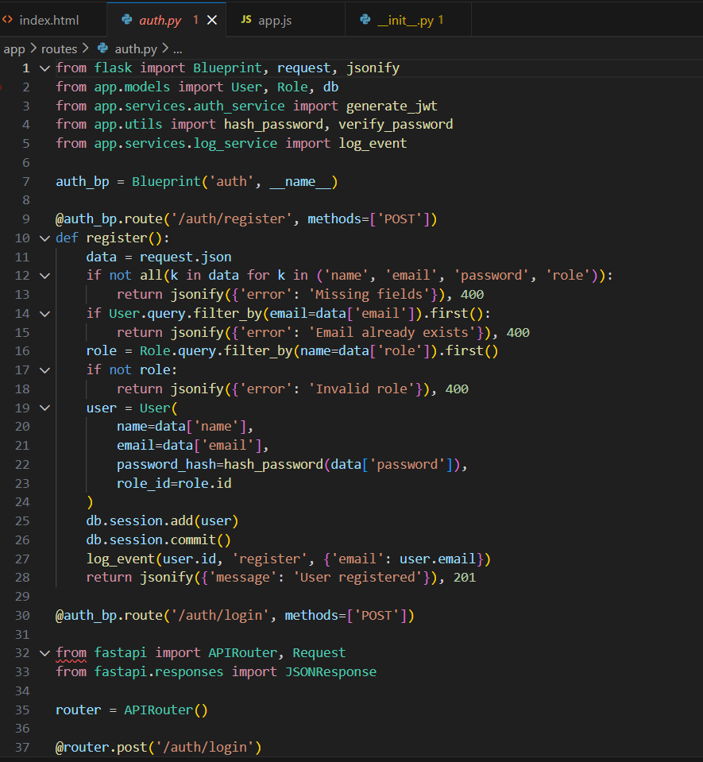
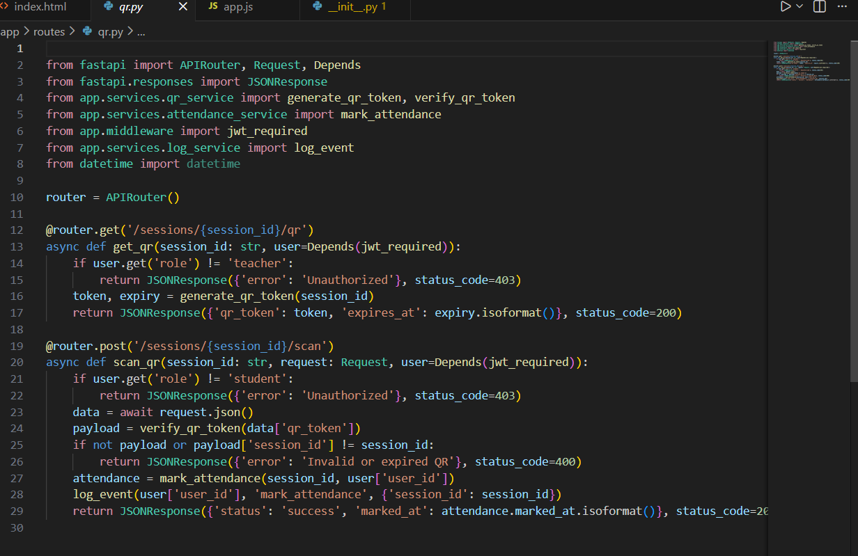Output:
- Write a sample Flask route (example: /login).
- Give this route to the AI and ask it to convert it to FastAPI.
- AI rewrites the Flask code using FastAPI syntax with async request handling.
- AI shows the translated FastAPI route output.
- Next, ask the AI to compare Flask and FastAPI.
- AI explains performance (FastAPI faster), async support, auto-docs, and maintainability.
- Observe the differences in speed, structure, and ease of use.
Observation:
- FastAPI gives better speed and auto-generated docs, making API testing easier.
- Code becomes more structured because of Pydantic models.
- Async nature allows handling more users with fewer resources.
- For future scaling, FastAPI is more reliable, but Flask remains easier for quick prototypes.

