# AI ASSISTED CODING

# ASSIGNMENT 4.4

## 2403A51236-SIRI

## BATCH 11

ask 1: Auto-Complete a Python Class for Bank Account  
Task Description #1  
• Write a class definition comment and start the constructor for a class called BankAccount with account_holder and balance attributes. Use GitHub Copilot to auto-complete the rest of the  
class, including methods to deposit, withdraw, and display balance.

Expected Output #1  
• Complete class with methods like: deposit(self, amount)  
withdraw(self, amount) display_balance(self)

• Output from sample usage:

Promt: Auto-Complete a Python Class for Bank Account. start the constructor for a class called Bank Account with account_holder and balance attributes auto-complete the rest of the class, including methods to deposit, withdraw, and display balance.

Task Description #2  
• Write a comment and the initial line of a loop to iterate over a list. Allow GitHub Copilot to complete the logic to sum all even numbers in the list.  
Expected Output #2  
• Code that:  
• Iterates over a list  
• Checks if the number is even using % 2 == 0  
• Accumulates the sum  
• Sample input/output

Promt:A uto-Complete a For Loop to Sum Even Numbers in a List

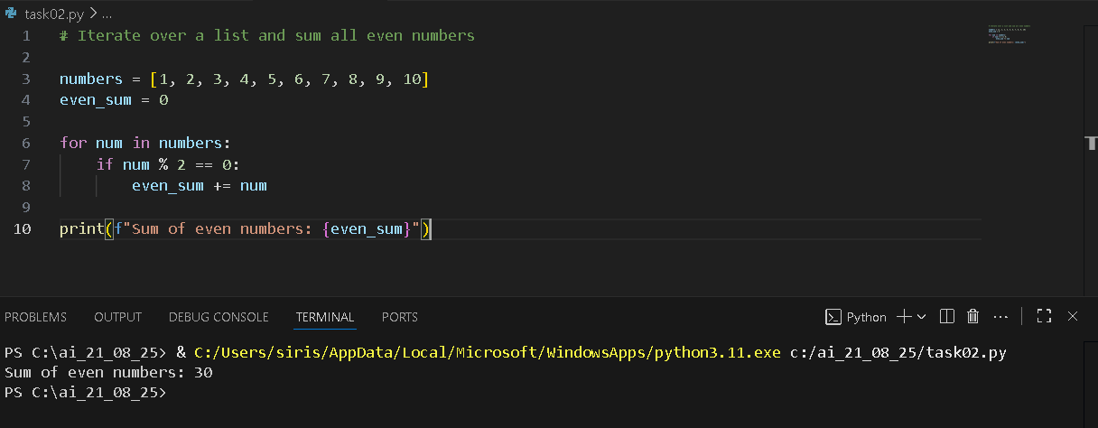

Task 3: Auto-Complete Conditional Logic to Check Age Group  
Task Description #3  
• Start a function that takes age as input and returns whether the person is a child, teenager,  
adult, or senior using if-elif-else. Use Copilot to complete the conditionals.  
Expected Output #3  
• Function like:  
Output for age_group(45) ➝ "Adult"

Promt: Auto-Complete Conditional Logic to Check Age Group

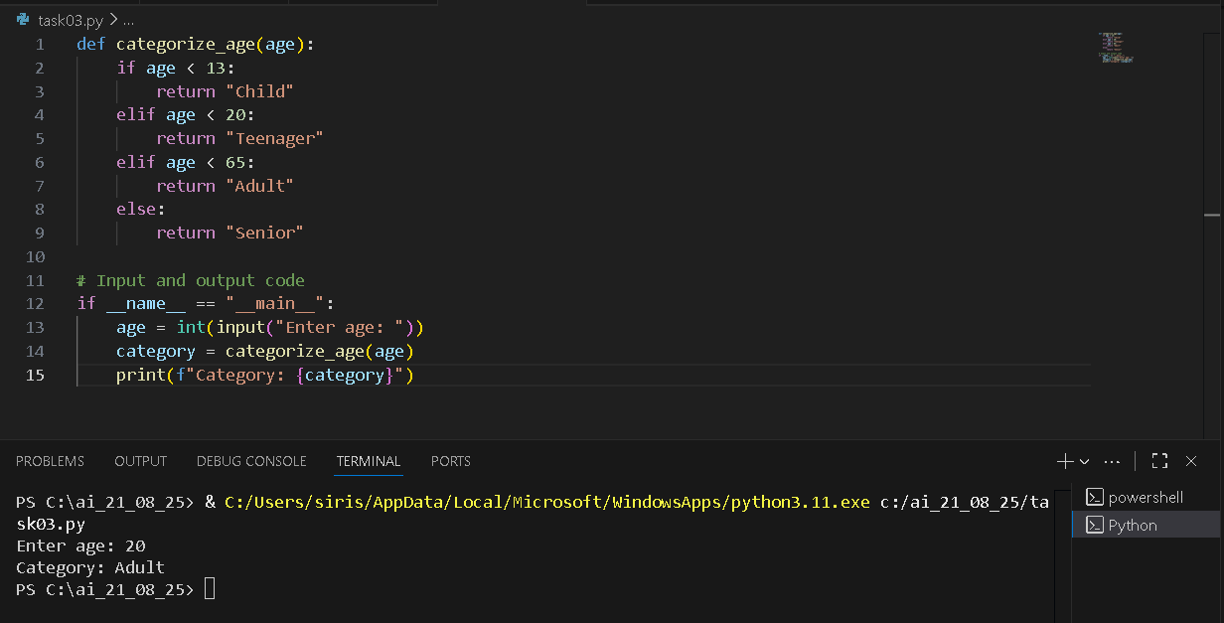

Task 4: Auto-Complete a While Loop to Reverse Digits of a Number  
Task Description #4

• Write a comment and start a while loop to reverse the digits of a number. Let Copilot complete the loop logic.  
Expected Output #4  
• Functional loop: Output: 4321

Promt: Auto-Complete a While Loop to Reverse Digits of a Number

Task 5: Auto-Complete Class with Inheritance (Employee → Manager)  
Task Description #5  
• Begin a class Employee with attributes name and salary. Then, start a derived class Manager  
that inherits from Employee and adds department. Let GitHub Copilot complete the methods and constructor chaining.  
Expected Output #5  
• Auto-generated code like:  
Name: John, Salary: 50000, Dept: IT

Promt: uto-Complete Class with Inheritance (Employee → Manager)  
 Expected Output #5  
• Auto-generated code like:  
Name: John, Salary: 50000, Dept: IT

