# AI ASSISTED CODING

# ASSIGNMENT-5.4

## 2403A51236-S.SIRI

## BATCH 11

Task Description #1:  
• Prompt GitHub Copilot to generate a Python script that collects user data (e.g., name, age,  
email). Then, ask Copilot to add comments on how to anonymize or protect this data.

Expected Output #1:  
• A script with inline Copilot-suggested code and comments explaining how to safeguard or  
anonymize user information (e.g., hashing emails, not storing data unencrypted)

CODE:

OUTPUT:

Task Description #2:  
• Ask Copilot to generate a Python function for sentiment analysis. Then prompt Copilot to  
identify and handle potential biases in the data.  
Expected Output #2:  
• Copilot-generated code with additions or comments addressing bias mitigation strategies (e.g.,  
balancing dataset, removing offensive terms)

CODE:

Output:

Task Description #3:  
• Use Copilot to write a Python program that recommends products based on user history. Ask  
it to follow ethical guidelines like transparency and fairness.  
Expected Output #3:  
• Copilot suggestions that include explanations, fairness checks (e.g., avoiding favoritism), and  
user feedback options in the code

CODE:

Output:

Task Description #4:  
• Prompt Copilot to generate logging functionality in a Python web application. Then, ask it to  
ensure the logs do not record sensitive information.  
Expected Output #4:  
• Logging code that avoids saving personal identifiers (e.g., passwords, emails), and includes  
comments about ethical logging practices.

Code:

Output:

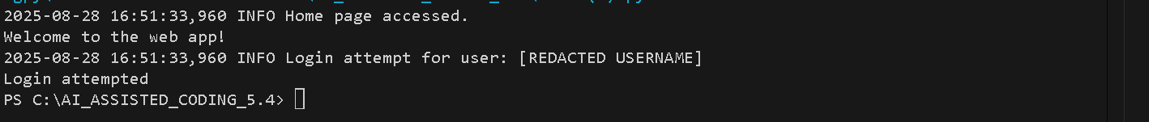

Task Description #5:  
• Ask Copilot to generate a machine learning model. Then, prompt it to add documentation on  
how to use the model responsibly (e.g., explainability, accuracy limits).  
Expected Output #5:  
• Copilot-generated model code with a README or inline documentation suggesting  
responsible usage, limitations, and fairness considerations

Code:

Documentation :

**# Machine Learning Model Example: Logistic Regression**

**## Overview**

This project demonstrates a simple machine learning model using logistic regression on the Iris dataset.

**## Responsible Usage Guidelines**

- **\*\*Purpose:\*\*** This model is for educational and demonstration purposes only. It may not be suitable for production use.

- **\*\*Explainability:\*\*** Be transparent with users about how predictions are made. Use model coefficients to explain feature importance.

- **\*\*Accuracy Limits:\*\*** Always validate the model's accuracy and fairness on your own data before deployment. The model's performance may vary with different datasets.

- **\*\*Human Oversight:\*\*** Do not use the model for high-stakes or sensitive decisions without human review.

- **\*\*Bias and Fairness:\*\*** Ensure your training data is diverse and representative. Check for and mitigate any bias in the data or model predictions.

- **\*\*Limitations:\*\*** The model's predictions are only as good as the data used for training. Document known limitations and regularly review model performance.

**## How to Run**

1. Make sure you have Python and the required packages installed (`scikit-learn`).

2. Run the script:

   python task5.py

3. Review the printed accuracy and classification report.

**## Fairness Considerations**

- Use balanced datasets for training.

- Regularly audit model predictions for bias.

- Solicit feedback from diverse users and stakeholders.