AI Assisted coding

2403a51247

Batch 11

**Task1:**

**Prompt:**

write a python function that reads a list of numbers and calculates the mean,minimum,and maximum values

code generated by gemini colab:

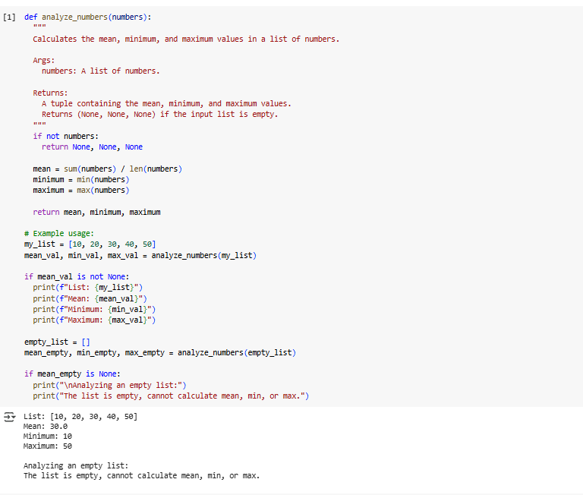

**Task2:**

**Prompt:**

**write a python function to check whether the given number is armstrong or not**

Code generated by gemini collab:

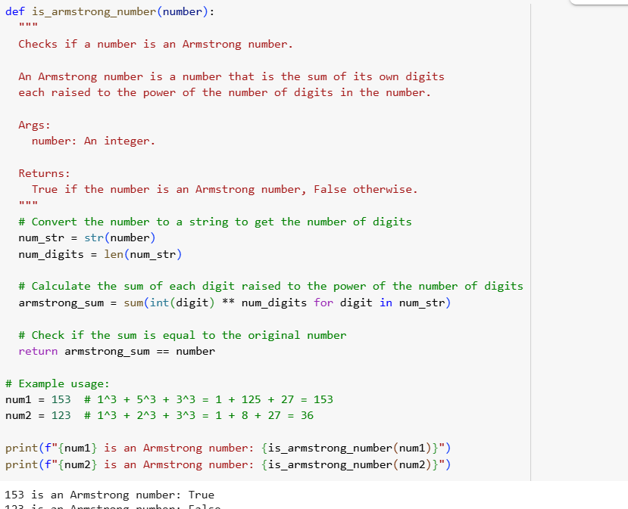

Code generated by copilot:

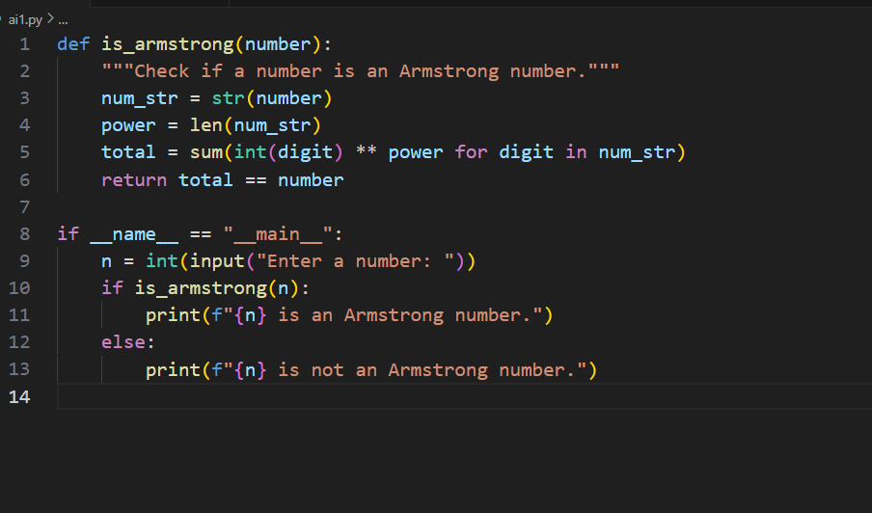

**Task 3:**

**Prompt:**

write a python function to check wether a number is prime and explain the code line by line

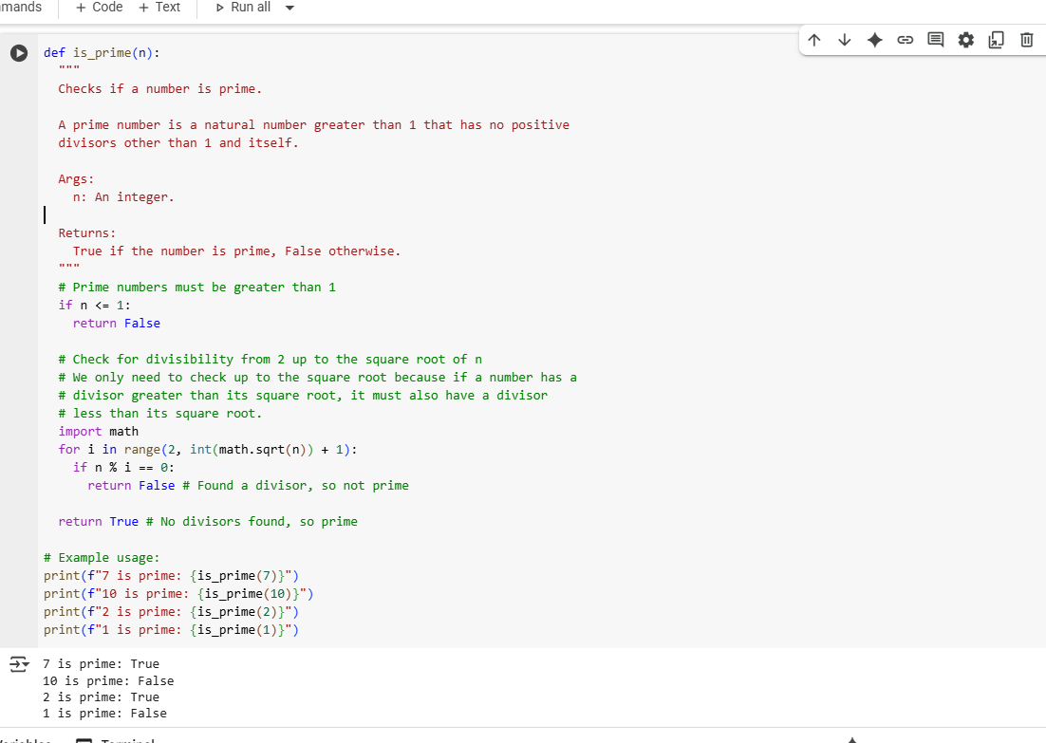

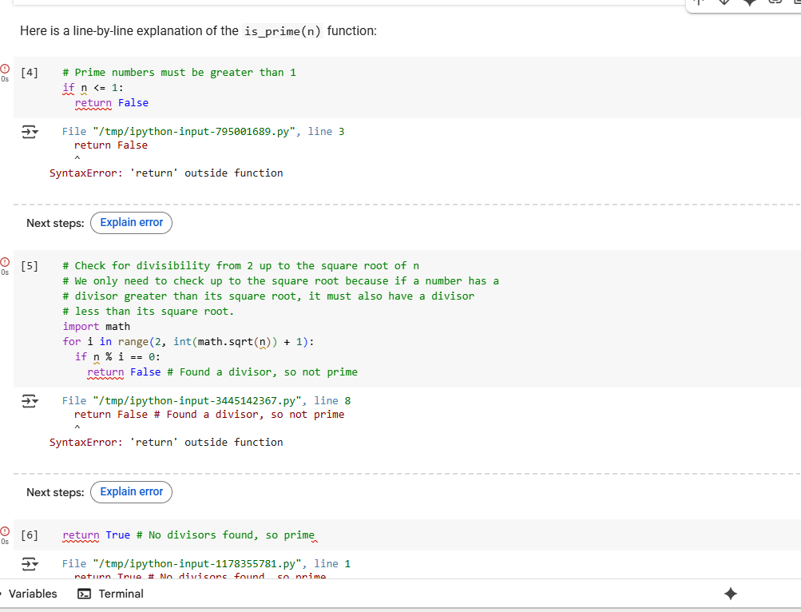

**Task 4:**

Use cursor Ai to generate a python function (ex: sum of firs n natural numbers) and test its output. Optionally compare cursorAI’s generated code with Gemini’s output

**Prompt:**

Generate a python funtion for sum of first n natural numbers

**Code generated in Gemini collab:**

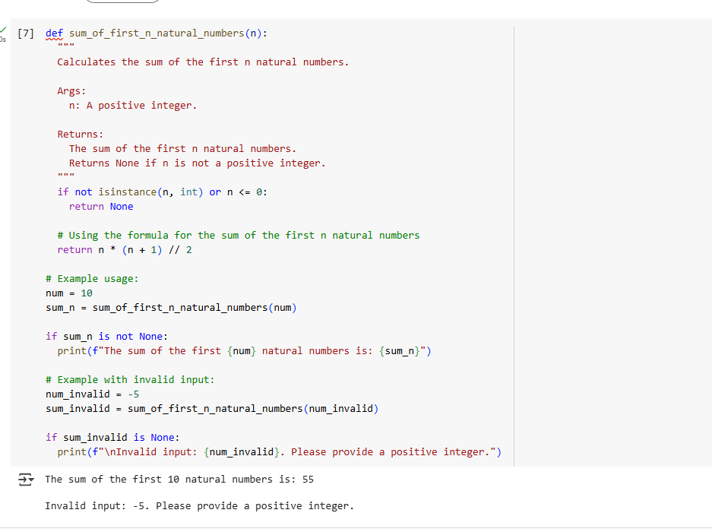

**Code generated in Cursor AI:**

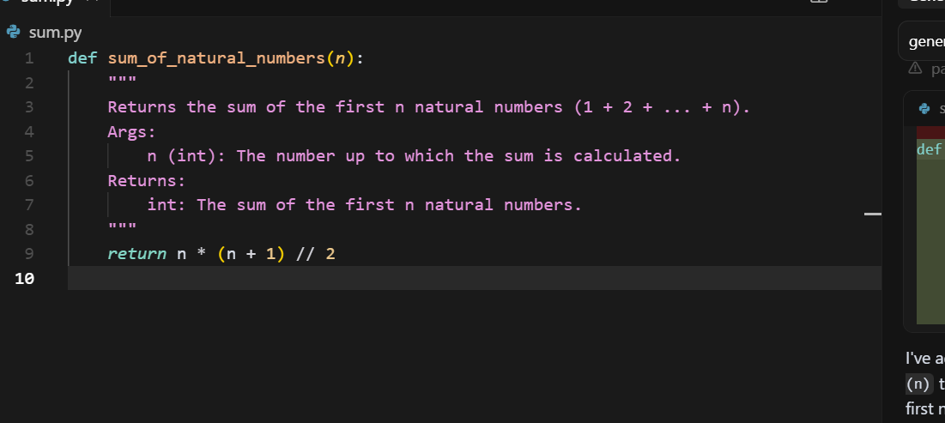

**Summary of Differences Between Cursor AI and Gemini Colab Code**

1. **Input Validation**:
   * Cursor AI doesn't validate input.
   * Gemini Colab checks if the input is a positive integer.
2. **Error Handling**:
   * Cursor AI assumes valid input.
   * Gemini Colab handles invalid input by returning None and printing an error message.
3. **Usage Examples**:
   * Cursor AI provides no examples.
   * Gemini Colab includes working examples for both valid and invalid inputs.
4. **User Feedback**:
   * Cursor AI code gives no feedback for bad input.
   * Gemini Colab gives clear messages to guide the user.
5. **Code Purpose**:
   * Cursor AI focuses on simplicity and brevity.
   * Gemini Colab focuses on robustness, clarity, and education.
6. **Best Use Case**:
   * Cursor AI: Good for controlled, technical environments.
   * Gemini Colab: Better for beginners, learning, and real-world usage.