**AI ASSISTED CODING**

2403A51247

B.RANHITHA

BATCH-11

**TASK-1:**

**Prompt :** Auto-Complete a Python Class for Bank Account. Write a class definition comment and start the constructor for a class called BankAccount with

account_holder and balance attributes. auto-complete the rest of the

class, including methods to deposit, withdraw, and display balance.

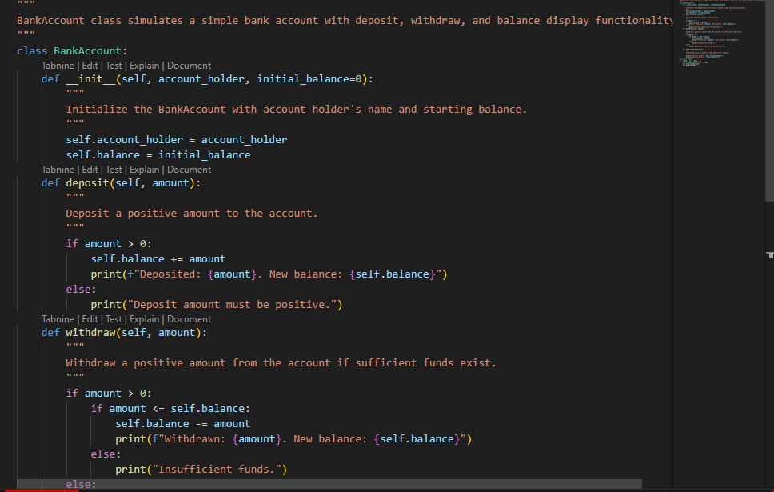

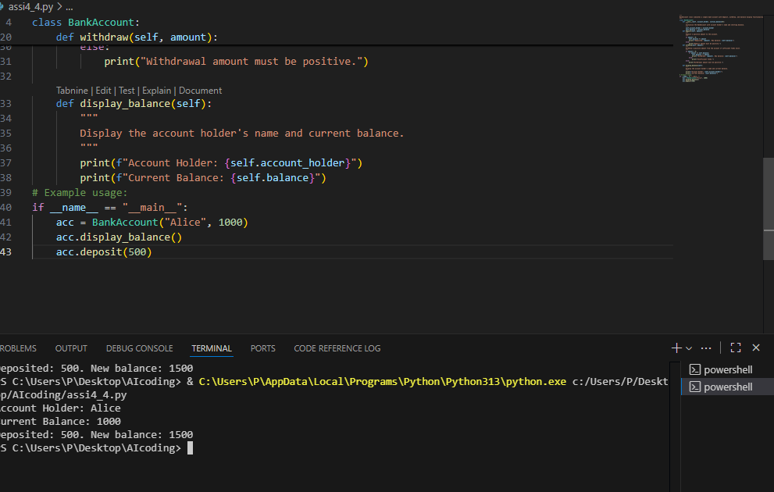

**Task – 2**

**Prompt :** Auto-Complete a For Loop to Sum Even Numbers in a List. Write a comment and the initial line of a loop to iterate over a list. complete the logic to sum all even numbers in the list.

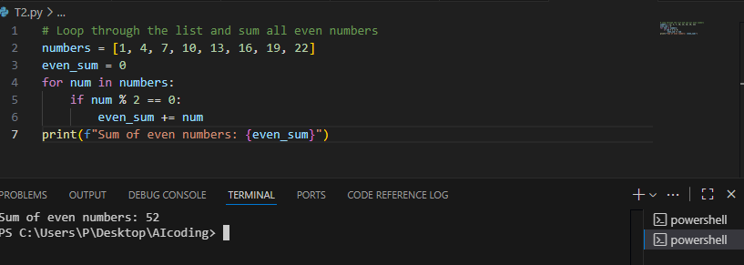

**Task-3:**

**Prompt**: Auto-Complete Conditional Logic to Check Age Group. Start a function that takes age as input and returns whether the person is a child, teenager,

adult, or senior using if-elif-else. complete the conditionals.

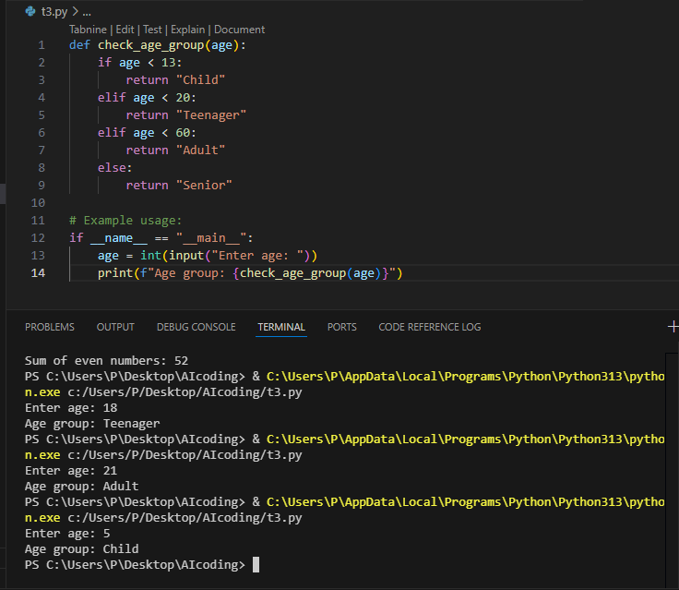

**Task-4**

**Prompt**: Auto-Complete a While Loop to Reverse Digits of a Number. Write a comment and start a while loop to reverse the digits of a number. complete the loop logic.

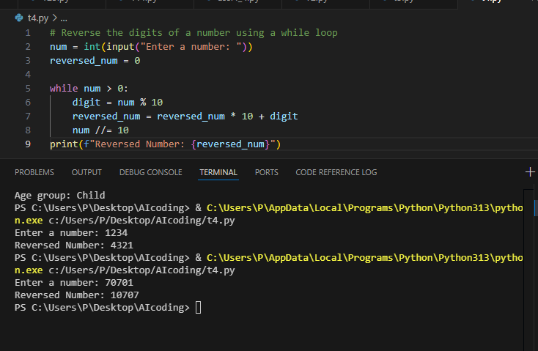

**Task-5:**

**Prompt:** Auto-Complete Class with Inheritance (Employee → Manager). Begin a class Employee with attributes name and salary. Then, start a derived class Manager

that inherits from Employee and adds department. complete the methods

and constructor chaining.

