**AI ASSISTED CODING**

**ASSIGNMENT—5.4**

**B.Ranhitha**

**2403a51247**

**Batch—11**

**Task—1**

**Prompt**: Write a Python script that collects user data (name, age, email). Add comments on how to anonymize or protect this data.

**Output:**

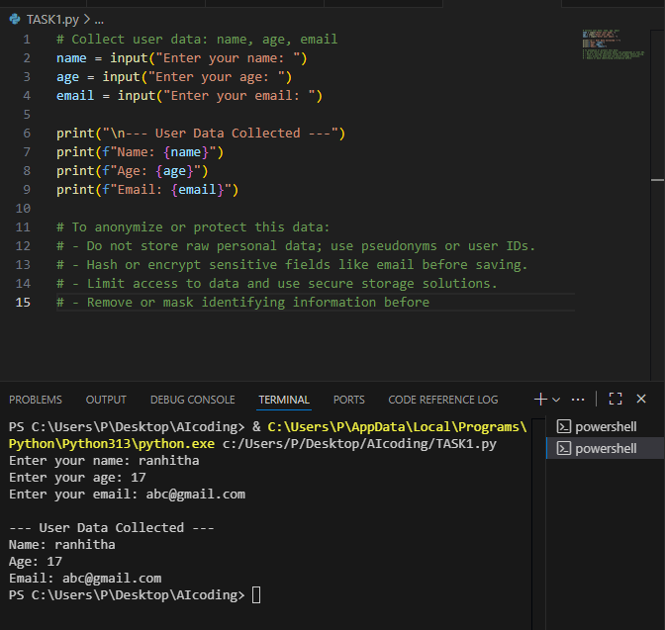

**Task—2:**

**Prompt:** “Write a Python function for sentiment analysis. Add comments on how to detect and handle potential biases.”

**Output:**

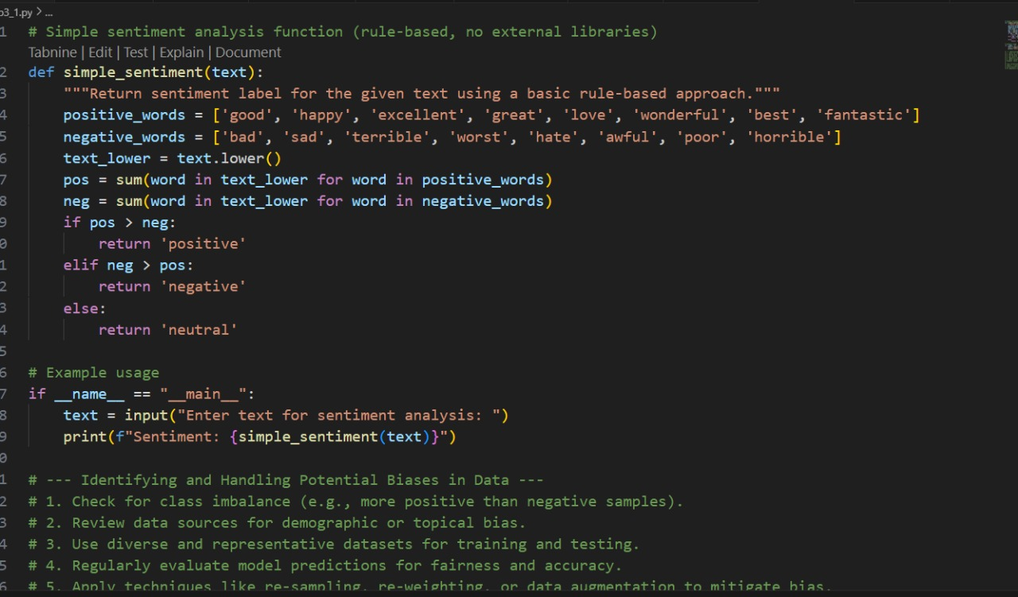

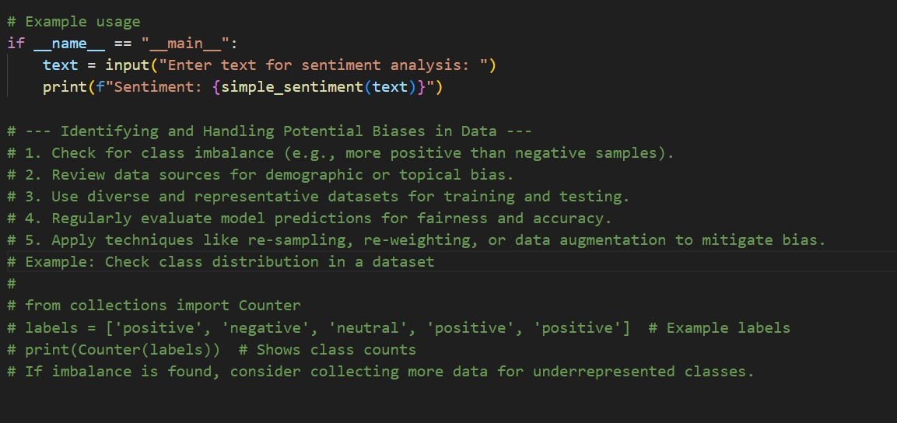

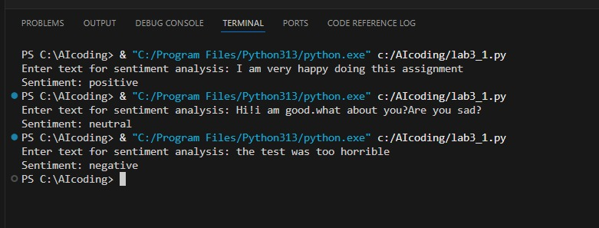

**Task—3**

**Prompt:** “Write a Python program to recommend products based on user history. Ensure transparency, fairness, and give users feedback options.”

**Output:**

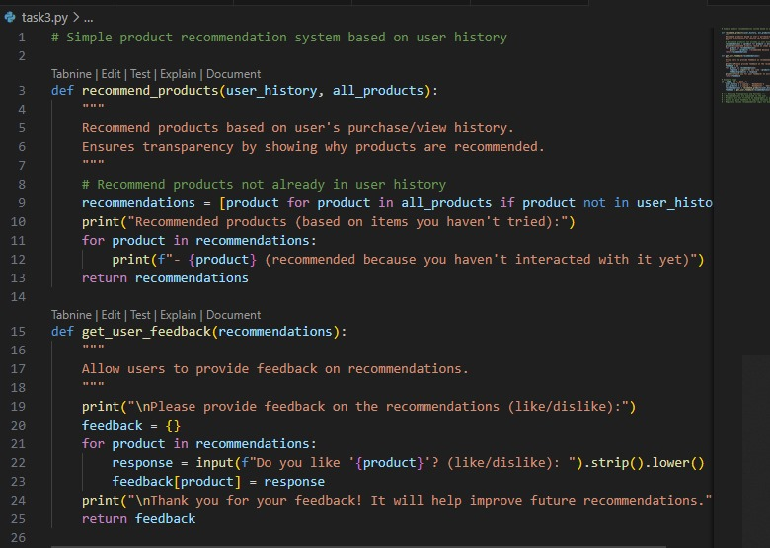

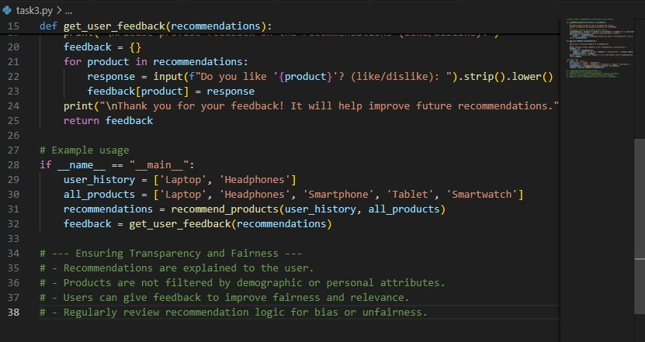

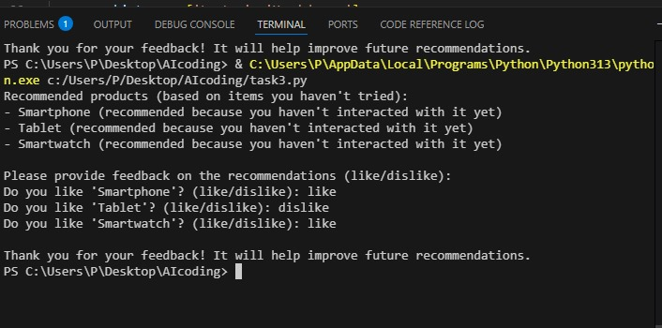

**Task-4:**

**Prompt**: Generate logging functionality in a Python web app, but avoid recording sensitive info (passwords, emails).

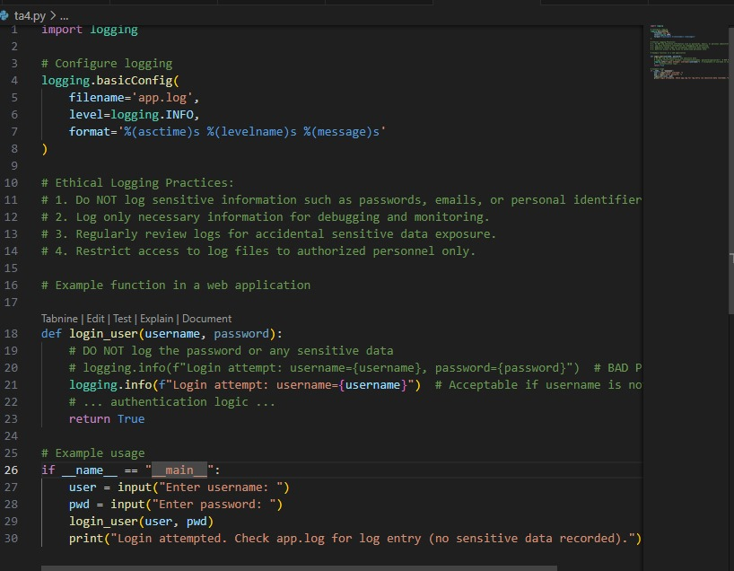

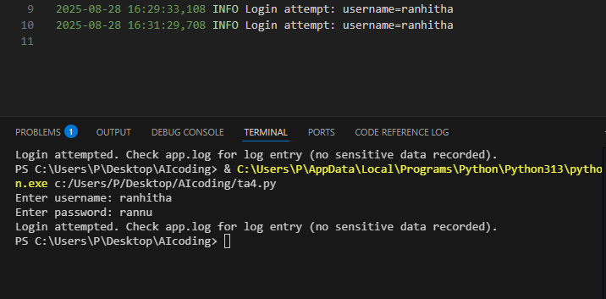

**Task—5**

**Prompt:** Write a simple ML model in Python. Add documentation on responsible usage, accuracy limits, and fairness considerations.

**Output:**

