**AI ASSISTED CODING**

**CLASS TEST-1**

**2403A51247**

**B.Ranhitha**

**Batch—11**

**1.**

**Question:**  write a python code to calculate the sum of odd and even numbers in a given list using github co-pilot along with vs code. and using Zero shot prompting.

**Prompt**: write a python code to calculate the sum of odd and even numbers in a given list. and using Zero shot prompting.

**Output:** 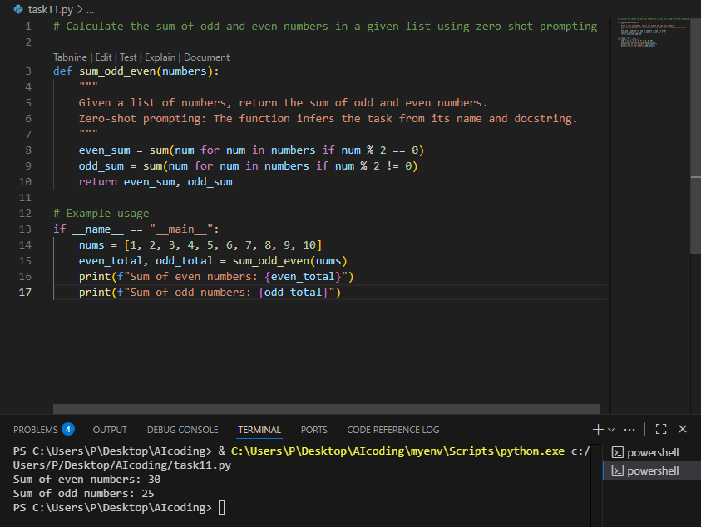

Task—2:

**Question:** write a python code for a given list of integers remove duplicates and print the sorted results. Github co-pilot along with the vs code. Use one short promptming.

**Prompt:** Example: Input: [5, 3, 5, 2, 8, 3] -> Output: [2, 3, 5, 8]

Now write a Python function that removes duplicates from a list of integers and prints the sorted result.

**Output:**

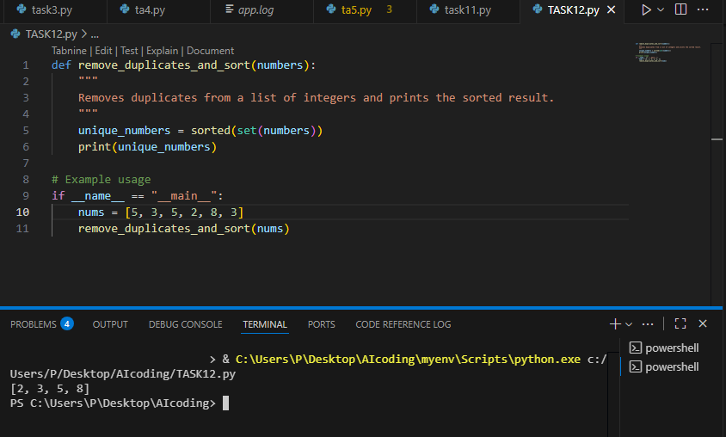

**Task—3**

**Question:** write a python function that converts temperature between Celsius , Fahrenheit and kelvin based on your choice .use the cursor AI tool.use few shot prompting.

**Prompt:** Example 1:

Input: 0 Celsius to Fahrenheit

Output: 32.0

Example 2:

Input: 100 Celsius to Kelvin

Output: 373.15

Example 3:

Input: 212 Fahrenheit to Celsius

Output: 100.0

Write a Python function that converts temperature between Celsius, Fahrenheit, and Kelvin based on user's choice

**Code:**

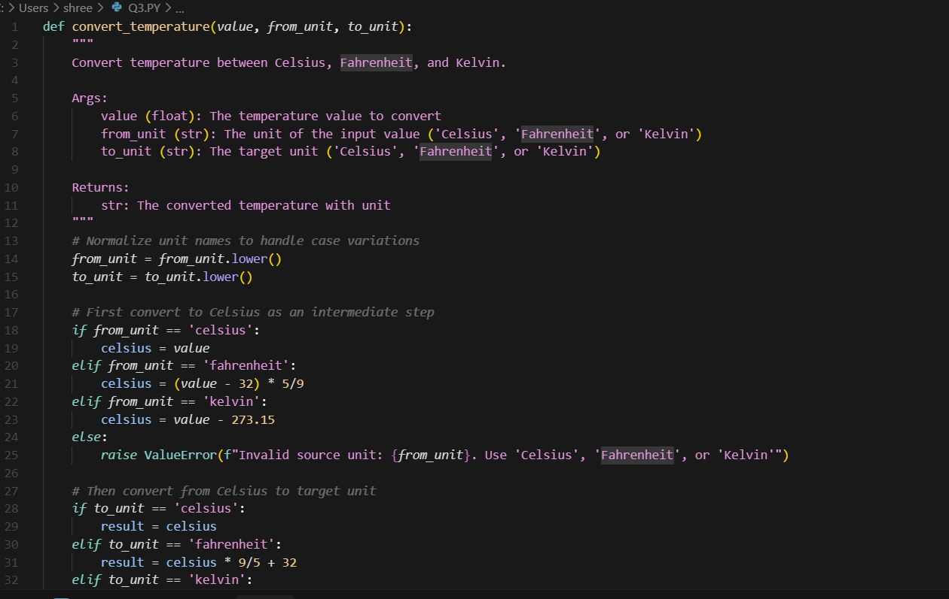

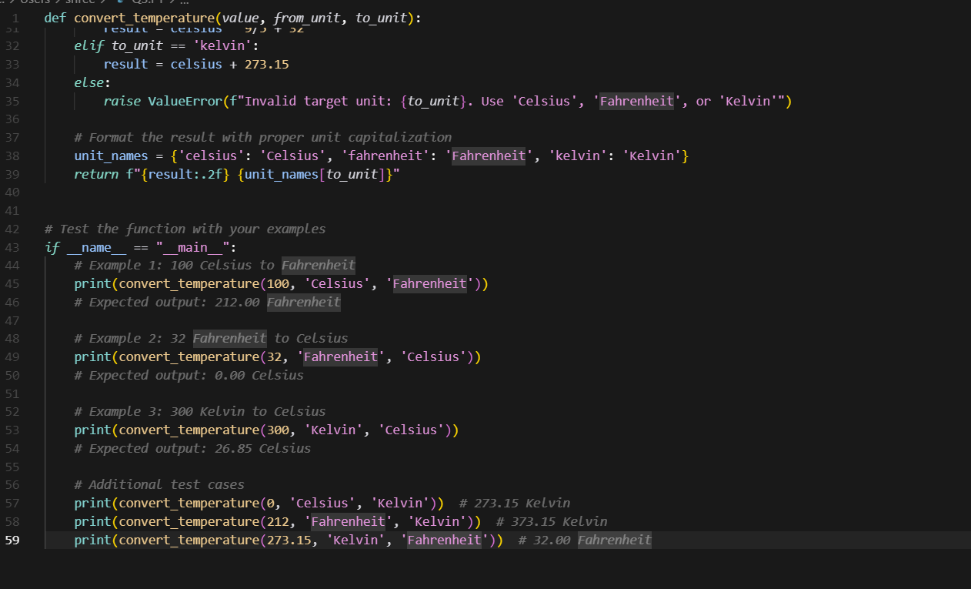

**Output:**

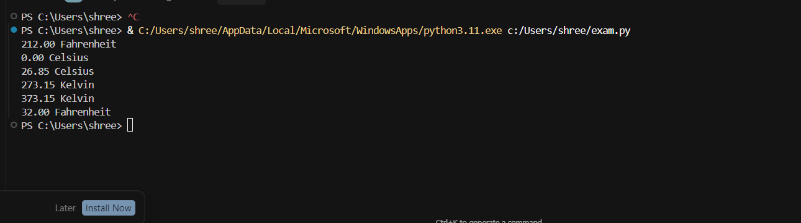

**Q4)**Write a python function to remove punctuation,convert to lower case,and remove stop words from a given text.Use cursor AI tool.Use zero short prompting

**PROMPT:**

Write a python function to remove punctuation,convert to lower case,and remove stop words from a given text by Using zero short prompting.

**Code:**

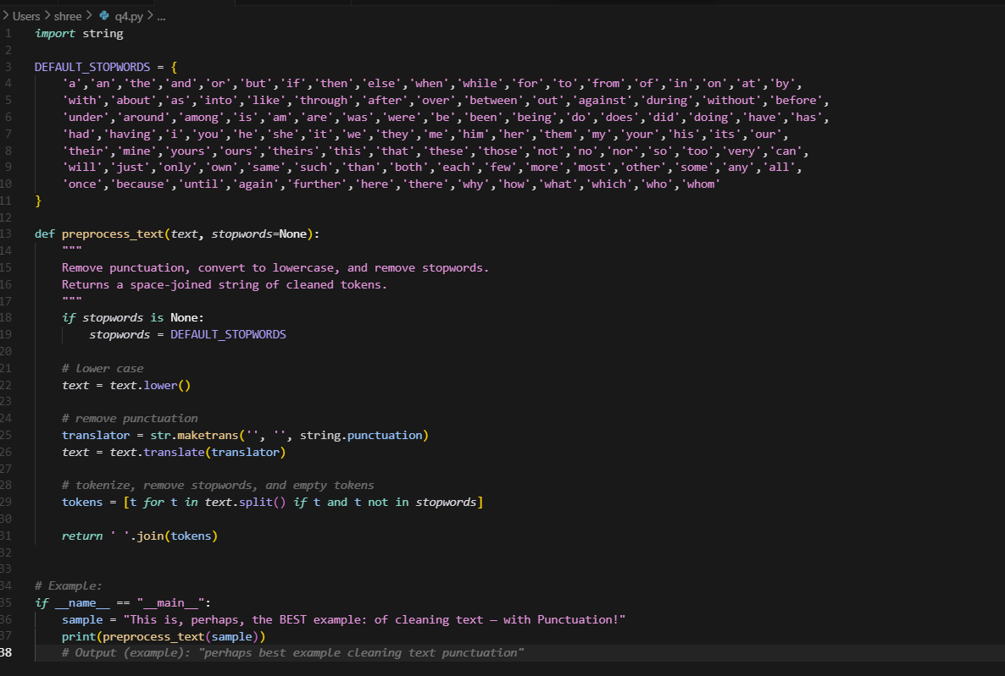

**Output:**

