AI ASSISTED CODING
ASSIGNMENT-1.1
B.Ranhitha
2403A51247
Batch:11
Task 1: Factorial without Functions
Description:
Use GitHub Copilot to generate a Python program that calculates the
factorial of a number without defining any functions (using loops
directly in the main code).
● Expected Output:
o A working program that correctly calculates the factorial for
user-provided input.
o Screenshots of the code generation process
Prompt: Write a Python program that calculates the factorial of a user-provided non-negative integer using a loop directly in the main code, without defining any functions. Include input validation for negative numbers and print the result.

Code:
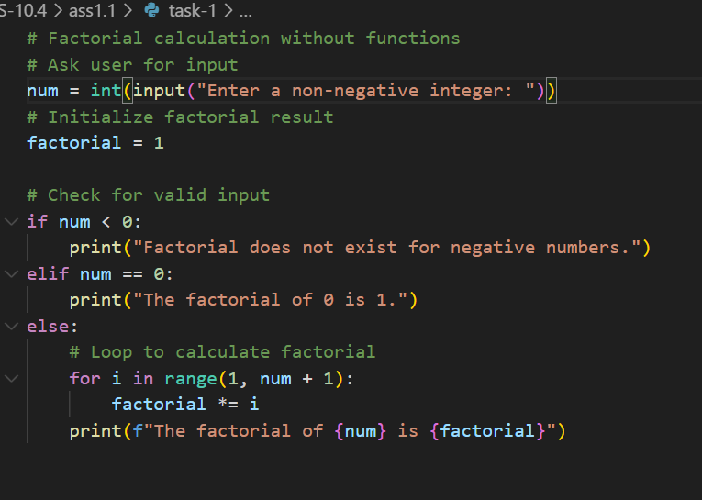
Output:
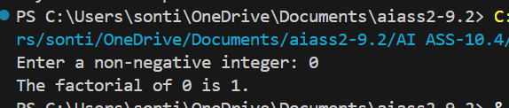
Task 2: Improving Efficiency
Description:
Examine the Copilot-generated code from Task 1 and demonstrate
how its efficiency can be improved (e.g., removing unnecessary
variables, optimizing loops).
● Expected Output:
o Original and improved versions of the code.
o Explanation of how the improvements enhance performance.
Without Functions.
Prompt: Improve the following Python code that calculates factorial without using functions. Optimize it by removing unnecessary variables and redundant operations, and make the loop more efficient while keeping the output correct.
Code:
Original Copilot-Generated Code
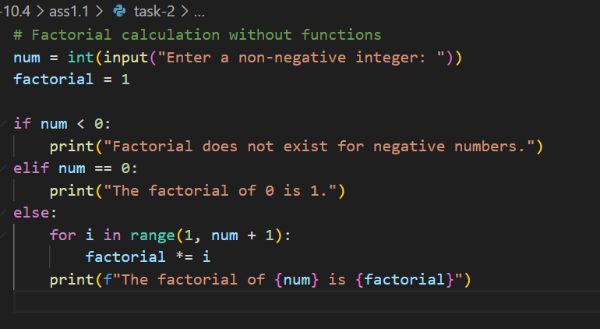
Improved Version
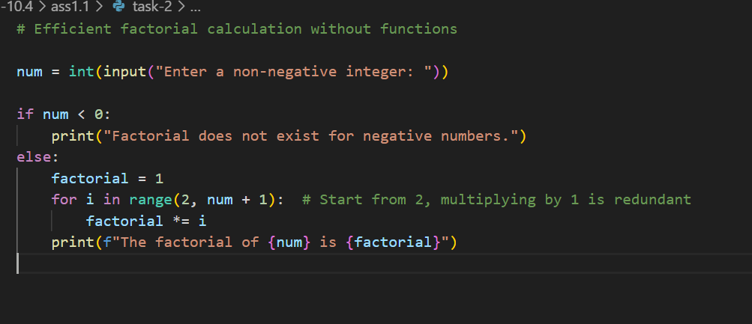
Output:
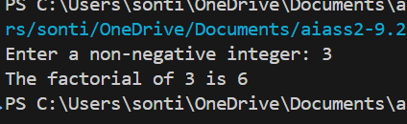
Task-3: Factorial with Functions
Description:
Use GitHub Copilot to generate a Python program that calculates the
factorial of a number using a user-defined function.
● Expected Output:
o Correctly working factorial function with sample outputs.
o Documentation of the steps Copilot followed to generate the
function.
Prompt: Write a Python program that calculates the factorial of a user-provided non-negative integer using a user-defined function. Include input validation for negative numbers and print the result. Provide clear comments.

Code:
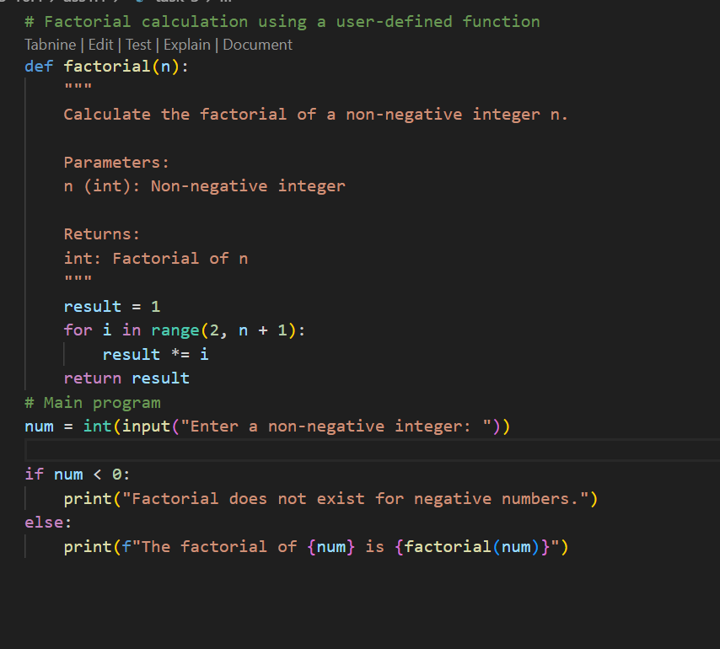
Output:
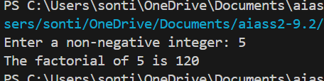
Task 4: Comparative Analysis – With vs Without Functions
Description:
Differentiate between the Copilot-generated factorial program with
functions and without functions in terms of logic, reusability, and
execution.
● Expected Output:
o A comparison table or short report explaining the differences.
Prompt: Compare two Python programs: one that calculates factorial without using functions and one that uses a user-defined factorial function. Explain the differences in terms of logic, reusability, and execution, and provide a short report.
Code:
Without Functions:
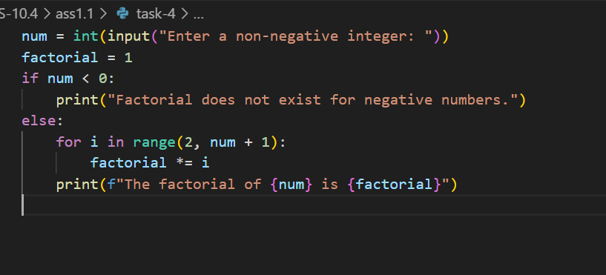
With Functions:
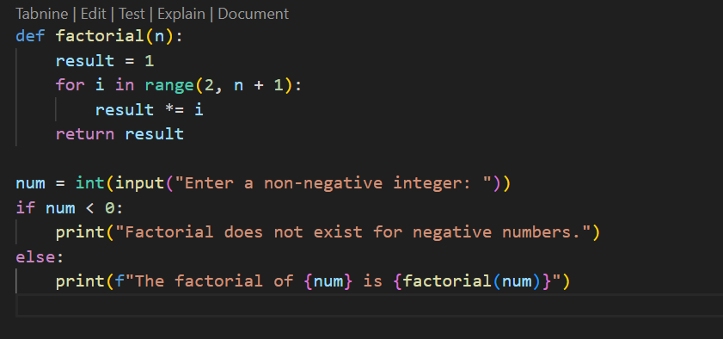

Output:
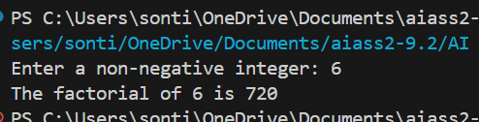
Task 5: Iterative vs Recursive Factorial
Description:
Prompt GitHub Copilot to generate both iterative and recursive
versions of the factorial function.
● Expected Output:
o Two correct implementations.
o A documented comparison of logic, performance, and
execution flow between iterative and recursive approaches.
Prompt: Write two Python programs that calculate the factorial of a non-negative integer: one using an iterative approach with a loop, and one using recursion. Include input validation and comments explaining the logic. Provide a comparison of the two approaches in terms of logic, performance, and execution flow.

Code:
Iterative Factorial:
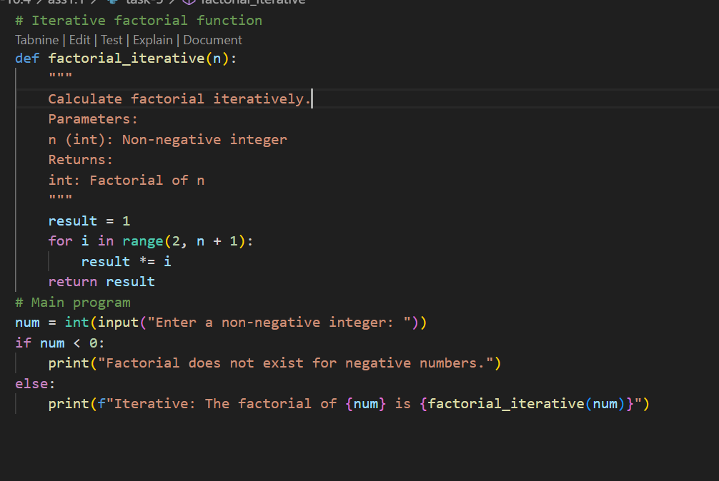
Recursive Factorial:
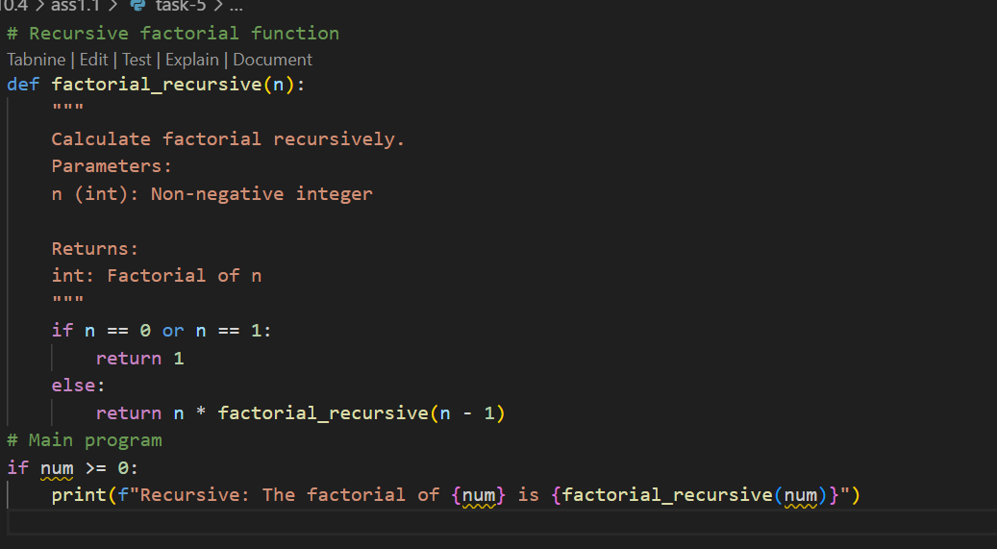

Output:
