AI ASSISTED CODING
ASSIGNMENT-1.4
B.Ranhitha
2403A51247
Batch:11
Task-1: A function in Python that returns the maximum of three numbers using GitHub Copilot. Use an appropriate comment as a prompt.
Expected Output -1:
• Python function that takes three inputs and returns the largest value. Include the code and output.
Prompt: Write a Python function that takes three numbers as input and returns the largest number among them. Include proper comments and an example usage.
Code:
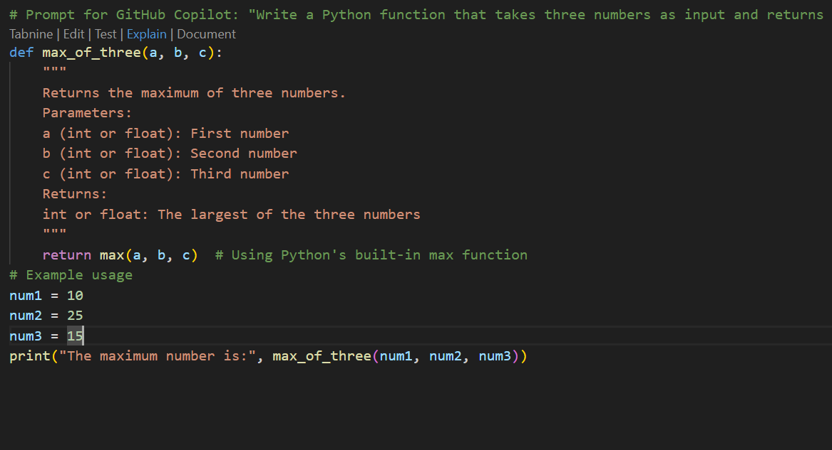

Output:
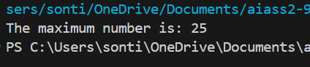
Task-2: Use GitHub Copilot to create a recursive Python function that calculates the factorial of a
number.
Expected Output -2:
• Python function for factorial using recursion with input and output examples
Prompt: Write a recursive Python function to calculate the factorial of a number. Include comments and an example showing input and output.
Code:
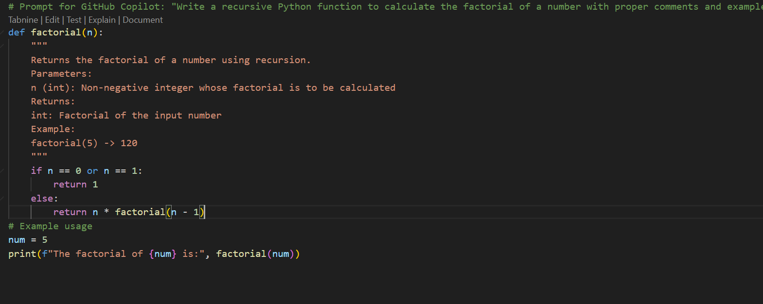
Output:
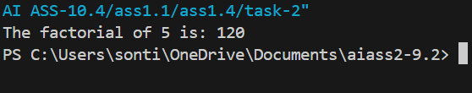
Task-3: Prompt GitHub Copilot to create a class named Student with attributes name, roll_no, and
marks. Add a method to display student details.
Expected Output-3:
• Python class definition with an initializer and a display method. Include object creation and
output.
Prompt: Create a Python class named Student with attributes name, roll_no, and marks. Add a method to display student details. Include example of object creation and output.
Code:
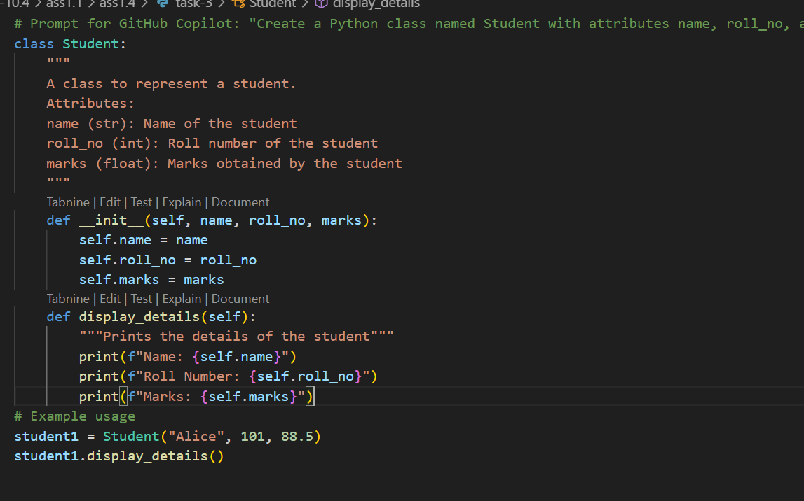
Output:
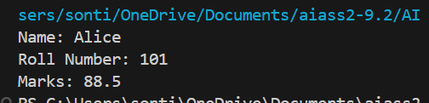
Task-4: Ask GitHub Copilot to generate a Python function that takes a string as input and returns the
frequency of each word.
Expected Output-4:
• Python function that returns word frequency using a dictionary. Provide sample input and
output.
Prompt: Write a Python function that takes a string as input and returns the frequency of each word using a dictionary. Include sample input and output.
Code:
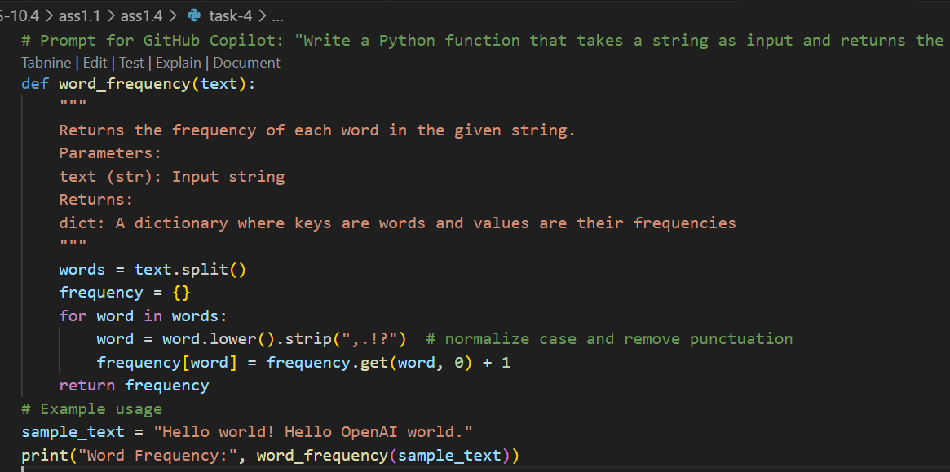
Output:
