AI ASSISTED CODING:

ASSIGNMENT-10.1
  - B.Ranhitha
  - 2403A51247
  - BATCH-11
  - CSE-GEN

TASK1: Refactor Nested Conditionals

Task: Provide AI with the following nested conditional code and ask it
to simplify and refactor for readability.

GIVEN CODE:
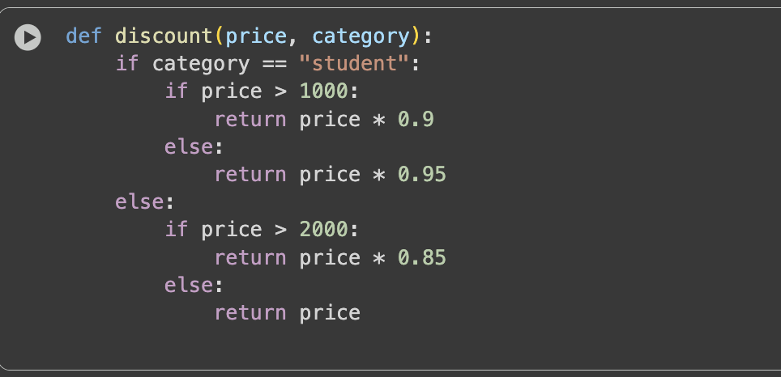
PROMPT:
simplify and refactor for readability.
REFACTORED CODE:
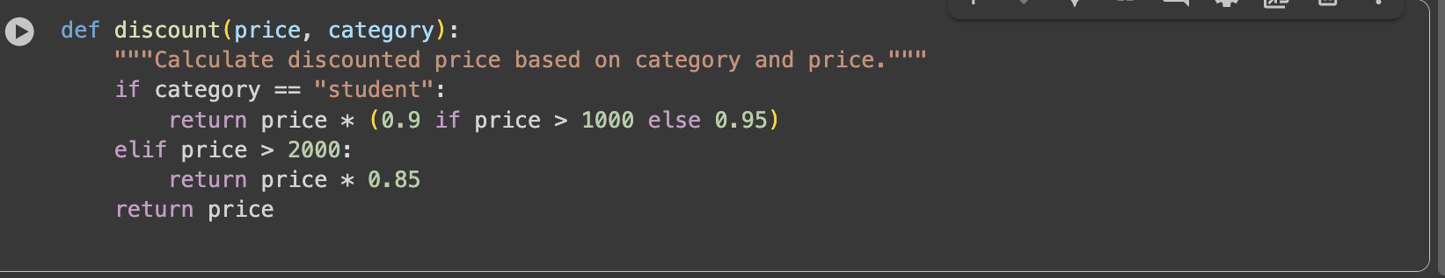

TASK2:

Task: Give AI this messy loop and ask it to refactor and optimize.

GIVEN CODE:
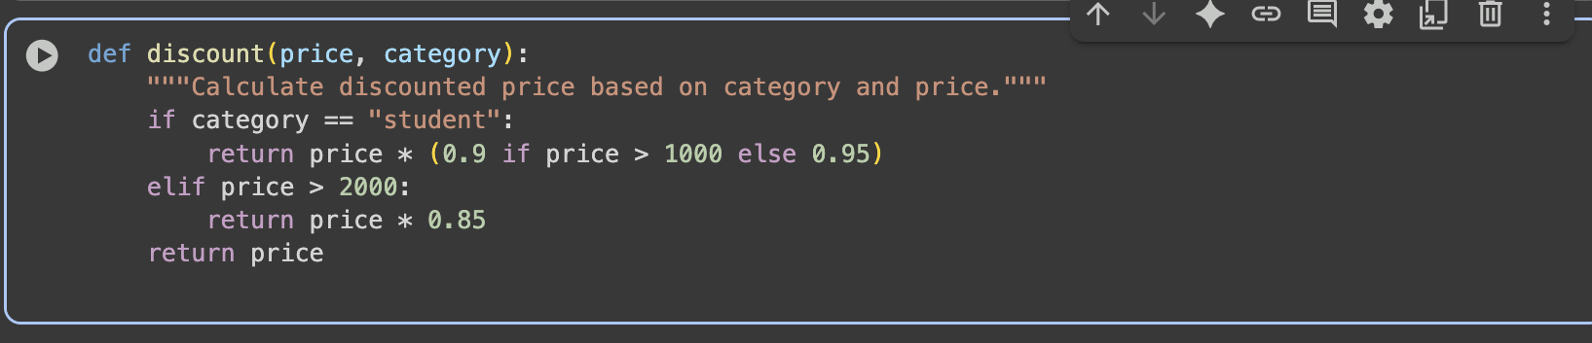

PROMPT:
simplify and refactor for readability

REFACTORED CODE:

TASK3:
Task: Provide this class with poor readability and ask AI to improve:
• Naming conventions
• Encapsulation
• Readability & maintainability

GIVEN CODE:

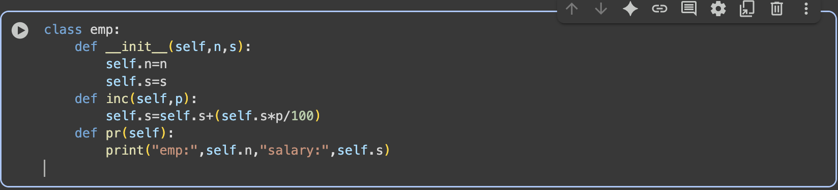

PROMPT:
simplify and refactor for readability
REFACTORED CODE:

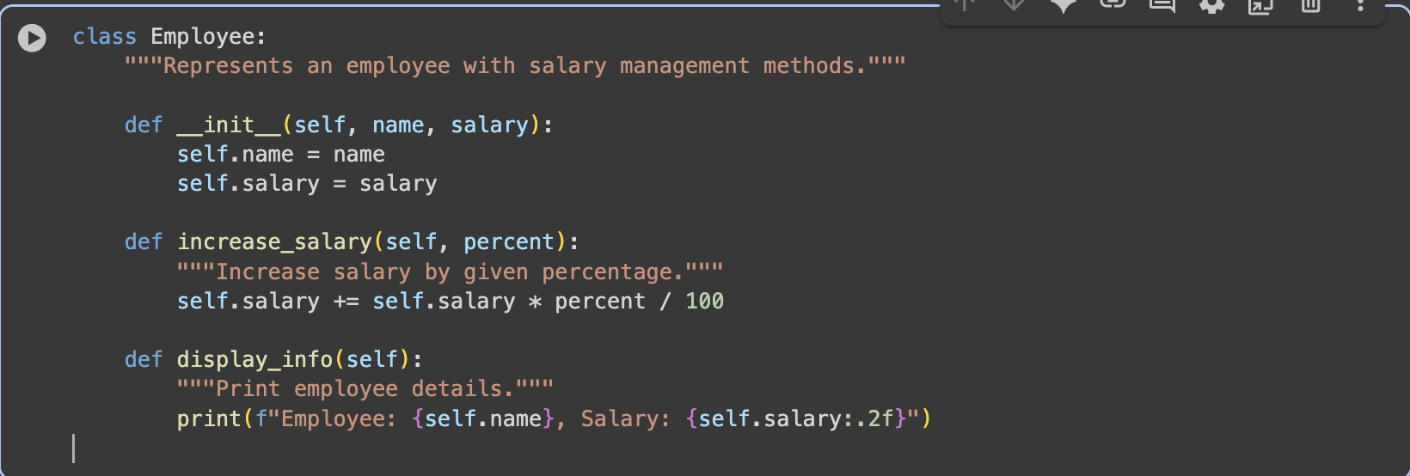

TASK4:Modularize Long Function
Task: Give AI this long unstructured function and let it modularize into
smaller helper functions.

GIVEN CODE:
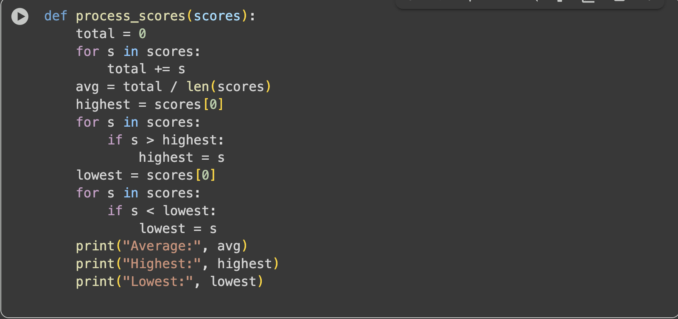

PROMPT:
simplify and refactor for readability

REFACTORED CODE:
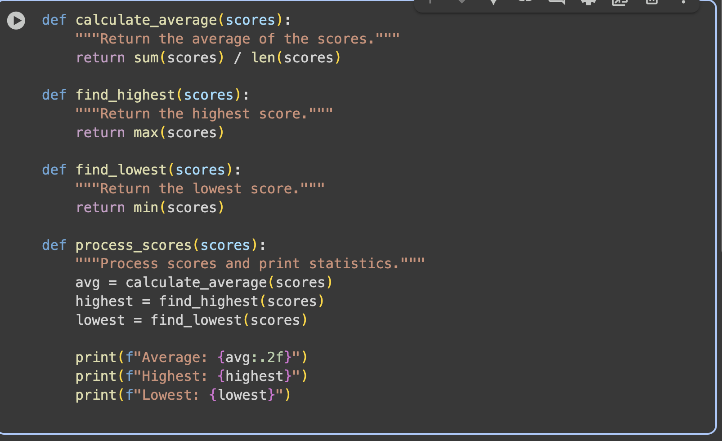

TASK5:
Code Review on Error Handling
Task: Provide AI with this faulty code and ask it to improve error
handling, naming, and readability.
GIVEN CODE:
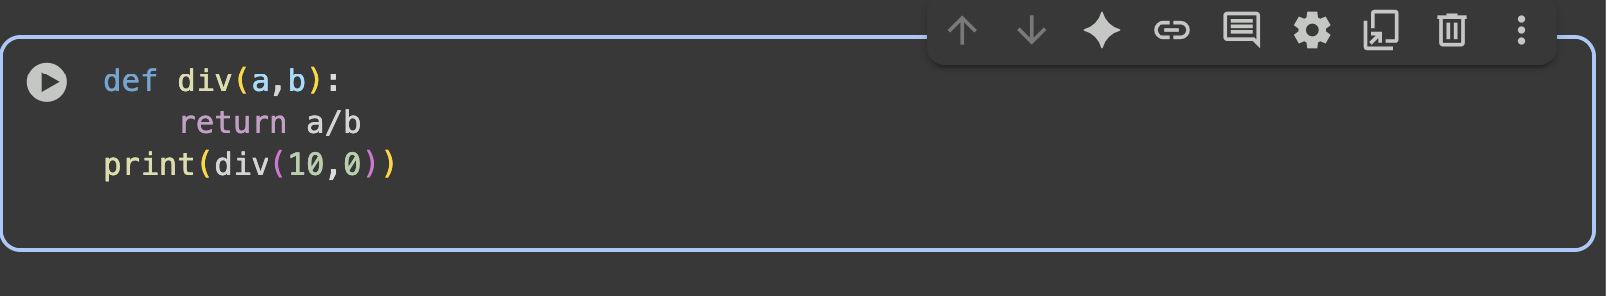
PROMPT:

simplify and refactor for readability

REFACTORED CODE:
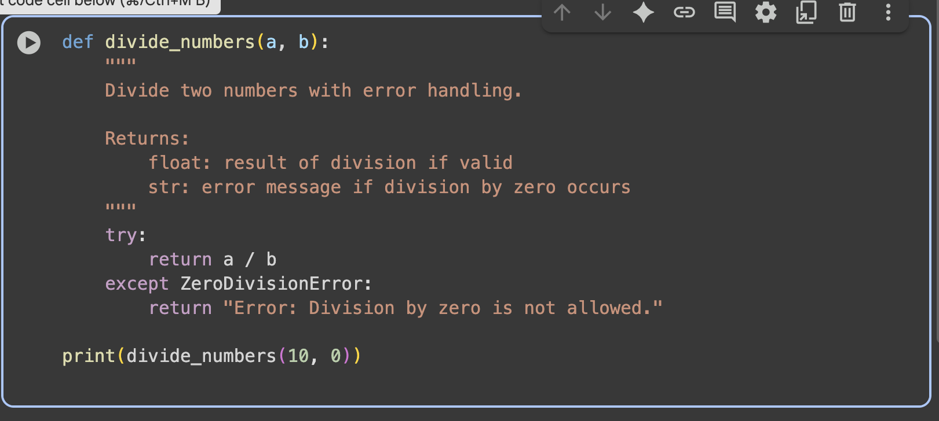

TASK6:Complexity Reduction
Task: Use AI to simplify overly complex logic.
GIVEN CODE:
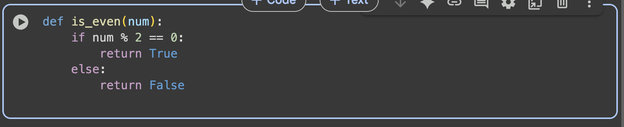

PROMPT:
simplify and refactor for readability

REFACTORED CODE:
