ASSIGNMENT-20.1
Name: Bollam Sathvika
Rollno:2403A51344
Batch:14
Task-1
Prompt:
Generate a simple Python script that asks a user to input a username and password to log in. Then, analyze the script for input validation or sanitization vulnerabilities. Identify any security risks in how the input is handled, and explain what should be improved. Finally, rewrite the script to make it more secure by adding proper input validation using regular expressions (the re module) and other safe coding practices.
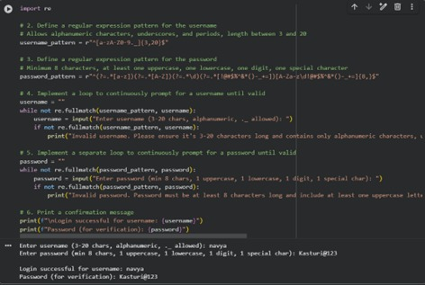

TASK-2
Prompt:
Generate a Python script that connects to a SQLite or MySQL database and fetches user details based on a username input. First, show a version that uses string concatenation in the SQL query (which may be vulnerable to SQL injection). Then, refactor the code to use parameterized queries (prepared statements) to prevent SQL injection.
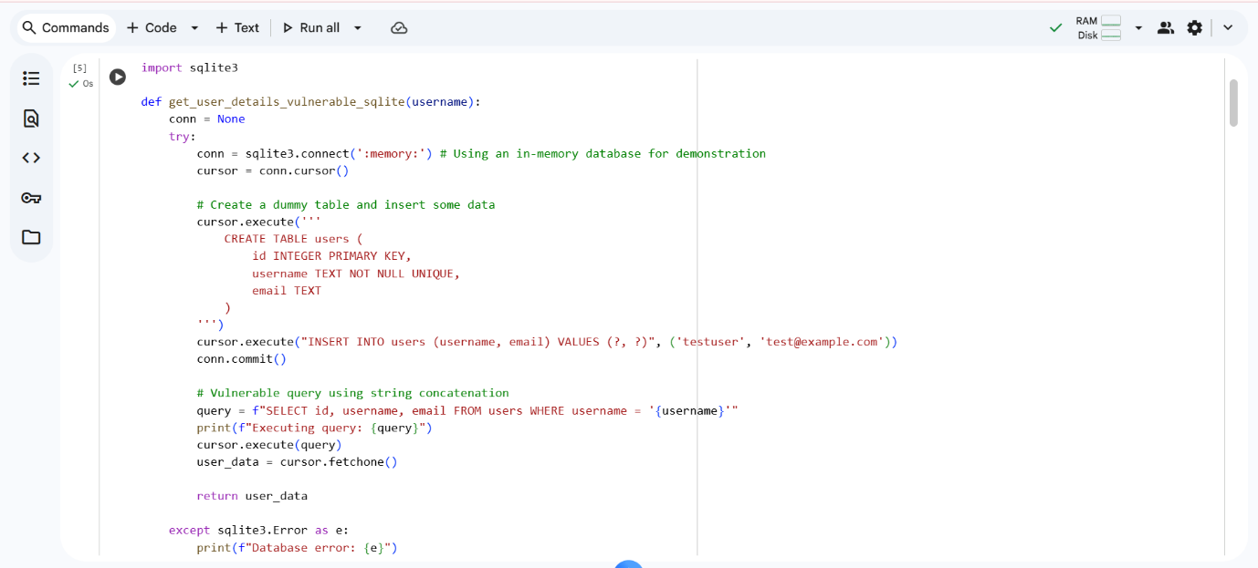
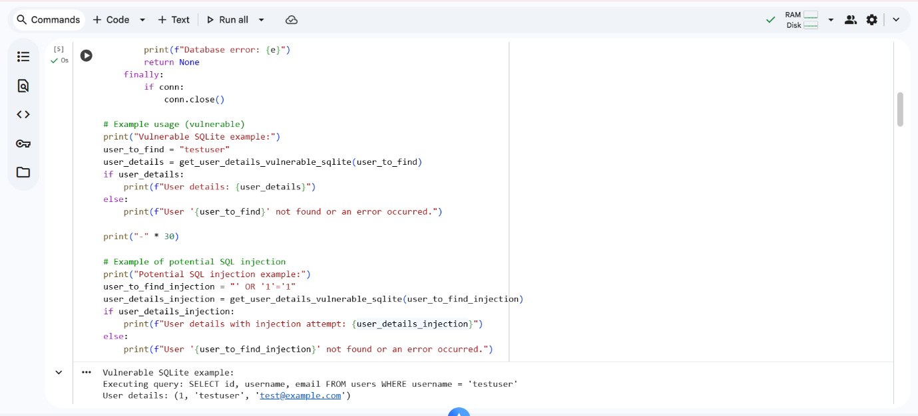
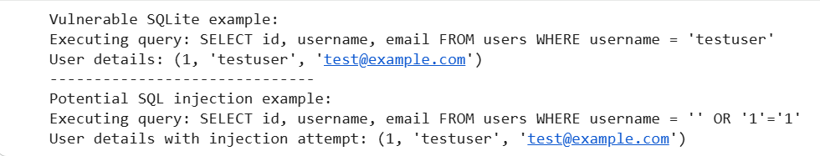
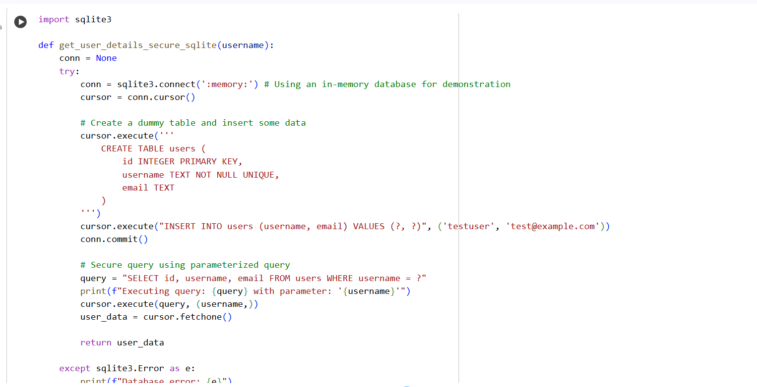
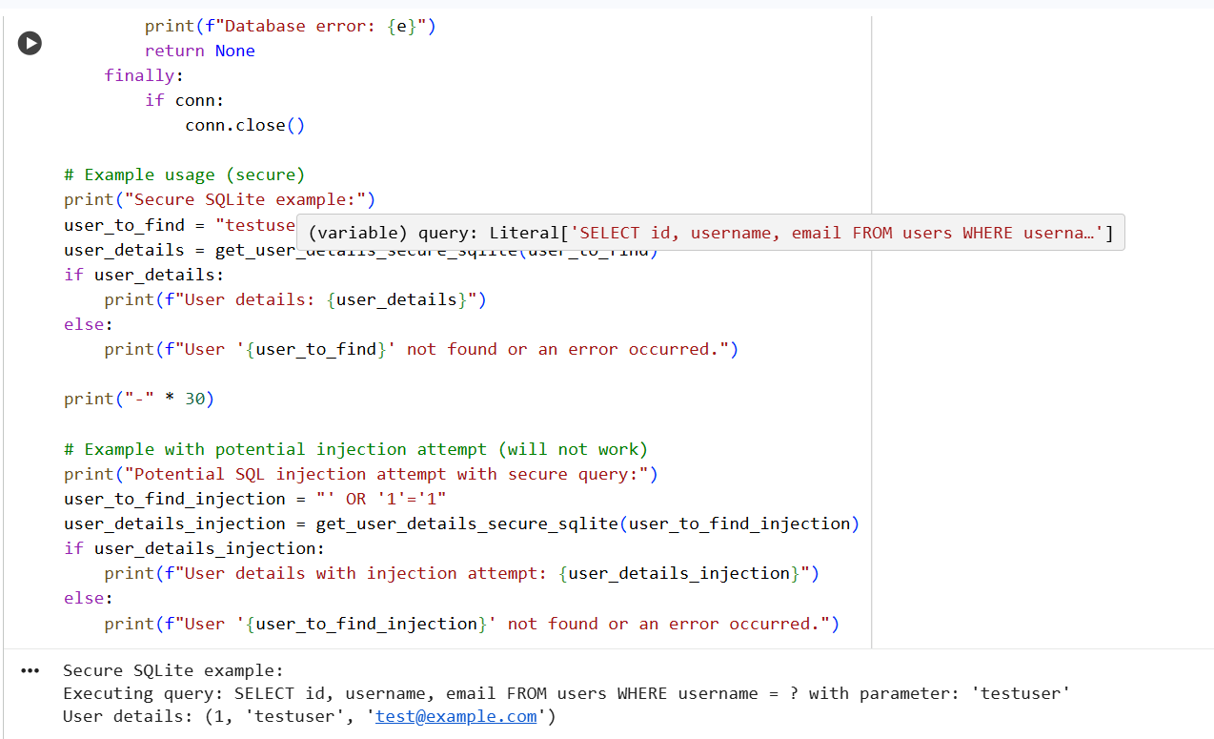
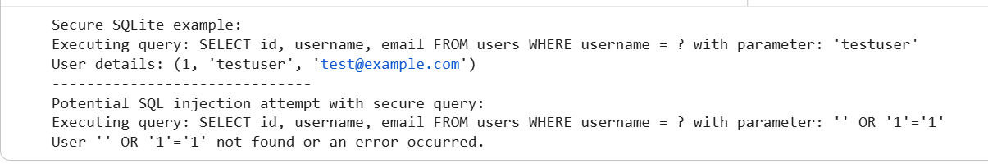
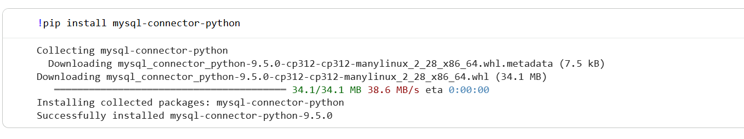
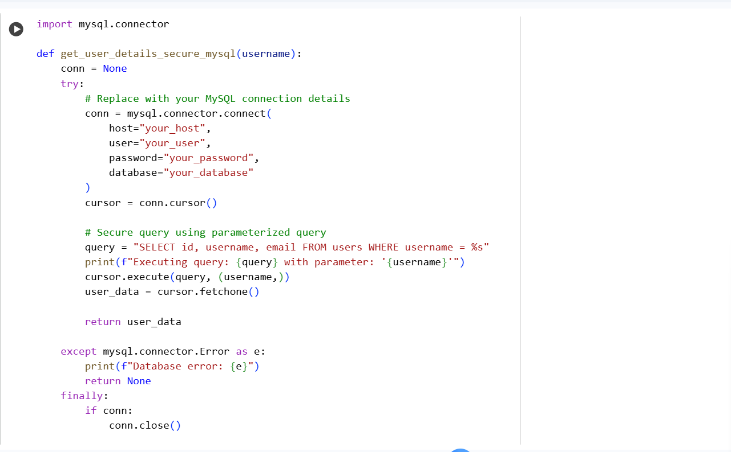
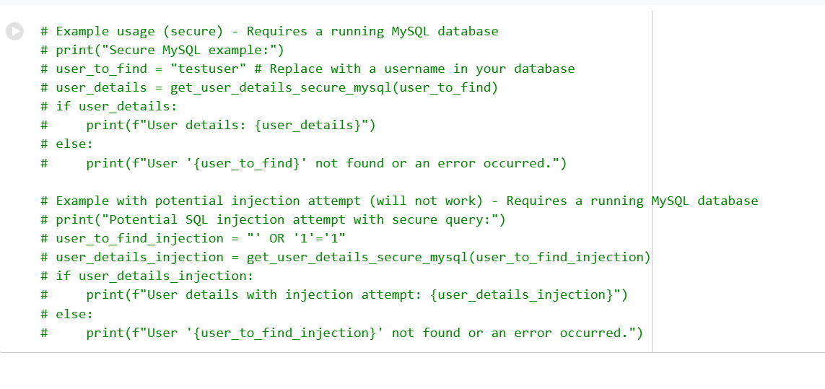
TASK-3:
Prompt:
Generate a simple HTML feedback form that uses JavaScript to display the user's submitted feedback on the same page. Then, analyze the code for potential Cross-Site Scripting (XSS) vulnerabilities—specifically checking if untrusted user input is rendered directly into the page without escaping. Identify any security risks and explain how to fix them. Finally, rewrite the form securely by escaping HTML entities, validating inputs, and adding protections such as a Content Security Policy (CSP).
CODE:
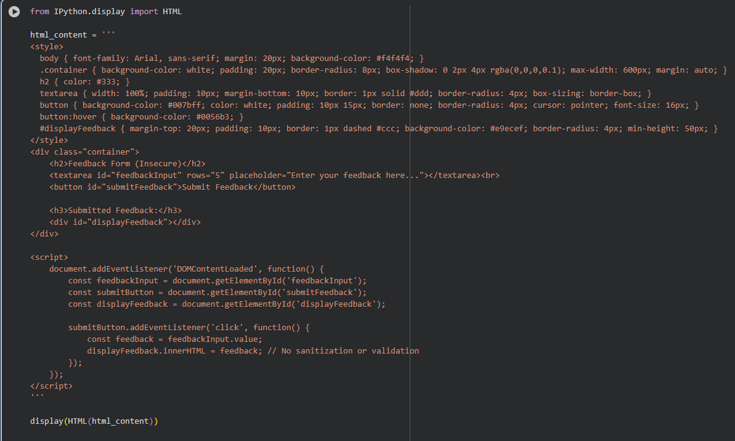
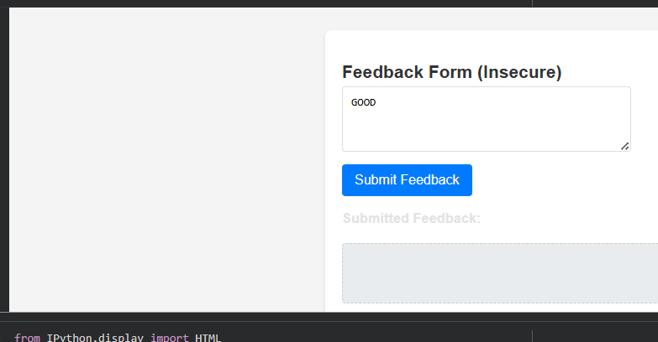
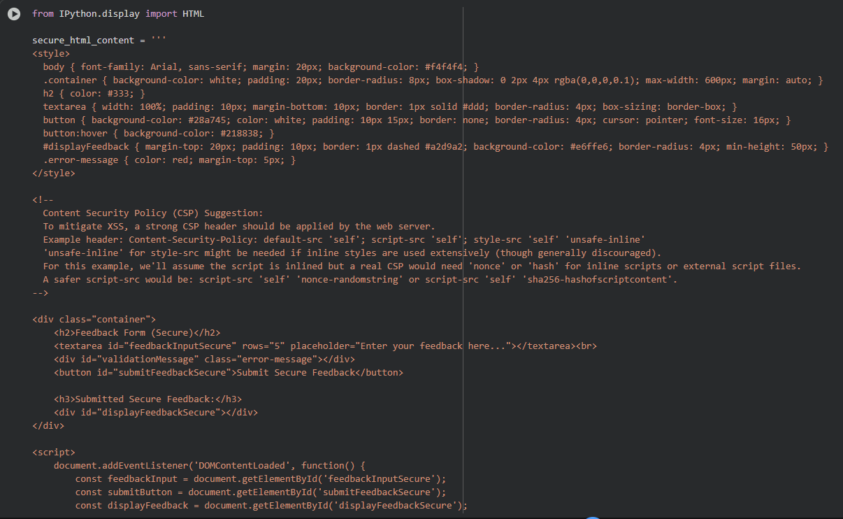
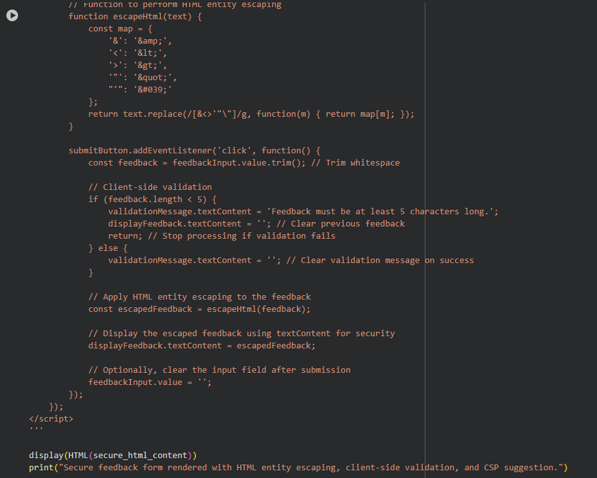
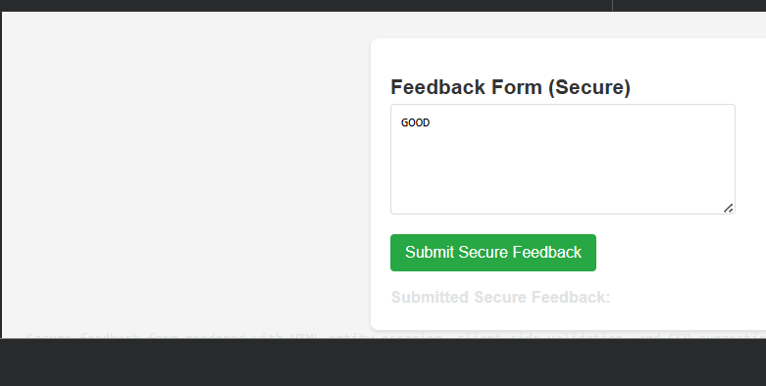
TASK-4:
Prompt:
Provide a small Python project snippet, such as a login form, API integration, or file upload functionality. Then, perform a detailed security audit of the code. Identify all potential vulnerabilities (e.g., input validation issues, SQL injection, file upload risks). Suggest secure coding practices to fix these issues, and rewrite the code in a secure version. Present both the insecure and secure versions side by side, with comments explaining the vulnerabilities and how they were fixed.
CODE:
