ASSIGNMENT-21.1
Name: Bollam Sathvika
Rollno:2403A51344
Batch:14
Task-1
Lab 21 – Collaborative AI Coding: Pair Programming and Version
Control Integration

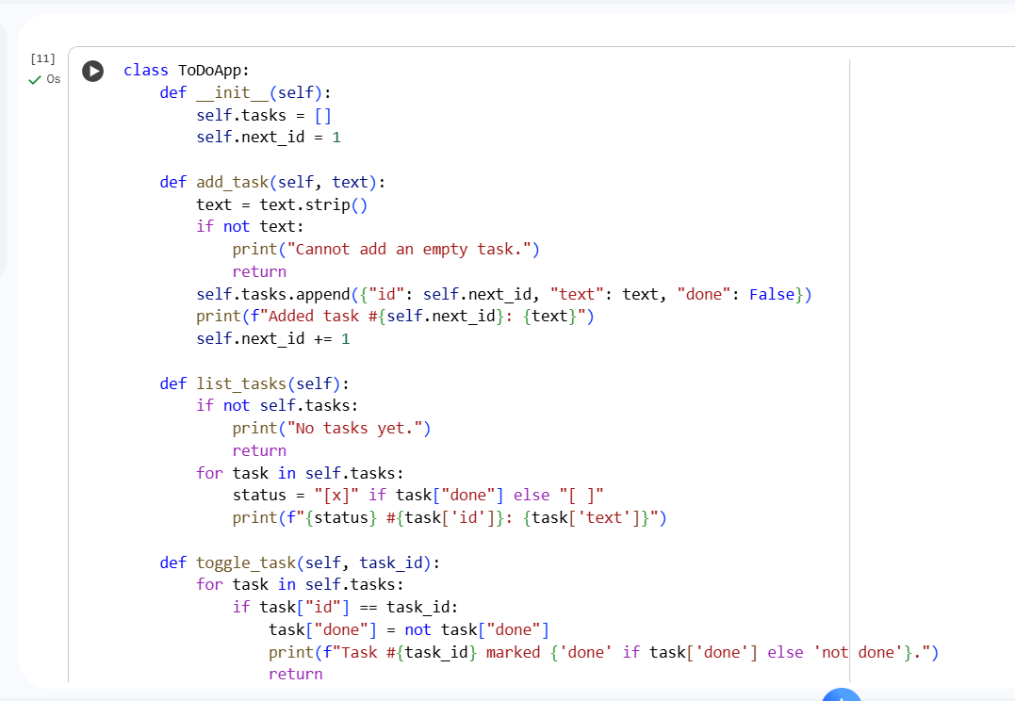
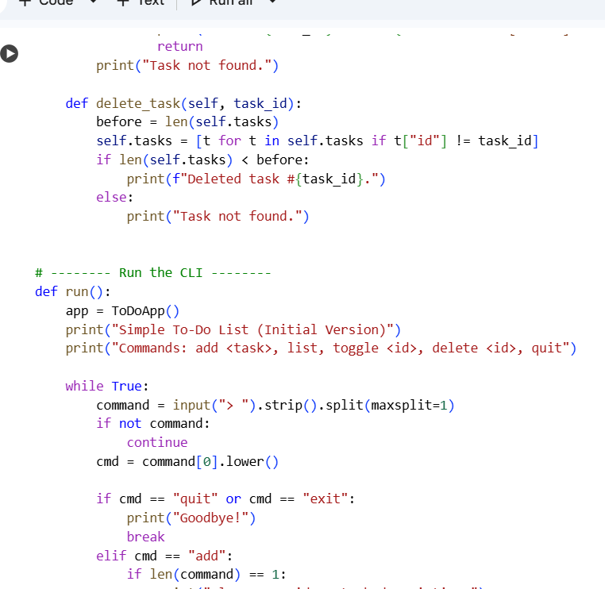

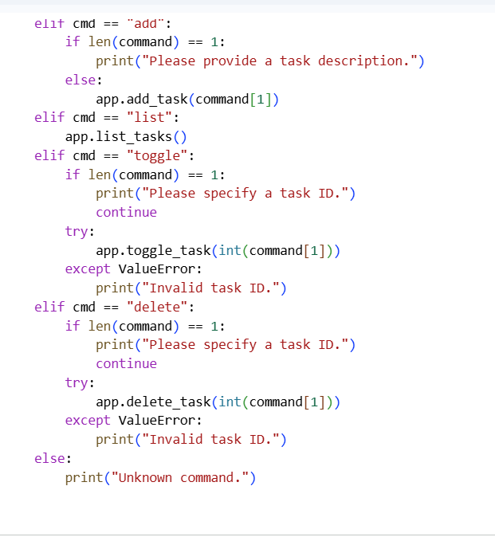
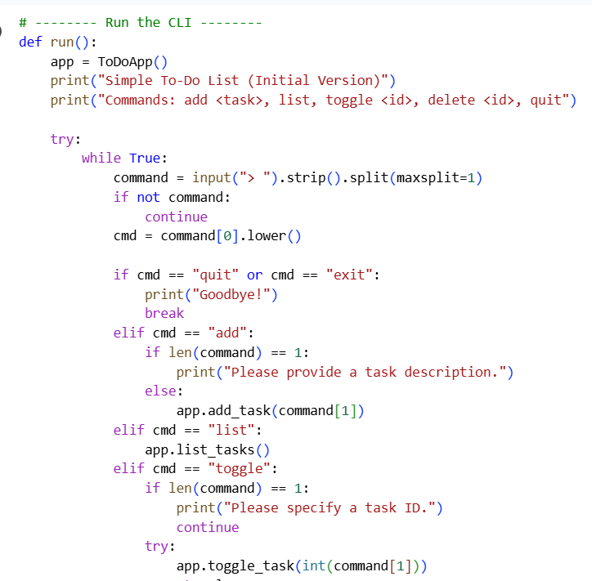
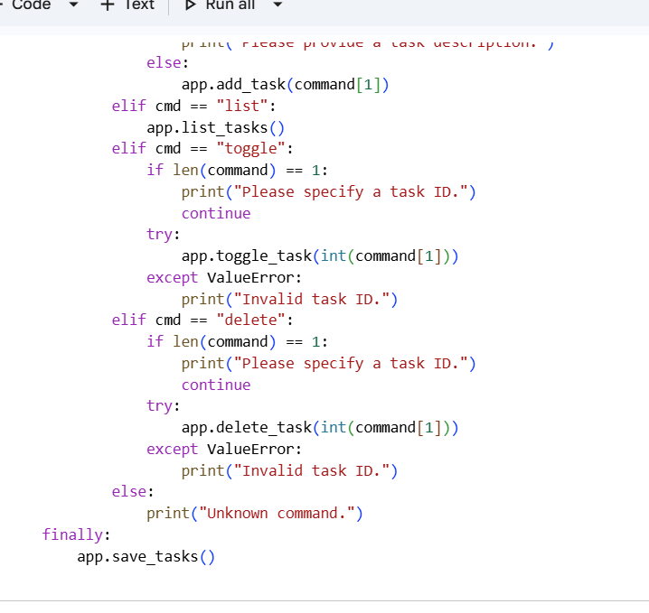
ENHANCED CODE
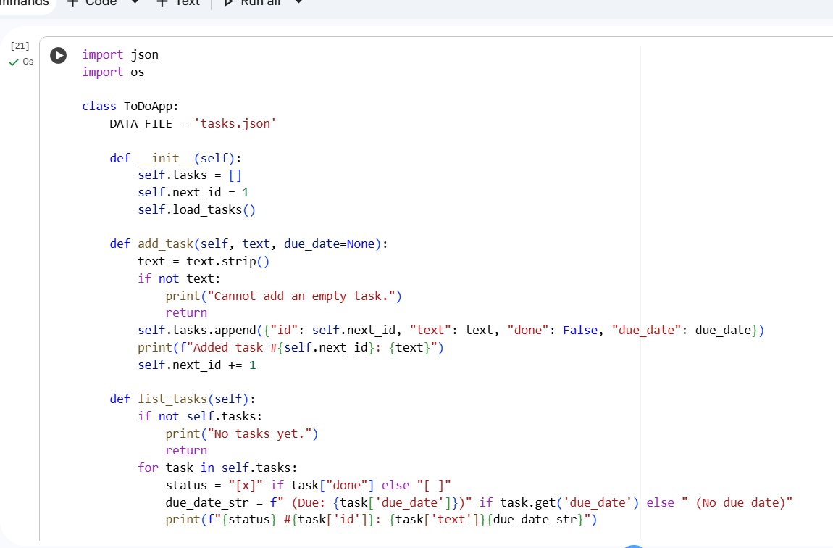
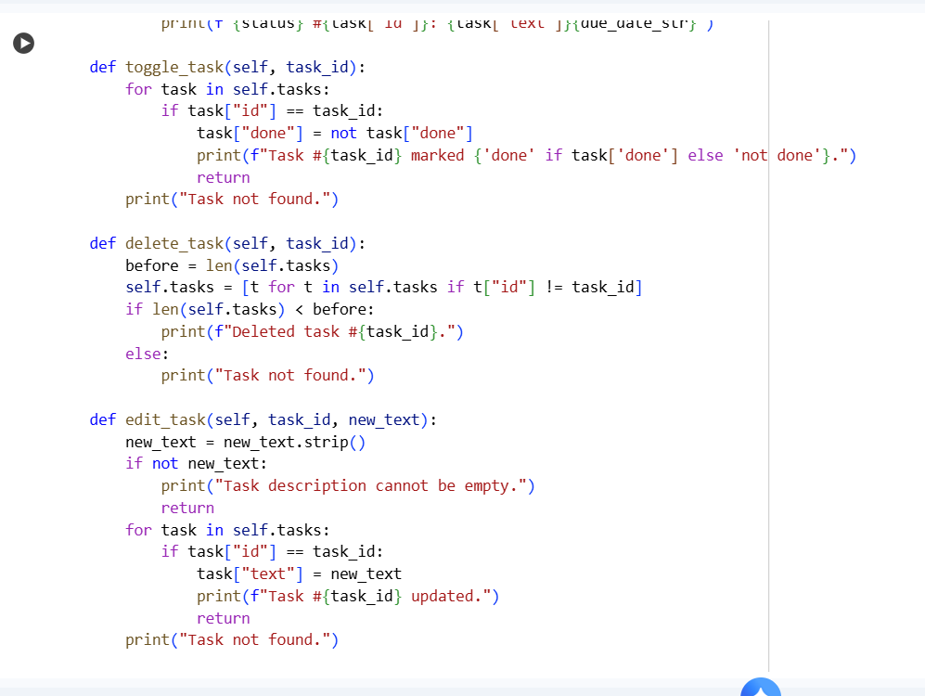
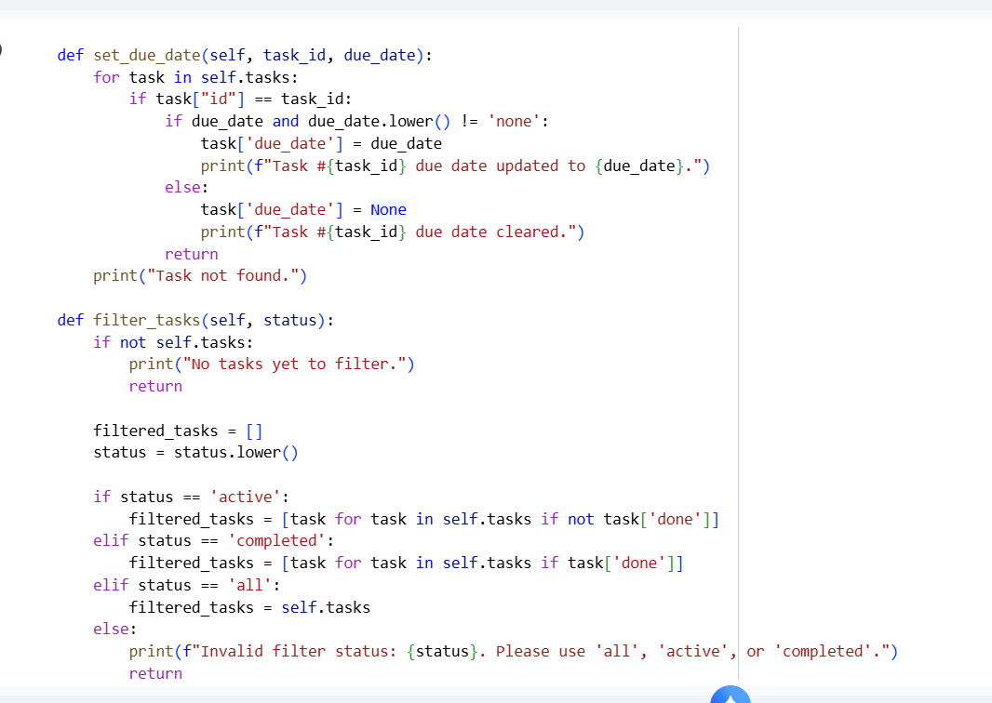
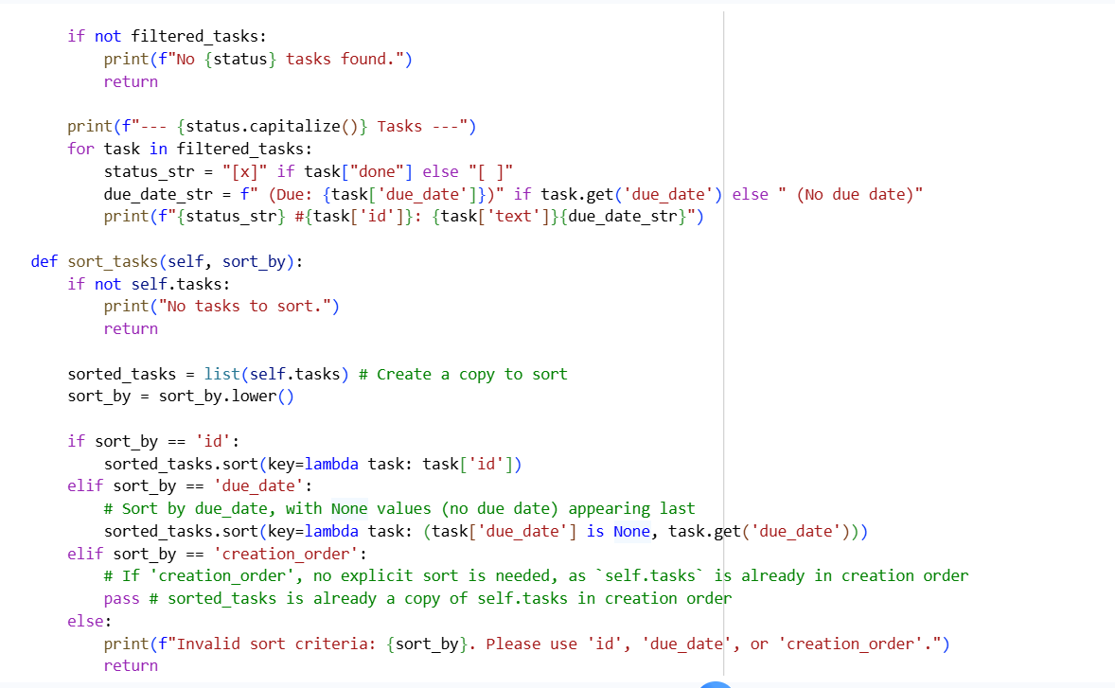
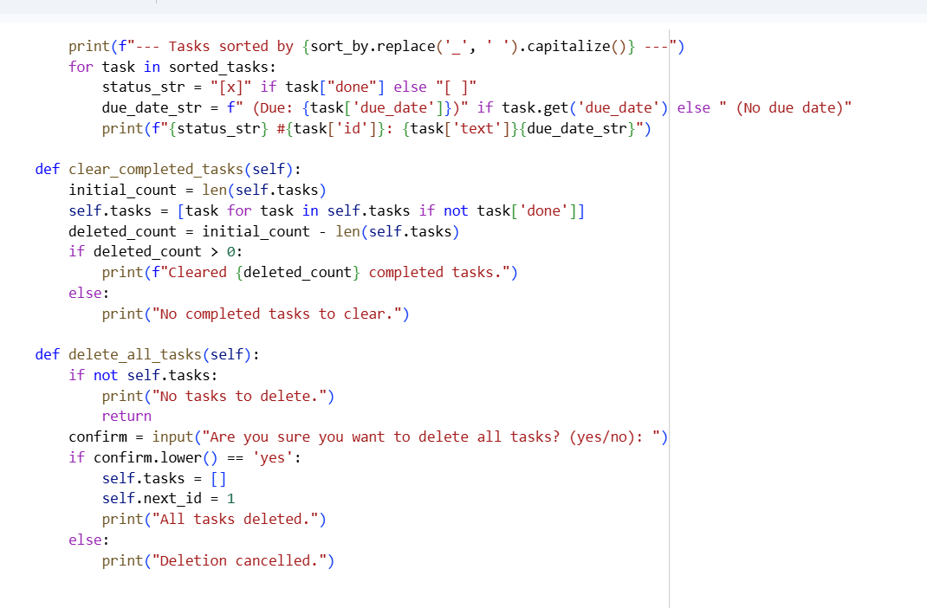
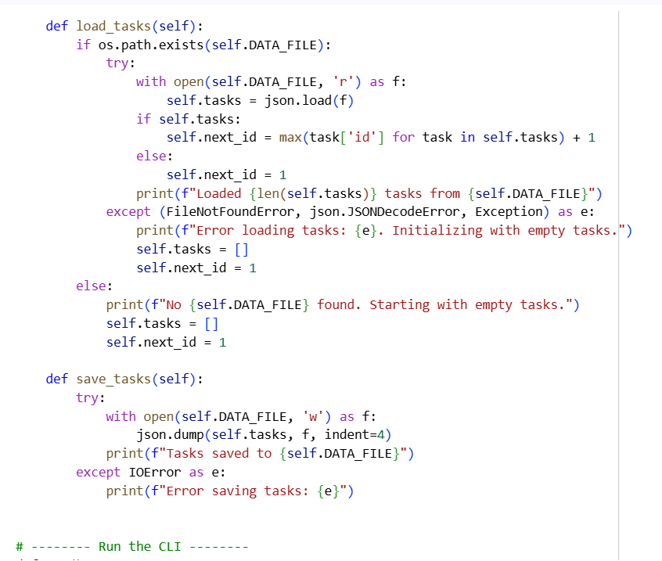
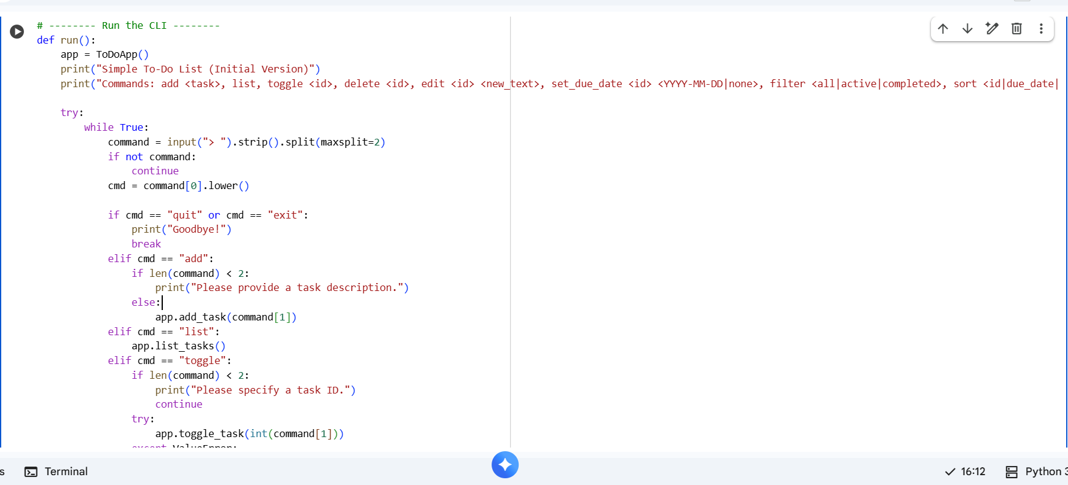
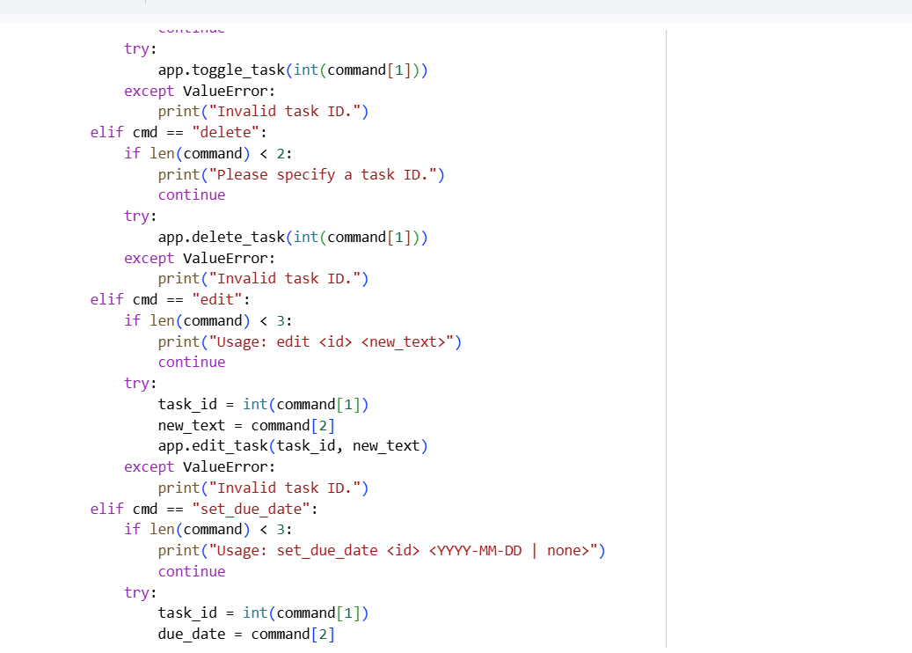
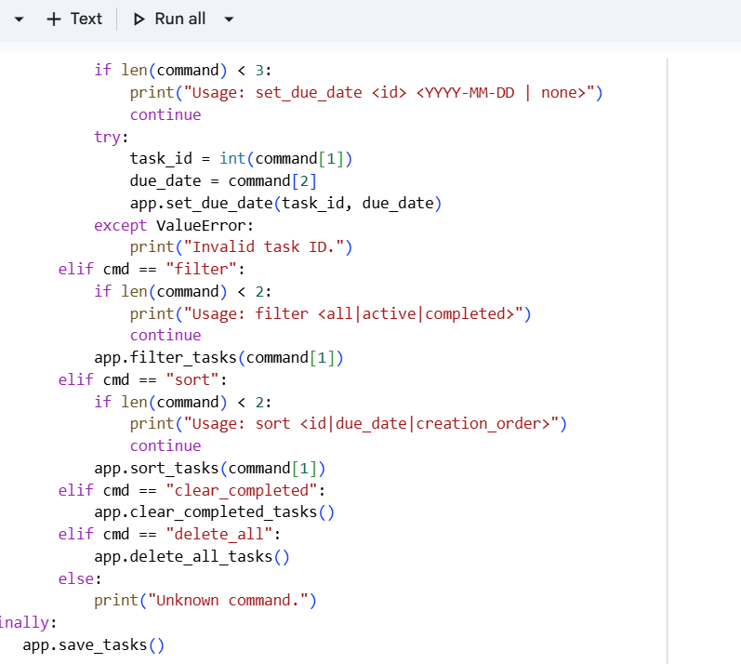
COMPARISION
Aspect | Initial Code | AI-Enhanced Version
Persistence | None | JSON file storage
Error Handling | Minimal | Input validation + exceptions
User Features | Add / List / Delete | Edit / Due date / Filter / Summary
Structure | Plain script | Class-based OOP design
User Experience | Basic CLI | Interactive, realistic workflow
Learning Outcome | Teaches logic flow | Shows real-world software practices

AI COLLABORATION
AI acts as a pair programmer — it doesn’t just generate code, it suggests improvements and introduces best practices that a beginner or human developer might overlook.
Through collaboration:
- Human provides intent and core logic.
- AI adds structure, optimization, and extra functionality.
- Together, they evolve a toy script into a mini-application.
This demonstrates how AI can:
- accelerate learning,
- act as a tutor or code reviewer,
- and improve software design iteratively.
Task-2
Use AI-assisted code/content modification and integrate it into a Git version control workflow by performing the following:
- Initialize a Git repository.
- Create a new branch for AI-generated improvements.
- Ask an AI model to modify, improve, or add content.
- Add the AI-generated changes into the branch and commit with a meaningful message.
- Merge these changes back into the main branch.
- Finally, reflect on how Git helps in collaborating with an AI model, and how maintaining separate branches for AI-generated changes can support safe experimentation.

Code and Output:
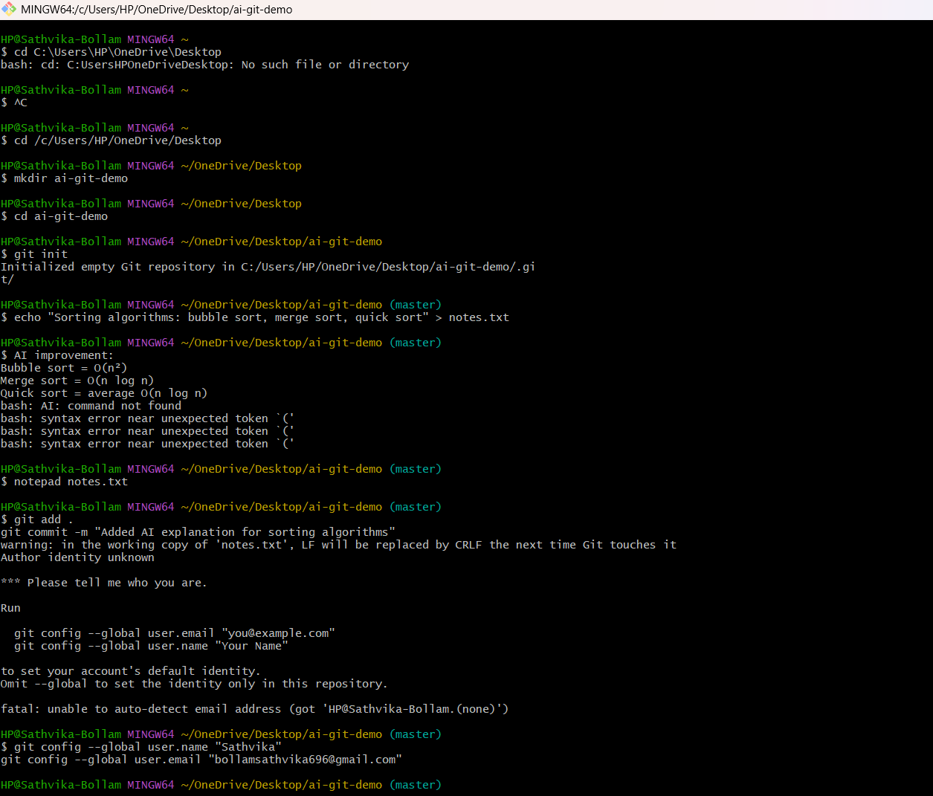
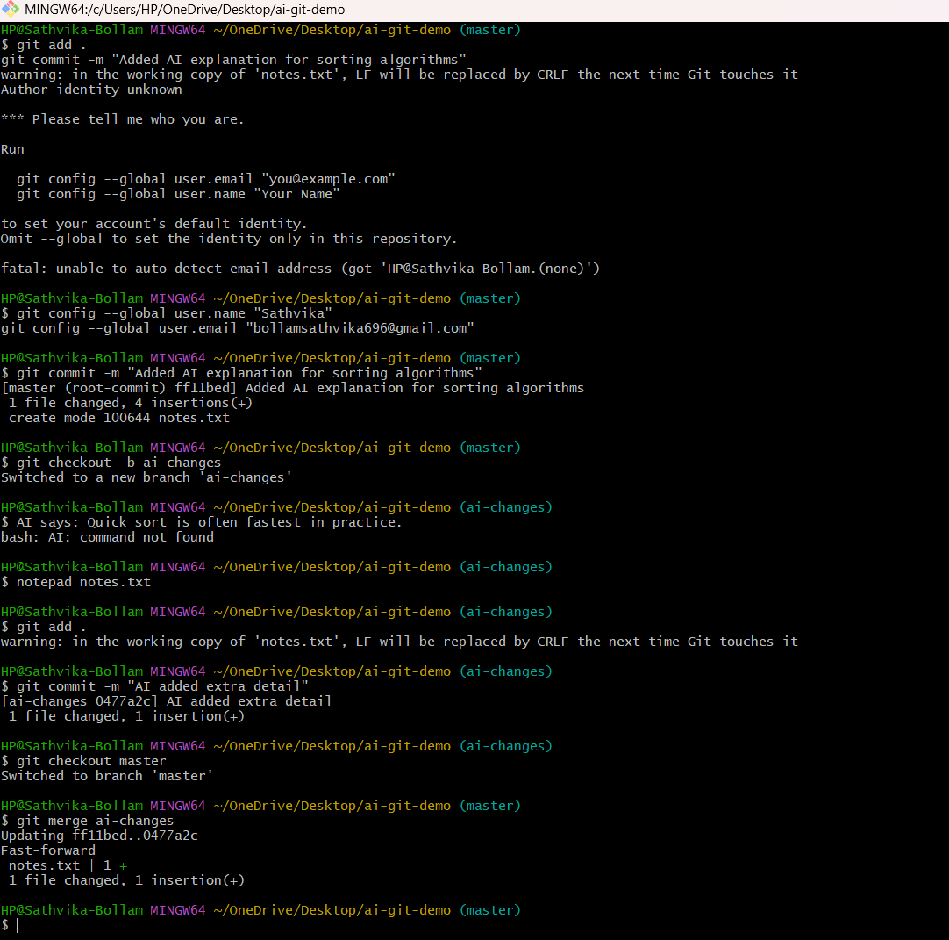
Observation:
I observed that using Git with AI assistance made my development process more organized. By keeping AI-generated updates in a separate branch, I was able to clearly see what the AI changed, review the differences, and only then merge it into the main branch. This reduced the chance of mistakes and helped maintain a clean history of all changes.

#Task-3:
Prompt: generate concise, meaningful commit messages based
on the changes made.
Compare AI-generated messages with human-written ones.
Code and Output:
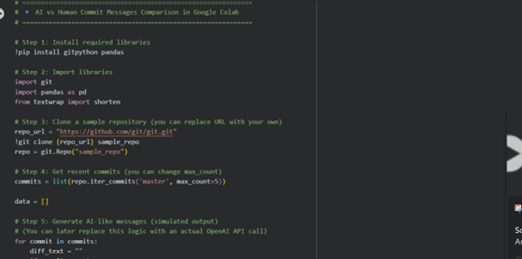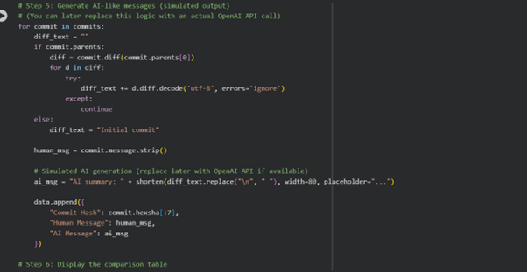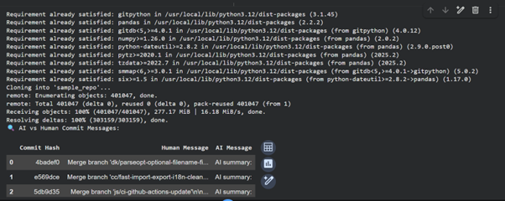
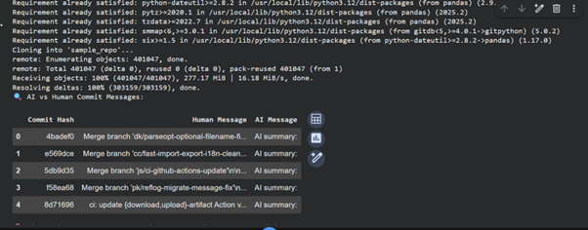Observation:
- The code installs required libraries (gitpython),( pandas) for commit analysis.
- It clones a public GitHub repository into the Colab environment.
- Recent commits are fetched using GitPython.
- For each commit, code differences (diffs) are extracted.
- Initial commits are handled separately to avoid errors.
- A simulated AI message is generated for each diff.
- Human and AI messages are displayed side by side in a table.
- The comparison helps show how AI could summarize code changes.
- A discussion explains AI’s benefits in documentation and traceability.
10.The script can easily be extended to use real AI models with an API key.

#TASK-4
Prompt: We are simulating pair programming in Git. Student A wrote the initial version of a simple program. Now suggest improvements or add extra features to this program. While giving suggestions, also mention how these changes will be managed in Git branching and merging. Provide optimized code and explain why those changes are better.
Code and Output:
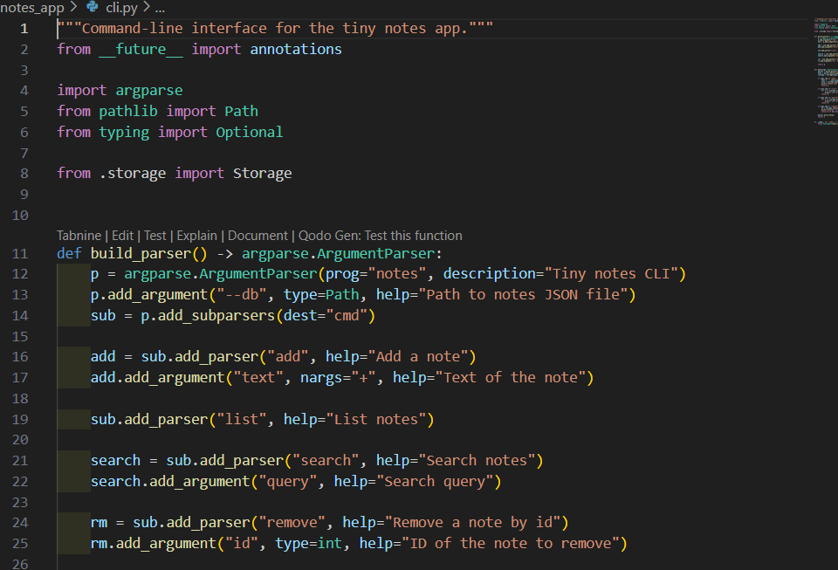

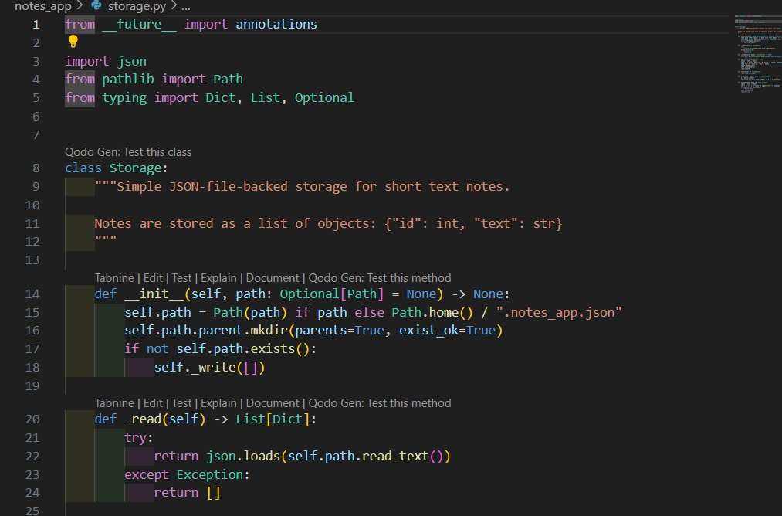
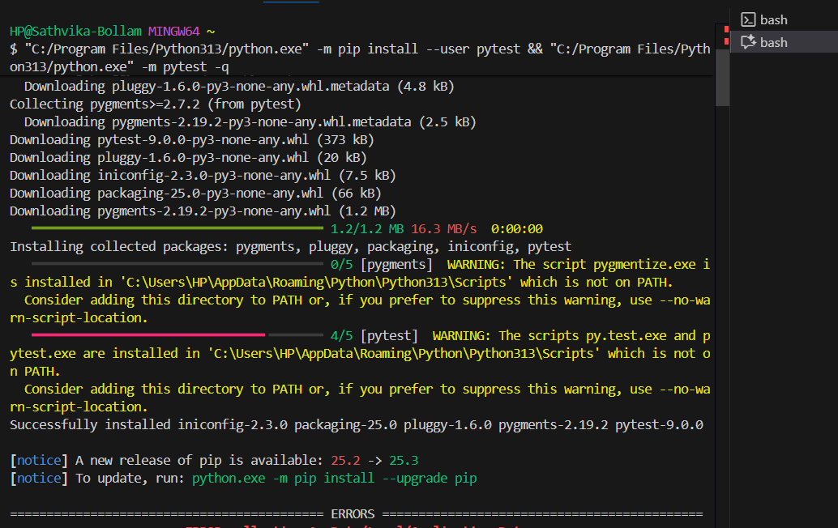
Observation :
In this activity, I observed that AI helped in improving the program written by Student A by suggesting better logic and adding extra features. The AI also guided how to use Git effectively by working in separate branches and then merging changes back to the main branch. I learned how collaboration becomes easier when using Git for branching and merging. I also understood that AI assistance can reduce time and help in writing clean and efficient code. This simulated a real working environment where two developers collaborate on the same project using version control and AI assistance.

