WTMP

2403A51355

BATCH -18

Set B

1. Write a Python program to extract all email addresses from a block of text using regular expressions. GitHub Copilot along with VS Code. Use zero shot prompting.

Prompt:- Write a Python program to extract all email addresses from a block of text using regular expressions.

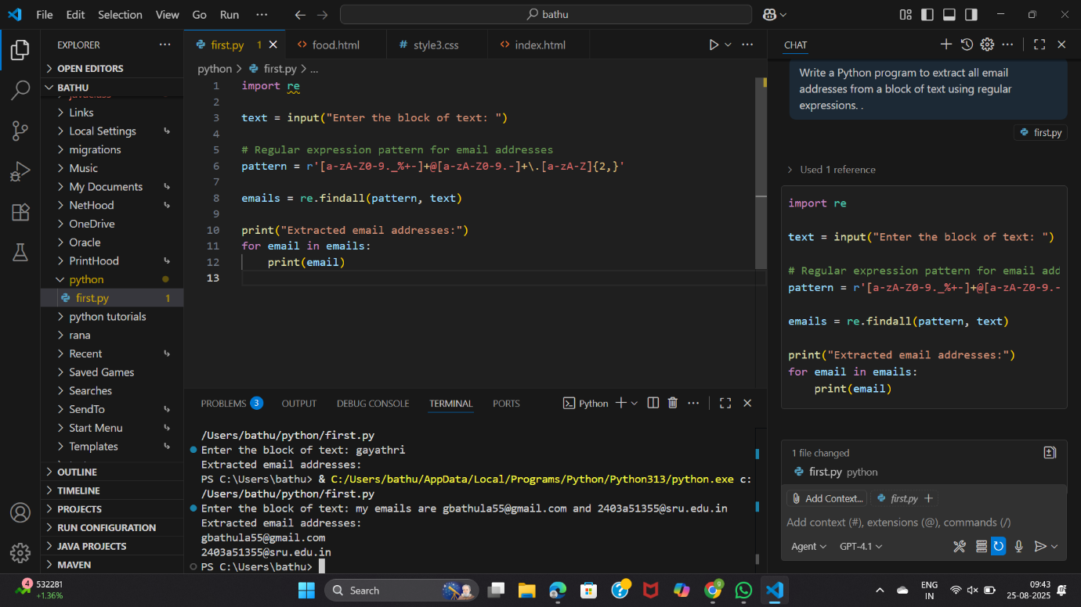

1. Given a list of movies with their genres, Write a Python function that recommends movies based on a user’s preferred genre. Use the Cursor AI tool. Use few shot prompting

Prompt:- Given a list of movies with their genres, Write a Python function that recommends movies based on a user’s preferred genre.  
Input:  
Movies: [("Inception", "Sci-Fi"), ("Titanic", "Romance"), ("Interstellar","Sci-Fi")]  
Preferred genre: Sci-Fi  
Output:  
Recommended movies: Inception, Interstellar  
  
input:  
Movies:[("mad max","funny"),("blind spot", "suspense")]  
Preffered genre:suspense  
output:  
recommended movies: blindspot.

