AI ASSISTED CODING
ASSIGNMENT – 10.1
2403A54098
BATCH – 18
Task 1: Use AI to identify and fix syntax and logic errors in a faulty
def calc_average(marks):
total = 0
for m in marks:
total += m
average = total / len(marks)
return avrage # Typo here
marks = [85, 90, 78, 92]
print("Average Score is ", calc_average(marks)
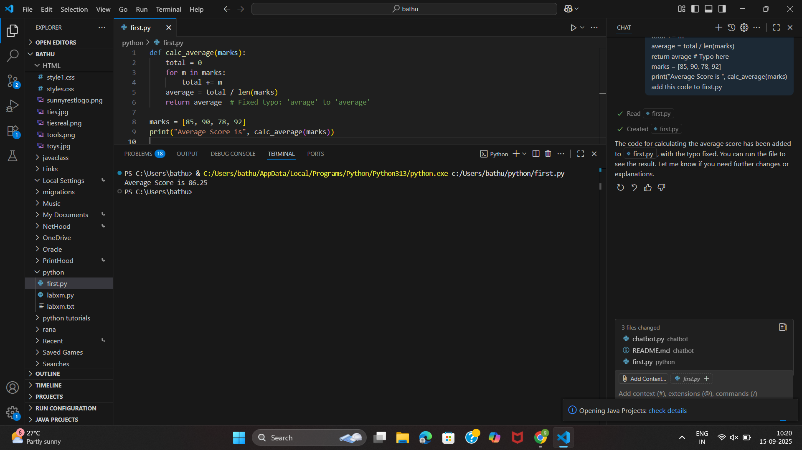
AI fixing the typo error.
Task 2: Use AI to refactor Python code to follow PEP 8 style guidelines.
Sample Input Code:
def area_of_rect(L,B):return L*B
print(area_of_rect(10,20))
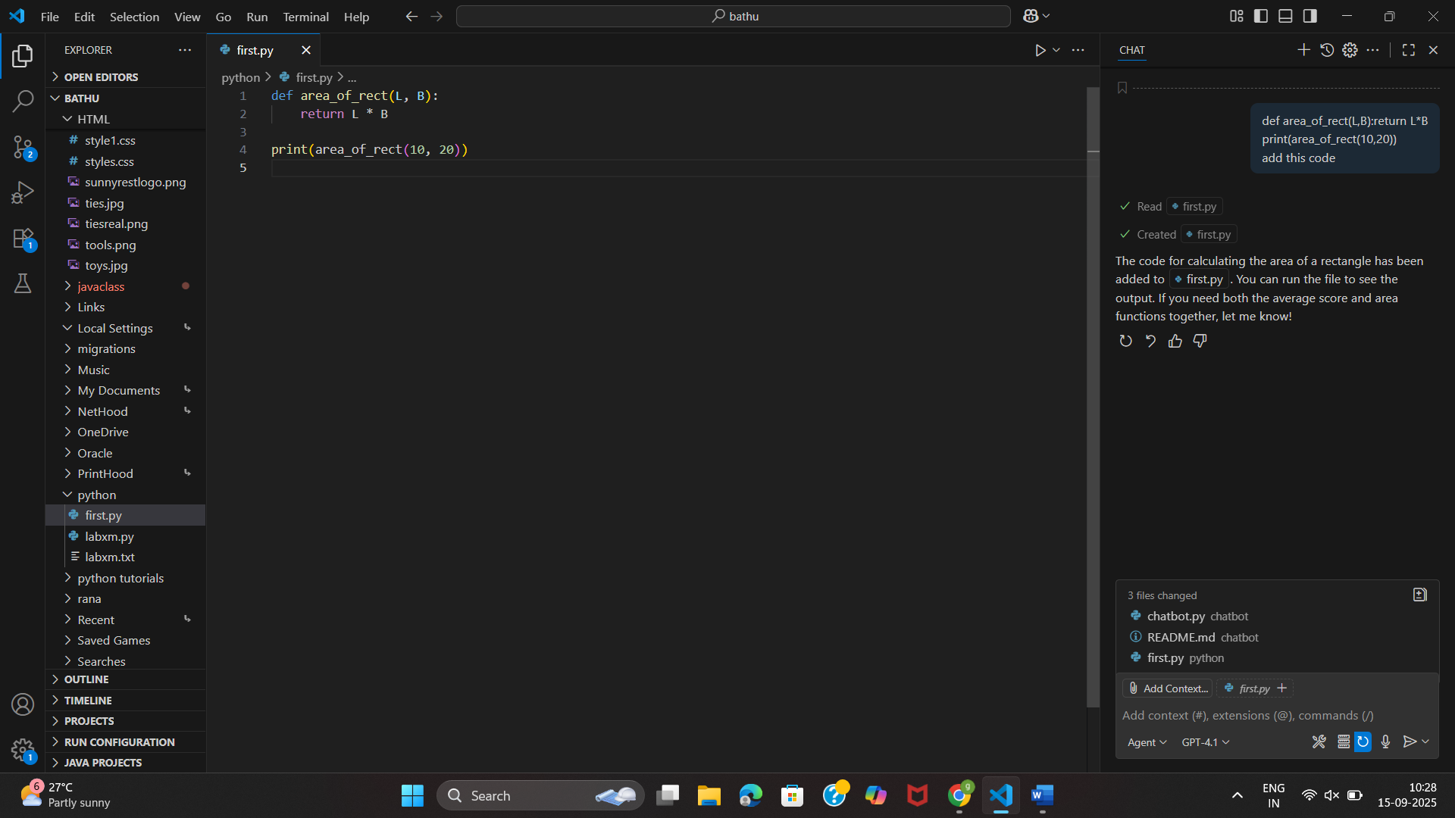

After following PEP 8 style guidelines
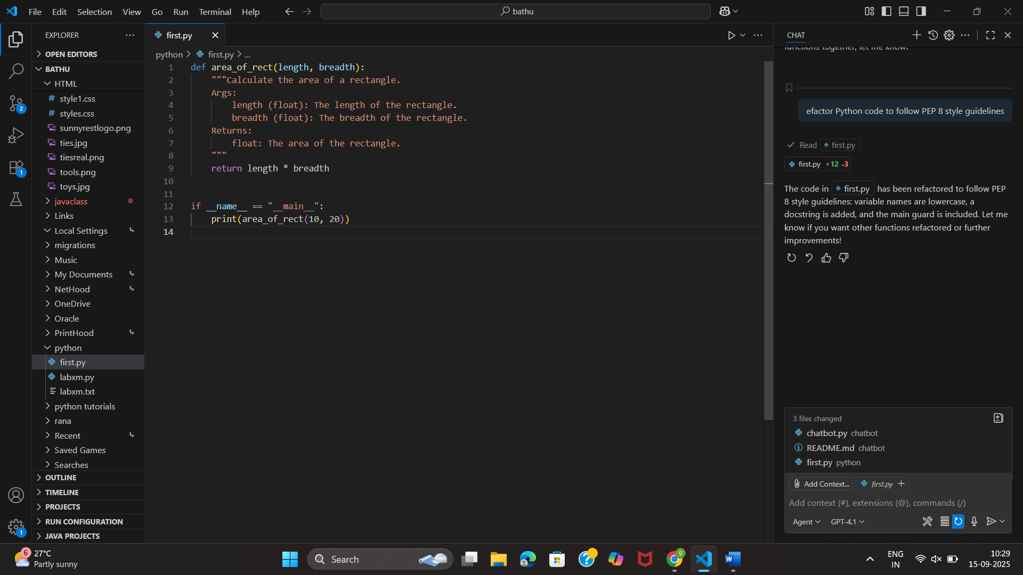
Task 3: Use AI to make code more readable without changing its logic.
Sample Input Code:
def c(x,y):
return x*y/100
a=200
b=15
print(c(a,b))
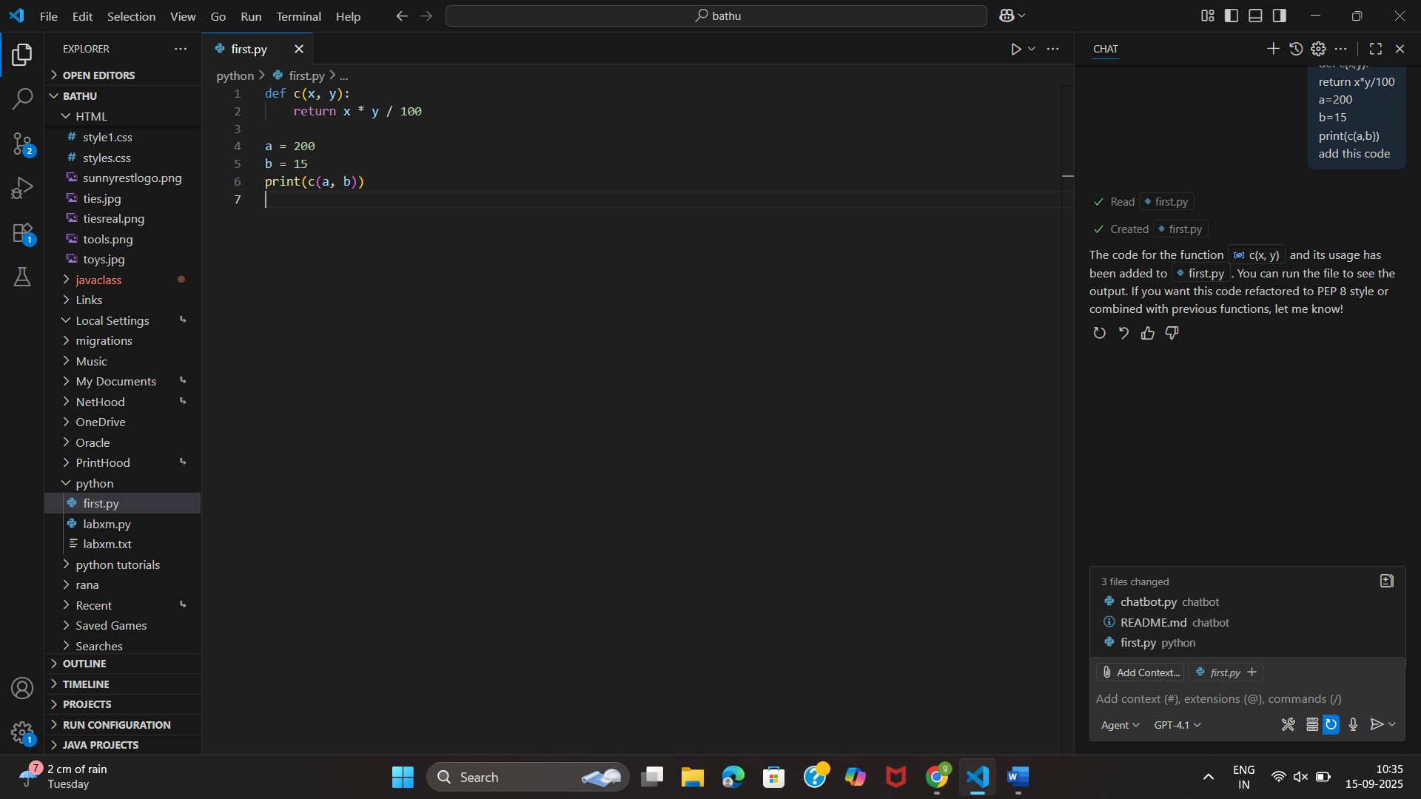
Making code understandable without changing its logic
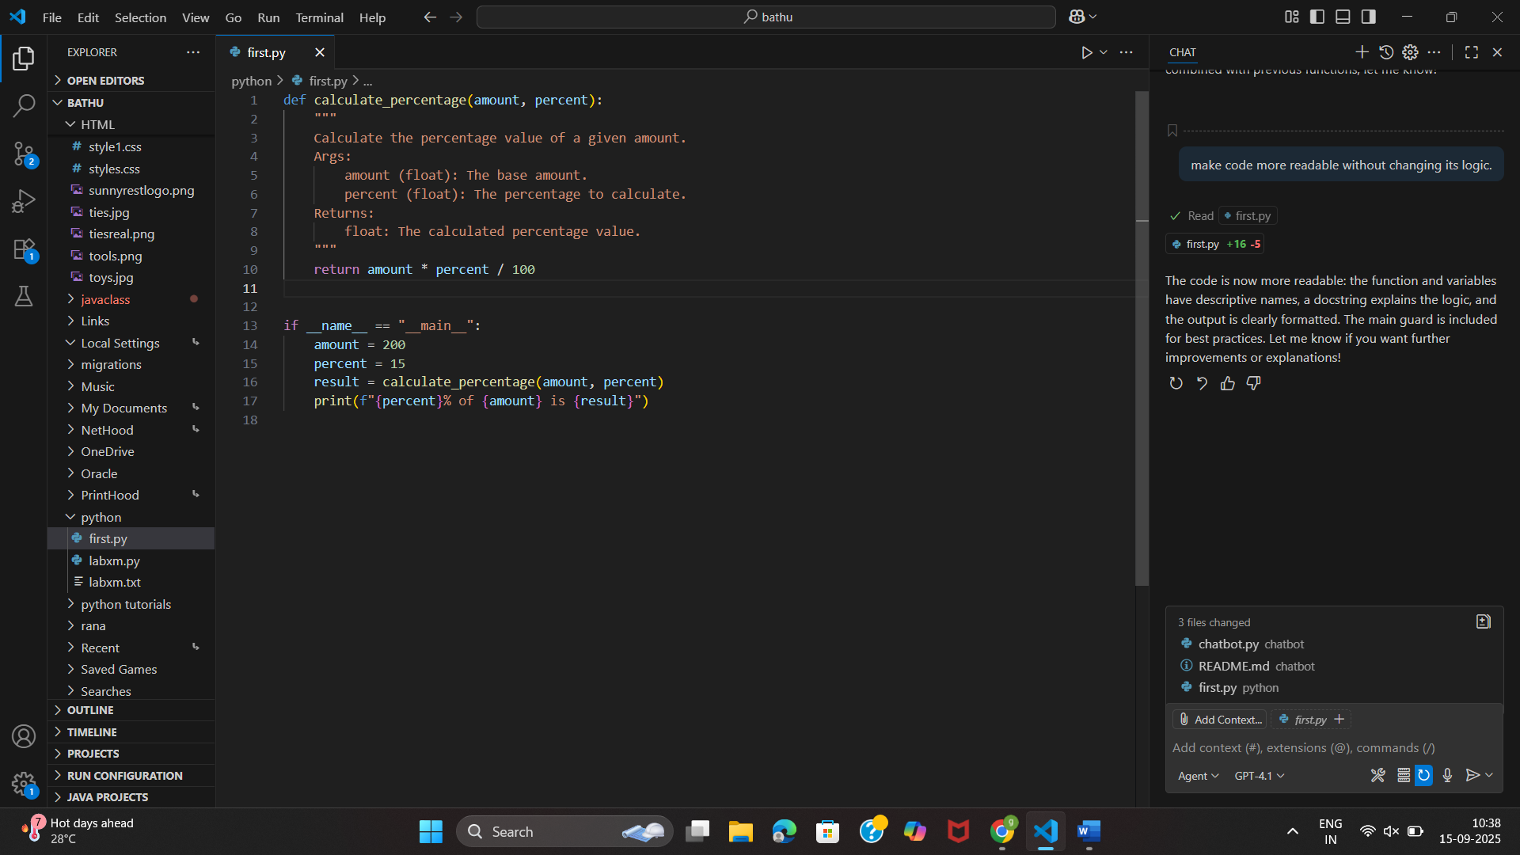
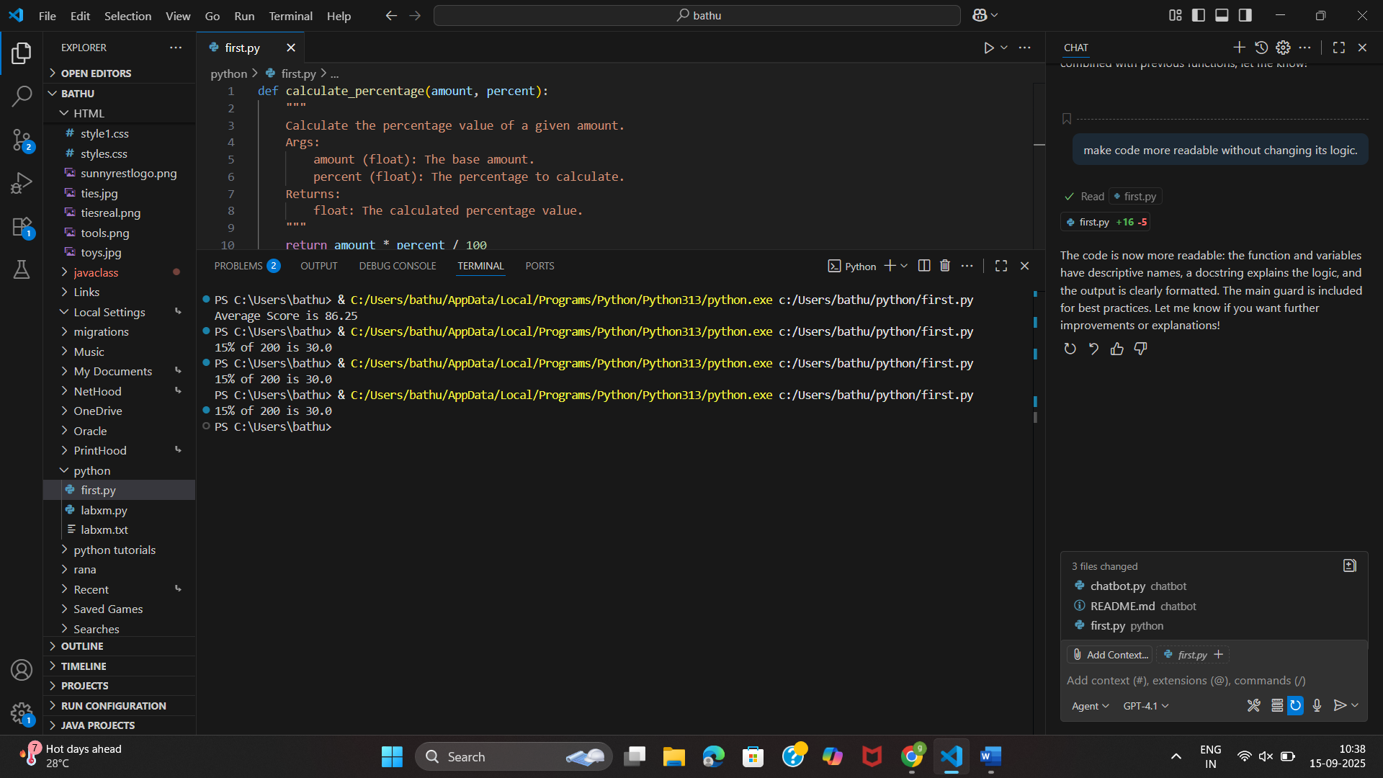
Task 4: Use AI to break repetitive or long code into reusable functions.
Sample Input Code:
students = ["Alice", "Bob", "Charlie"]
print("Welcome", students[0])
print("Welcome", students[1])
print("Welcome", students[2]
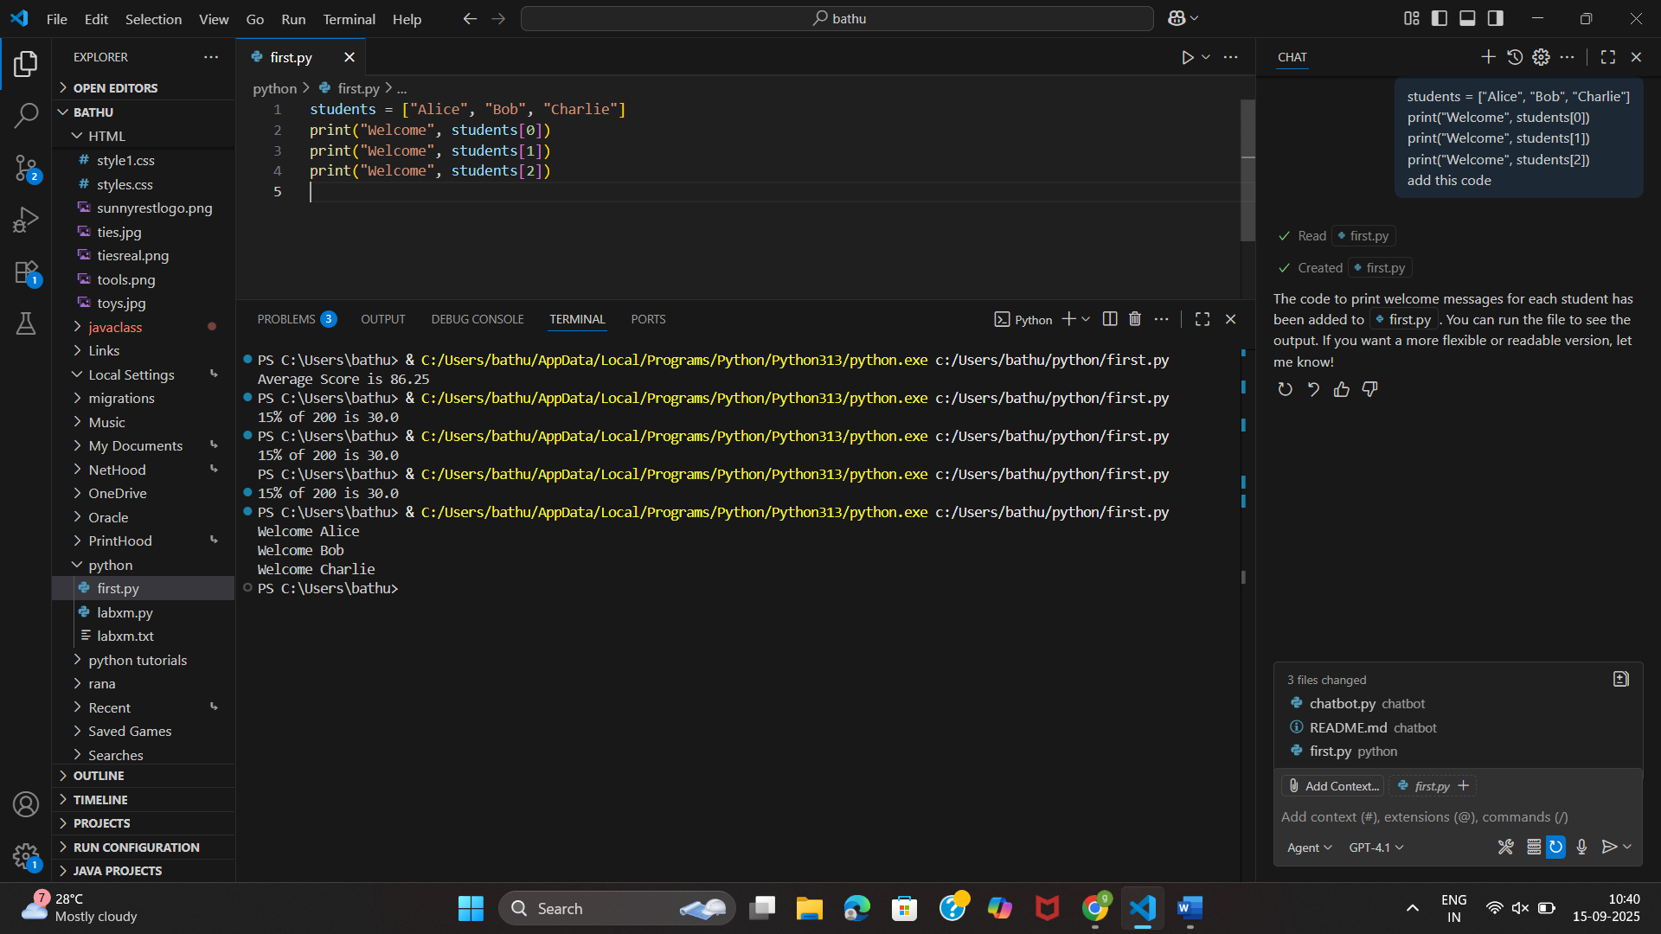
long code into reusable functions.
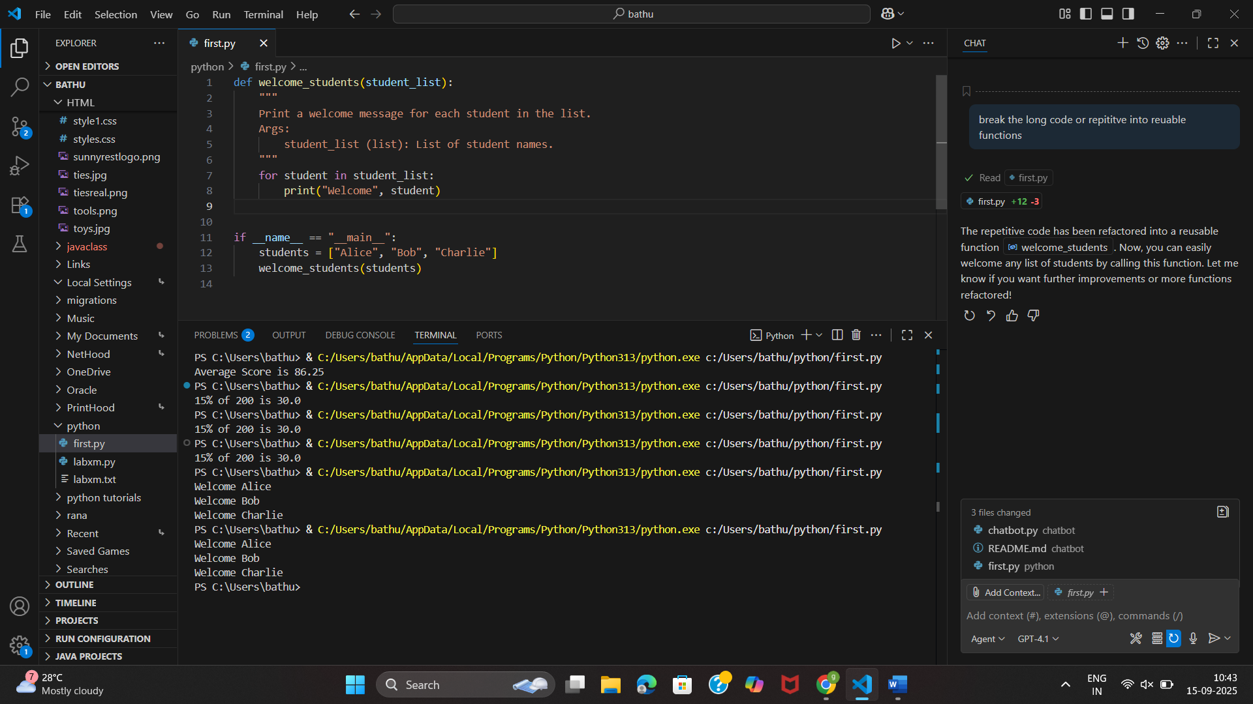
Task 5: Use AI to make the code run faster.
Sample Input Code:
# Find squares of numbers
nums = [i for i in range(1,1000000)]
squares = []
for n in nums:
squares.append(n**2)
print(len(squares))
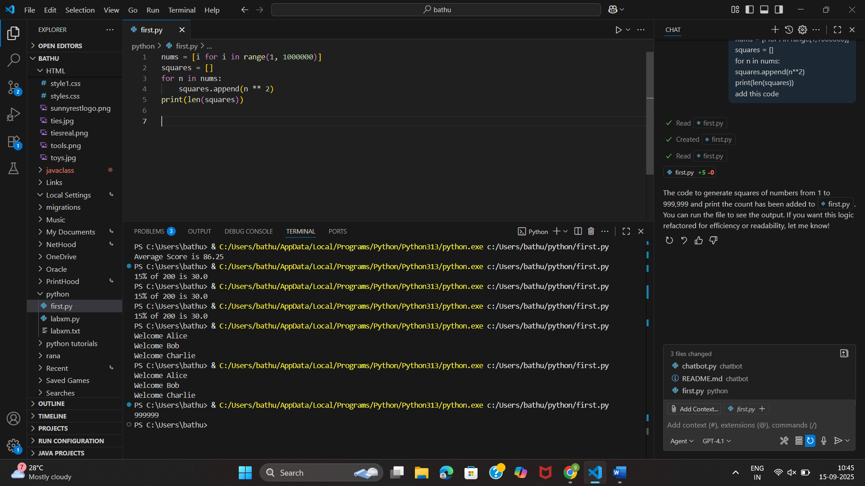
Optimized code
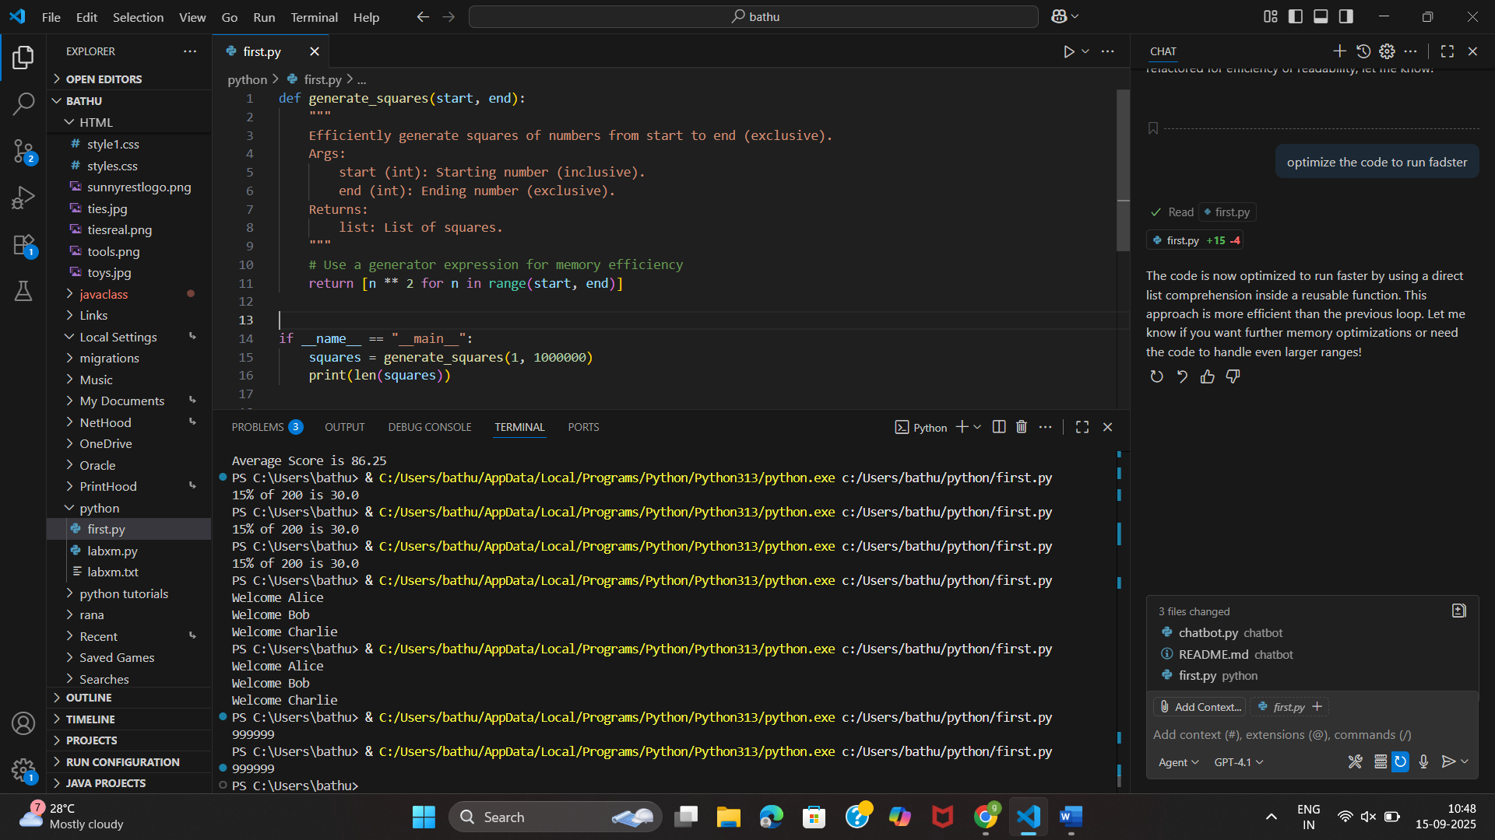
Task 6: Use AI to simplify overly complex logic.
Sample Input Code:
def grade(score):
if score >= 90:
return "A"
else:
if score >= 80:
return "B"
else:
if score >= 70:
return "C"
else:
if score >= 60:
return "D"
else:
return "F"
