School of Computer Science and Artificial Intelligence

Lab Assignment # 10.2

Program : B. Tech (CSE)
Specialization : -
Course Title : AI Assisted Coding
Course Code : 23CS002PC304
Semester : II
Academic Session : 2025-2026
Name of Student : A.Sreeja
Enrollment No. : 2403A51L02
Batch No. : 51
Date : 10/02/26

Submission Starts here

Screenshots:
Task Description -1(Error Detection and Correction)

Code used:
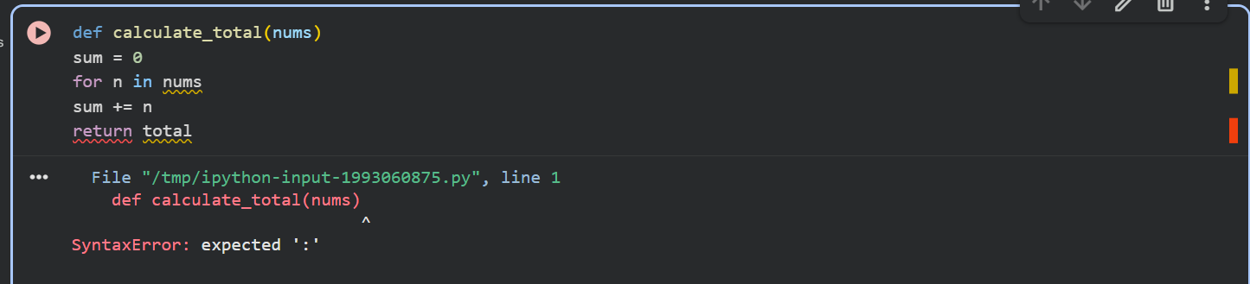

Prompt:
Correct the code and give brief explanations of the
identified syntax and logic errors.

Output:
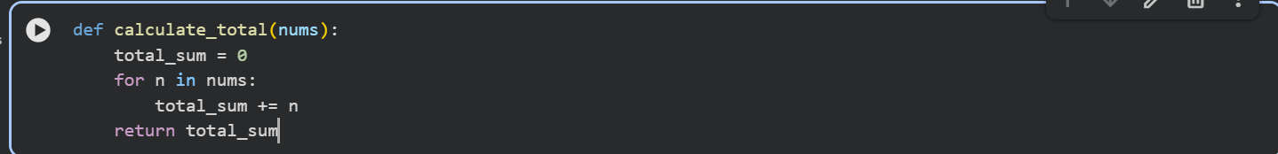

Explaination:

Missing colons: Python requires a colon : at the end of def (function definition) and for (loop definition) statements.

Variable shadowing: I renamed the sum variable to total_sum to avoid overwriting Python's built-in sum() function, which can lead to unexpected behavior.

Undefined variable: The function was trying to return total, but the variable was named sum (or total_sum after the fix). I've corrected it to return total_sum.

Task Description -2(Code Style Standardization)

Code Used:

Prompt:
convert the code to follow standard style conventions.

Output:
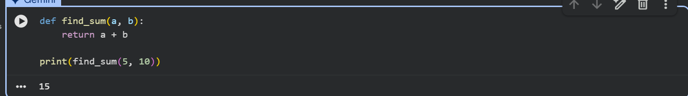

Task Description -3(Code Clarity Improvement)

Code used:
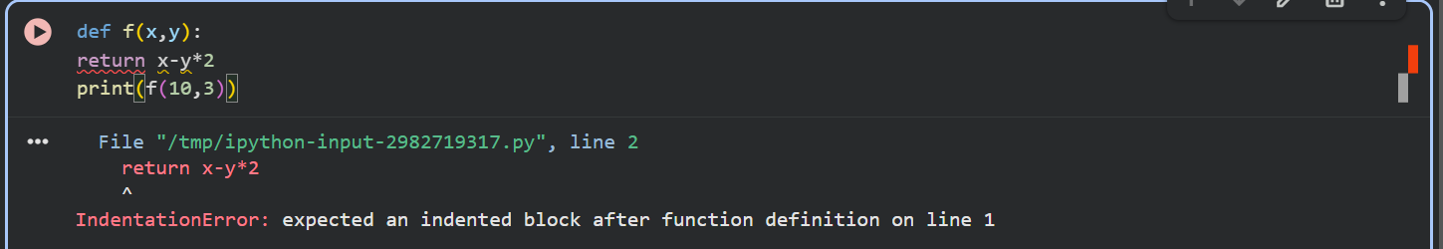

Prompt:
rewrite the code with meaningful function and variable names,
proper indentation, and improved clarity.

Output:
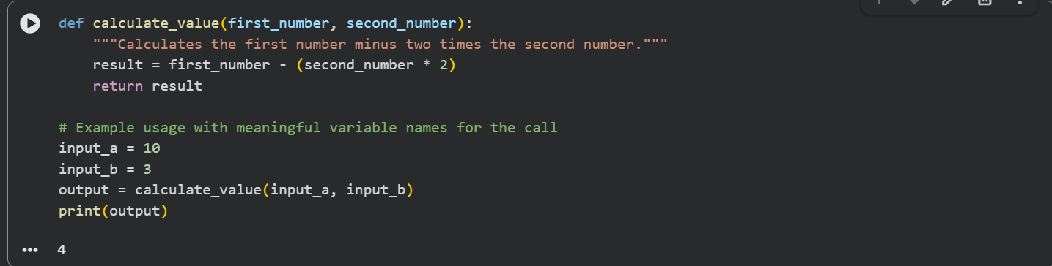

Task Description -4(Structural Refactoring)

Code used:
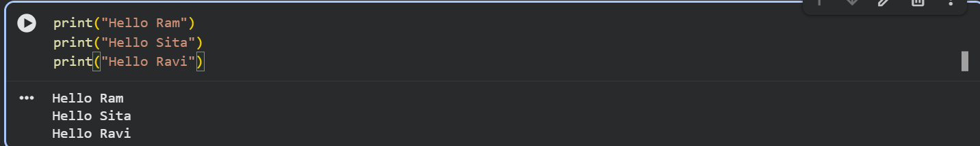

Prompt:
make the code modular using reusable functions to eliminate repetition.

Output:
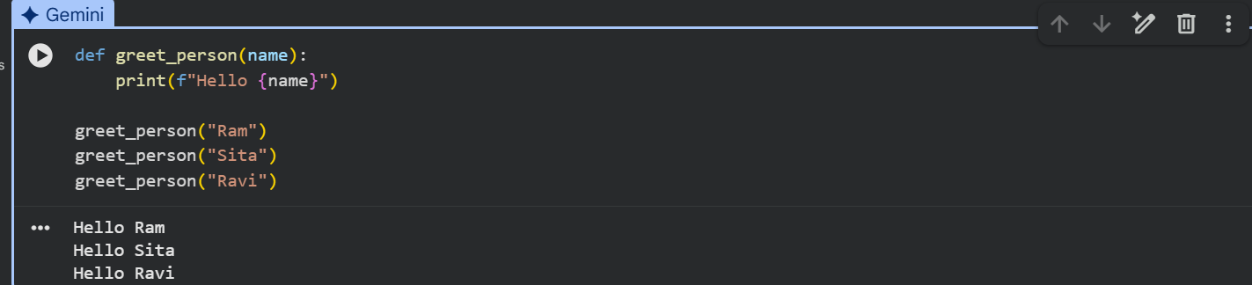

Task Description -5(Efficiency Enhancement)

Code used:
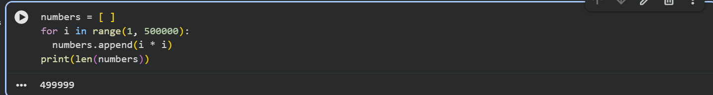

Prompt:
Optimize the code to achieve the same result with improved
performance.

Output:
