AI ASSISTANT CODING Lab Assignment 1.5
Atla.Sreeja
2403A51L02
51
Task 1: AI-Generated Logic Without Modularization (Reverse a String)
Prompt Used: “write a simple python program on reverse a string without using functions”

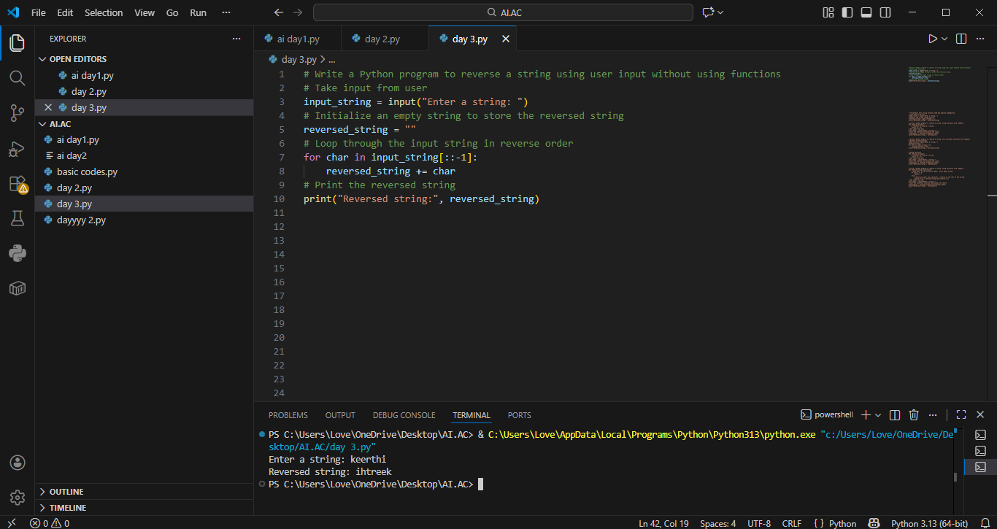

- Keeps the program simple
- Suitable for small scripts
- Easy for basic understanding
- No function call overhead

Task 2: AI Code Optimization & Cleanup Original Code:
Prompt Used: “optimize this code & simplify logic and improve readability”
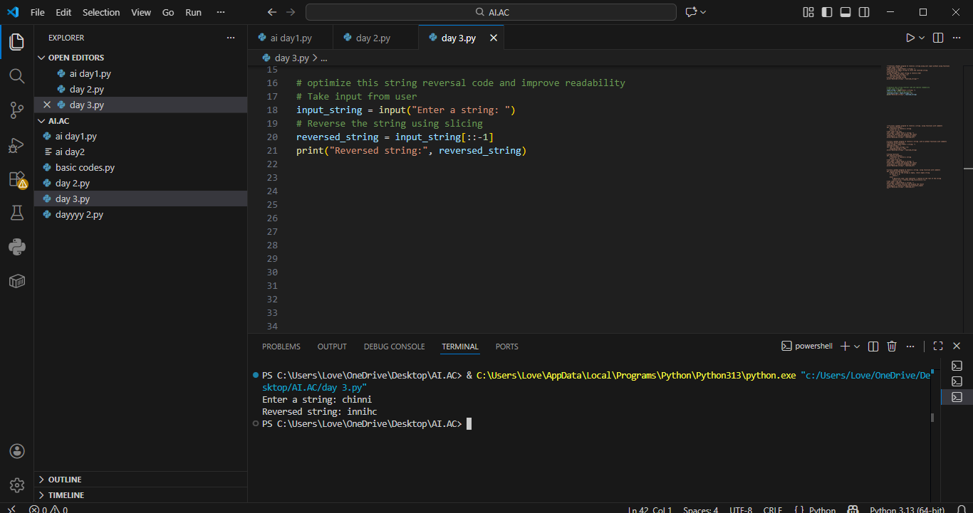

Code is cleaner and easier to maintain
The optimized version improves clarity, maintainability, and readability without affecting performance.

Task 3: Modular Design Using AI Assistance (Reverse a string with Functions)
Prompt Used: “ Write a simple python program of reverse a string using with function”

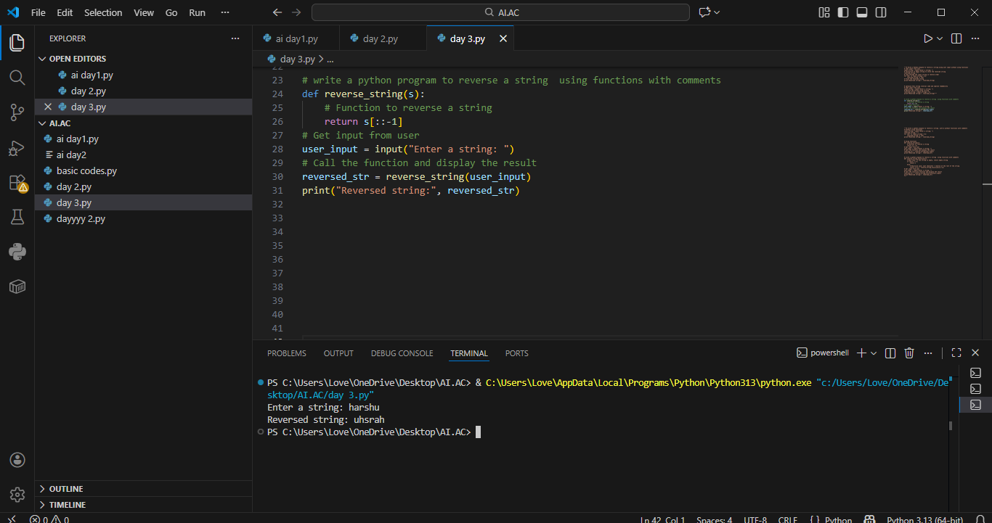

Using functions improves reusability because the same logic can be called multiple times.
It also improves readability and debugging.
Modular code is easier to maintain in large projects.

Task 4: With and Without Using Functions(Reverse a string)
Prompt Used: “ Write a simple python program of reverse a string using with function and without using function”

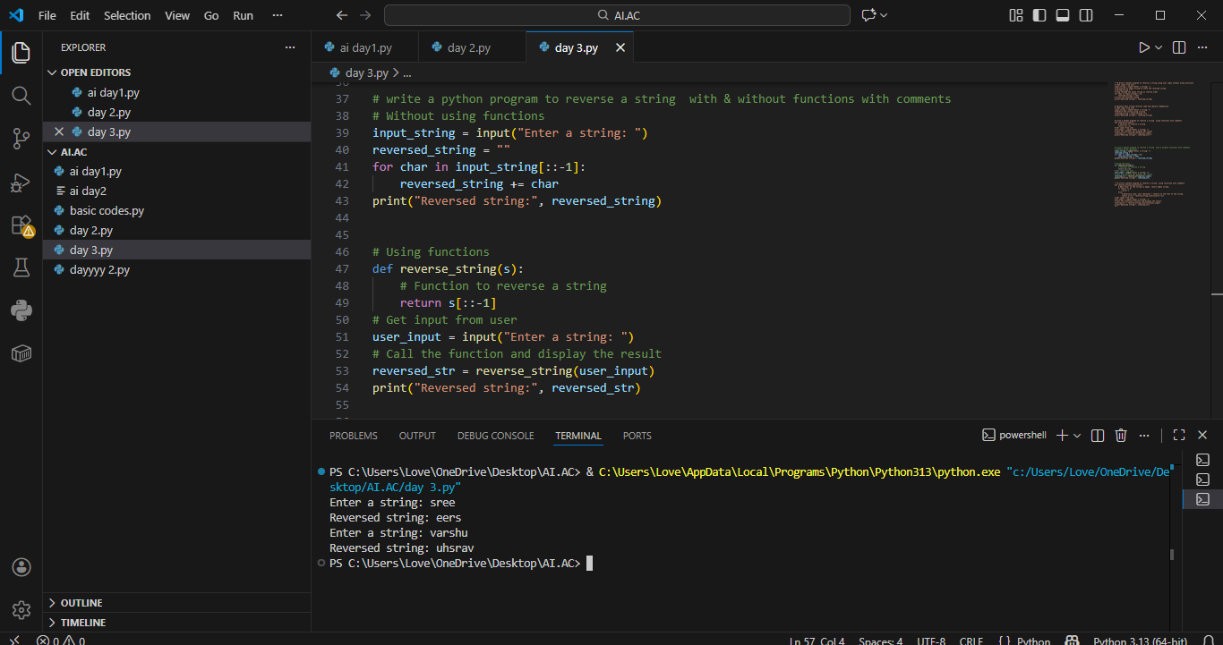

Without using functions: Helps beginners clearly understand the basic logic and step-by-step execution of an Armstrong number program.
Using functions: Makes the code modular, reusable, and easier to read and maintain.
Overall: Using functions follows good programming practices, especially for larger or real-world programs.

Task 5: Iterative vs Recursive AI Code
Prompt Used: “Generate iterative and recursive function reverse a string in Python”

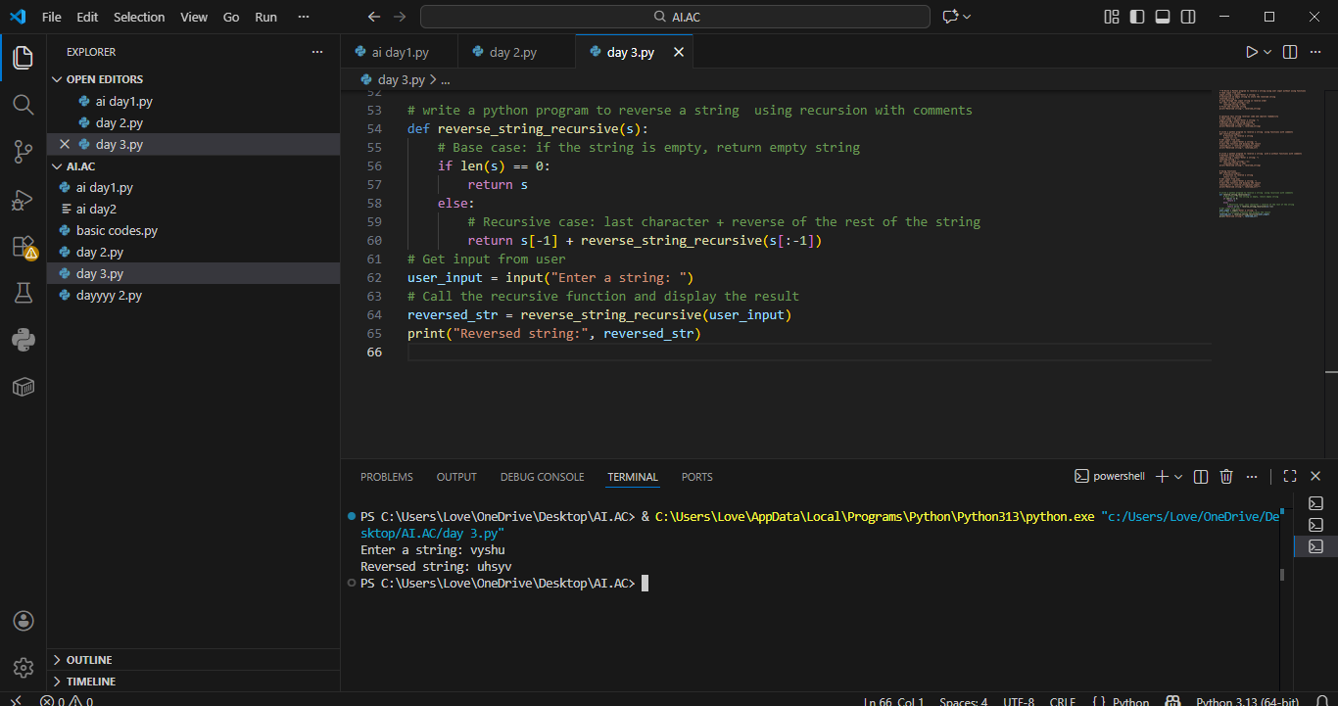

Execution Flow Explanation
- Iterative version uses loops
- Recursive version uses function calls
- Recursive calls stack memory

