School of Computer Science and Artificial Intelligence

Lab Assignment # 17.1

Program : B. Tech (CSE)
Specialization : -
Course Title : AI Assisted Coding
Course Code : 23CS002PC304
Semester : II
Academic Session : 2025-2026
Name of Student : I.Sathwik Rajeshwara Chary
Enrollment No. : 2403A51L03
Batch No. : 51
Date : 31/03/26

Submission Starts here

Screenshots:

Task 1 – Customer Data Cleaning

Prompt:
Generate a Python script using pandas to clean the dataset.
- Handle missing values in age, income, city
- Remove duplicates
- Convert city names to lowercase
- Encode categorical columns gender and city
- Return cleaned dataframe

Output:

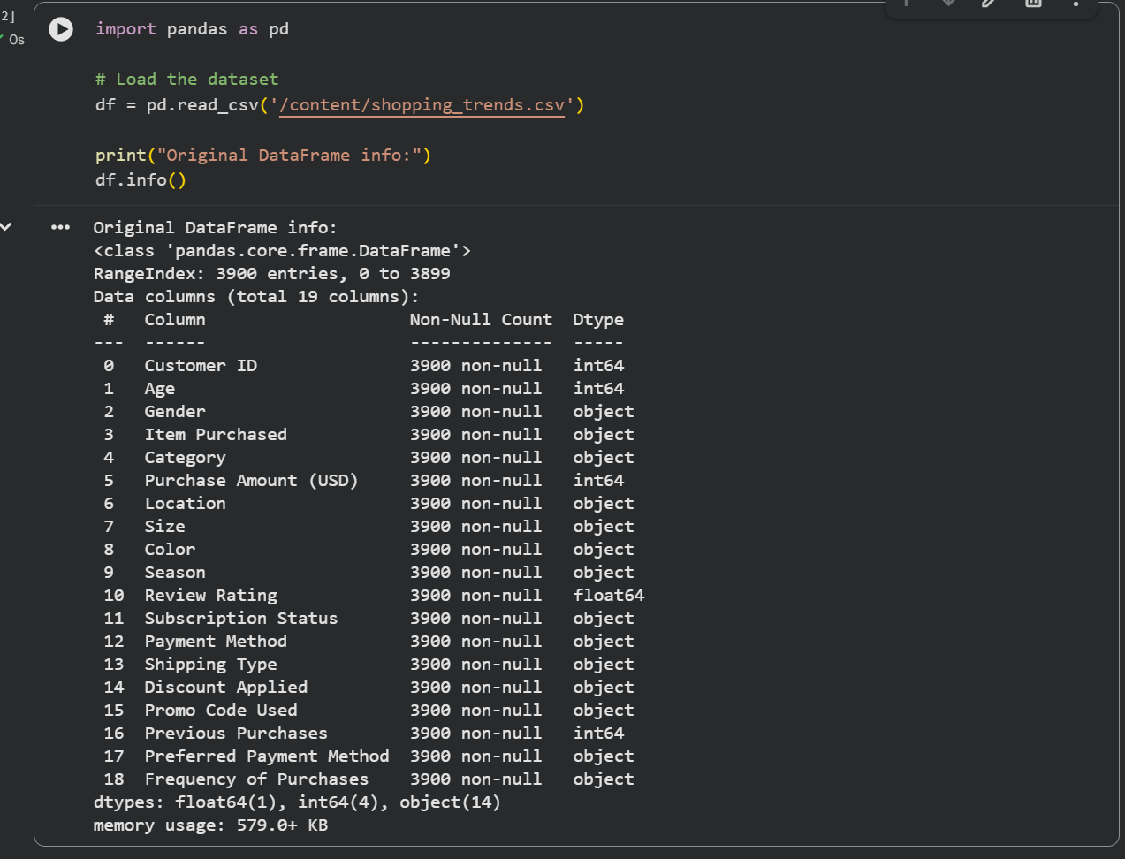

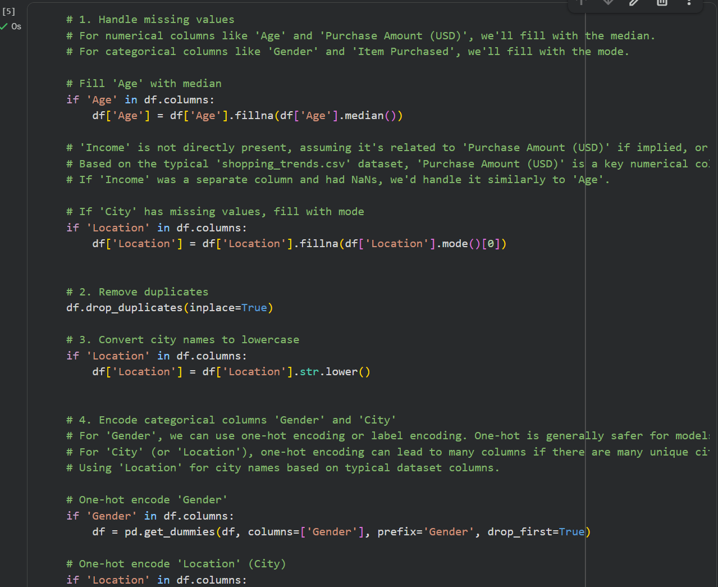

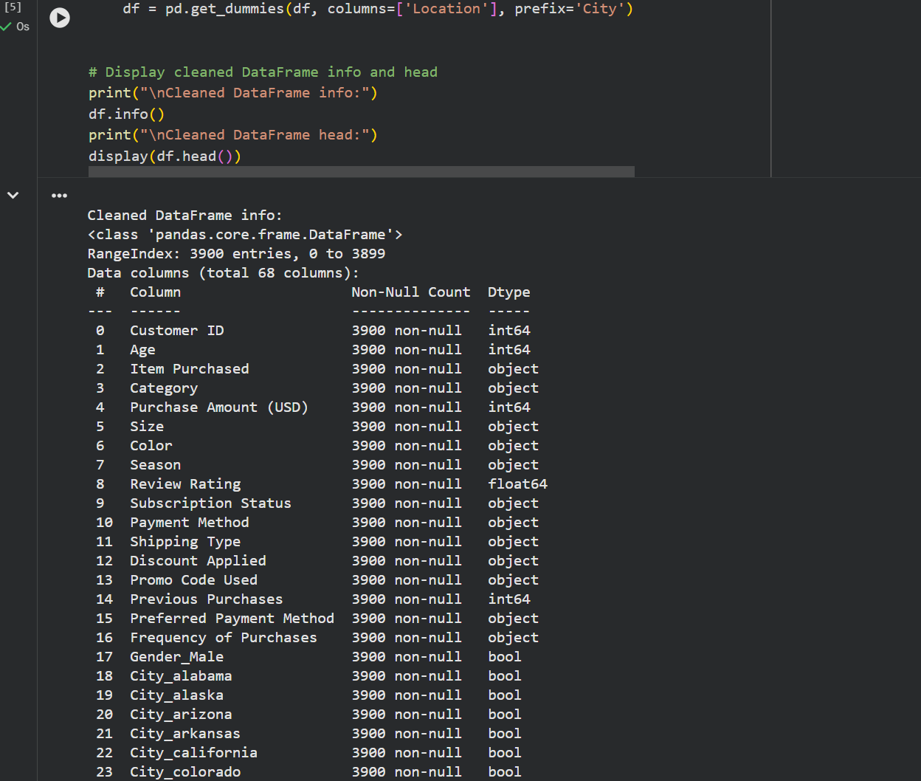

Task 2 – Sales Data Preprocessing

Prompt:
Generate Python preprocessing code:
- Convert date column to datetime
- Extract month, year, day_of_week
- Normalize sales column
- Detect and remove outliers using IQR

Output:

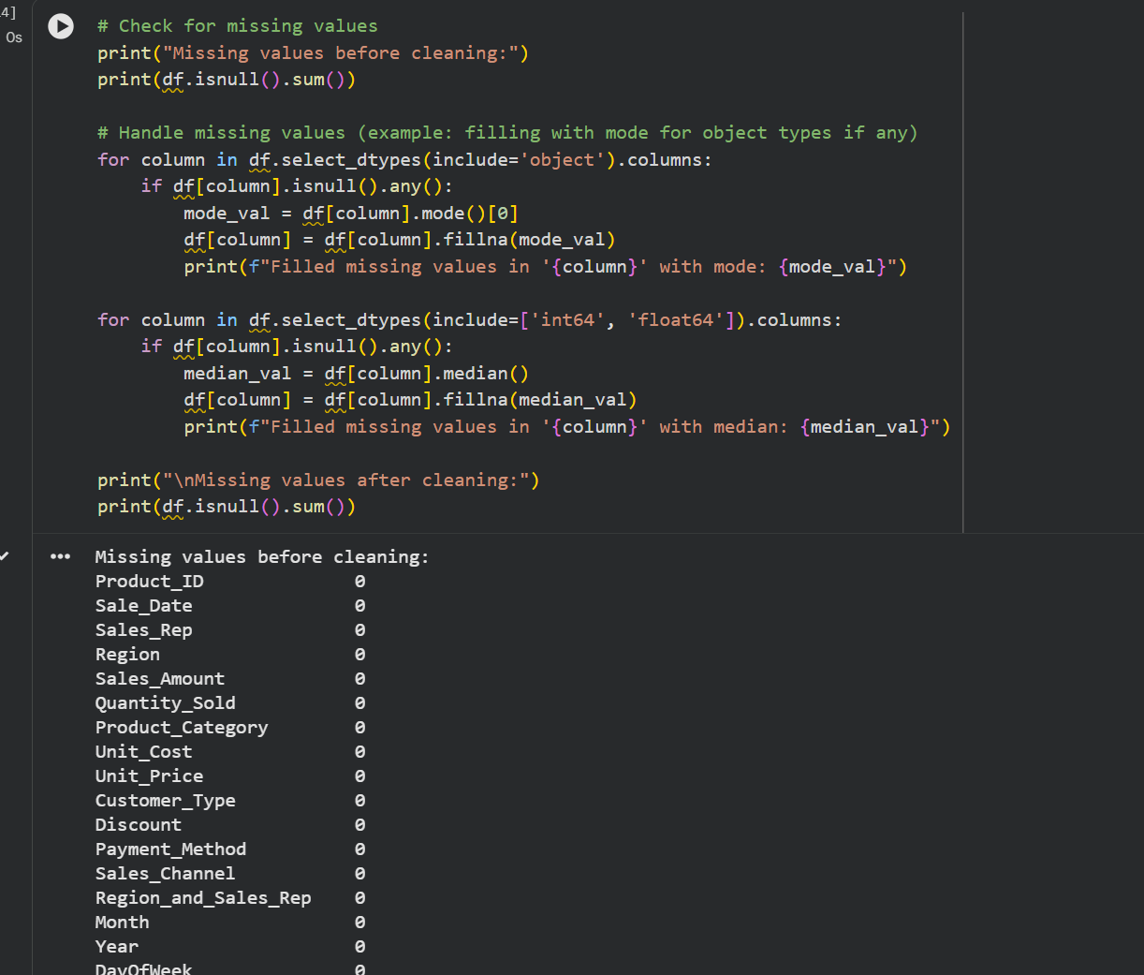

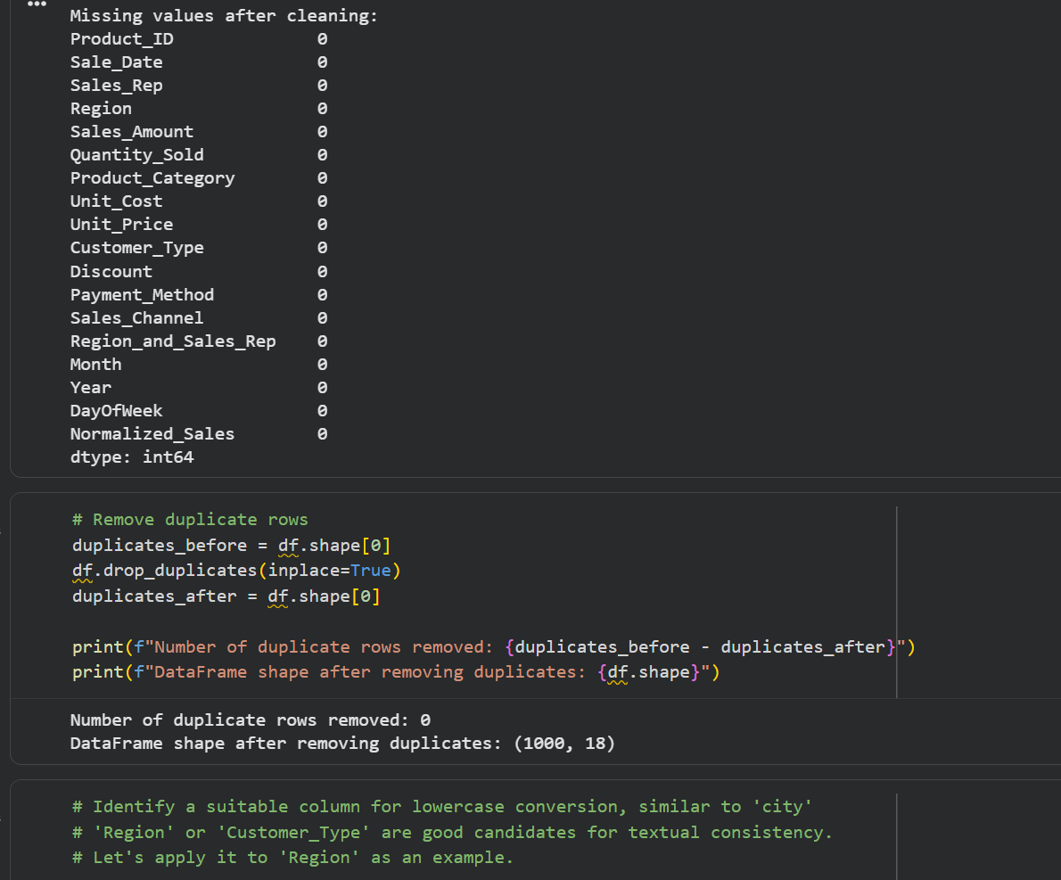

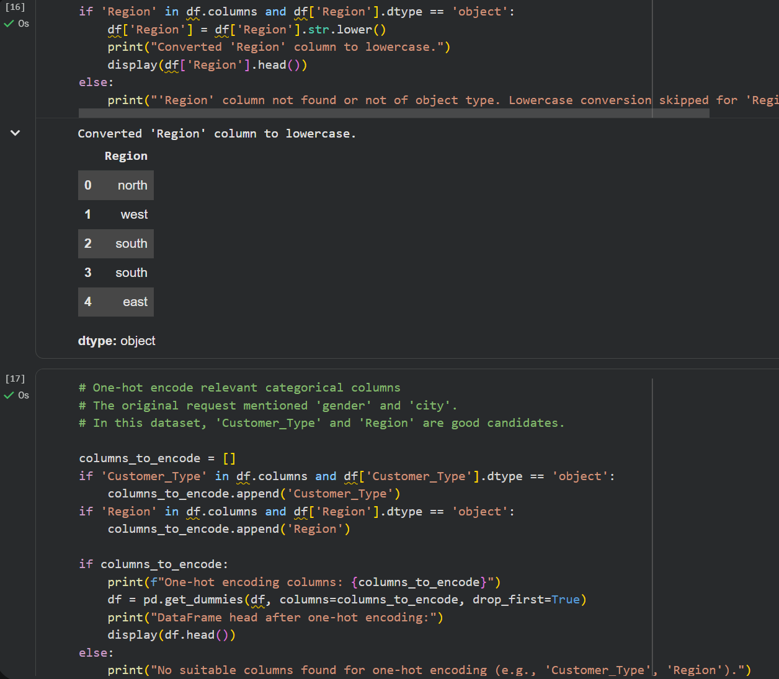

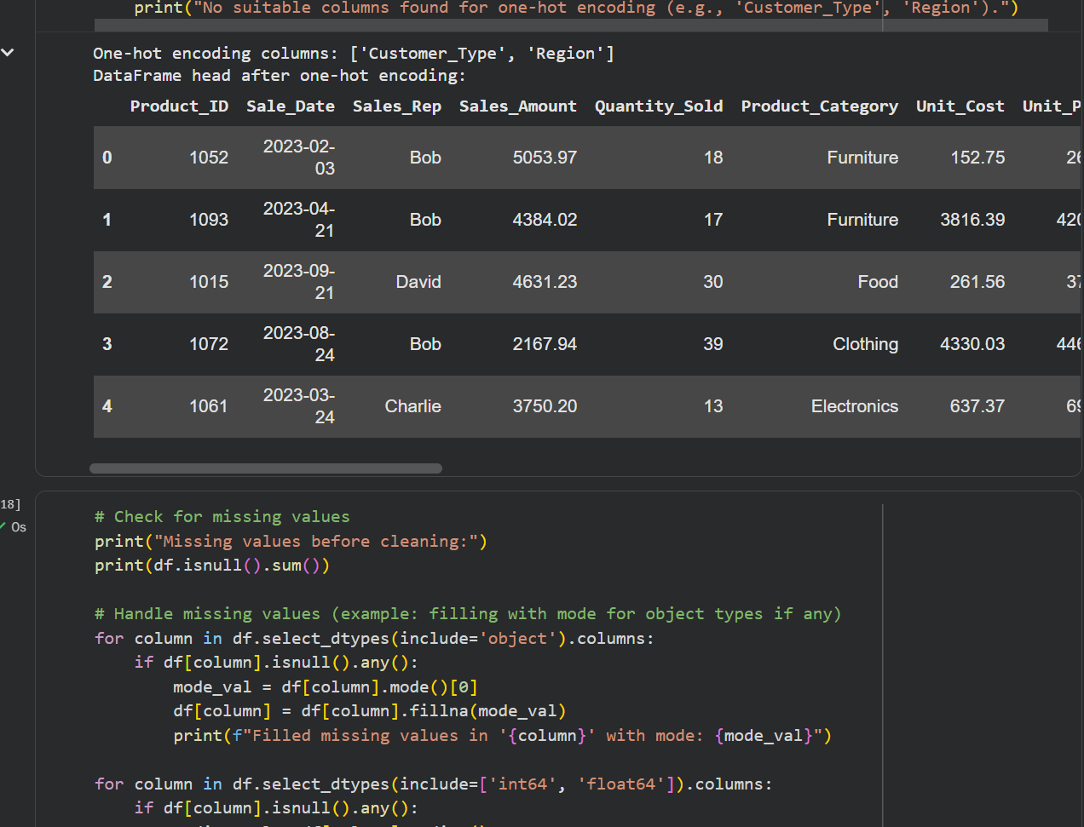

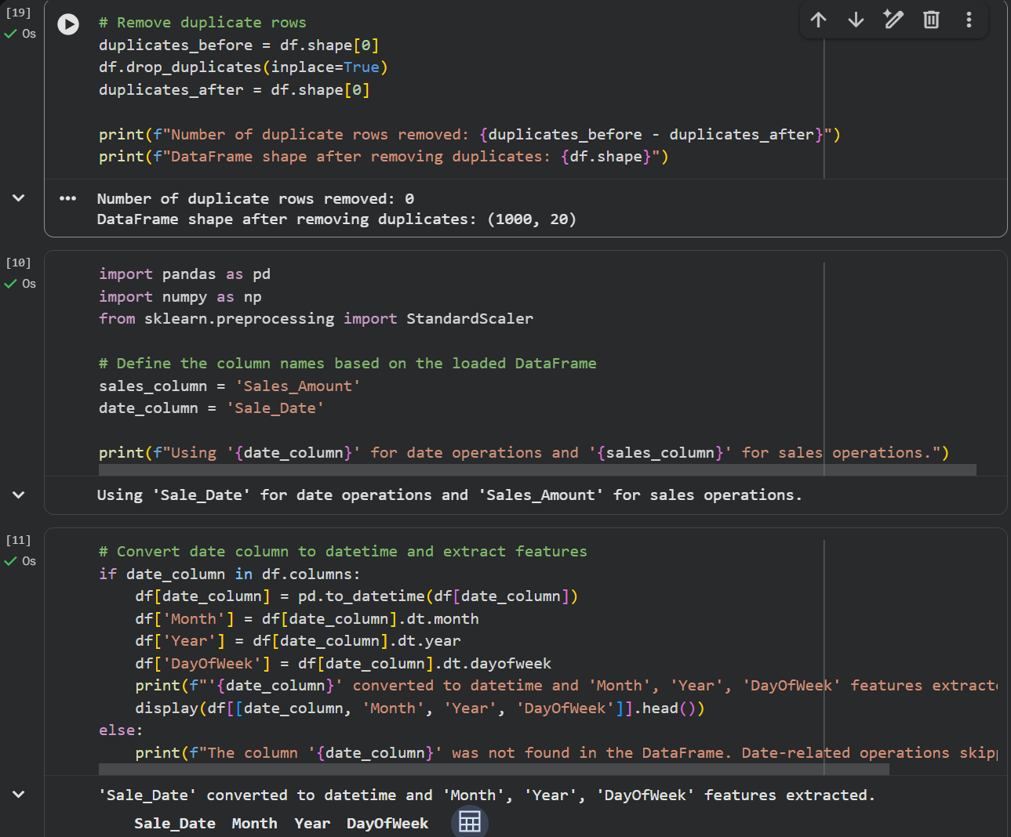

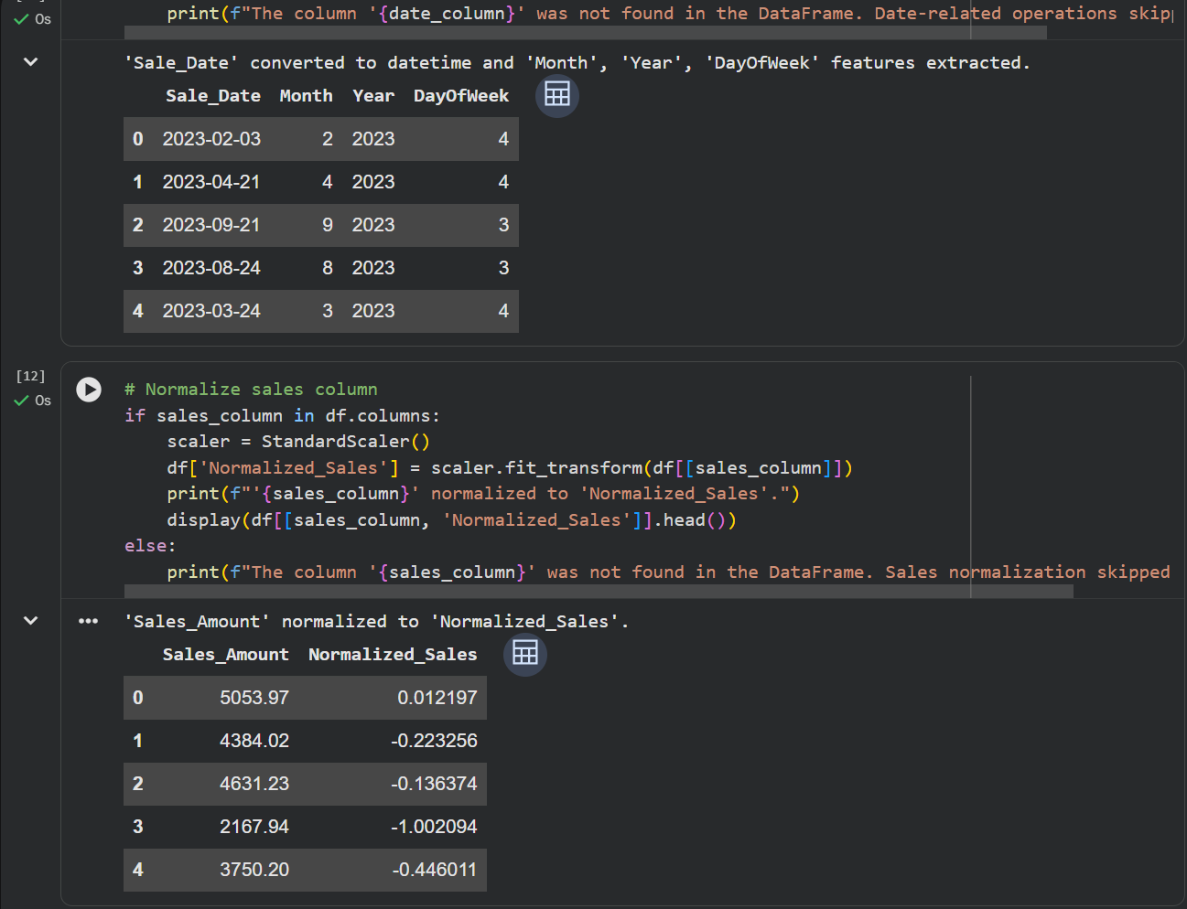
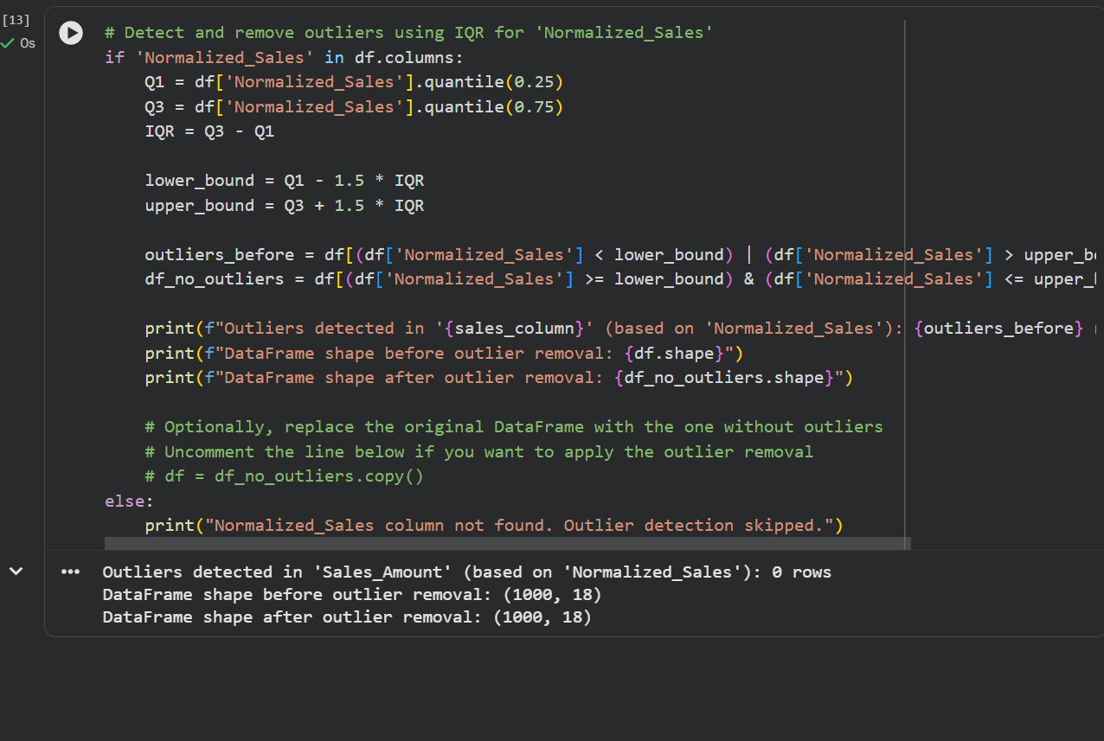

Task 3 – Healthcare Data Preparation

Prompt:
Generate Python preprocessing script:
- Fill missing values in blood_pressure and cholesterol
- Encode categorical columns
- Apply standard scaling
- Split dataset into train and test

Output:

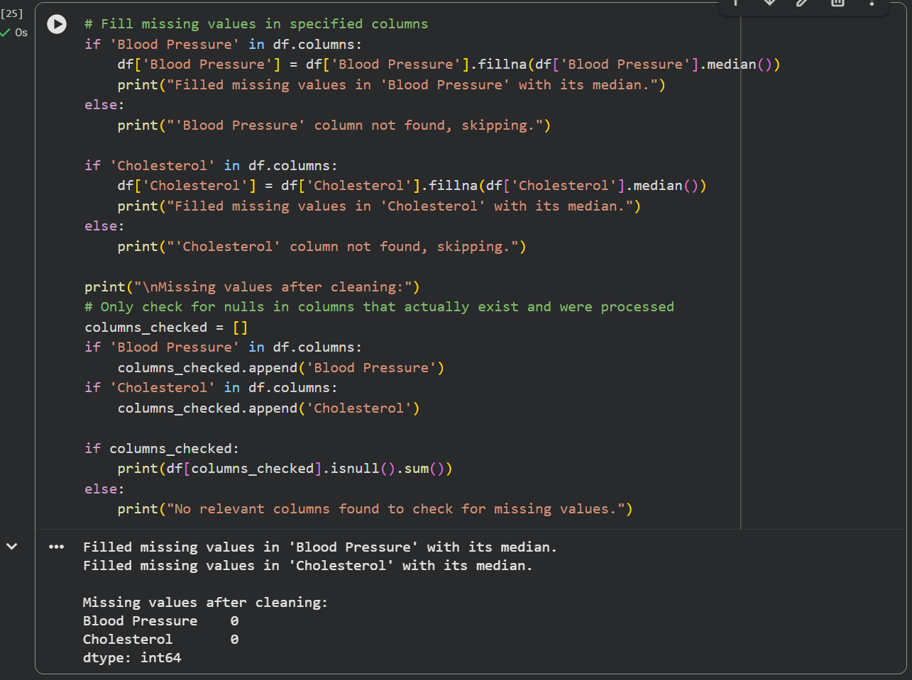

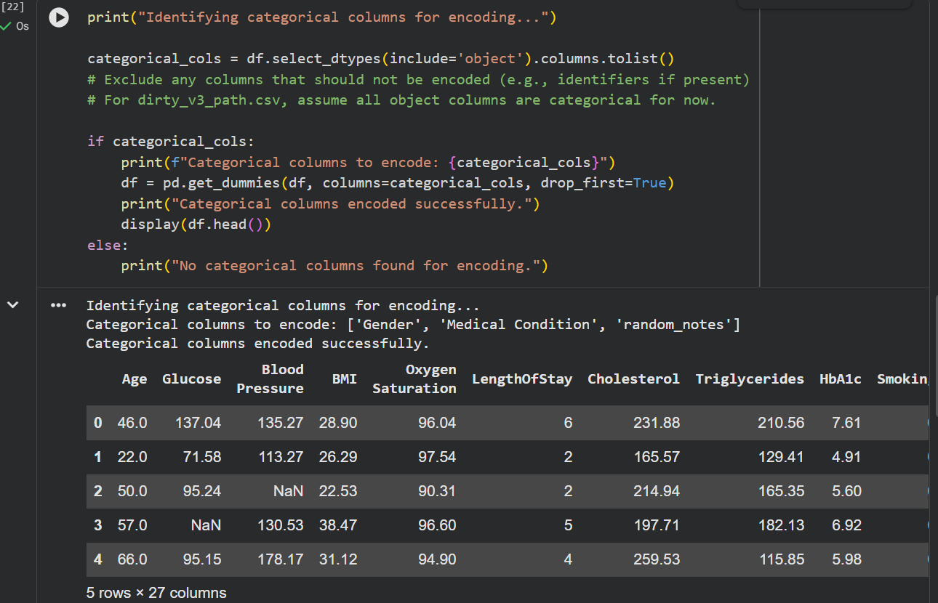
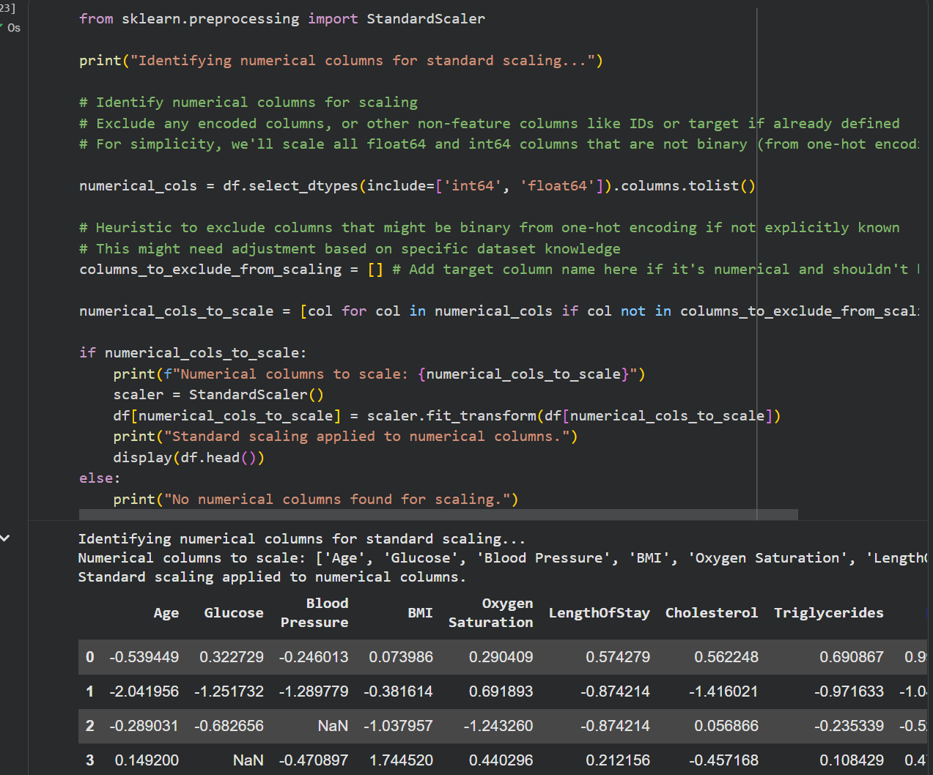

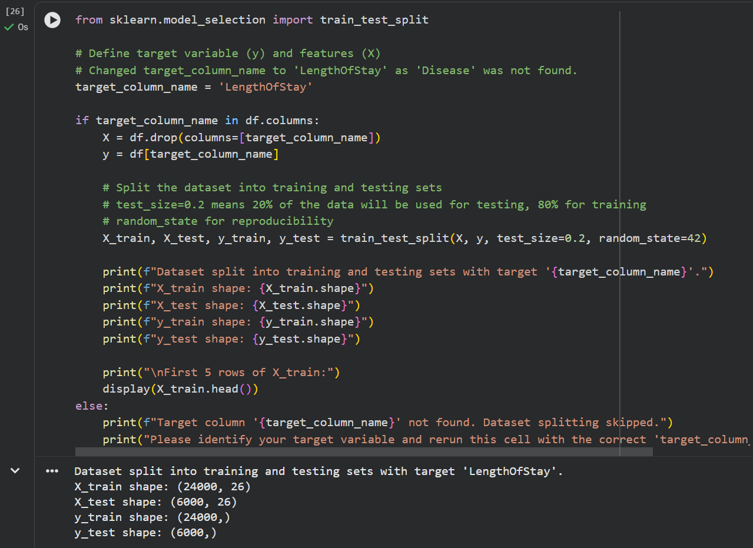

Task 4 – Employee Salary Data Preprocessing

Prompt:
Write Python code to:
- Handle missing values
- Remove salary outliers
- Convert department to lowercase
- Apply label encoding to department and job location

Output:
