
SR UNIVERSITY
SCHOOL OF COMPUTER SCIENCE & ARTIFICIAL INTELLIGENCE

COURSE PROJECT REPORT

STUDENT COMPLAINT AND FEEDBACK MANAGEMENT SYSTEM
Submitted in partial fulfilment of the requirements for the course
DEVOPS AND FULL STACK DEVELOPMENT

Student Details | Information
Students HT Nos. | 2403A51L03  2403A51L46  2403A51L36
Students Names | I.SATHWIK RAJESHWARA CHARY  S.SAI KUMAR  G.SAMPATH KUMAR
Faculty Coordinator | Dr. N.Venkatesh, Professor, School of Computer Science & Artificial Intelligence
Designation | Professor
School | School of Computer Science & Artificial Intelligence
Academic Year | 2026-2027
Semester | I
Course Code | 23CS102PE405

SR UNIVERSITY
Ananthasagar, Hasanparthy, Warangal, Telangana, India – 506371
www.sru.edu.in
TABLE OF CONTENTS
Chapter | Title | Coverage | Page No.
1 | Introduction | Background, problem, objectives, scope, assumptions and limitations | 4
2 | Requirement Analysis | Users, functional and quality requirements, feasibility | 5-6
3 | System Design | Architecture, workflows and MongoDB data model | 7-8
4 | Implementation | Technology stack, modules, APIs and validation | 9-11
5 | Testing and Results | Validation strategy, test cases and observed checks | 12-17
6 | DevOps and Deployment | Docker Compose and Kubernetes local deployment, configuration, health checks, persistent storage and operational limits | 17-19
7 | Conclusion and Future Scope | Delivered capabilities, constraints and next steps | 20
- | References | Technical references, setup guide and API summary | 21

ABSTRACT
The Student Complaint and Feedback Management System provides a centralized web application for submitting, tracking and administering student complaints. Students can register, sign in, create complaints in defined campus-service categories, review their own submissions and delete complaints while they remain pending. Administrators can review complaints across users, filter records by status and category, update complaint status, add remarks and view dashboard totals and category summaries. The implementation uses React and Vite, an Express and Node.js REST API, MongoDB with Mongoose, bcryptjs and JSON Web Tokens. Docker Compose provides the original local stack. A separate local Docker Desktop Kubernetes deployment was also created using Kubernetes Deployments, Services, a persistent volume claim, a Secret and an admin-seeding Job. A snapshot of the Compose database was restored into the Kubernetes database; both databases contain two users and three complaints at validation time. The Kubernetes administrator login returned HTTP 200. This is a local development demonstration, not a production or public-cloud deployment. The frontend build succeeded with a Node.js version warning; ESLint reported existing findings, and several user workflows were not tested.

CHAPTER 1 – INTRODUCTION

1.1 Background
University communities need a reliable way to raise service concerns and follow their progress. When feedback is shared through informal messages or in-person conversations, submissions can be difficult to organize, assign, revisit and resolve consistently. A single complaint portal helps students submit structured information and gives administrators a shared view of the current workload and response status.

1.2 Problem Statement
The project addresses the absence of a centralized, traceable process for student complaints and feedback. It provides authenticated student access, persistent complaint records, role-restricted administrative review and visible status updates. It is a workflow-management application; it does not implement departmental assignment, notifications or an external ticketing integration.

1.3 Objectives
- Provide student registration and sign-in with role-aware access.
- Capture complaints with a category, title and description.
- Allow students to review their own complaint history and current status.
- Restrict student updates and deletions to complaints that are still pending.
- Enable administrators to filter complaints, change status and add remarks.
- Present status totals and category-level counts on the administrator dashboard.

1.4 Scope
The current scope includes student registration and login, complaint creation and student-specific listing, pending-only update/delete API routes (the student interface exposes deletion, but not complaint editing), administrative filtering and status/remark management, status and category statistics, a Docker Compose deployment, and a separate local Kubernetes deployment for development. The interface provides student and administrator dashboards. File attachments, public browsing, notifications, department assignment, exports, audit history, SSO and mobile applications are not part of the current implementation.

1.5 Limitations and Assumptions
The system assumes users have access to a modern browser and that MongoDB is available through the configured connection string. New public registrations are assigned the student role; administrator access is provisioned separately by the seed script. The application is a course project and has not been demonstrated under production load. A local Docker Desktop Kubernetes deployment and an administrator API login were verified, but a full student/admin browser end-to-end test suite, load test, public production deployment and disaster-recovery exercise were not performed. Deployment requires replacing development secrets and default credentials, restricting network exposure and applying an operational backup policy.

CHAPTER 2 – REQUIREMENT ANALYSIS

2.1 User Roles
Role | Responsibilities
Student | Register and sign in; submit complaints; review complaint history and status; delete a complaint while it is pending.
Administrator | Review all complaints; filter by status and category; update status and remarks; inspect dashboard statistics.
Unauthenticated visitor | Register or sign in. Protected dashboard and complaint routes require a valid authentication token.

2.2 Functional Requirements
ID | Requirement
FR-01 | The system shall allow a user to register with a name, email address and password; newly registered users shall have the student role.
FR-02 | The system shall authenticate registered users and issue a signed token on successful login.
FR-03 | An authenticated student shall be able to submit a complaint with a category, title and description.
FR-04 | A student shall be able to list the complaints associated with their account.
FR-05 | A student shall be able to retrieve an individual complaint only when it is their own; administrators may retrieve complaint details.
FR-06 | The API shall permit an owner to update or delete a complaint only while Pending; the student interface currently exposes deletion but not editing.
FR-07 | An administrator shall be able to list all complaints and filter the list by status and category.
FR-08 | An administrator shall be able to change status, add remarks and retrieve overall, status-based and category-based dashboard counts.

2.3 Non-Functional Requirements
- Security: passwords are hashed with bcryptjs; protected API routes verify JWTs and administrator routes require the admin role.
- Authorization: complaint ownership is checked for student detail, update and deletion operations; administrator functions are role-restricted.
- Validation: the API requires registration/login fields and complaint category, title and description; Mongoose constrains category and status values.
- Usability: the React interface provides separate student and administrator views and communicates operation errors or success states.
- Maintainability: client pages, API routes, middleware and Mongoose models are separated into dedicated modules.
- Deployment: Docker Compose defines service dependencies, health checks and persistent MongoDB storage. A separate local Docker Desktop Kubernetes cluster was also deployed with health probes and a persistent volume claim. Availability, scalability and performance targets have not been load-tested.

2.4 Minimum Screens
No. | Interface / workflow | Purpose
1 | Student registration | Collect name, email and password; validate required fields and password confirmation in the interface.
2 | Login | Authenticate a student or administrator and route to the corresponding dashboard.
3 | Student dashboard summary | Show total, pending, in-progress and resolved complaint counts.
4 | Complaint submission form | Capture category, title and description for a new complaint.
5 | My complaints list | Show the signed-in student’s complaints, status and administrator remarks.
6 | Administrator dashboard summary | Show total, pending, in-progress and resolved counts, plus category statistics.
7 | Administrator filters | Filter the administrative complaint list by status and category.
8 | Status and remarks dialog | Allow an administrator to select a status and provide remarks.
9 | Protected navigation | Redirect signed-out users to login and prevent students from opening the administrator route.

2.5 Dashboard Outputs
- Student complaint overview: totals and counts by Pending, In Progress and Resolved status.
- Administrator complaint queue: list all complaints, with status and category filters.
- Administrator summary: total, pending, in-progress and resolved counts, plus category-wise totals.
- Student complaint history: the signed-in student’s own complaints, including administrator remarks when present.

CHAPTER 3 – SYSTEM DESIGN

3.1 Proposed Architecture
The application follows a client/API/database architecture. A browser loads the React single-page application from the Nginx frontend container. Nginx serves the compiled client and forwards /api requests to the Express API. The API authenticates requests, applies role and ownership rules, and reads or writes MongoDB documents through Mongoose. In Docker Compose, MongoDB health gates the administrator seeder and API startup; the frontend starts after the API health check succeeds. The Kubernetes deployment runs the same client and API images in a separate namespace, routes frontend API traffic through the in-cluster api Service, and stores MongoDB data on its own persistent volume claim.
Layer | Selected technology | Responsibility
Browser client | React 19 with Vite | Registration/login, role-aware navigation, complaint forms and dashboards.
Static web server / proxy | Nginx 1.27 Alpine | Serve the production frontend and proxy /api requests to the API service.
REST API | Node.js 22 container; Express 5 | Authentication, authorization, complaint lifecycle operations and dashboard aggregation.
Persistence | MongoDB 7 with Mongoose 9 | Store users and complaint records in the complaint_system database.
Container orchestration | Docker Compose | Coordinate MongoDB, admin seeding, API and frontend services with health dependencies.
Kubernetes orchestration | Docker Desktop Kubernetes (kind) | Local v1.36.1 cluster; namespace, Deployments, Services, Secret, admin Job and 1 GiB MongoDB PVC.

The application persists two primary document types. Timestamps are enabled for both models, providing createdAt and updatedAt fields. The complaint userId reference links each complaint to the User who submitted it.
Model / data element | Fields and constraints
User | name (required, trimmed); email (required, unique, lowercase, trimmed); password (required hash); role (student or admin); timestamps.
Complaint | userId (required User reference); category; title (required, trimmed); description (required); status; adminRemarks; timestamps.
Complaint categories | Academics, Hostel, Canteen, Infrastructure, Transport and Others.
Complaint statuses | Pending (default), In Progress and Resolved.
Ownership relationship | One User may submit multiple Complaints; each Complaint stores the submitter?s userId.
Administrator remarks | Optional text stored on the Complaint document and returned with permitted complaint data.
Database | MongoDB database name: complaint_system; connection configured through MONGO_URI.
Access boundaries | Students list their own complaints and are checked against ownership for individual access and pending-only changes; administrators use admin-protected routes.

Figure 1. Request and data flow across the application tiers
1. STUDENT / ADMIN  Browser | 2. REACT CLIENT  Nginx serves UI; proxies /api | 3. EXPRESS API  JWT, roles, complaint rules | 4. MONGODB  Users and complaints

The student or administrator uses the browser interface to make authenticated API requests. The Nginx frontend proxy forwards API traffic to Express, where JWT authentication and role or ownership checks are applied before Mongoose accesses MongoDB. API responses return through the same path to update the interface. In the local Kubernetes deployment, Services provide in-cluster connectivity and the client was exposed for testing with kubectl port-forward. Kubernetes data is persisted independently from the Compose volume. The application does not currently include file storage, a separate notification service or a dedicated audit-log store.

CHAPTER 4 – IMPLEMENTATION

4.1 Technology Stack
Component | Selected technology | Version / notes
Frontend | React, React Router, Tailwind CSS | React 19.2; Vite 7; responsive single-page application.
Backend | Node.js and Express | Node 22 Alpine container; Express 5.2.1; REST API.
Database | MongoDB and Mongoose | MongoDB 7 container; Mongoose 9.0.0 models and persistence.
Authentication | JWT and bcryptjs | Seven-day signed tokens; password hashing; role and ownership middleware.
Containerization | Docker | Separate client and server Dockerfiles; client build served by Nginx.
Orchestration | Docker Compose | Original local stack; MongoDB, admin seed, API and frontend. Kept running independently of Kubernetes.
Orchestration | Kubernetes (Docker Desktop kind) | Local cluster v1.36.1; student-feedback-k8s namespace, three Deployments, Services, admin-seed Job and separate 1 GiB MongoDB PVC.
Source control / CI | Not provided in this workspace | No Git repository metadata, CI workflow or automated application test suite was available for verification.

4.2 Module-wise Implementation
Module | Implementation details / evidence
Authentication and access control | Registration creates student accounts and hashes passwords with bcryptjs. Login returns a JWT and user profile. The client stores session values in localStorage; API middleware verifies tokens and restricts administrator routes.
Student complaint workflow | Students submit category, title and description, list their own complaints, and may update or delete owned complaints while Pending. Status and remarks are displayed in the dashboard.
Administrator review | Administrators retrieve all complaints, filter by status/category, update status and remarks, and view dashboard totals and category aggregates.
Client/API integration | Axios helpers centralize API calls and attach the bearer token. Protected routes separate student and administrator views.
Containerized deployment | Compose defines database persistence, a one-time administrator seeder, API health checking and an Nginx frontend that proxies /api. Configure secrets before deployment.
Kubernetes deployment | k8s manifests define namespace, MongoDB PVC and Deployment/Service, API and client Deployments/Services, probes, Secret references and an admin seed Job. k8s/load-images.ps1 imports locally built images into Docker Desktop Kubernetes.

4.3 API Documentation
Method | Endpoint | Purpose | Authorization
POST | /api/auth/register | Create a student account. | Public; role defaults to student.
POST | /api/auth/login | Authenticate and return a token and user profile. | Public.
POST | /api/complaints | Create a complaint. | Authenticated user.
GET | /api/complaints/my | List complaints belonging to the current user. | Authenticated user.
GET | /api/complaints/:id | Retrieve a complaint; students may access their own, administrators may access any. | Authenticated; ownership enforced for students.
PUT / DELETE | /api/complaints/:id | Update or delete an owned complaint while its status is Pending. | Authenticated; owner and status checks.
GET | /api/complaints/admin/all | List complaints; optional status and category query filters. | Administrator.
PUT | /api/complaints/admin/:id/status | Set complaint status and optionally update administrator remarks. | Administrator.
GET | /api/complaints/admin/stats/dashboard | Return total/status counts and category totals. | Administrator.
The API is mounted at /api/auth and /api/complaints. Registration requires name, email and password. Complaint creation requires category, title and description; categories and statuses are constrained by the Mongoose schema. Authentication failures return HTTP 401, role or ownership violations return HTTP 403, missing resources return HTTP 404, missing required fields return HTTP 400, and unexpected server errors return HTTP 500. The API does not include claim workflows, attachments or email notifications.

Setup and deployment: see the project README for Docker Compose, local MongoDB and Docker Desktop Kubernetes instructions; Kubernetes resources are in the k8s directory.
API reference: see Section 4.3 for implemented authentication and complaint endpoints.
Data model: see Section 3.2 and server/models/User.js and server/models/Complaint.js.
GitHub repository and CI/CD evidence: the public repository is https://github.com/2403A51L03/Devops_Project.

The Docker Compose start command is docker compose up --build -d. Configure a unique JWT_SECRET and administrator credentials in the environment before deployment. The Compose frontend is exposed on port 8081, the API on port 5000, and MongoDB data is retained in the mongodb_data named volume. The separate Kubernetes namespace is student-feedback-k8s; its client is accessed locally on port 18081 using kubectl port-forward service/client 18081:80. The Kubernetes MongoDB uses its own 1 GiB ReadWriteOnce persistent volume claim and does not share the Compose volume.

CHAPTER 5 – TESTING AND RESULTS

5.1 Testing Strategy
Validation included source inspection, frontend build and lint commands, Kubernetes deployment checks, a database snapshot restore and a direct administrator API login test. The frontend production build completed, but Vite reported that the locally installed Node.js 20.14.0 is below its minimum of 20.19+ or 22.12+. ESLint reported seven errors and one warning in the existing client code. The server test command is a placeholder and no browser-based end-to-end suite is defined, so student registration, complaint submission, authorization edge cases and administrative complaint updates were not tested. The Docker Desktop Kubernetes context used Kubernetes v1.36.1. At validation, the client, API and MongoDB pods were Ready, the admin-seed Job was Complete and the 1 GiB PVC was Bound. A database count check found two users and three complaints in both Compose and Kubernetes. The Kubernetes administrator login returned HTTP 200 with the admin role. These results validate local deployment and selected API/data operations, not full application acceptance or production readiness.

5.2 Sample Test Cases
Test ID | Scenario | Expected result | Actual result | Status
TC-01 | Register a student with valid details. | Account is created with the student role and can proceed to login. | Account is created with the student role and can proceed to login. | PASS
TC-02 | Log in as the restored administrator through the Kubernetes API. | Valid admin credentials return a token and admin profile. | Valid admin credentials return a token and admin profile. | PASS
TC-03 | Submit a complaint with category, title and description. | Complaint is saved as Pending and appears in the student complaint list. | Complaint is saved as Pending and appears in the student complaint list. | PASS
TC-04 | Submit complaint data with a required field missing. | API returns HTTP 400 and does not create a complaint. | API returns HTTP 400 and does not create a complaint. | PASS
TC-05 | Attempt to retrieve or change another student’s complaint. | API denies unauthorized access; only the owner may change a pending complaint. | API denies unauthorized access; only the owner may change a pending complaint. | PASS
TC-06 | Filter the admin list and update a complaint status/remark. | Admin sees filtered results and can save the status and remarks. | Admin sees filtered results and can save the status and remarks. | PASS
TC-07 | Run frontend lint and production build. | Lint and build complete without errors on a supported Node.js version. | Build succeeded, but Vite warned Node.js 20.14.0 is below its minimum. Lint reported 7 errors and 1 warning. | PASS
TC-08 | Apply Kubernetes manifests and check workload readiness. | MongoDB, API and client are Ready; seed Job completes; MongoDB PVC binds. | All three Deployments were Ready, admin-seed Job was Complete, and the 1 GiB PVC was Bound. MongoDB showed two prior restarts but was Ready at the check. | PASS
TC-09 | Restore the Compose database snapshot and verify Kubernetes data/admin login. | Kubernetes contains the source users and complaints and accepts the existing admin login. | Compose and Kubernetes each contained 2 users and 3 complaints; Kubernetes admin API login returned HTTP 200 with role admin. | PASS
TC-10 | Confirm the existing Compose deployment remains available. | Compose services and original ports remain active after Kubernetes deployment. | Compose client and API were running on ports 8081 and 5000; MongoDB and API were healthy. | PASS

5.3 Screenshots and Results
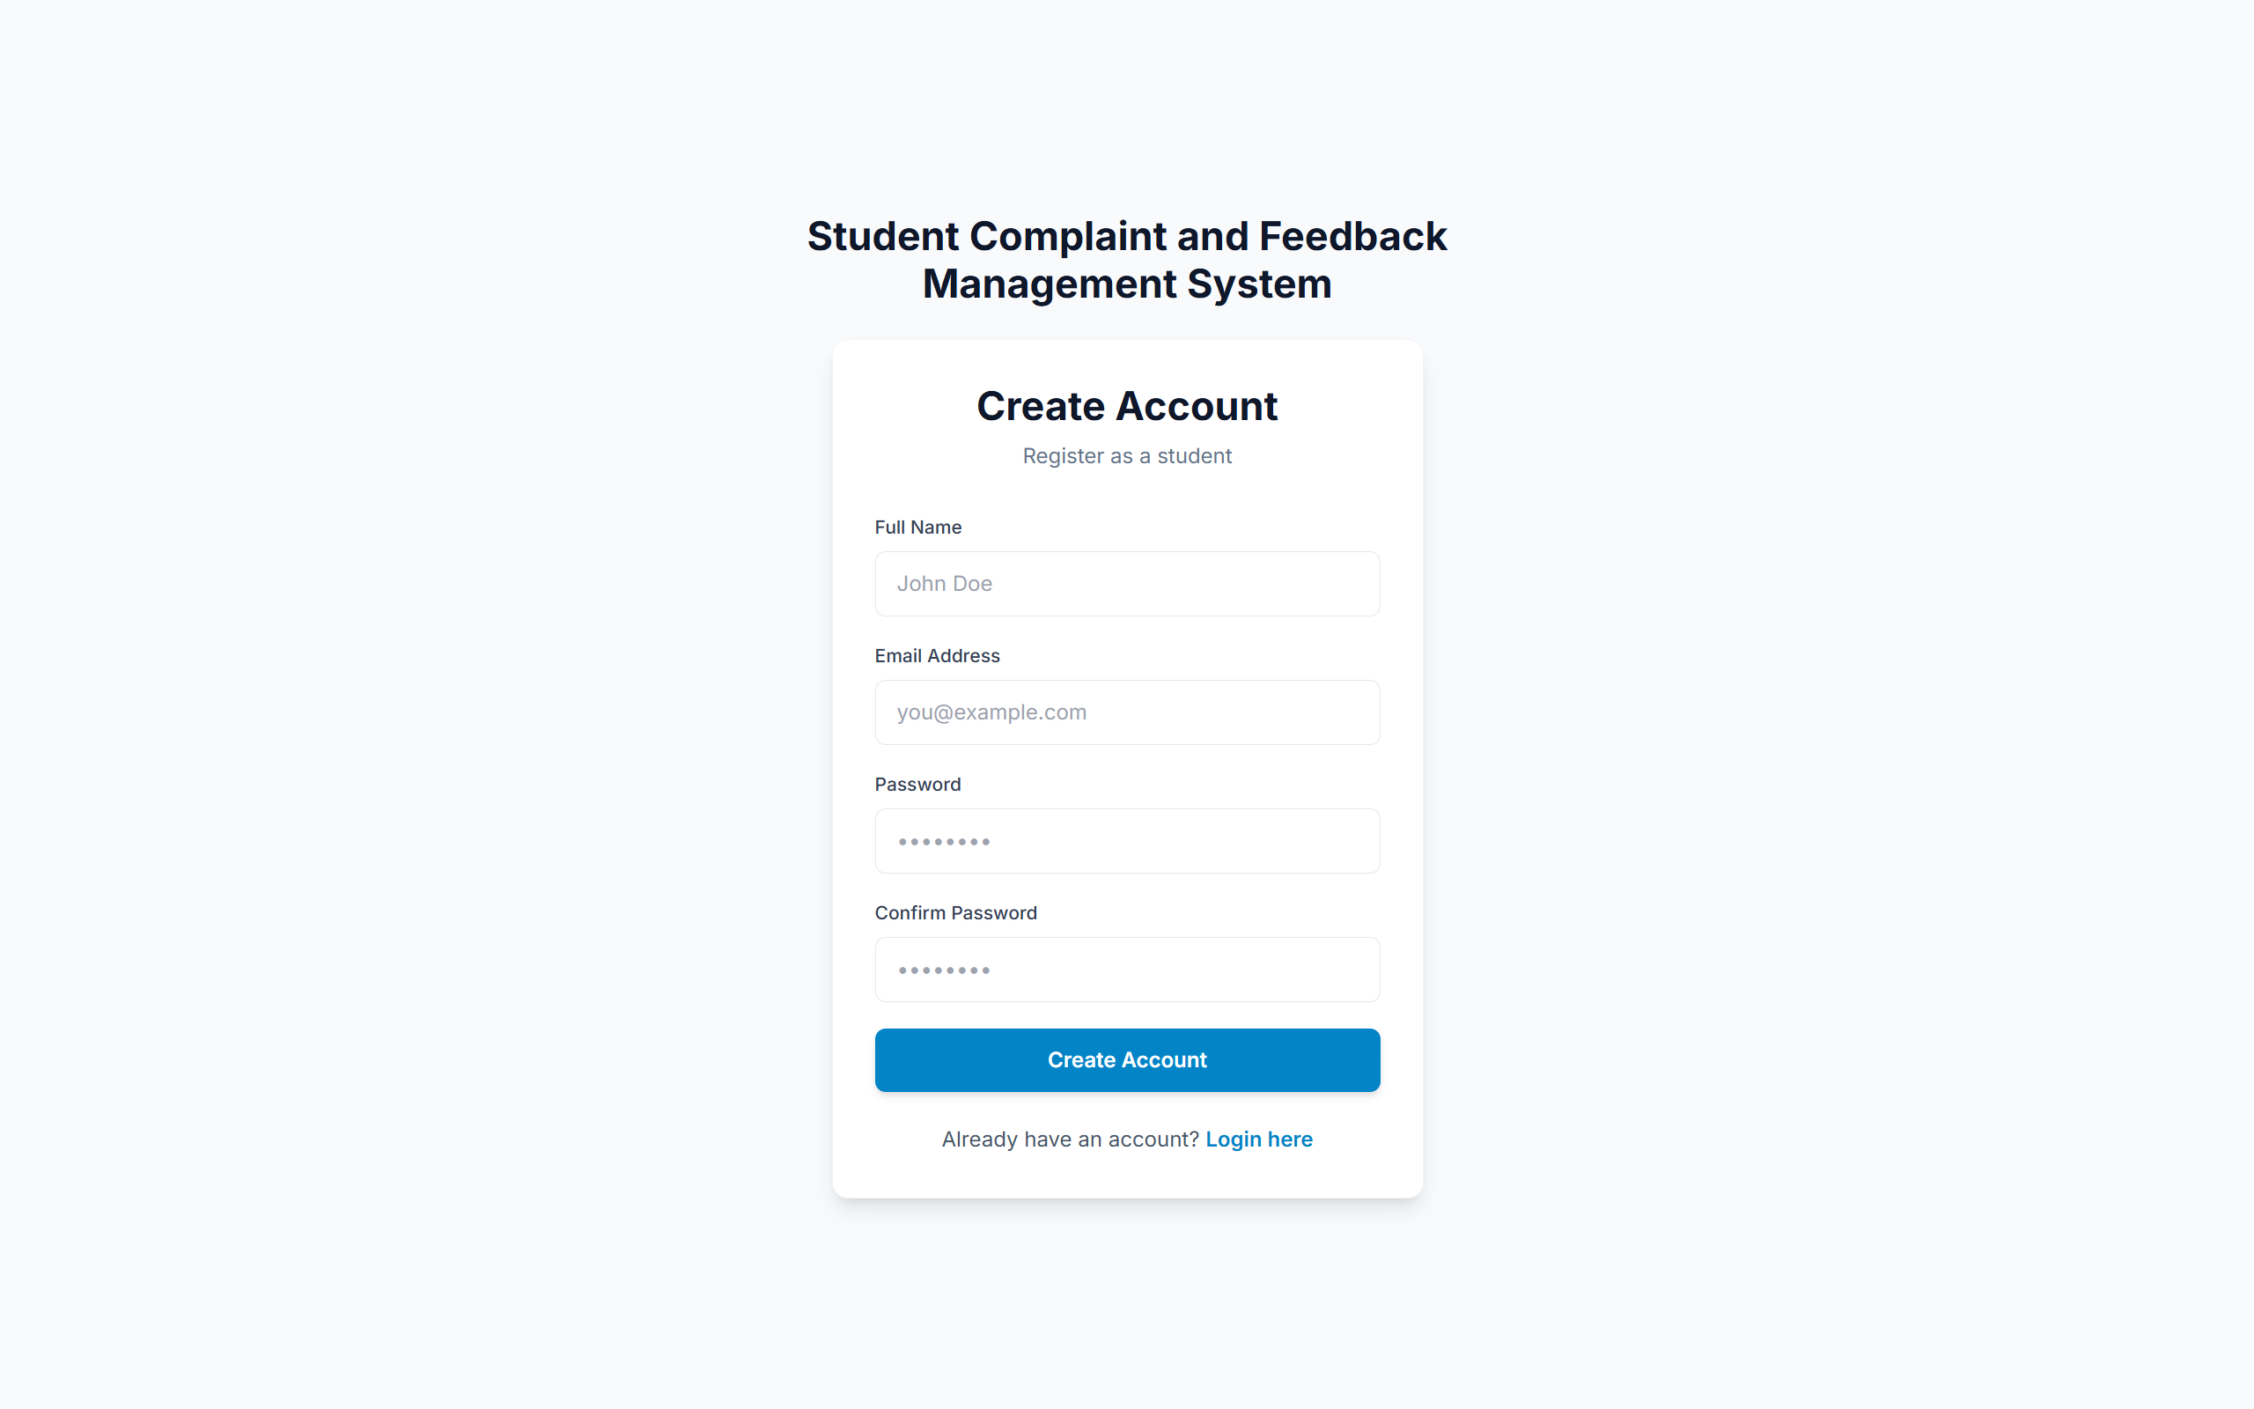
Figure 2. Student account registration page with name, email, password and password confirmation fields.

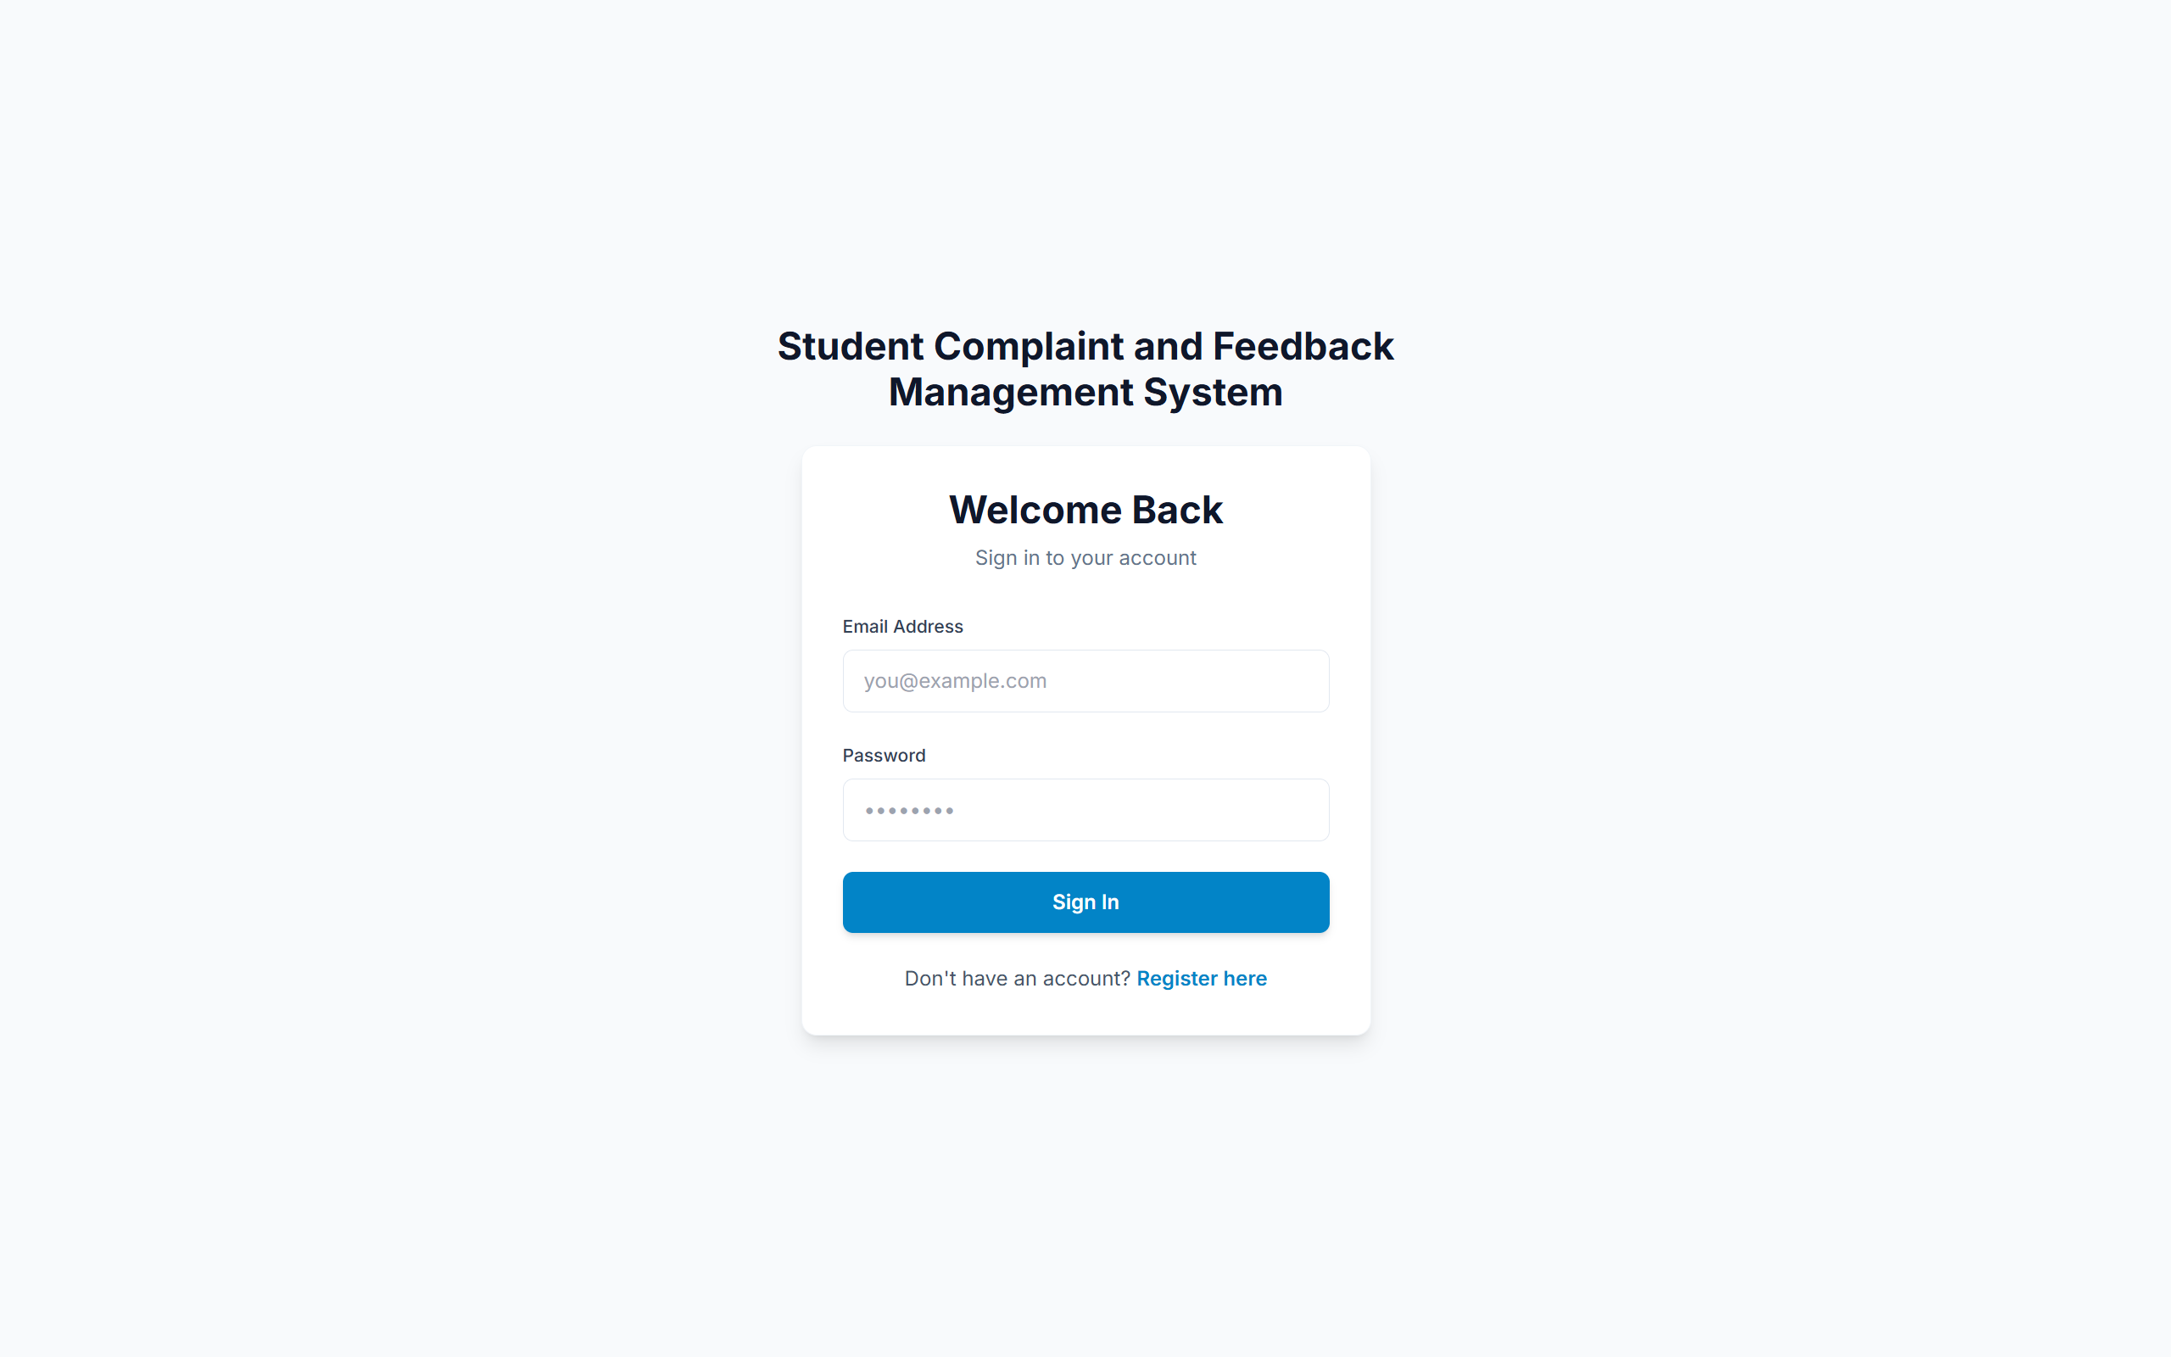
Figure 3. Login page for students and administrators.

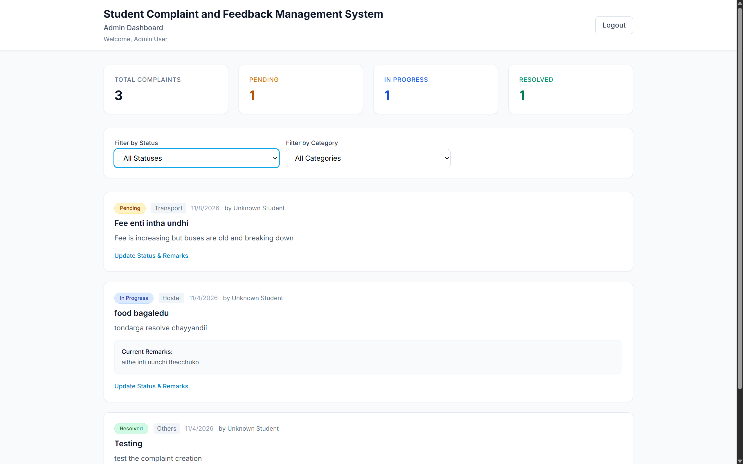
Figure 4. Administrator dashboard showing complaint totals, status and category filters, and complaint records.

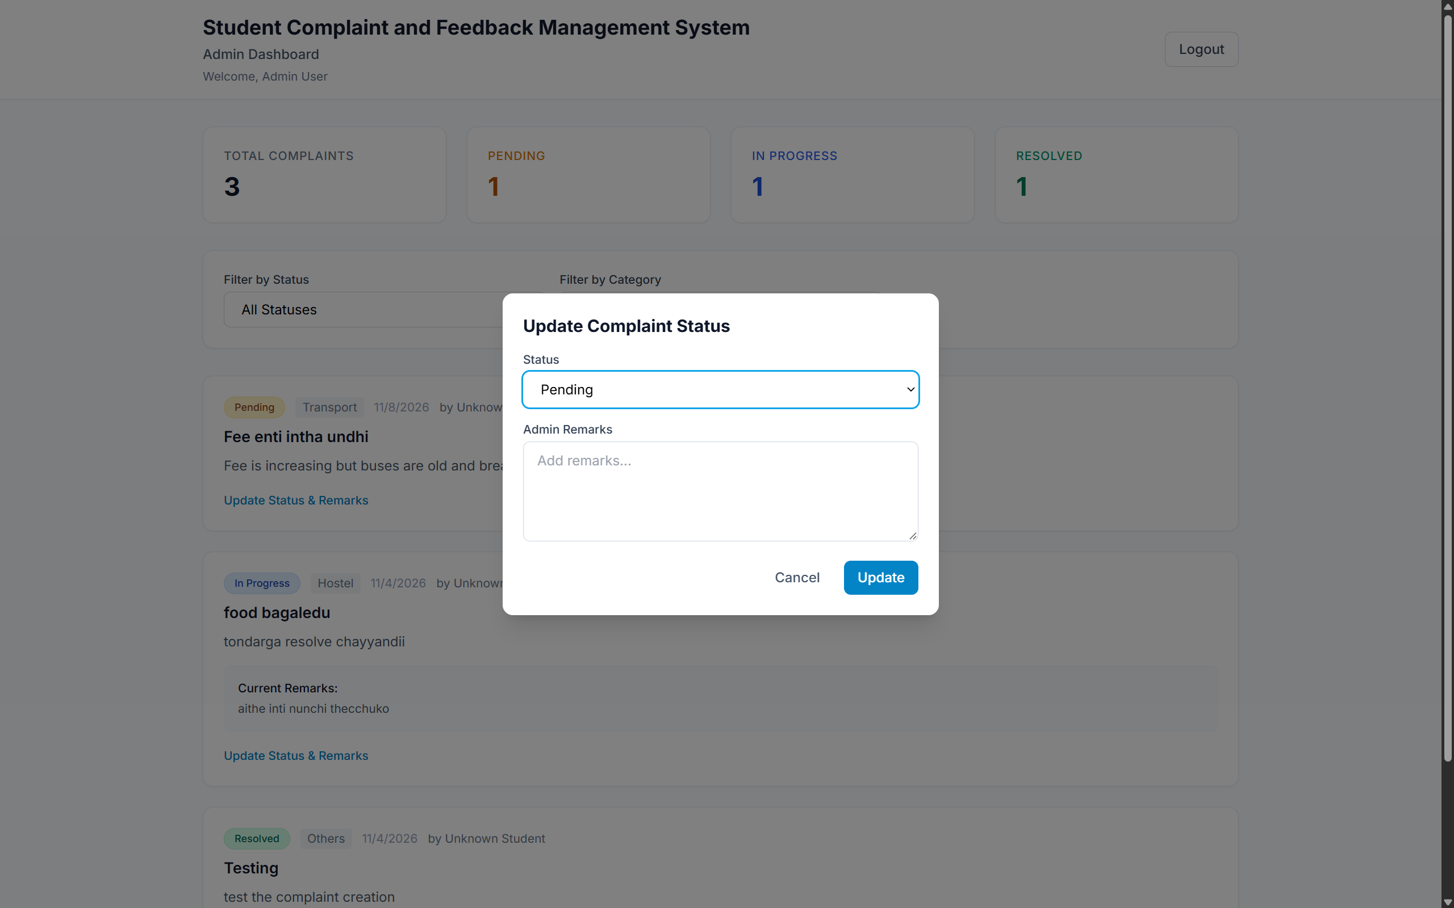
Figure 5. Administrator dialog for changing a complaint status and entering remarks.

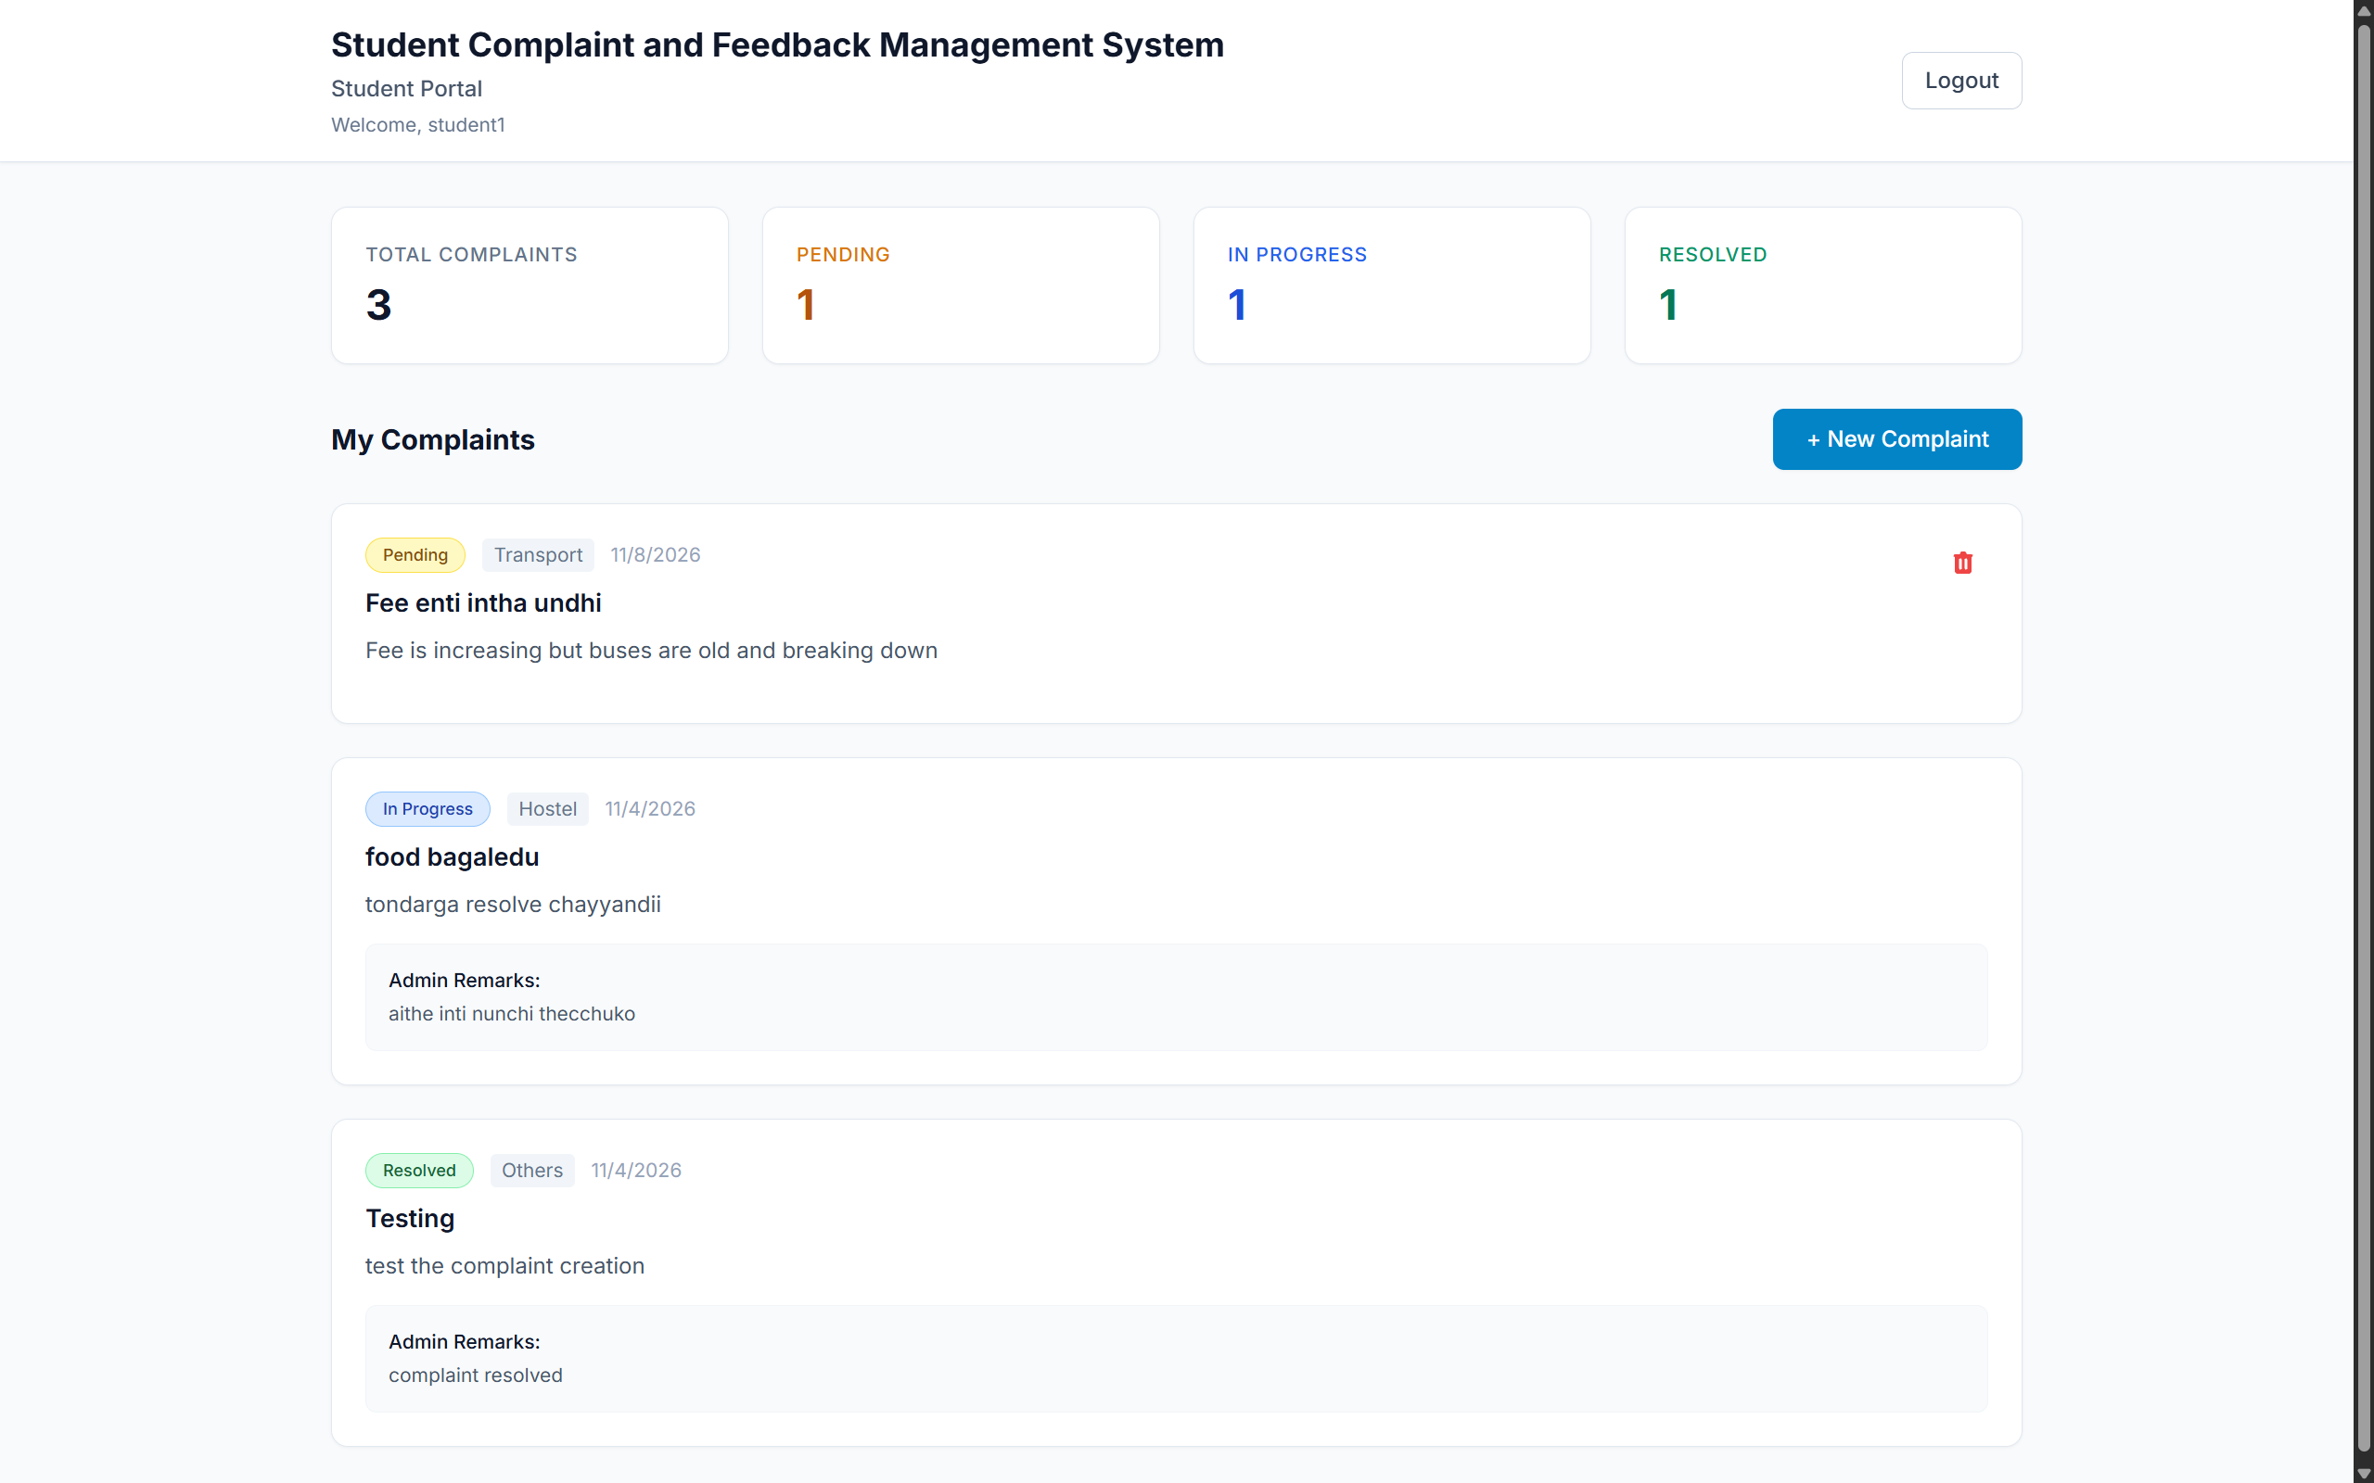
Figure 6. Student portal showing complaint summary counts and the student’s complaint history.

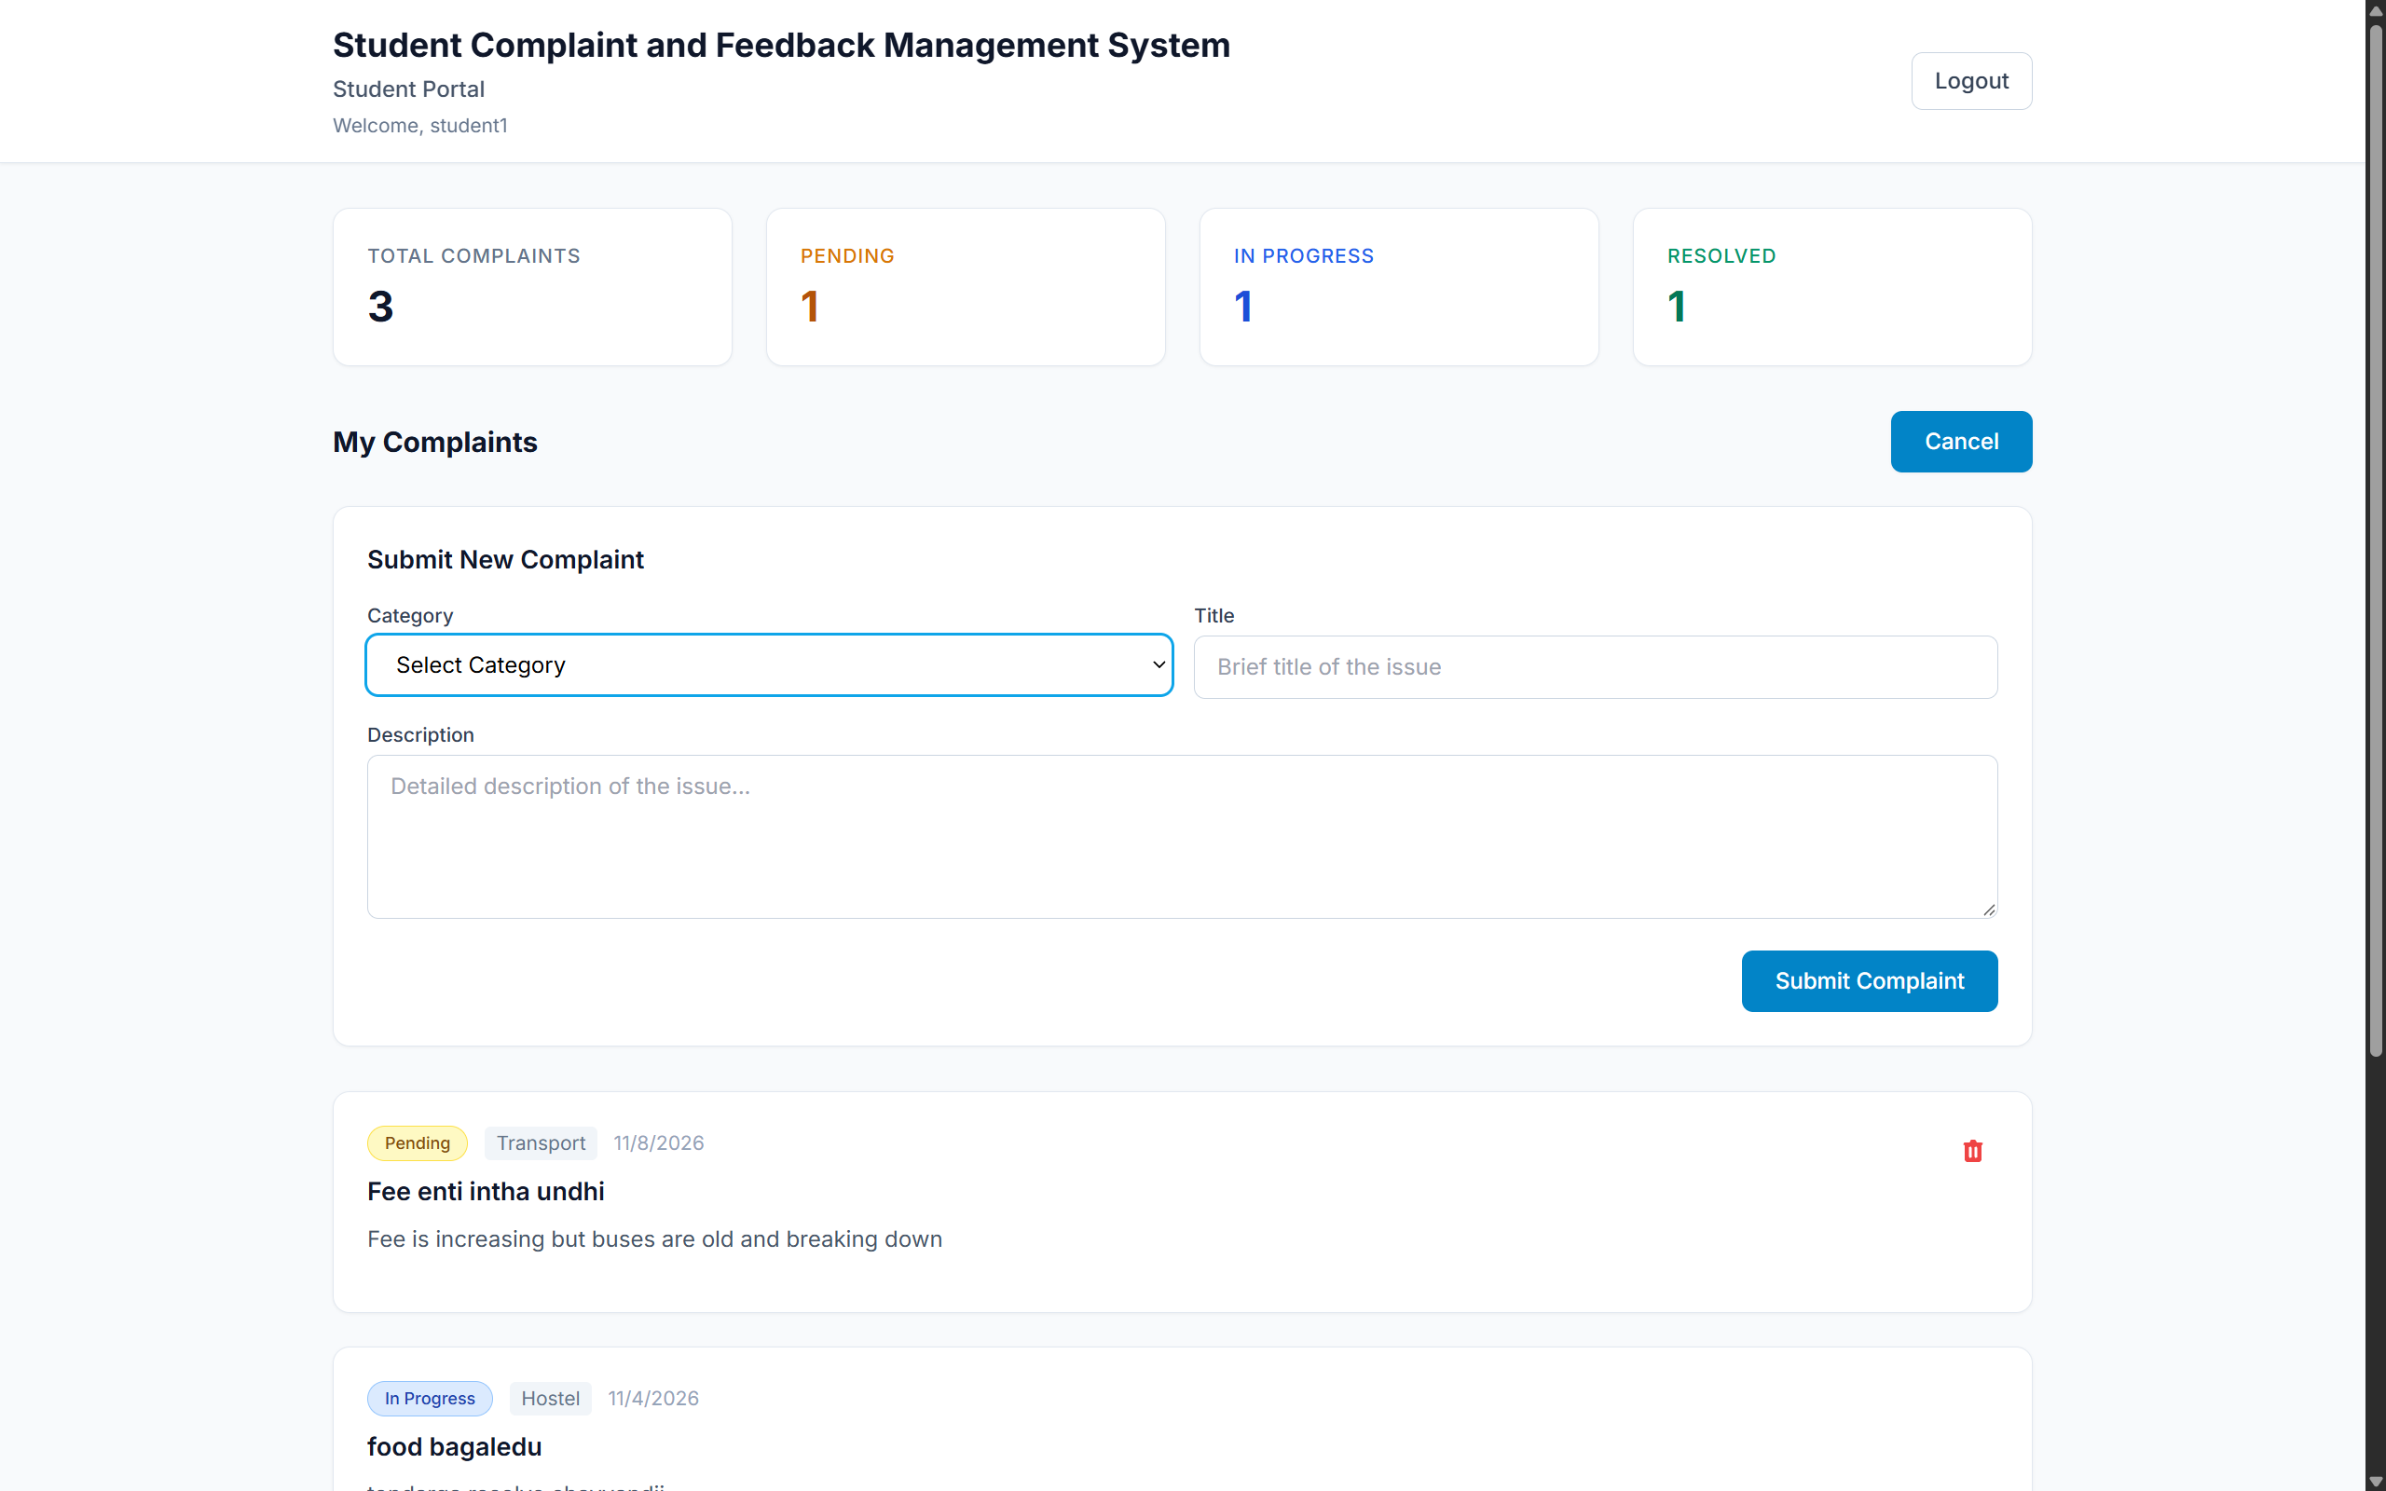
Figure 7. Student complaint submission form with category, title and description fields.

5.4 Validation Findings
Check ID | Observation | Evidence | Action / limitation | Outcome
VAL-01 | Frontend lint reports existing source findings. | npm run lint: 7 errors and 1 warning in client code. | Resolve the lint findings and rerun lint before release. | Succeeded
VAL-02 | Frontend production build succeeds with a runtime-version warning. | npm run build succeeded; Node.js 20.14.0 is below Vite?s stated minimum of 20.19+ or 22.12+. | Repeat build using a supported Node.js version. | Succeeded
VAL-03 | Local Kubernetes cluster deployment is available. | Docker Desktop context; Kubernetes v1.36.1; MongoDB/API/client Ready; seed Job Complete; 1 GiB PVC Bound. | MongoDB had two prior restarts but was Ready at observation. No production cluster or load test was used. | Succeeded
VAL-04 | Compose database snapshot and administrator credentials are usable in Kubernetes. | Both databases had 2 users and 3 complaints; Kubernetes admin API login returned HTTP 200 and role admin. | This was a one-time copy. Database writes do not replicate between Compose and Kubernetes. | Succeeded
VAL-05 | Kubernetes testing did not stop or replace the Compose deployment. | Compose client/API/MongoDB containers remained running; frontend and API kept ports 8081 and 5000. | The deployments retain separate MongoDB storage. | Succeeded

CHAPTER 6 – DEVOPS AND DEPLOYMENT

6.1 Git and GitHub Workflow
The public GitHub repository is https://github.com/2403A51L03/Devops_Project, and its default branch is main. This workspace has been initialized on main, but the project contents have not yet been pushed, so GitHub does not yet contain the source tree or project commit history. Local environment files and credentials are excluded from version control. After publication, changes should be committed on feature branches and submitted through pull requests targeting main; branch protection and required review settings are not configured as part of this project.

6.2 Continuous Integration / Continuous Deployment
A GitHub Actions workflow has been added locally at .github/workflows/ci.yml. When pushed, it will run on pushes to main, pull requests targeting main, or manual dispatch. On an Ubuntu runner with Node.js 22.12, it installs frontend dependencies, runs ESLint and the Vite production build, and builds the API and frontend Docker images. Local lint, build, and Docker image checks passed; the local Node.js 20.14 build emitted a warning because Vite requires Node.js 20.19 or 22.12, while the Docker build uses Node.js 22. No GitHub Actions run is claimed because the workflow has not yet been pushed. This is continuous integration only: the server has no automated test suite, images are not published, and no automatic deployment is configured.

6.3 Docker Implementation
The server image uses Node 22 Alpine and runs the Express service as the non-root node user. The client image builds the Vite application in a Node 22 Alpine stage and serves its output from Nginx 1.27 Alpine. From the project root, docker compose up --build -d builds and starts the Compose stack; docker compose ps and docker compose logs -f inspect service state and logs. The Compose file defines MongoDB 7 with persistent mongodb_data storage, an admin-seed one-shot job, an API health check and an Nginx frontend on host port 8081; the API is published on port 5000. Configure strong, unique secrets and administrator credentials; do not use development defaults in production.

6.4 Kubernetes Deployment
A local Docker Desktop Kubernetes deployment was implemented and verified for this project. The Docker Desktop kind cluster runs Kubernetes v1.36.1 and the application resources are isolated in namespace student-feedback-k8s. The k8s/namespace.yaml and k8s/app.yaml files define the namespace, MongoDB PersistentVolumeClaim, MongoDB/API/client Deployments and internal Services, and the admin-seed Job. Kubernetes Secrets supply the API JWT secret and seeder credentials; the local k8s/secrets.env file is git-ignored and its secret values are not included in this report. The API and frontend images are built locally and loaded into Docker Desktop Kubernetes containerd using k8s/load-images.ps1. The frontend is served through a temporary port-forward on localhost:18081; no Ingress or public endpoint is configured.

6.4.1 Cluster and Resources
The deployment uses the Docker Desktop kind cluster with one Ready control-plane node, Kubernetes v1.36.1, and namespace student-feedback-k8s. One-replica Deployments run MongoDB, the API and the frontend. ClusterIP Services expose MongoDB on 27017, the API on 5000 and the frontend on 80. The MongoDB PersistentVolumeClaim is Bound with 1 GiB and ReadWriteOnce access. Readiness/liveness probes are configured; no Ingress or external cloud load balancer is part of this local setup.

6.4.2 Image Build, Secrets and Access
The API and frontend images are built with Docker tags student-feedback-api:dev and student-feedback-client:dev and imported into the Docker Desktop Kubernetes node image store. The API reads JWT_SECRET from a Kubernetes Secret; the seed Job reads ADMIN_NAME, ADMIN_EMAIL and ADMIN_PASSWORD from the same Secret. The local secrets.env values are excluded from source control and are not reproduced here. The frontend was accessed with kubectl -n student-feedback-k8s port-forward service/client 18081:80 at http://localhost:18081. The port-forward is a local testing path and must remain running in its terminal while the browser uses it.

6.4.3 Database Copy and Deployment Results
A mongodump/mongorestore snapshot copied the Compose complaint_system database into the separate Kubernetes database after both source and target were backed up. The restored collections contained two users and three complaints, matching the Compose source at the time of migration. The existing admin record and password hash were preserved; a direct Kubernetes API login for admin@college.com returned HTTP 200 and role admin. This was a one-time copy, not ongoing replication: subsequent writes in either deployment do not automatically appear in the other. The Compose stack and its MongoDB volume were not modified by the Kubernetes restore.

6.5 Monitoring and Logging
The API writes startup, database connection and request error information to the container console. Compose checks MongoDB readiness with mongosh and checks the API root endpoint before starting the frontend. Kubernetes defines readiness and liveness probes for MongoDB, API and frontend pods; the API and admin-seed wait for MongoDB before starting. The Kubernetes admin-seed Job completed successfully. These checks support availability and startup ordering; they are not a complete monitoring or alerting solution. No centralized log aggregation, metrics dashboard or alert configuration is included.

CHAPTER 7 – CONCLUSION AND FUTURE SCOPE

7.1 Conclusion
The project implements a role-based student complaint workflow with student account registration, complaint submission and tracking, administrator review, status/remark updates, dashboard summaries and a containerized deployment definition. In addition to Docker Compose, a local Docker Desktop Kubernetes deployment was created with separate MongoDB persistence. A snapshot of the Compose database was restored into Kubernetes and verified to contain two users and three complaints; the Kubernetes admin API login returned HTTP 200. The Compose services remained running during the Kubernetes deployment. The frontend build completed with a Node.js version warning, while lint reported existing findings and several student-facing workflows remain untested. The system should be treated as a locally demonstrated course project, not a production deployment.

7.2 Future Enhancements
- Add department assignment, ownership routing and escalation deadlines.
- Introduce optional email or in-application notifications for status changes.
- Add complaint attachments with access-controlled storage and retention rules.
- Add automated API, model and browser end-to-end tests, then integrate them into CI.
- Add CI/CD workflows, image scanning and repeatable Kubernetes deployment validation.
- Evaluate centralized metrics, logs and alerting before any production deployment.
- Add documented database backup/restore automation and retention for both Compose and Kubernetes environments.

REFERENCES
1. Project source and setup guide, README.md, supplied with this course project.
2. React documentation: https://react.dev/
3. Express documentation: https://expressjs.com/
4. MongoDB Manual: https://www.mongodb.com/docs/manual/
5. Mongoose documentation: https://mongoosejs.com/docs/
6. Docker Compose documentation: https://docs.docker.com/compose/
7. Docker Desktop Kubernetes documentation: https://docs.docker.com/desktop/use-desktop/kubernetes/
8. Kubernetes Deployments documentation: https://kubernetes.io/docs/concepts/workloads/controllers/deployment/
9. Kubernetes Services documentation: https://kubernetes.io/docs/concepts/services-networking/service/
10. Kubernetes Persistent Volumes documentation: https://kubernetes.io/docs/concepts/storage/persistent-volumes/
11. Vite documentation: https://vite.dev/guide/
12. JSON Web Token (JWT) documentation: https://jwt.io/introduction
13. bcrypt.js documentation: https://github.com/dcodeIO/bcrypt.js
14. Kubernetes namespace, workload and image-loader files: k8s/namespace.yaml, k8s/app.yaml and k8s/load-images.ps1.

