School of Computer Science and Artificial Intelligence

Lab Assignment # 8.5

Program : B. Tech (CSE)
Specialization : -
Course Title : AI Assisted Coding
Course Code : 23CS002PC304
Semester : II
Academic Session : 2025-2026
Name of Student : T.Varun
Enrollment No. : 2403A51L05
Batch No. : 51
Date : 30/01/26

Submission Starts here

Screenshots:
Task Description #1 (Username Validator – Apply AI in
Authentication Context)

Prompt:

Generate at least 3 assert-based test cases for a Python function is_valid_username(username) with the following rules: - Username length must be between 5 and 15 characters. - Only alphabets and digits allowed. - Username must not start with a digit. - No spaces allowed. Then implement the function using Test-Driven Development so that all tests pass.

Code:
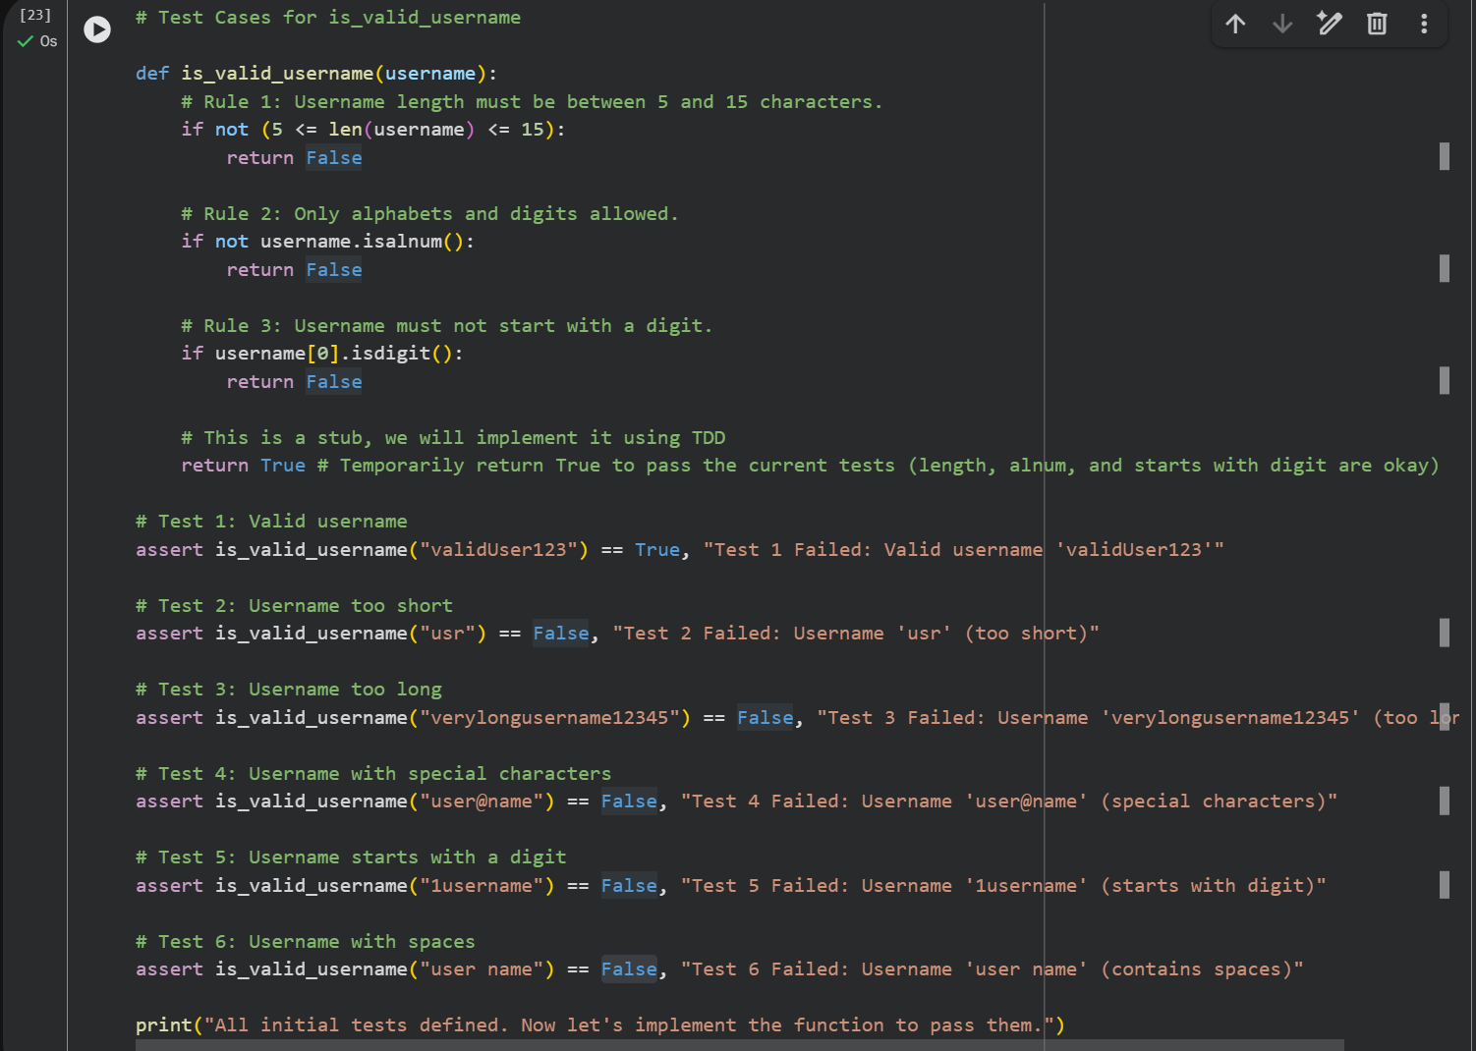

Output:

Task Description #2 (Even–Odd & Type Classification – Apply
AI for Robust Input Handling)

Prompt:
Generate at least 3 assert test cases for a Python function
classify_value(x) and implement the function using conditional logic
and loops with the following rules:

- If input is integer, return "Even" or "Odd".
- If input is 0, return "Zero".
- If input is non-numeric, return "Invalid Input".
Ensure all tests pass.

Code:
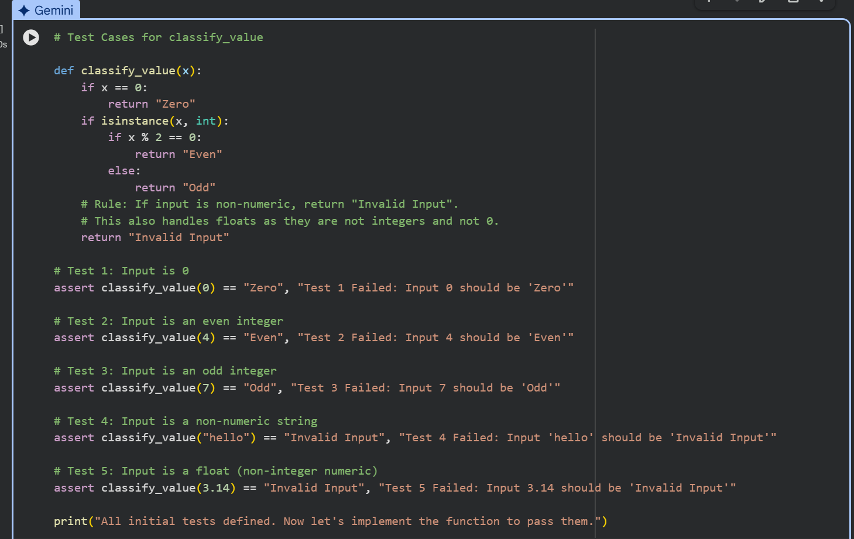

Output:

Task Description #3 (Palindrome Checker – Apply AI for
String Normalization)

Prompt:

Generate at least 3 assert test cases for a function
is_palindrome(text) and implement the function.

Requirements:
- Ignore case, spaces, and punctuation.
- Handle empty string and single characters.
- Ensure all tests pass.

Code:
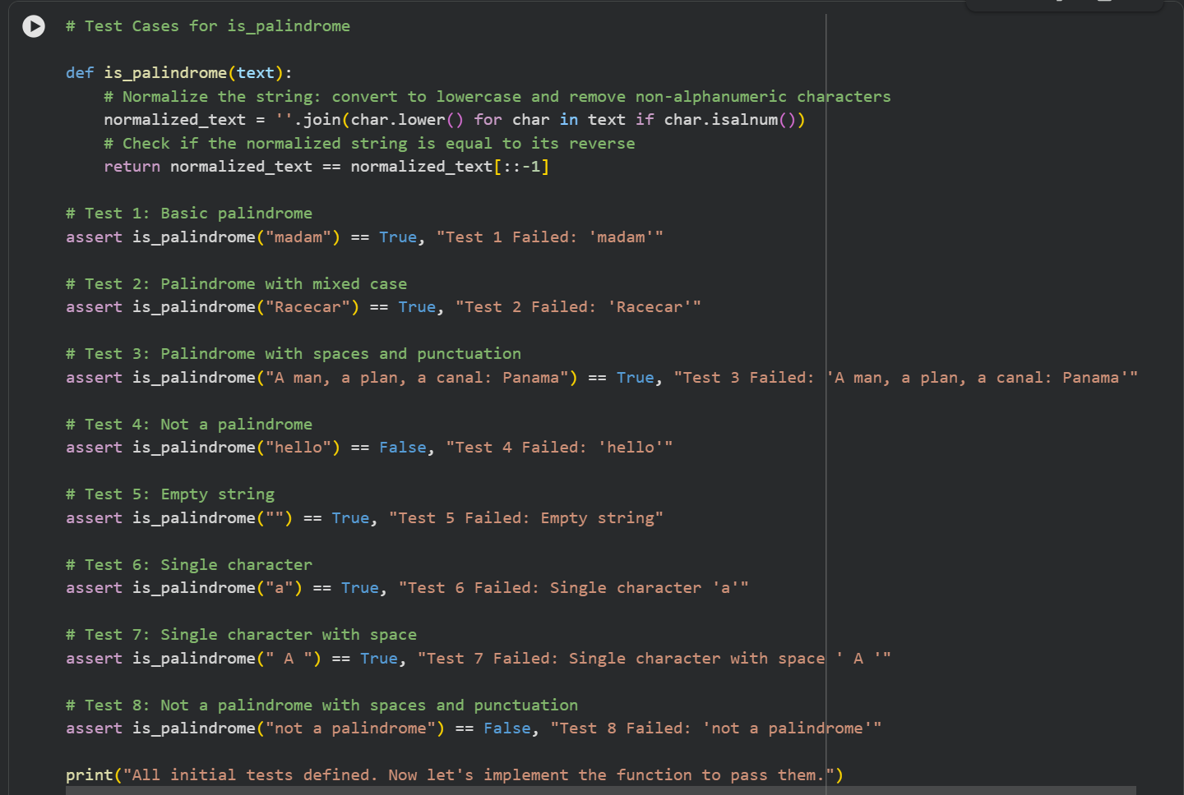

Output:

Task Description #4 (BankAccount Class – Apply AI for
Object-Oriented Test-Driven Development)

Prompt:

Generate at least 3 assert-based test cases for a Python
BankAccount class and then implement the class.

Methods required:
- deposit(amount)
- withdraw(amount)
- get_balance()

Ensure implementation passes all tests.

Code:
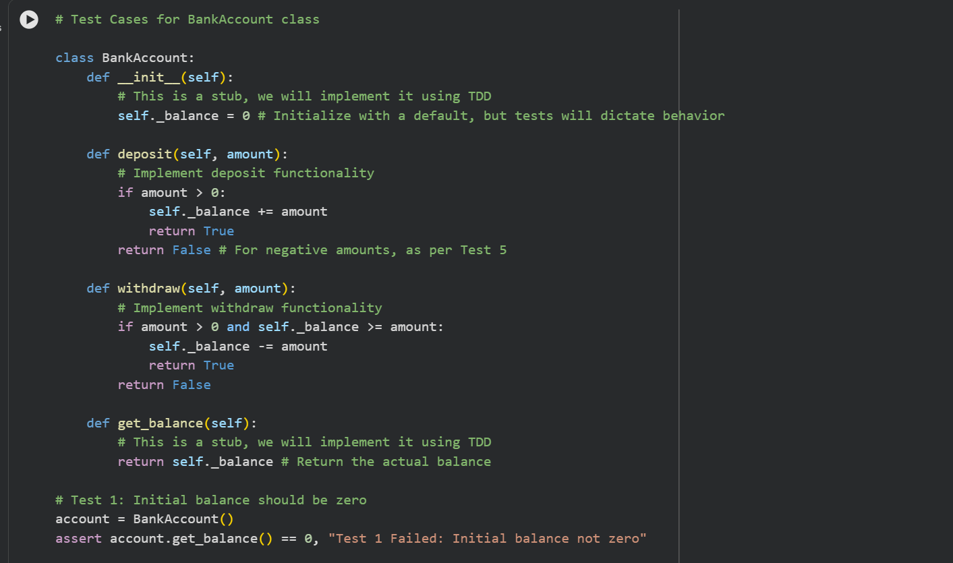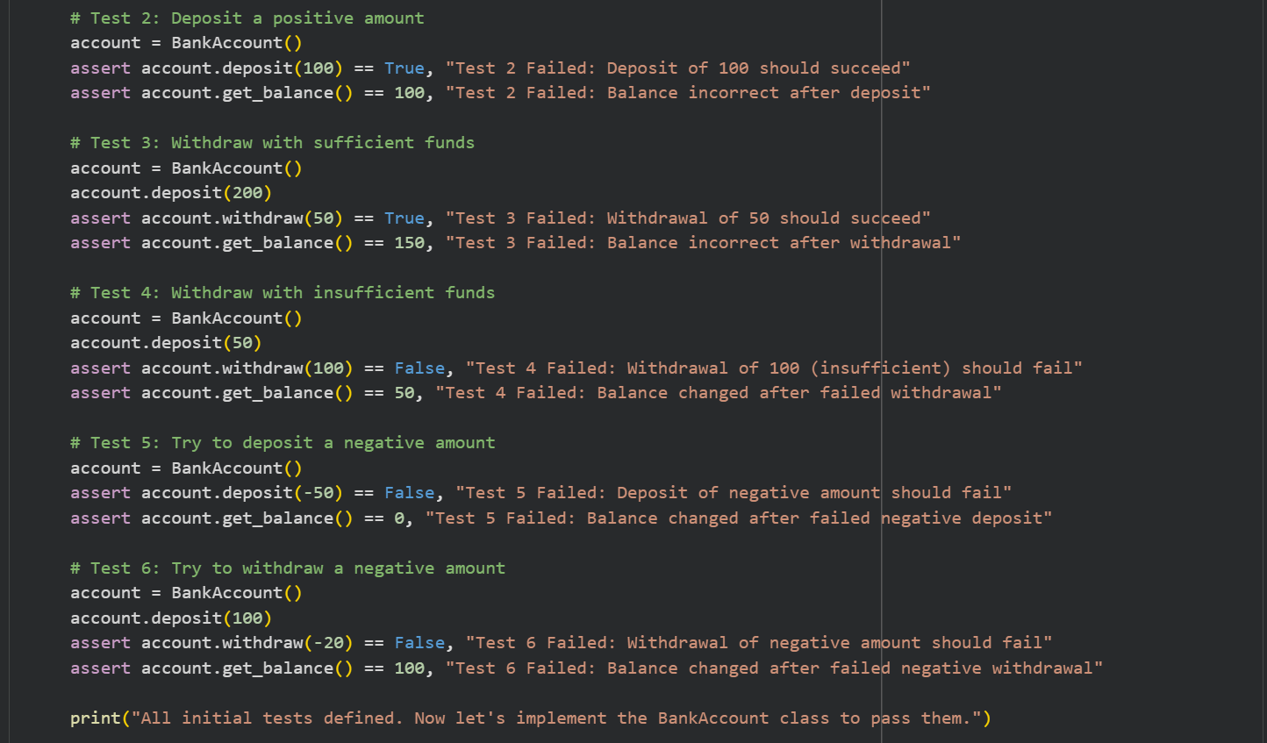

Output:

Task Description #5 (Email ID Validation – Apply AI for Data
Validation)

Prompt:

Generate at least 3 assert test cases for a function
validate_email(email) and implement the function.

Rules:
- Must contain @ and .
- Must not start or end with special characters.
- Handle invalid formats gracefully.
Ensure all tests pass.

Code:
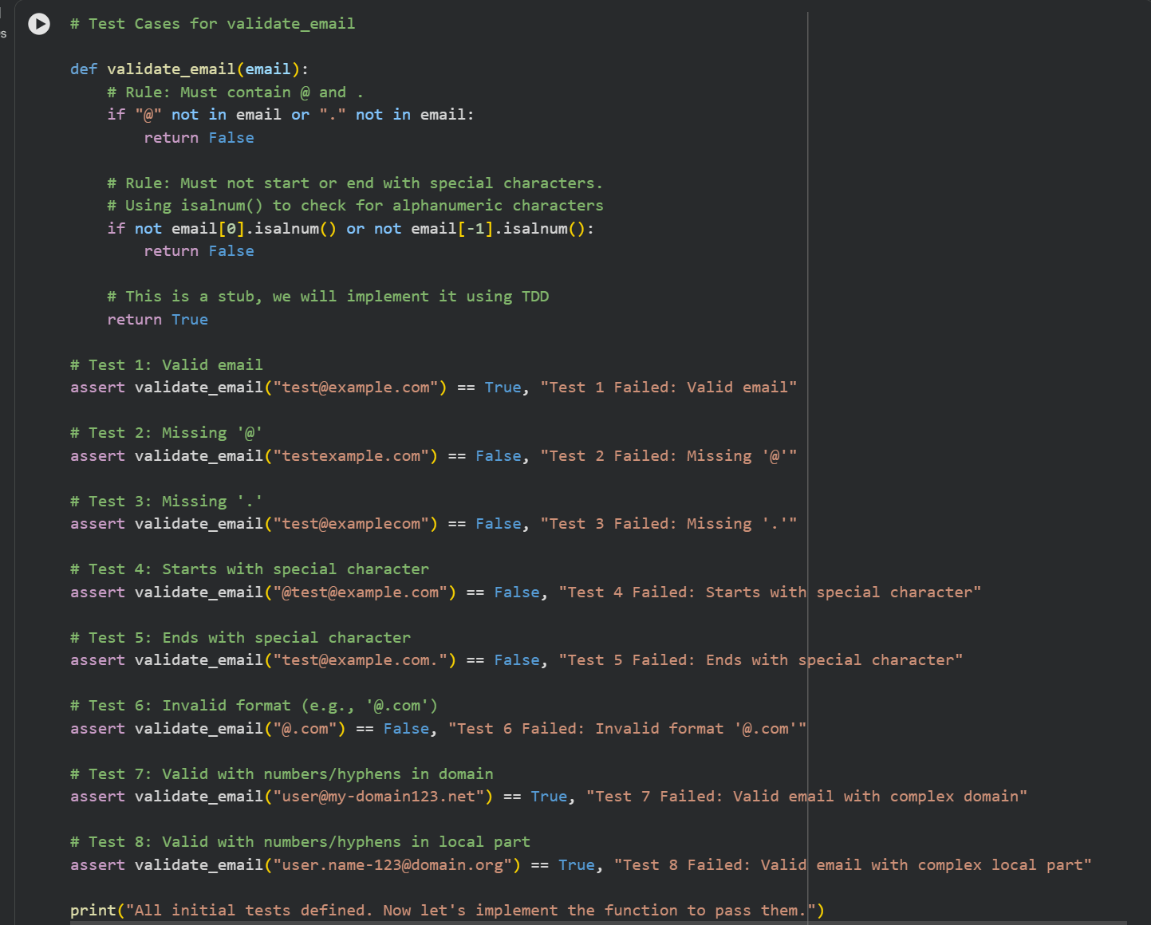

Output:

