School of Computer Science and Artificial Intelligence

Lab Assignment # 6.5

Program : B. Tech (CSE)
Specialization :
Course Title : AI Assisted coding
Course Code :
Semester : II
Academic Session : 2025-2026
Name of Student : Thota Varun
Enrollment No. : 2403A51L05
Batch No. : 51
Date :23-01-2026

Submission Start from here:

- Task 1: (AI-Based Code Completion for Conditional Eligibility Check)
- Task: Use an AI tool to generate eligibility logic.
- Prompt:
- “Generate Python code to check voting eligibility based on age and citizenship.”
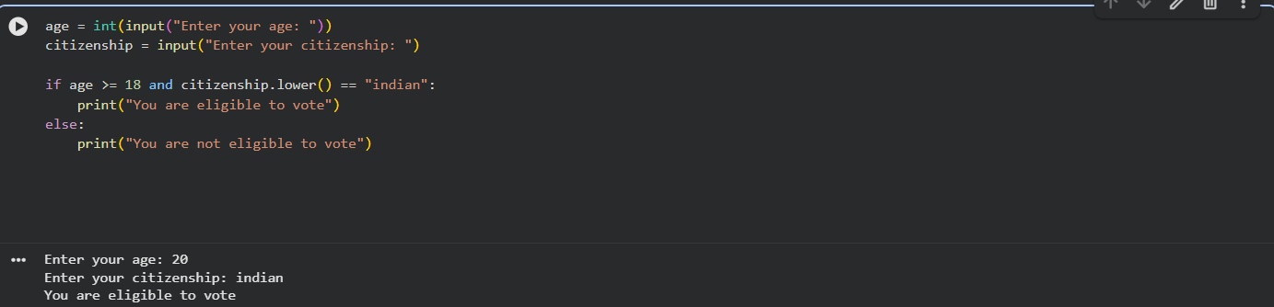

Explanation (Line by Line)
age = int(input("Enter your age: "))

- Takes the user’s age as input.
- input() reads the value as a string.
- int() converts it into an integer so we can compare numbers.
citizenship = input("Enter your citizenship: ")

- Takes the user’s citizenship as input.
- Stored as a string.
citizenship.lower()

- Converts the input to lowercase.
- This avoids problems with different cases like:
  - Indian
  - INDIAN
  - indian
if age >= 18 and citizenship.lower() == "indian":

- Checks two conditions:
  - Age must be 18 or above
  - Citizenship must be Indian
- The and operator means both conditions must be true.
print("You are eligible to vote")

- Executes when both conditions are satisfied.
else:
print("You are not eligible to vote")

- Executes when any one of the conditions is false.

- Task2:AI-Based Code Completion for Loop-Based String Processing)
- Task: Use an AI tool to process strings using loops.
- Prompt:
- “Generate Python code to count vowels and consonants in a string using a loop.”
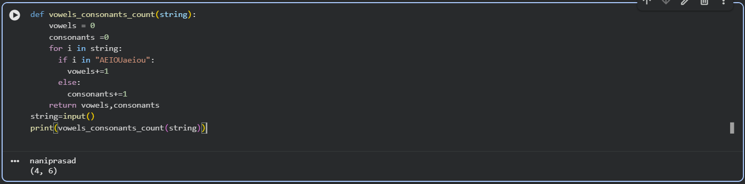

Explanation
def vowels_consonants_count(string):
- Defines a function named vowels_consonants_count.
- It takes one parameter string.
vowels = 0
consonants = 0
- Two variables are initialized to count vowels and consonants.
for i in string:
- Iterates through each character in the input string.
if i in "AEIOUaeiou":
- Checks whether the character is a vowel.
- Both uppercase and lowercase vowels are included.
vowels += 1
- Increments the vowel count if the condition is true.
else:
consonants += 1
- If the character is not a vowel, it is counted as a consonants
return vowels, consonants

- Returns both counts as a tuple (vowels, consonants).
string = input()
- Takes a string input from the user.
print(vowels_consonants_count(string))
- Calls the function and prints the result.

- Task3: Use an AI tool to generate a complete program using classes,
loops, and conditionals.
Prompt:
“Generate a Python program for a library management system
using classes, loops, and conditional statements.”
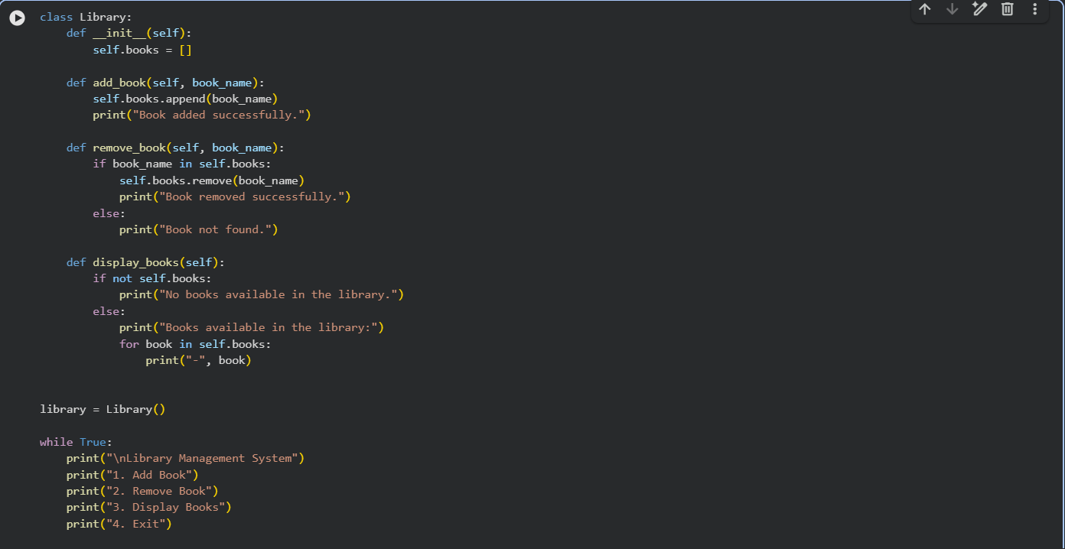
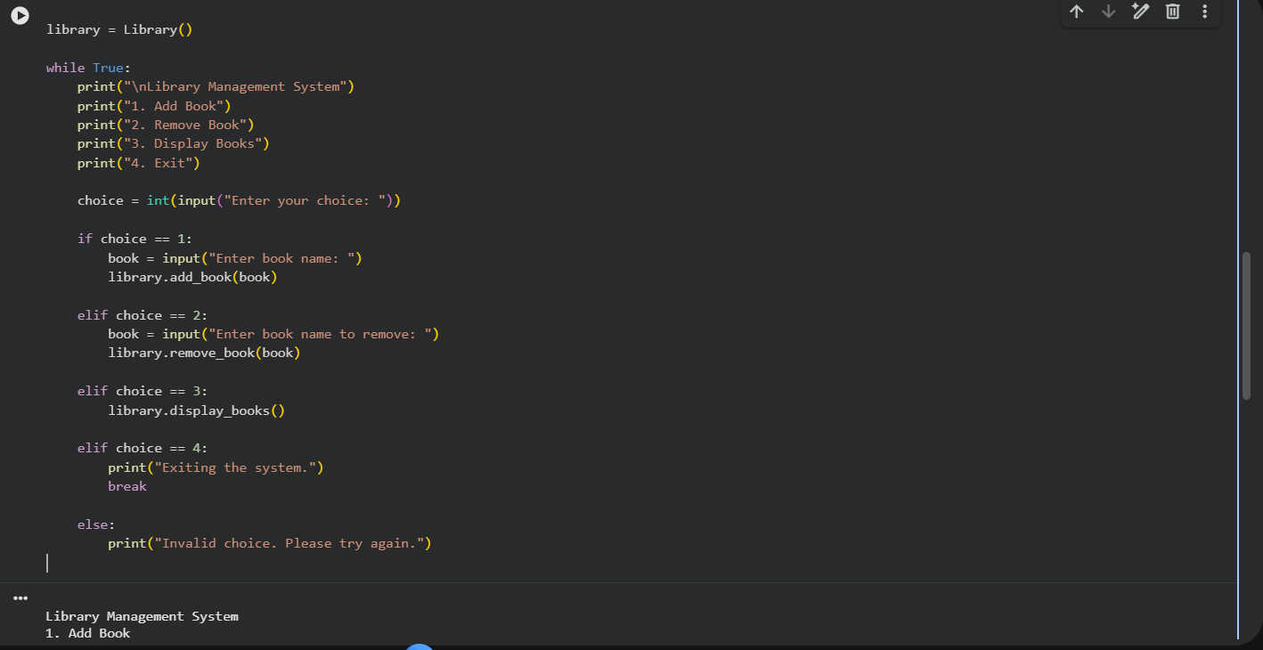
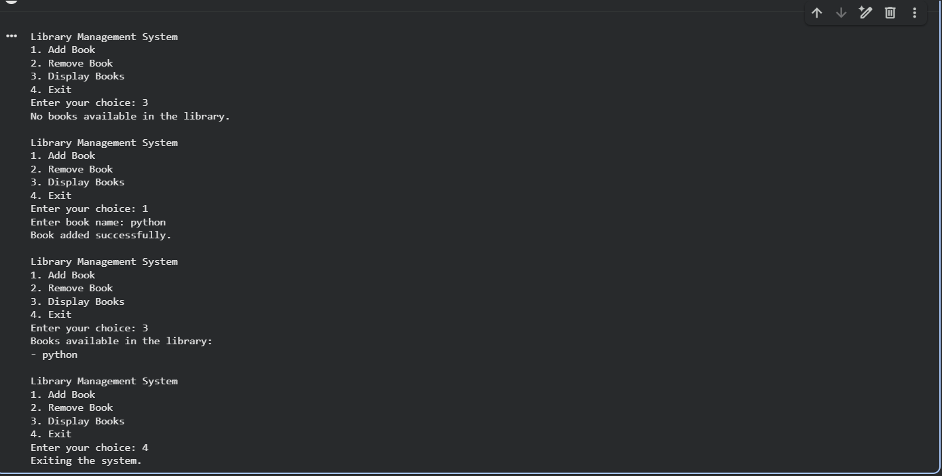

Library Management System – Explanation

1. Class Definition
class Library:
- Defines a class named Library.
- It represents a library and its operations.

2. Constructor (__init__ method)
def __init__(self):
self.books = []
- Initializes an empty list books.
- This list stores the names of books available in the library.

3. Add Book Method
def add_book(self, book_name):
self.books.append(book_name)
print("Book added successfully."
- Adds a new book to the library.
- Uses append() to store the book name in the lists.

4. Remove Book Method
def remove_book(self, book_name):
if book_name in self.books:
self.books.remove(book_name)
print("Book removed successfully.")
else:
print("Book not found.")
- Checks whether the book exists in the library.
- If found, it removes the book.
- Otherwise, it displays “Book not found”.

5. Display Books Method
def display_books(self):
if not self.books:
print("No books available in the library.")

else:
for book in self.books:
print("-", book)
- Checks if the library is empty.
- If not empty, uses a for loop to display all books.

6. Object Creation
library = Library()
- Creates an object of the Library class.
- This object is used to call library functions.

7. Menu-Driven Loop
while True:
- Keeps the program running until the user chooses to exit.

8. Conditional Statements
if choice == 1:
- Add a book.
elif choice == 2:
- Remove a book.
elif choice == 3:
- Display all books.
elif choice == 4:
- Exit the program.
else:
- Handles invalid input.

- Task Description #4 (AI-Assisted Code Completion for Class-
Based Attendance System)
Task: Use an AI tool to generate an attendance management class.
Prompt: “Generate a Python class to mark and display student
attendance using loops.”
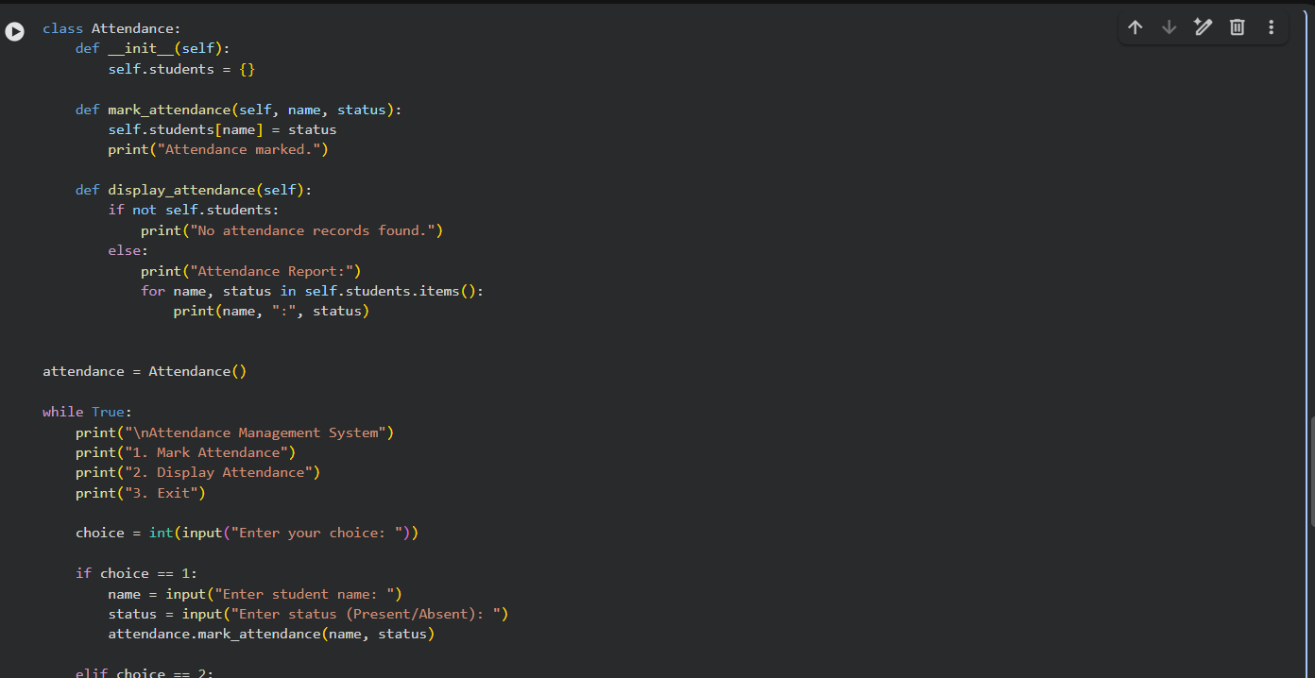
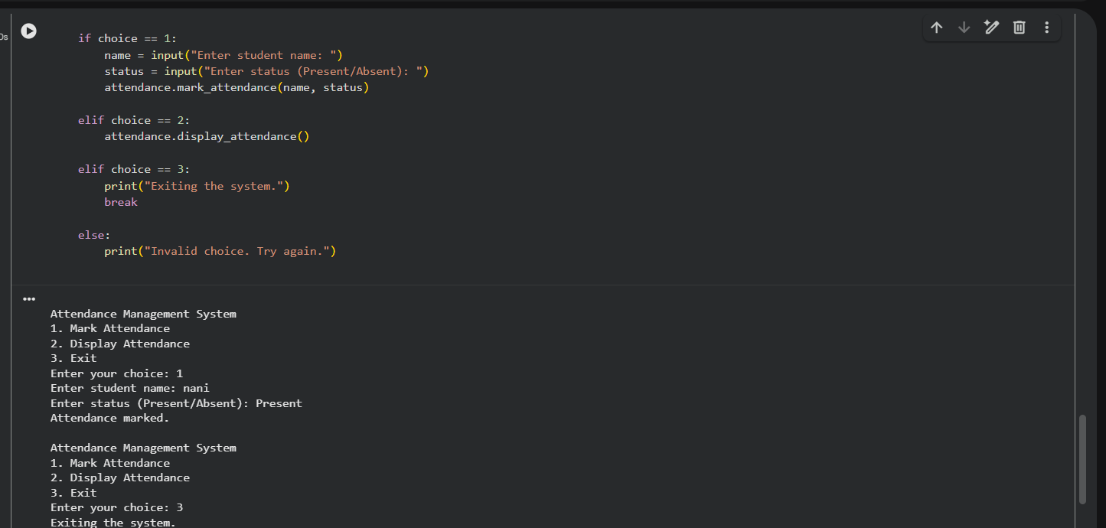

Program Explanation

1. Class Definition
class Attendance:

- Defines a class named Attendance.
- This class is responsible for managing student attendance.

2. Constructor (__init__ method)
def __init__(self):
self.students = {}
- Initializes an empty dictionary students.
- The dictionary stores:
  - Key → Student name
  - Value → Attendance status (Present / Absent)

3. Mark Attendance Method
def mark_attendance(self, name, status):
self.students[name] = status
print("Attendance marked.")
- Takes the student’s name and attendance status as input.
- Stores or updates the attendance in the dictionary.
- Prints a confirmation messages

4. Display Attendance Method
def display_attendance(self):
if not self.students:
print("No attendance records found.")
else:
print("Attendance Report:")

for name, status in self.students.items():
print(name, ":", status)
- Checks if attendance records exist.
- If empty, displays a message.
- Otherwise:
  - Uses a for loop to print each student’s attendances

5. Object Creation
attendance = Attendance()
- Creates an object of the Attendance class.
- This object is used to access class methods.

6. Menu-Driven Loop
while True:
- Keeps the program running until the user exits.

7. User Choices with Conditionals
if choice == 1:
- Marks attendance.
elif choice == 2:
- Displays attendance.
elif choice == 3:
- Exits the program.
else:
- Handles invalid input.

- Task Description #5 (AI-Based Code Completion for Conditional
Menu Navigation)
- Task: Use an AI tool to complete a navigation menu.
- Prompt: “Generate a Python program using loops and conditionals to simulate an ATM menu.”
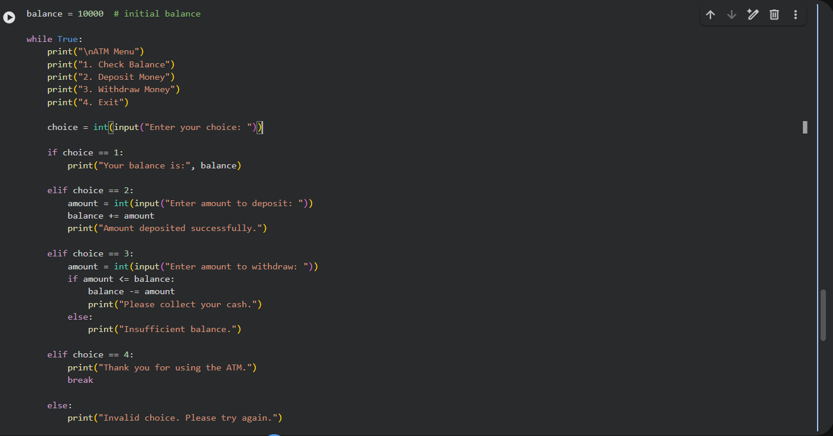
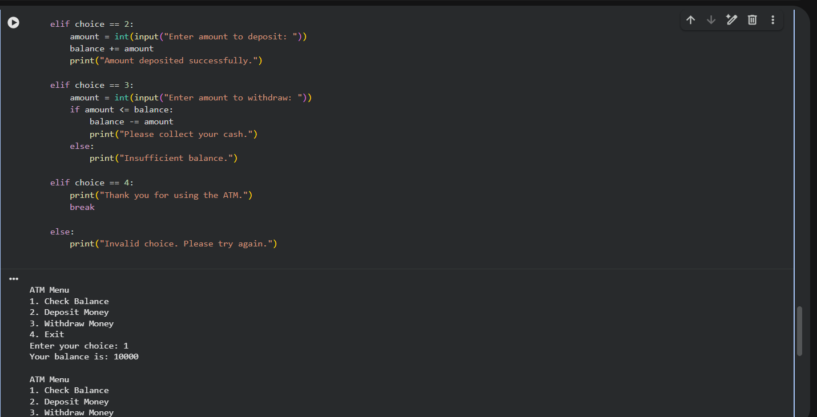
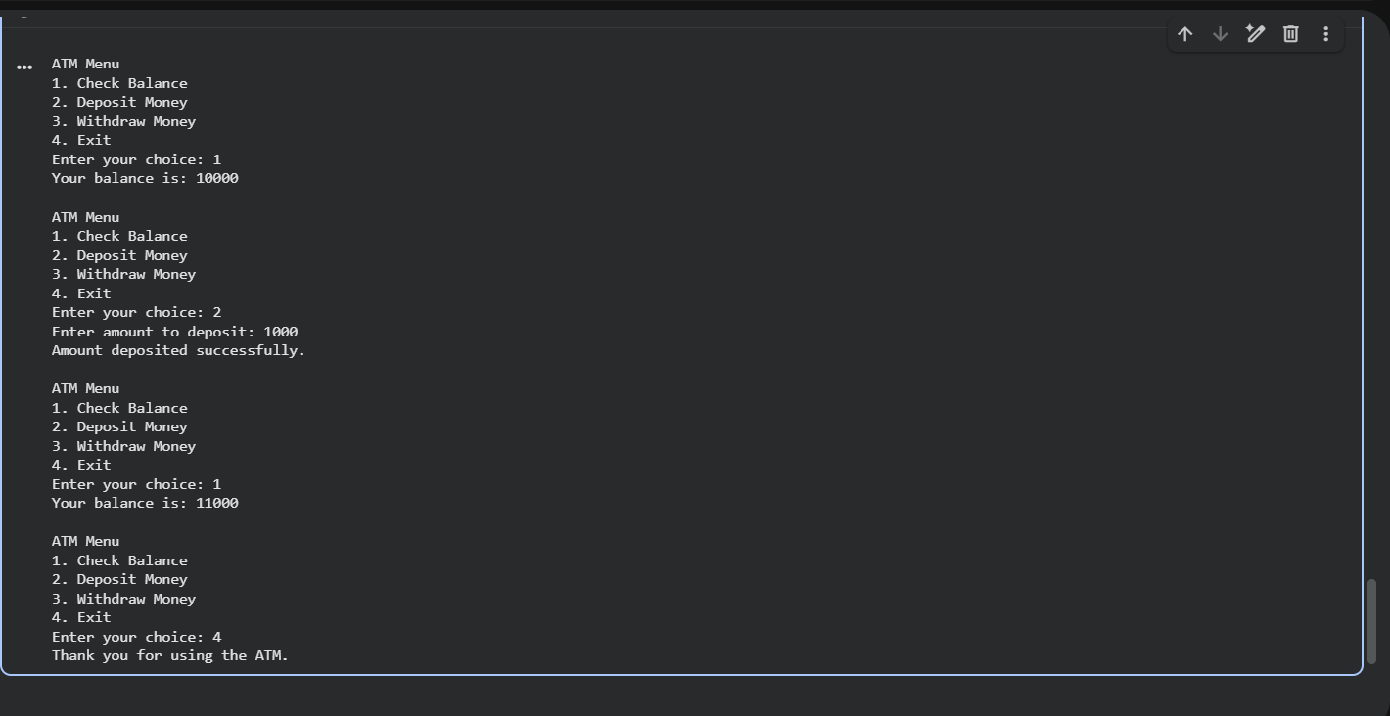

Explanation

1. Initial Balance
balance = 10000
- Stores the initial amount available in the account.

2. Loop Usage
while True:
- Keeps the ATM menu running continuously.
- Stops only when the user selects Exit.

3. Menu Display
print("\nATM Menu")
- Displays available ATM options to the user.

4. Conditional Statements
if choice == 1:

- Checks and displays current balance.
elif choice == 2:
- Deposits money and updates the balance.
elif choice == 3:
- Withdraws money.
- Uses a condition to check for sufficient balance.
elif choice == 4:
- Exits the program using break.
else:
- Handles invalid menu choices.

