School of Computer Science and Artificial Intelligence

Lab Assignment # 2.2

Program : B. Tech (CSE)
Specialization :
Course Title : AI Assisted coding
Course Code :
Semester : II
Academic Session : 2025-2026
Name of Student : Thota Varun
Enrollment No. : 2403A51L05
Batch No. : 51
Date :13-01-2026

Submission Starts here
Task-1: Cleaning Sensor Data
❖ Scenario:
❖ You are cleaning IoT sensor data where negative values are invalid.
❖ Task:
Use Gemini in Colab to generate a function that filters out all negative
numbers from a list.
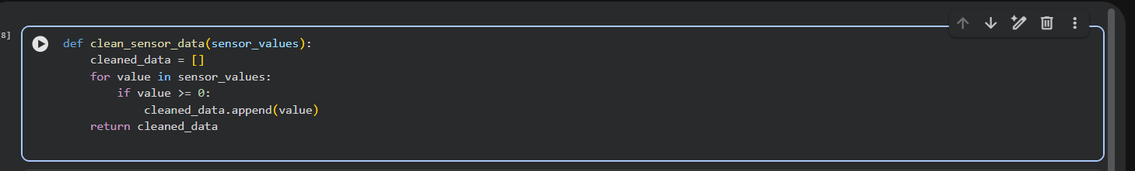

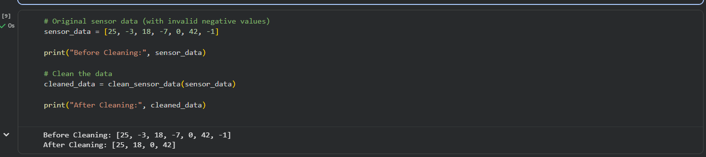

Line-by-Line Explanation
1️⃣ def clean_sensor_data(sensor_values):
- Defines a function named clean_sensor_data
- sensor_values is the input list containing sensor readings (may include negative values)

2️⃣ cleaned_data = []
- Creates an empty list
- This list will store only valid (non-negative) sensor values

3️⃣ for value in sensor_values:

- Loops through each value in the input sensor list

- Processes one sensor reading at a time

4️⃣ if value >= 0:
- Checks whether the sensor value is greater than or equal to zero
- This condition ensures that negative values are ignored

5️⃣ cleaned_data.append (value)
- Adds the valid sensor value to the cleaned_data list

6️⃣ return cleaned_data
- Returns the final list containing only valid sensor readings
▶️ Example Execution Explanation

sensor_data = [25, -3, 18, -7, 0, 42, -1]

- Input list contains both valid and invalid sensor values

cleaned_data = clean_sensor_data (sensor_data)
- Function removes all negative values
✅ Output:

[25, 18, 0, 42]

# Task 2: String Character Analysis
❖ Scenario:
You are building a text-analysis feature.
❖ Task:
Use Gemini to generate a Python function that counts vowels, consonants,
and digits in a string.
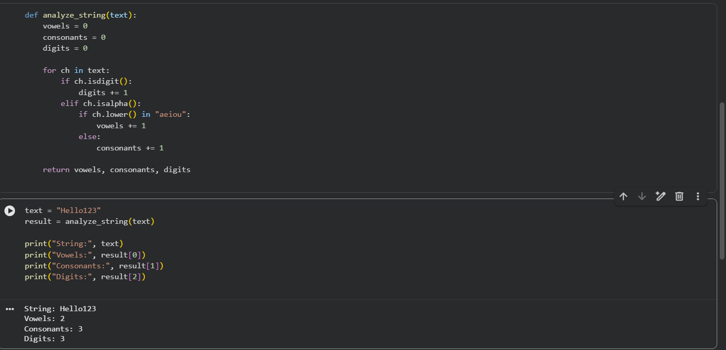

Explaination:
1️⃣ def analyze_string(text):
- Defines a function named analyze_string
- text is the input string that will be analyzed

2️⃣ vowels = 0, consonants = 0, digits = 0
- Initializes three counters
- These variables store the count of vowels, consonants, and digits

3️⃣ for ch in text:
- Loops through each character in the input string
- Processes one character at a time

4️⃣ if ch.isdigit():
- Checks if the character is a number (0–9)
- If true, the digit counter is increased
5️⃣digits += 1:
- Increments the digit count by 1

6️⃣ elif ch.isalpha():
- Checks if the character is an alphabet
- Ignores spaces and special characters

7️⃣ if ch.lower() in "aeiou":
- Converts the character to lowercase
- Checks if it is a vowel (a, e, i, o, u)

8️⃣ vowels += 1
- Increments the vowel count if the condition is true
9️⃣ else:
- If the alphabet is not a vowel, it must be a consonant

🔟 consonants += 1
- Increments the consonant count

1️⃣1️⃣ return vowels, consonants, digits
- Returns all three counts as a tuple

#Task 3: Palindrome Check – Tool Comparison
❖ Scenario:
You must decide which AI tool is clearer for string logic.
❖ Task:
Generate a palindrome-checking function using Gemini and Copilot, then
compare the results.

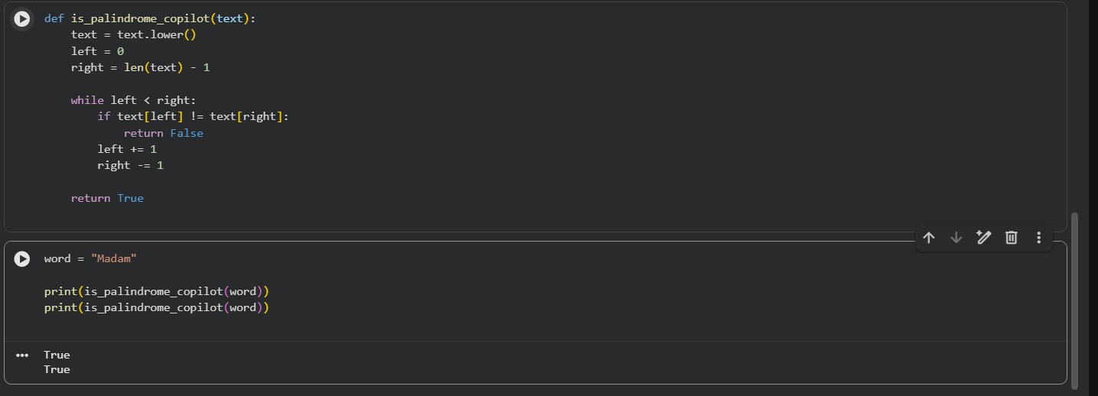

Explaination:
1️⃣ def is_palindrome_gemini(text):
- Defines a function to check whether a string is a palindrome
- text is the input string
2️⃣ text = text.lower()
- Converts all characters to lowercase
- This avoids case mismatch (e.g., Madam vs madam)
3️⃣ text[::-1]
- Reverses the string using Python slicing
- [::-1] means read the string from end to start
4️⃣ return text == text[::-1]
- Compares the original string with its reversed version
- Returns True if both are the same, otherwise False
def is_palindrome_copilot(text):
- Defines a function to check if a string is a palindrome
2️⃣ text = text.lower()
- Converts the string to lowercase for case-insensitive comparison
3️⃣ left = 0
- Points to the first character of the string
4️⃣ right = len(text) - 1
- Points to the last character of the string
5️⃣ while left < right:
- Loop runs until both pointers meet in the middle
6️⃣ if text[left] != text[right]:
- Compares characters from both ends
- If they are not equal, the string is not a palindrome
7️⃣ return False
- Immediately stops and returns False if mismatch is found
8️⃣ left += 1
- Moves the left pointer forward
9️⃣ right -= 1
- Moves the right pointer backward
🔟 return True
- If all characters match, the string is a palindrome

#Task 4: Code Explanation Using AI
❖ Scenario:
You are reviewing unfamiliar code written by another developer.
❖ Task:
Ask Gemini to explain a Python function (prime check OR palindrome
check) line by line.

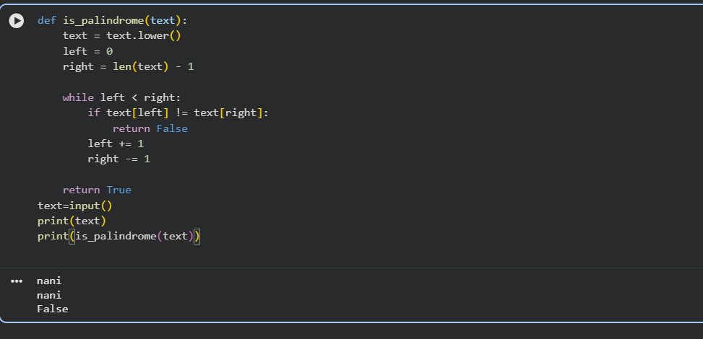

Explaination:
1️⃣ def is_palindrome(text):
- Defines a function named is_palindrome
- Takes a string text as input

2️⃣ text = text.lower()
- Converts all characters in the string to lowercase
- Ensures case-insensitive comparison (e.g., Madam = madam)

3️⃣ left = 0
- Initializes a pointer to the first character of the string

4️⃣ right = len(text) - 1
- Initializes a pointer to the last character of the string
5️⃣ while left < right:
- Starts a loop that runs until both pointers meet in the middle

6️⃣ if text[left] != text[right]:
- Compares characters at the left and right pointers
- If they are not equal, the string is not a palindrome

7️⃣ return False
- Immediately exits the function if a mismatch is found

8️⃣ left += 1
- Moves the left pointer one step forward
9️⃣ right -= 1
- Moves the right pointer one step backward

🔟 return True
- If all character pairs match, the string is a palindrome

