School of Computer Science and Artificial Intelligence

Lab Assignment # 7.2

Program : B. Tech (CSE)
Specialization : -
Course Title : AI Assisted Coding
Course Code : 23CS002PC304
Semester : II
Academic Session : 2025-2026
Name of Student : T.Varun
Enrollment No. : 2403A51L05
Batch No. : 51
Date : 30/01/26

Submission Starts here

Screenshots:
Task 1 – Runtime Error Due to Invalid Input Type

(Buggy Code):
num = input("Enter a number: ")
result = num + 10
print(result)

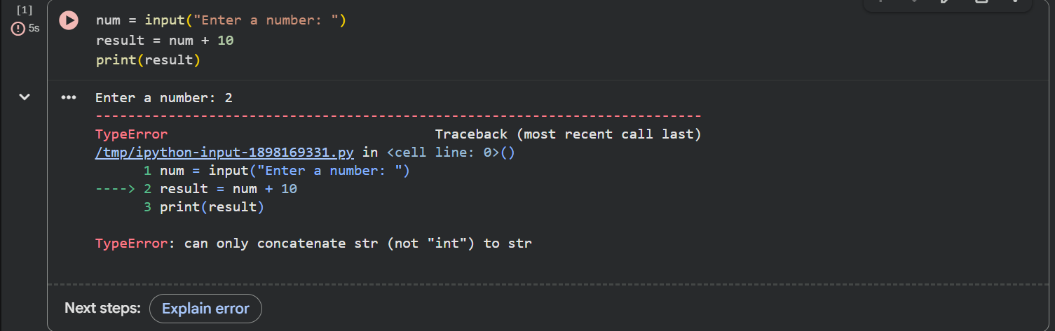

Output:

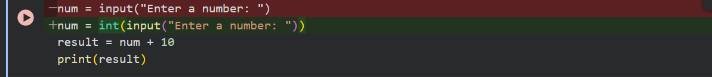

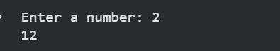

Task 2 – Incorrect Function Return Value

(Buggy Code):
def square(n):
result = n * n

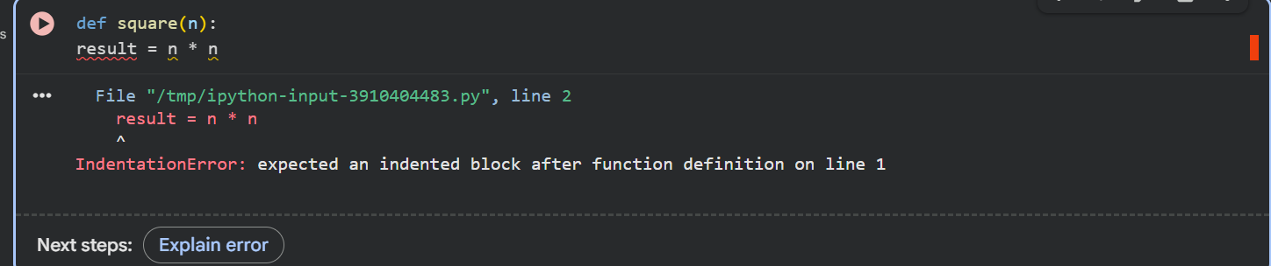

Output:
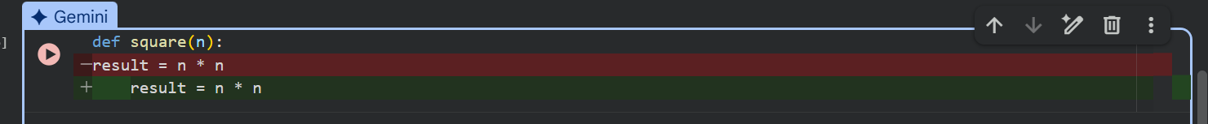

Task 3 – IndexError in List Traversal

(Buggy Code):
numbers = [10, 20, 30]
for i in range(0, len(numbers)+1):
print(numbers[i])

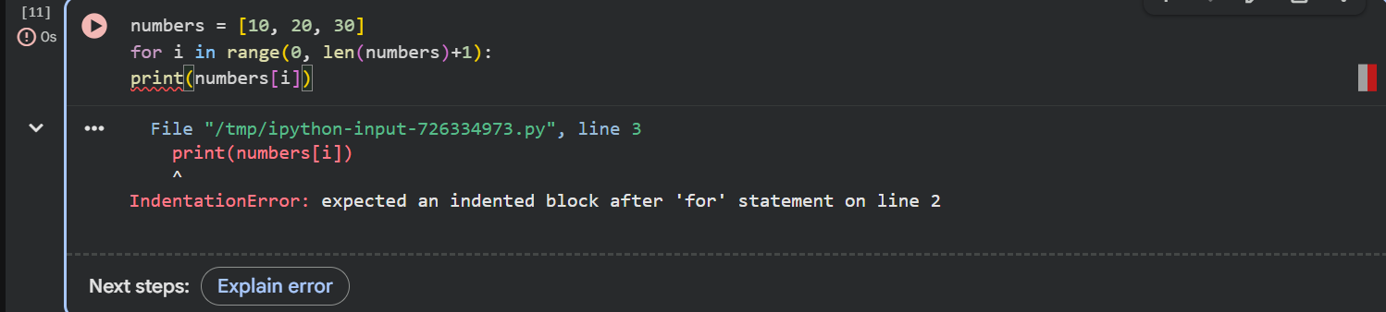

Output:
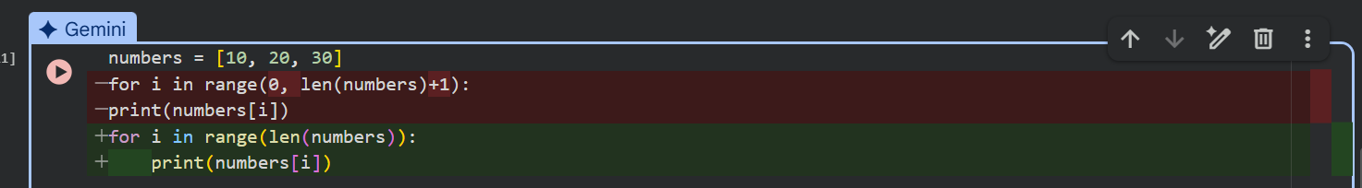



Task 4 – Uninitialized Variable Usage

(Buggy Code):
if True:
pass
print(total)

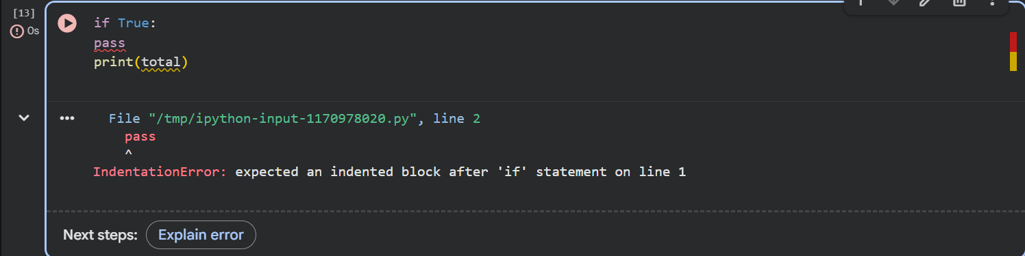

Output:
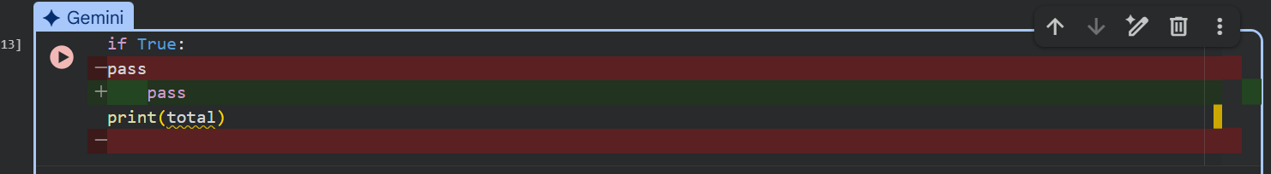

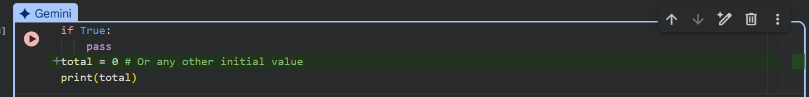

Task 5 – Logical Error in Student Grading System

(Buggy Code):
marks = 85
if marks >= 90:
grade = "A"
elif marks >= 80:
grade = "C"
else:
grade = "B"
print(grade)

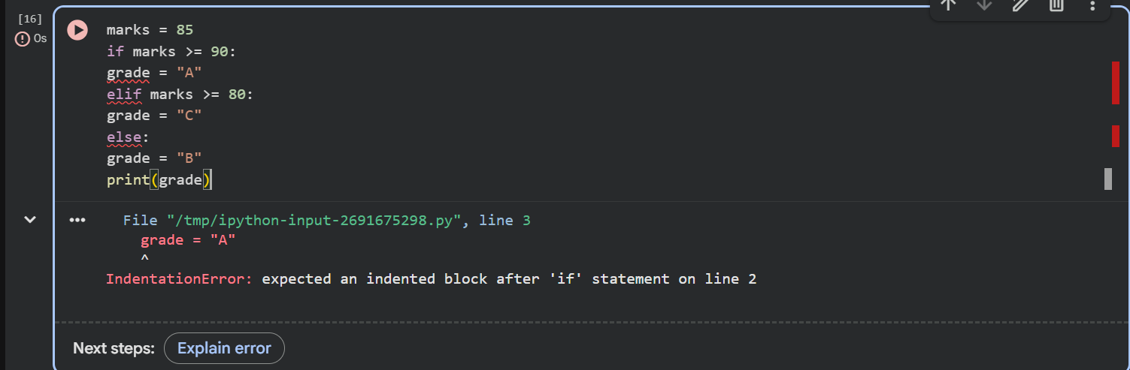

Output:

