AI ASSISTANT CODING
Lab Assignment 1.2
Name: E . Keerthana
Ht.No: 2403A51L06
Batch : 51

Task 0: GitHub Copilot Installation & Configuration
Steps Followed:
- Open Visual Studio Code
- Go to Extensions
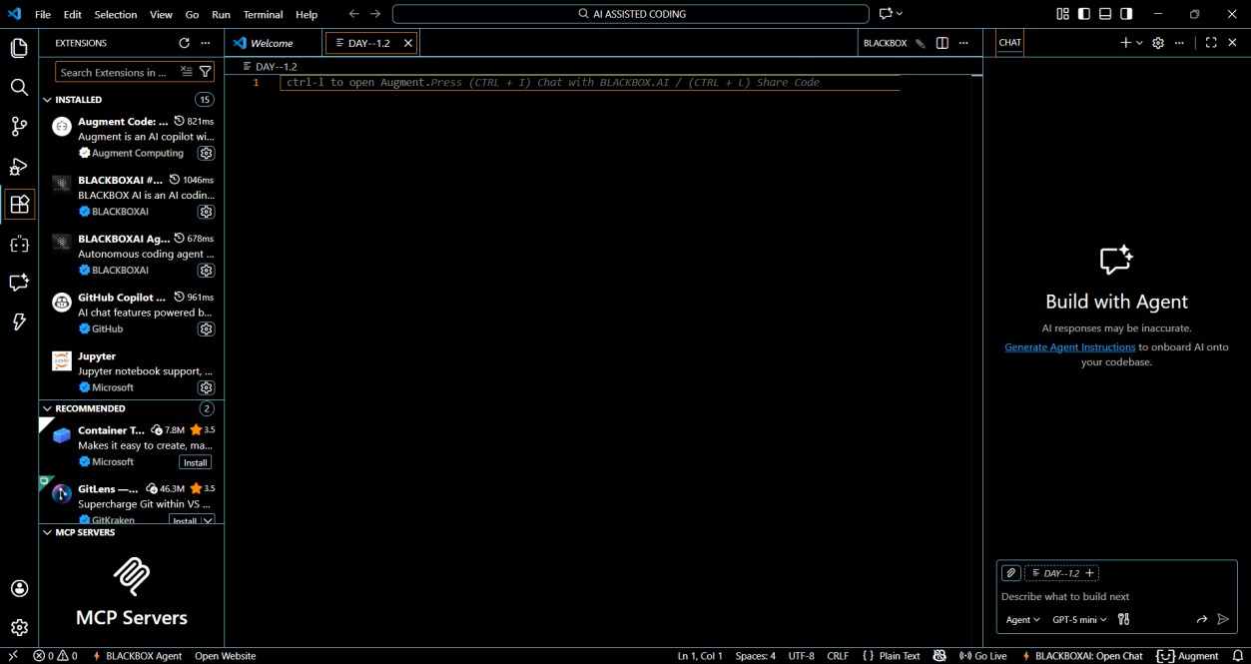
- Search for GitHub Copilot
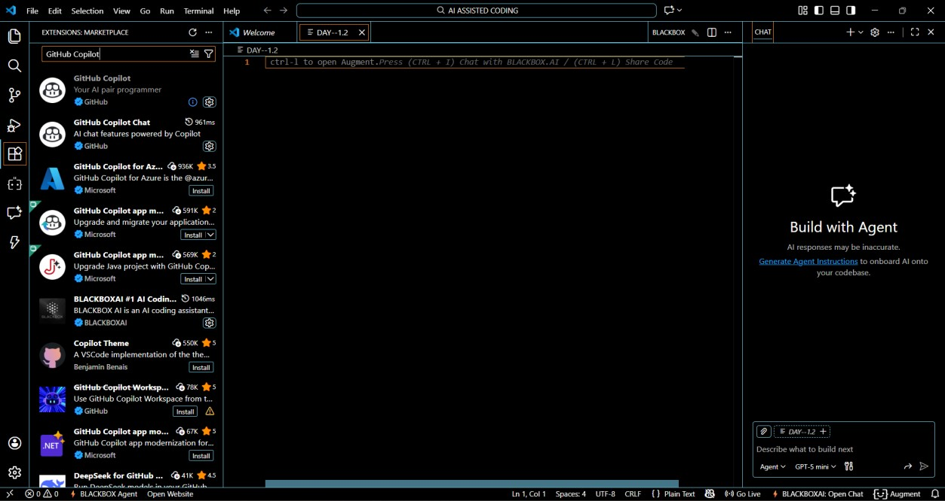
- Click Install

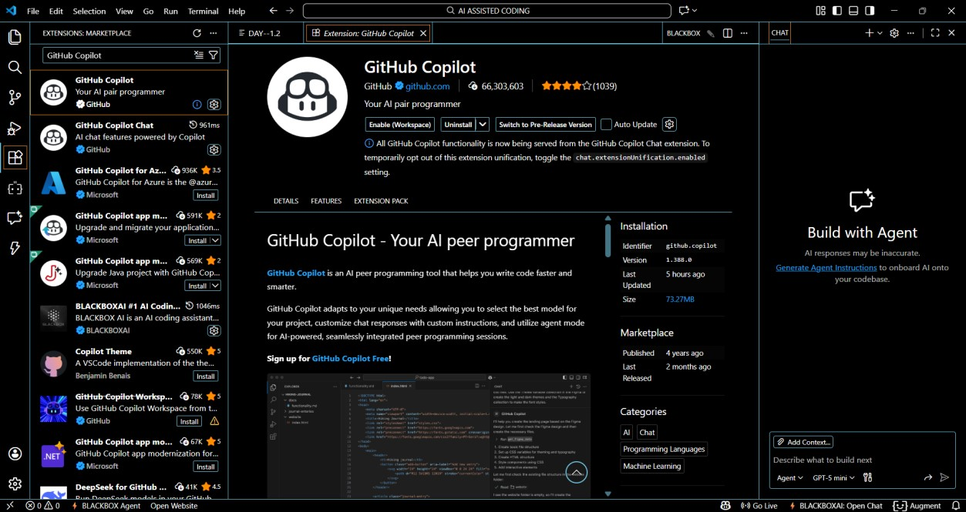
- Sign in using your GitHub account
- Enabled Copilot suggestions
- Verified Copilot inline suggestions in Python file

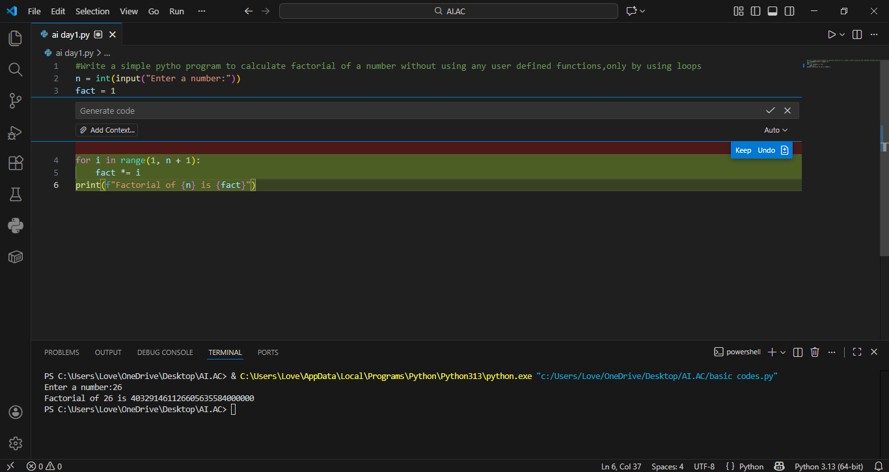

Task 1: AI-Generated Logic Without Modularization (Factorial without Functions)
Prompt Used:” Write a simple python program to calculate factorial of a number without using any user defined functions ,only by using loops”.

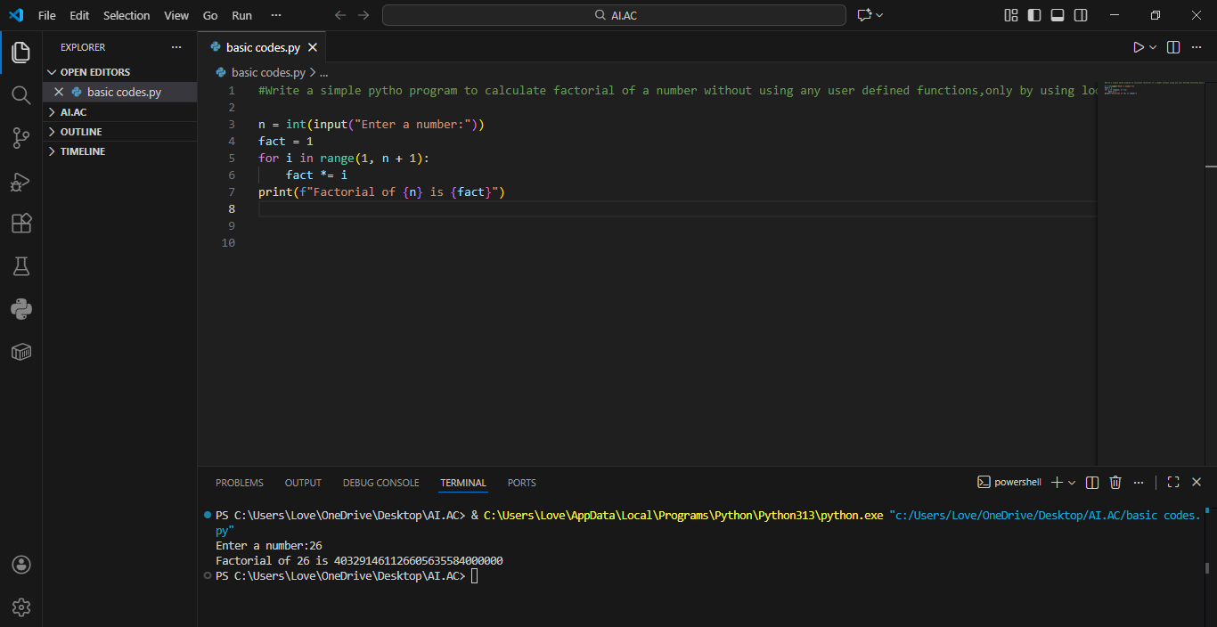

GitHub Copilot was very helpful for a beginner as it generated correct logic instantly.
The syntax and structure were easy to understand.
The code was readable and easy to understand.
Beginners can learn loop logic faster using Copilot assistance
However, it did not include input validation automatically.
Best practices like modular design were not applied unless explicitly prompted.

Task 2: AI Code Optimization & Cleanup Original Code:
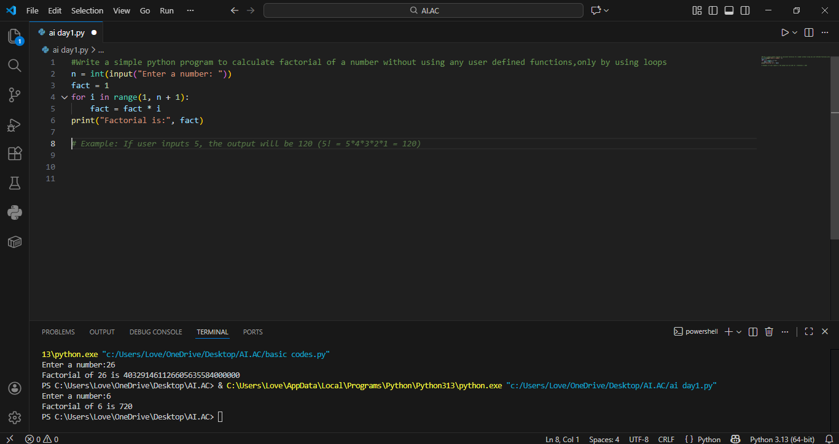

Prompt Used: “optimize this code & simplify logic and improve readability”
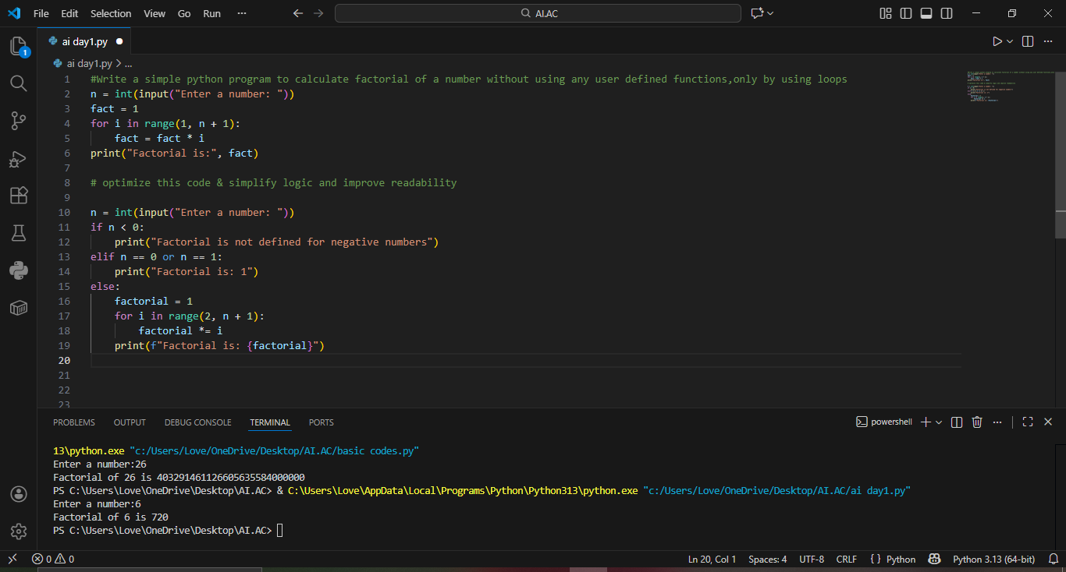
Code is cleaner and easier to maintain
The optimized version improves clarity, maintainability, and readability without affecting performance.

Task 3: Modular Design Using AI Assistance (Factorial with Functions)
Prompt Used: “ Create a python program to calculate factorial using a function”

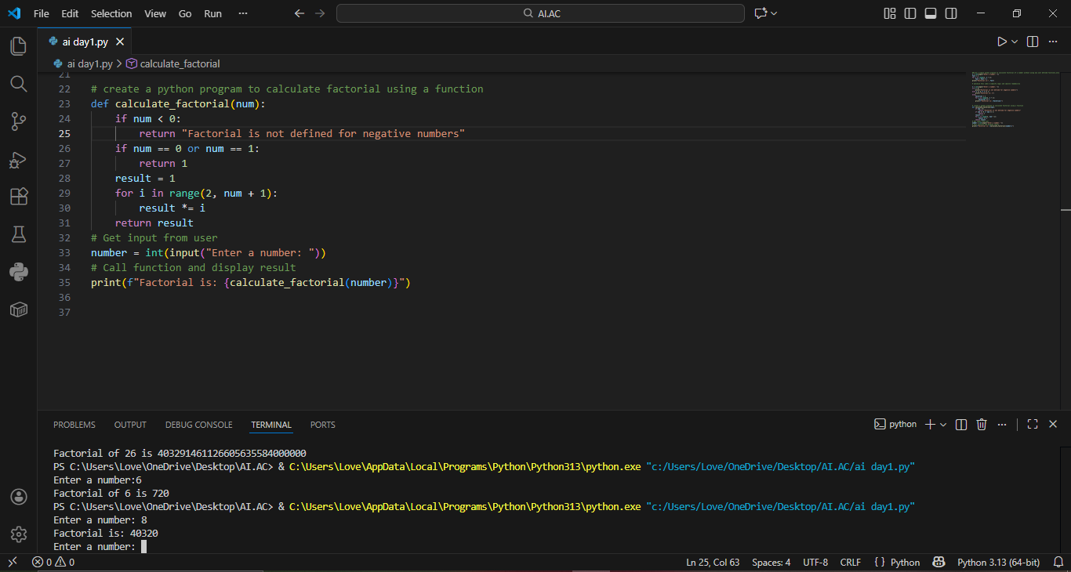

Using functions improves reusability because the same logic can be called multiple times.
It also improves readability and debugging.
Modular code is easier to maintain in large projects.

Task 4: Comparative Analysis
Procedural vs Modular AI Code

Criteria | Without Function | With Function
Logic Clarity | Moderate | High
Reusability | No | Yes
Debugging | Difficult | Easy
Large Projects | Not suitable | Highly suitable
AI Dependency Risk | Higher | Lower

Conclusion:
Function-based design is more scalable and suitable for real-world applications.
Procedural code is only suitable for small scripts

Task 5: Iterative vs Recursive AI Code
Prompt Used: “Generate iterative and recursive factorial programs in
Python”

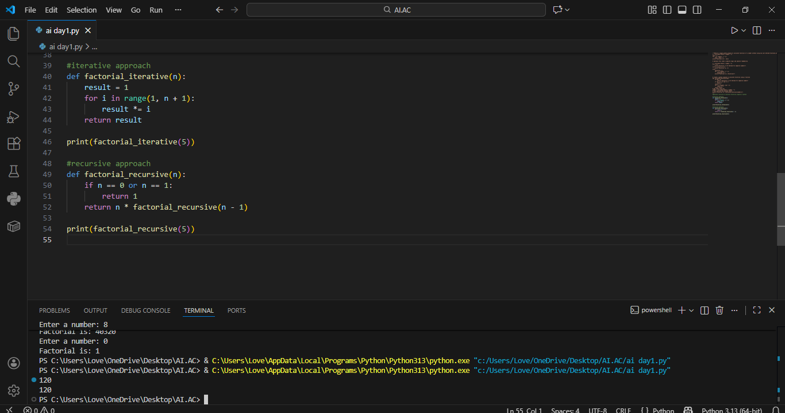
Execution Flow Explanation
- Iterative version uses loops
- Recursive version uses function calls
- Recursive calls stack memory

Comparison:

Aspect | Iterative |  | Recursive
Readability | Easy |  | Moderate
Stack Usage | No |  | Yes
Performance | Better |  | Slightly slower
Recommendation | Preferred | Avoid for large inputs

