Keerthana Erukala
2403A51L06
B-51

ASSIGNMENT -2.2
Task 1: Cleaning Sensor Data
PROMPT: Generate a Python function that removes all negative numbers from a list of sensor readings and show before and after output
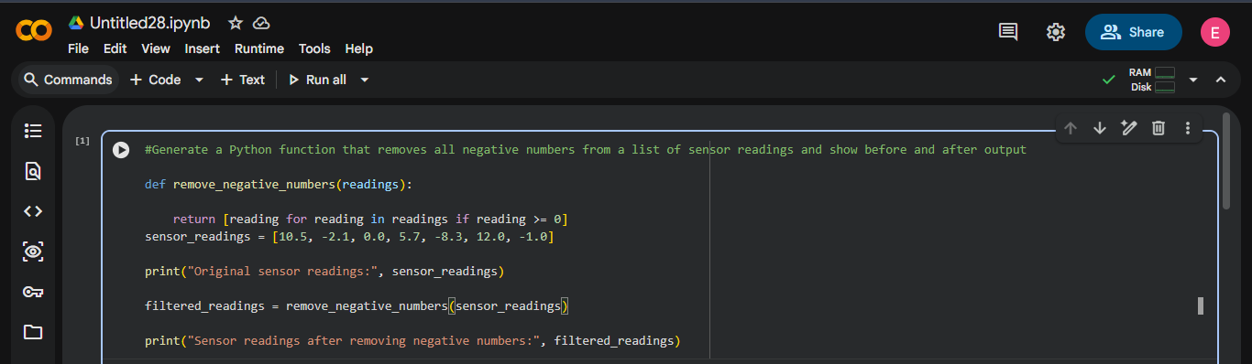

OUTPUT:
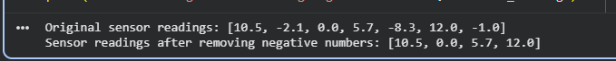

EXPLANATION:
This function removes invalid negative sensor values using list comprehension.
Only values greater than or equal to zero are retained, ensuring clean IoT sensor data.

Task 2: String Character Analysis
PROMPT: Create a Python function that counts vowels, consonants, and digits in a given string. Provide sample input and output.
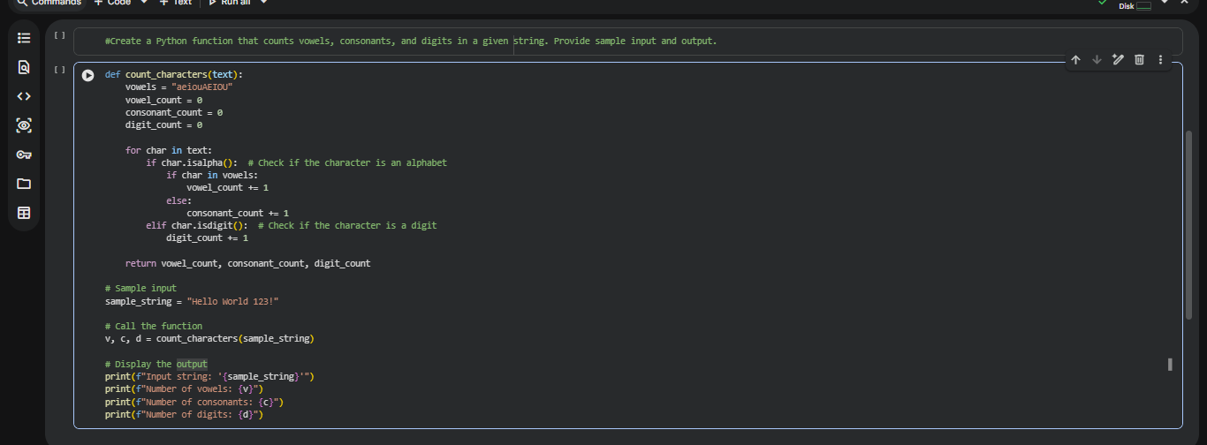
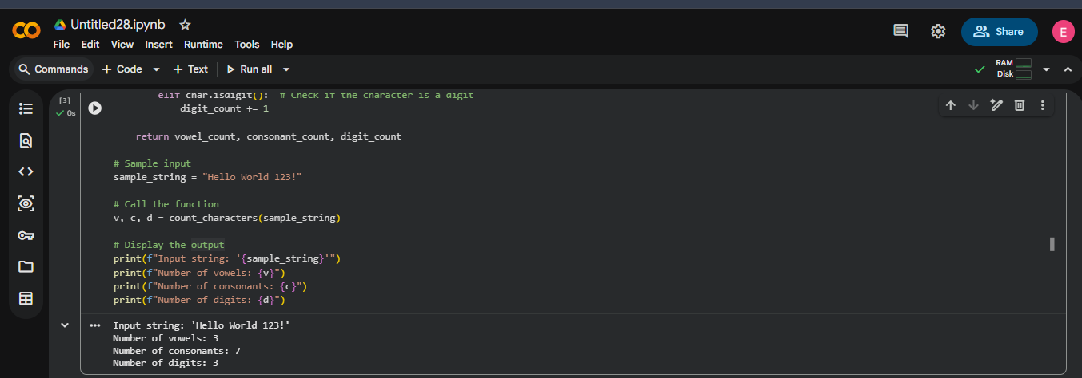

EXPLANATION:
The function iterates through each character and classifies it as a vowel, consonant, or digit.
Python string methods like isalpha() and isdigit() improve accuracy and readability.

Task 3: Palindrome Check – Tool Comparison
Gemini Prompt: Write a Python function to check if a string is a palindrome. Ignore spaces and capitalization.
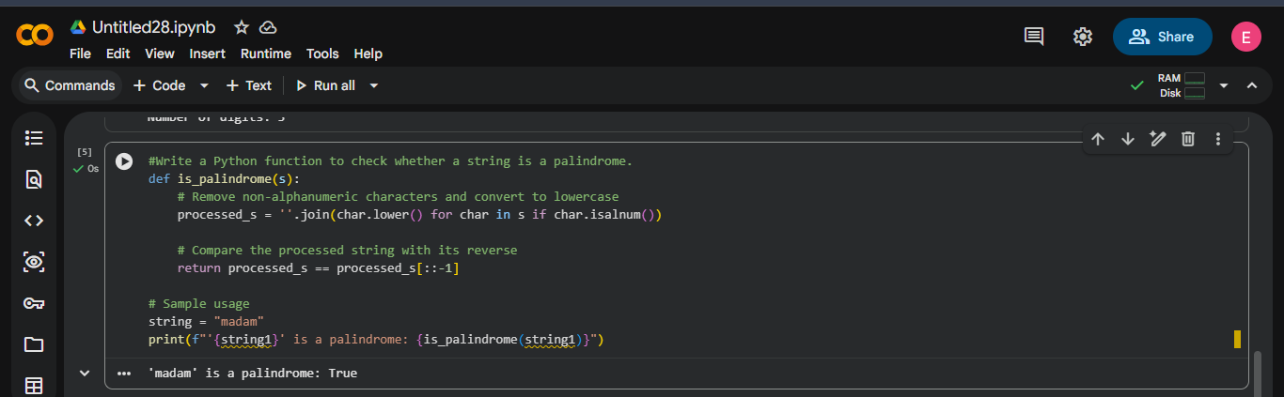

Copilot Prompt: Write a Python function to check palindrome. Consider only letters and ignore case.
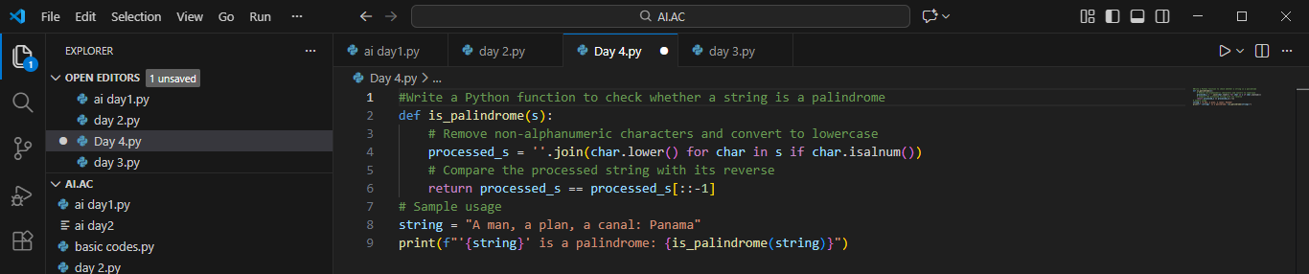

OUTPUT:
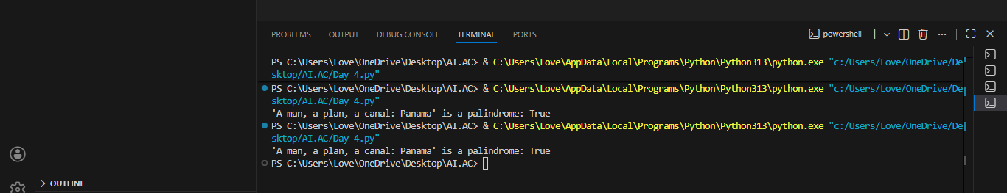

Comparison Table:
Feature | Gemini | Copilot
Clarity | Simple, minimal code | Slightly longer, more robust
Handling spaces/case | Ignores spaces, converts to lowercase | Ignores spaces and punctuation, lowercase
Readability | Very clear | Clear, slightly more detailed
Efficiency | Uses string slicing | Uses string comprehension

EXPLANATION:
Gemini provides concise and easy-to-read logic, making it beginnerfriendly.
Copilot generates more robust code that handles punctuation and special characters.

Task 4: Code Explanation Using AI Step 1 – Code Snippet:
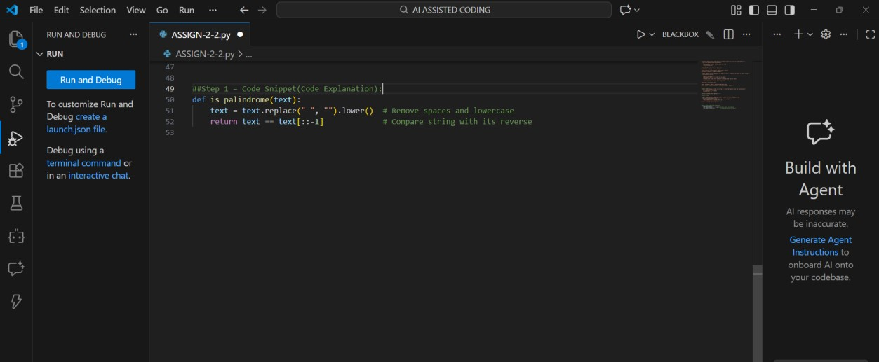

Step 2 – AI Explanation:
- text.replace(" ", "").lower() → Removes spaces and converts letters to lowercase.
- text == text[::-1] → Checks if the string is equal to its reverse.
EXPLANATION:
The function normalizes the string to avoid case and space mismatches.
It then compares the string with its reverse to verify palindrome logic.

