Harshitha Mogili
2403A51L01
Batch : 51

Lab 4: Advanced Prompt Engineering – Zero-shot, One-shot, and Few-shot Techniques

Task 1: Zero-shot Prompting

Prompt:
Write a Python function to determine whether a given number is prime.

Code :
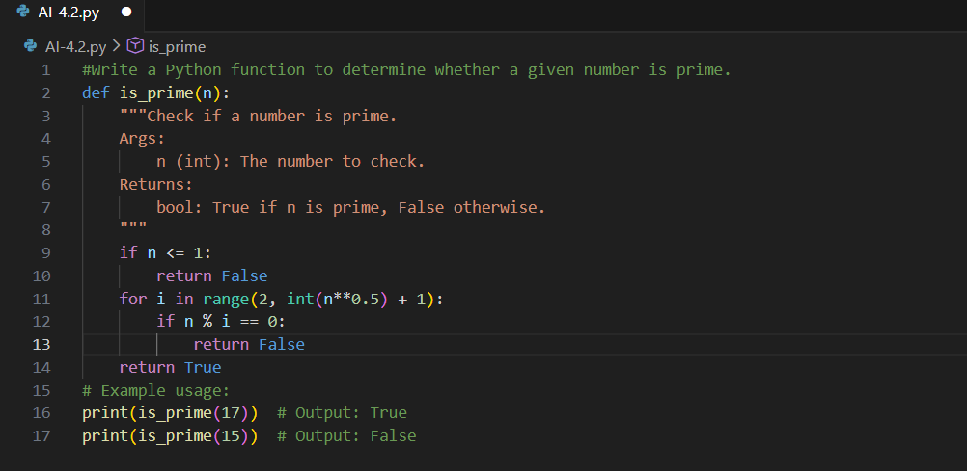

Explanation
- Uses only instruction, no examples.
- Checks divisibility up to √n.
- Correctly handles non-prime cases.

Output :
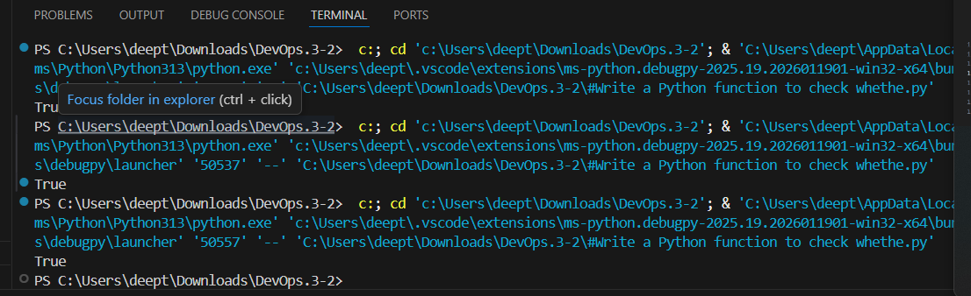

Task 2: One-shot Prompting

Prompt:
Generate a function to calculate the sum of elements in a list.

Code :
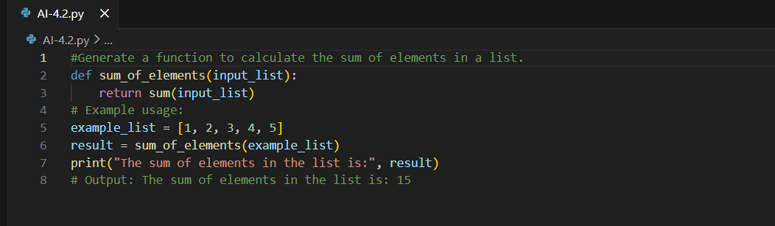

Explanation
- Single example guides the logic.
- Iterates through list and adds elements.

Output :

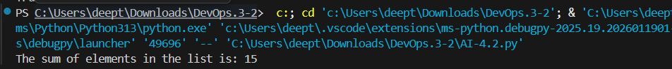

Task 3: Few-shot Prompting
Prompt :
Write a Python function that takes an alphanumeric string and returns only the digits.
Code :
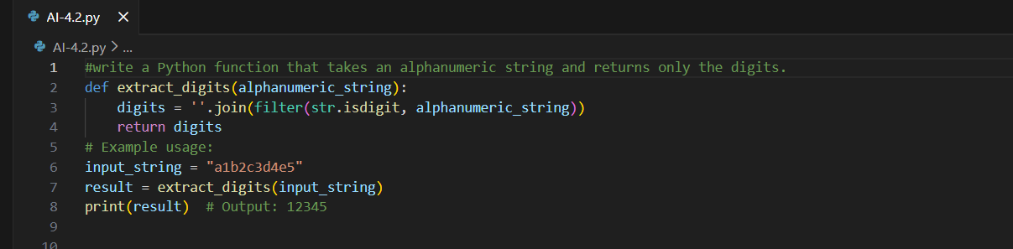

Explanation
- Multiple examples clarify pattern.
- Extracts only numeric characters.

Output :

Task 4: Zero-shot vs Few-shot Comparison (Vowel Count)

Prompt :

Write a Python function to count the number of vowels in a given string.

Code :

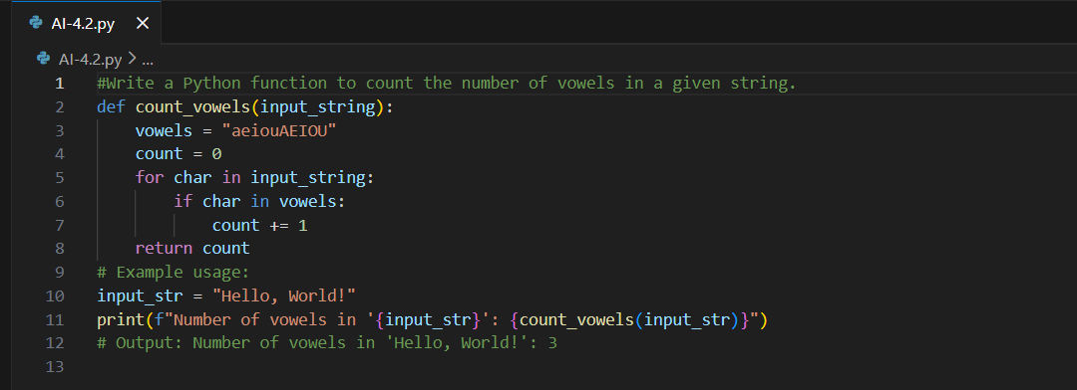

Comparison Explanation
- Zero-shot: Basic and longer logic.
- Few-shot: More optimized and concise.
- Examples help AI improve clarity and efficiency.

Output :

Task 5: Few-shot Prompting (Minimum of Three Numbers)
Prompt :
write a Python function that takes three numbers and returns the minimum value without using min().
Code :
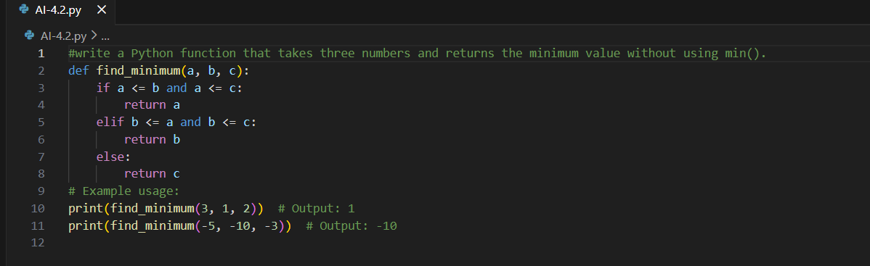

Explanation
- Uses conditional logic.
- Does not use built-in min().
- Covers all comparison cases.

Output :
