Harshitha Mogili
2403A51L01
B-51
Lab 5: Ethical Foundations – Responsible AI Coding Practices
Task Description – 1: Secure API Usage
Prompt: Generate a simple REST API for user registration.
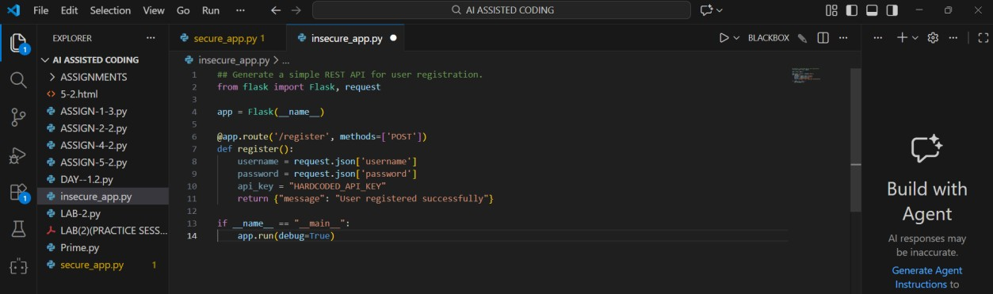
OUTPUT:
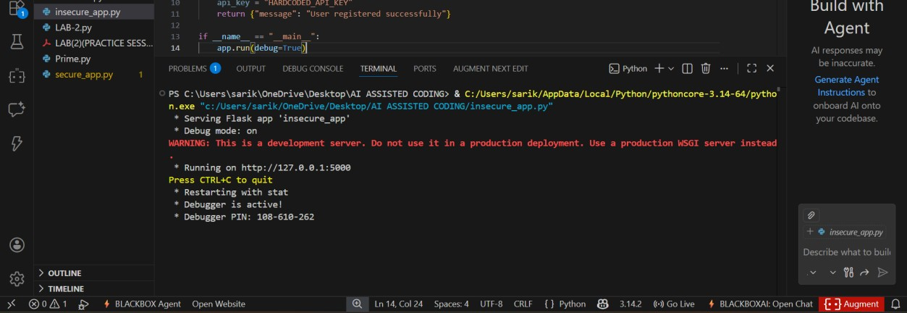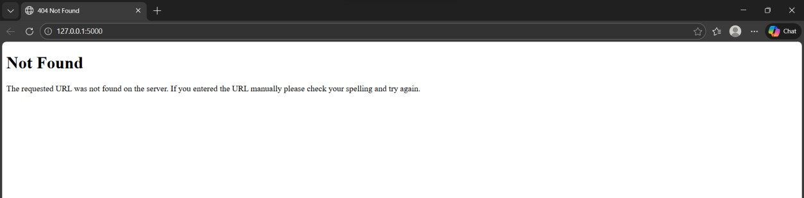
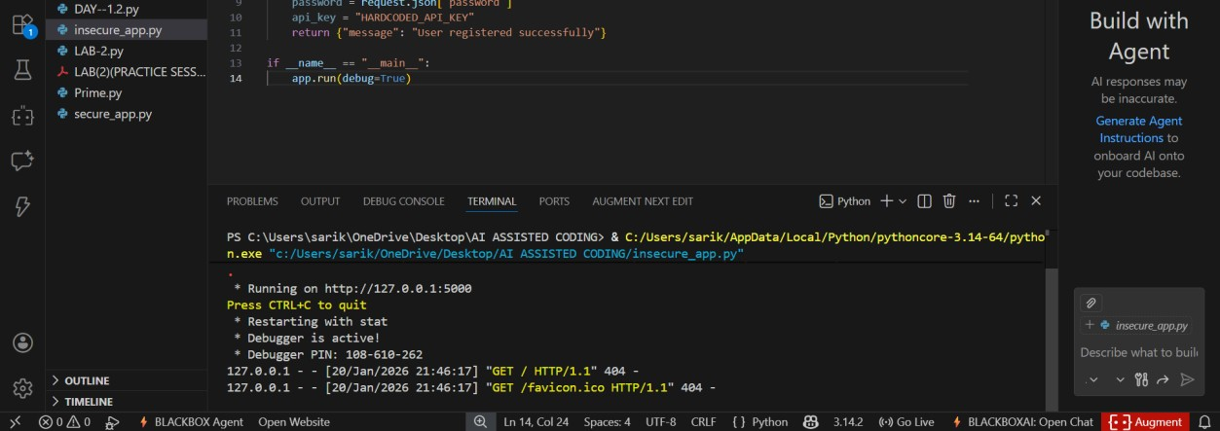
Explanation: You got 404 error because your Flask app does not have a home (/) route, so the browser cannot find that page.
Identified Security Flaws:
- API key is hardcoded, exposing sensitive credentials
- No authentication or authorization mechanism
- No input validation (password strength, missing fields)
- Password stored/used in plain text
- No token-based access control
Corrected Secure Version (Token-Based Authentication):
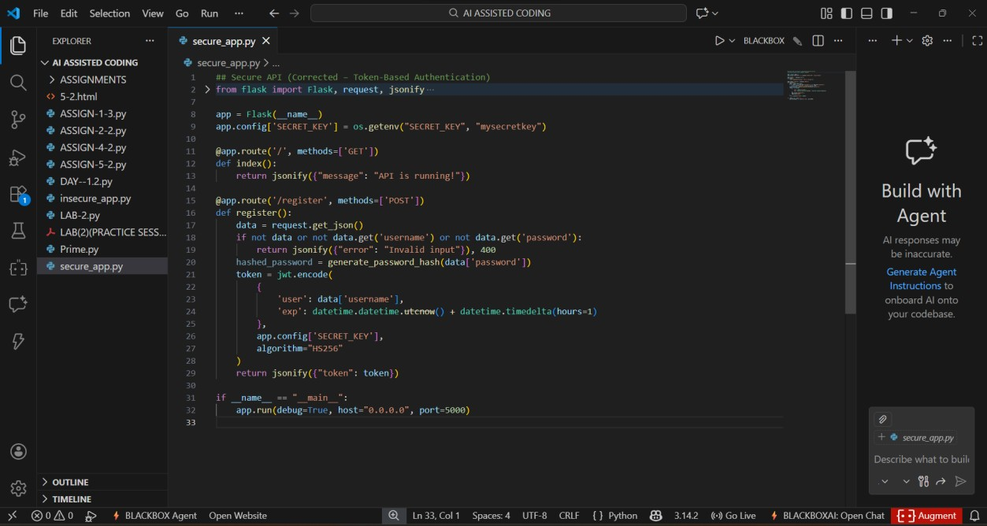
OUTPUT:
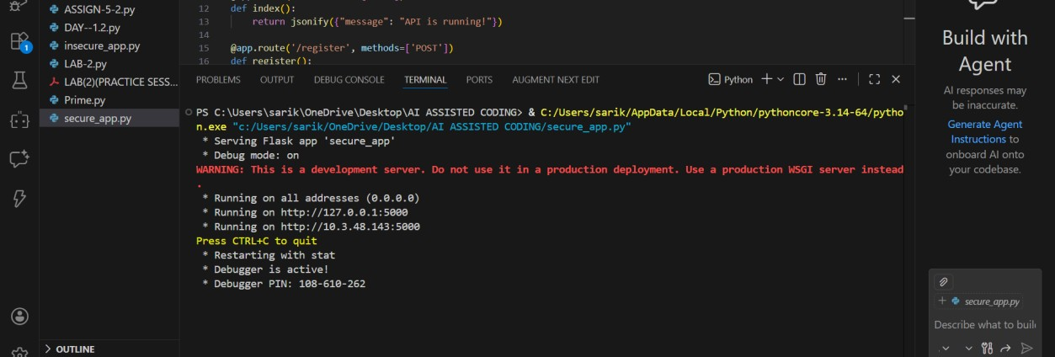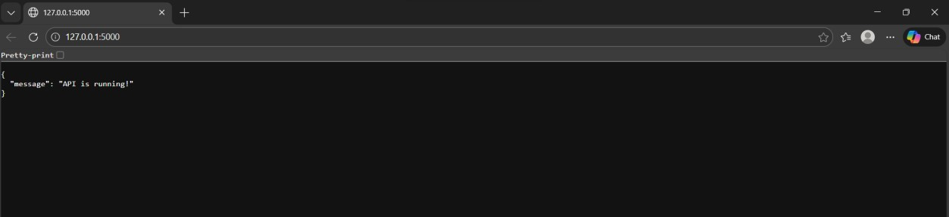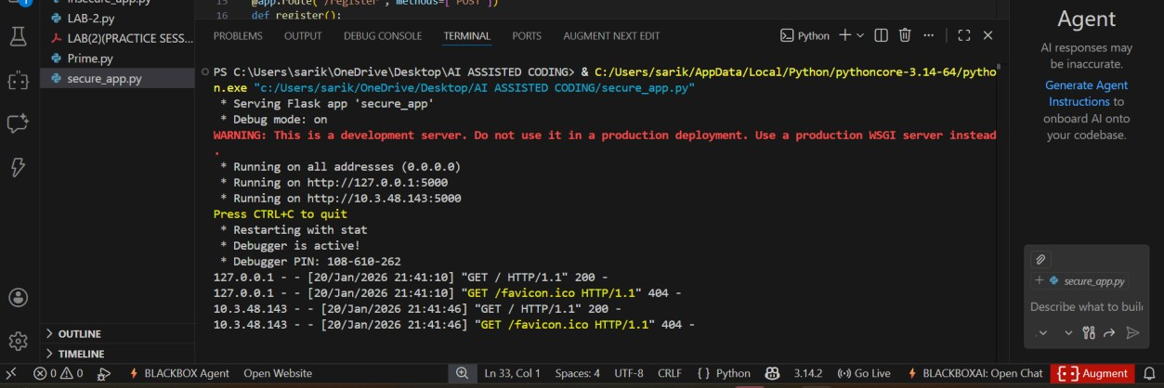
Observations: The initial API code is insecure because it uses a hardcoded API key and does not protect user data. The corrected version improves security by validating inputs, hashing passwords, and using token-based authentication for safer access control.
Task Description – 2: Fair Decision Logic
Prompt: Generate a scholarship eligibility checker based on academic score, family income, and location.
AI-Generated Code:
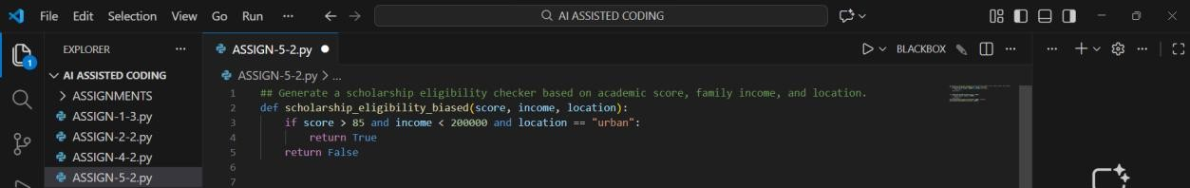
Observations:
- The logic unfairly favors urban students
- Rural or semi-urban students are excluded
- No flexibility or weighted scoring approach Improved Version:
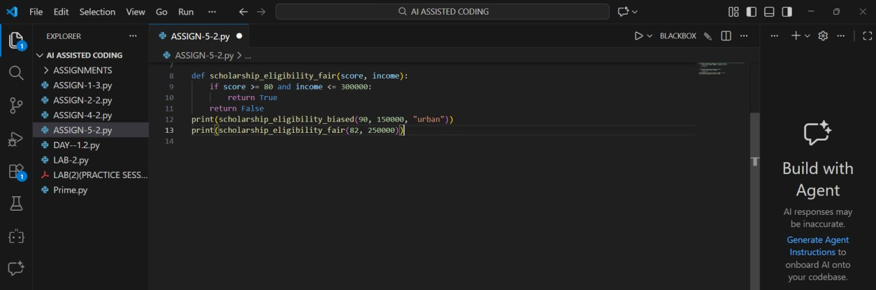
OUTPUT:
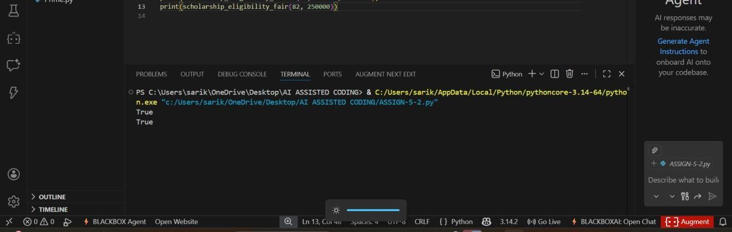
Explanation: The original logic introduces geographic bias by favoring urban students. Location should not be a deciding factor unless justified by policy. A fair system focuses on merit and economic need. Weighted or threshold-based criteria help ensure equitable access.
Task Description – 3: Explainability
Prompt: Generate a function to check whether a number is prime with comments and explanation.
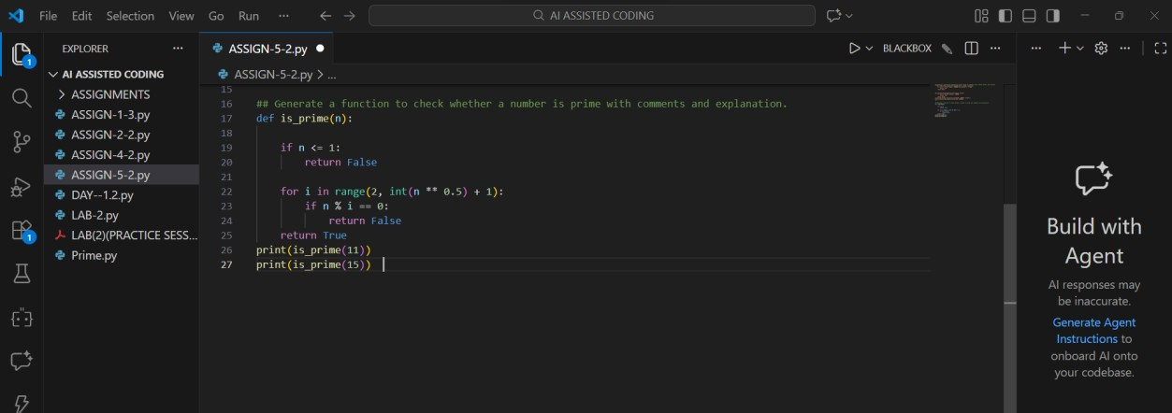
OUTPUT:
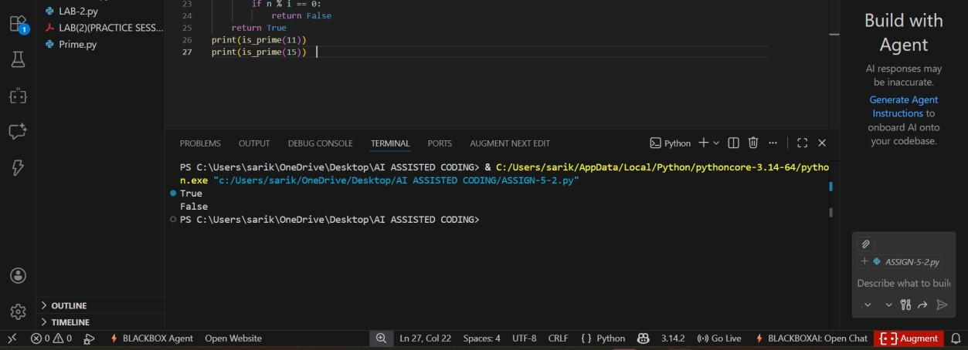
Explanation: The function first checks if the number is greater than 1. It then tests divisibility from 2 up to the square root of the number to reduce computation. If any divisor is found, the number is not prime; otherwise, it is prime.
The explanation is clear, correct, and efficient. Inline comments improve readability and help beginners understand the logic easily.
Task Description – 4: Ethical Scoring System
Prompt: Generate an employee performance evaluation system using project completion, teamwork, and attendance.
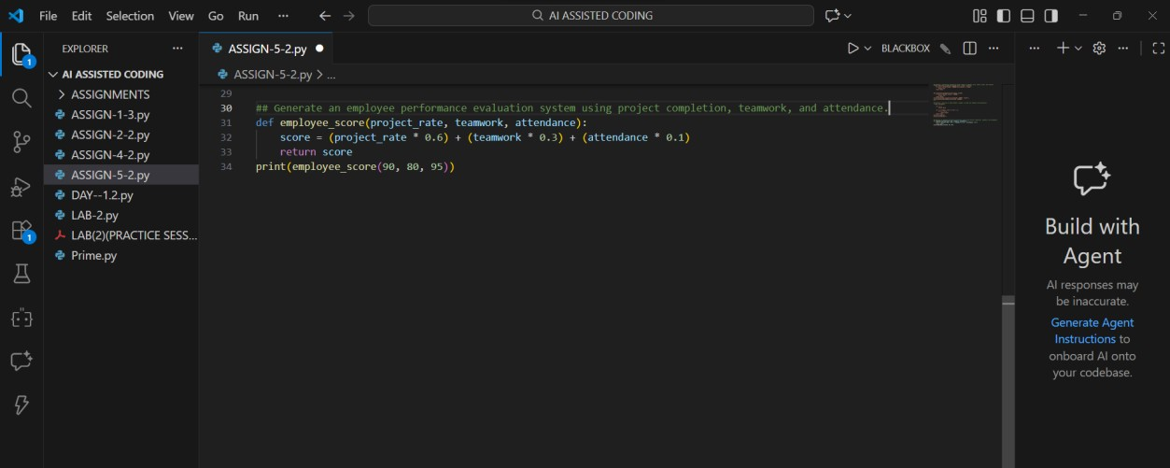
OUTPUT:
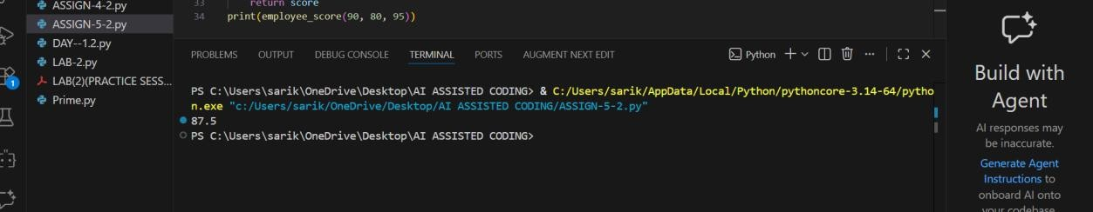
Observations:
- Heavy weight on project completion may disadvantage collaborative roles
- Attendance weighting may penalize employees with health or caregiving needs
- Teamwork score depends on subjective evaluation
The criteria are reasonable but require transparency and flexibility. Ethical systems should allow contextual review and avoid over-reliance on single metrics.
Task Description – 5: Accessibility and Inclusiveness Prompt: Generate a user feedback form application.
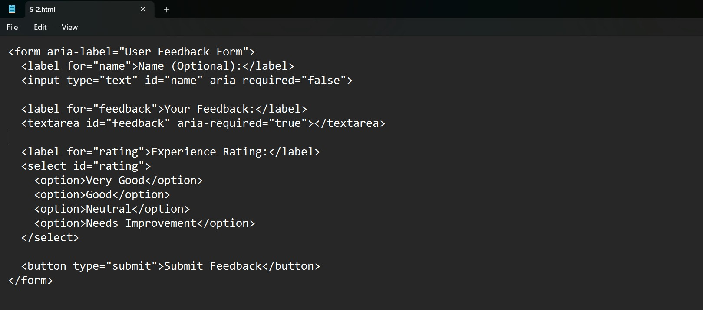
OUTPUT:
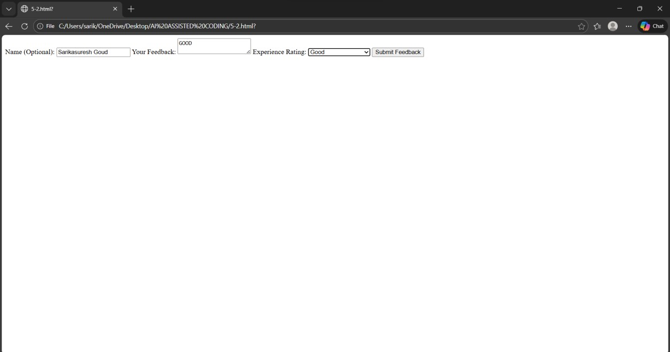
Observations: The feedback form uses neutral and inclusive language to avoid exclusion of any user group. Accessibility is enhanced through ARIA labels, optional fields, and simple input options for diverse users.

