Lab Assignment 9.2

Program : B. Tech (CSE)
Course Title : AI Assisted Coding
Course Code : 23CS002PC304
Semester : III
Academic Session : 2025-2026
Name of Student : Sankeerthana
Enrollment No. : 2403A51L41
Batch No. : 52
Date : 06-02-2026

Task 1:
Code:
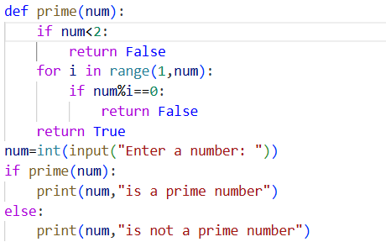
Prompt: Provide a short summary describing the purpose of the function.
Code:
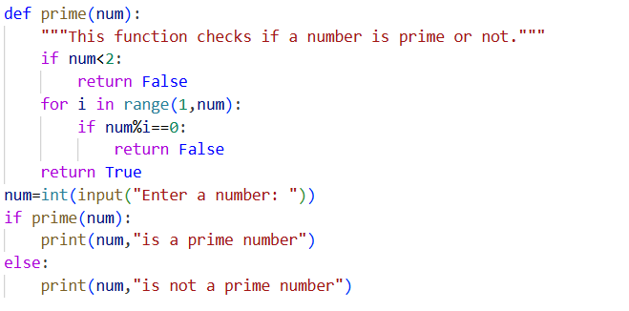

Output:
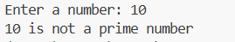
Explanation:
The first code is just a normal code. The code cannot understand to others.
The second tells the purpose of the code.
Task 2:
Code:

Prompt: Provide the document the logic behind the conditional statements and loops used in the function.
Code:
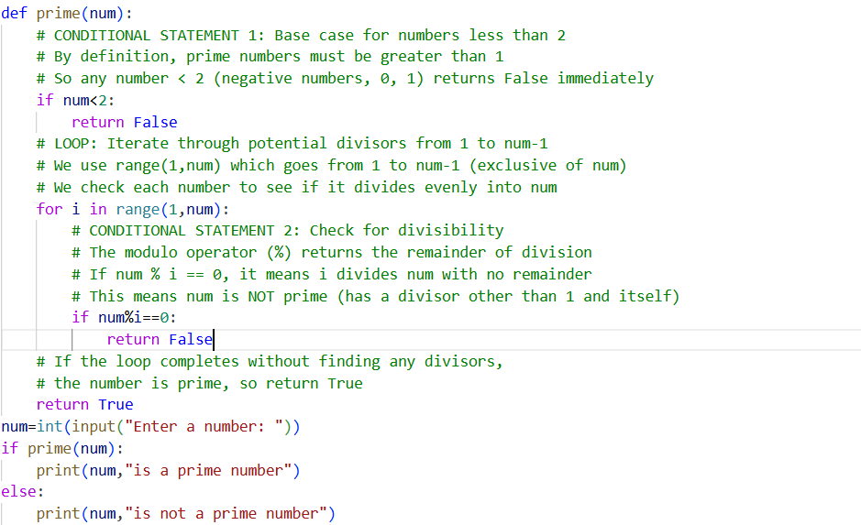

Output:

Explanation:
The first code is just a normal code. The code cannot understand to others.
And the second code gives the detailed explanation of loops & conditional statements used in the code.
Task 3:
Code:

Prompt: Generate a high-level overview describing the functionality of an entire Python file.
Code:
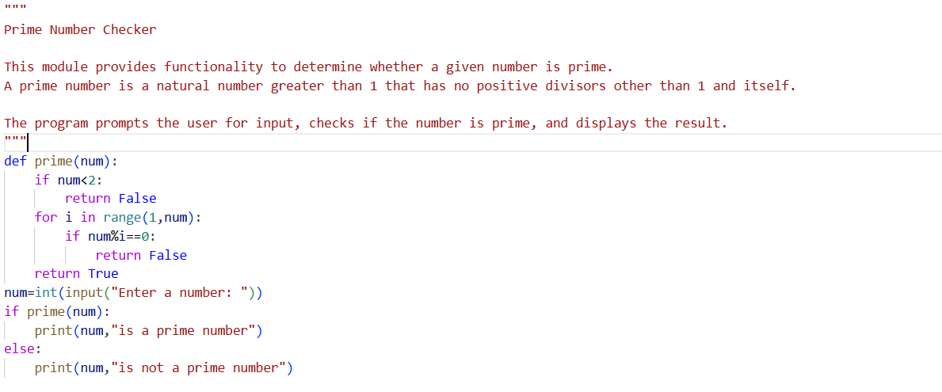
Output:


Explanation:
The first code is just a normal code. The code cannot understand to others.
And the second code explains the functionality of code.
Task 4:
Code:
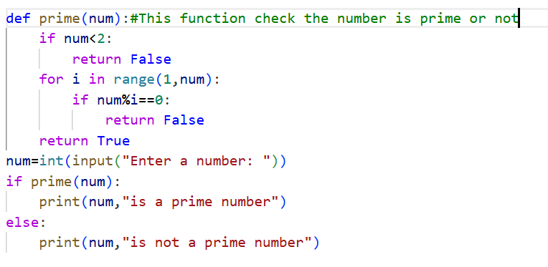
Prompt: A Python file with a clear and concise file-level overview at the beginning.
Code: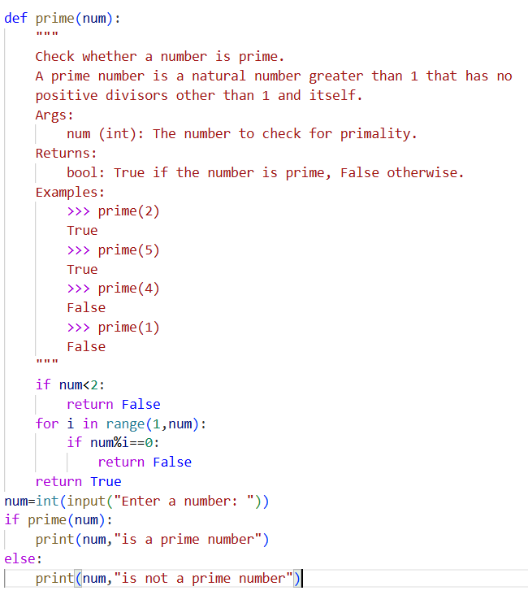
Output:

Explanation:
The first code just explains what the functions does.
But the second code explains with different examples.
Task 5:
Code:

Prompt: Provide a brief explanation of the code
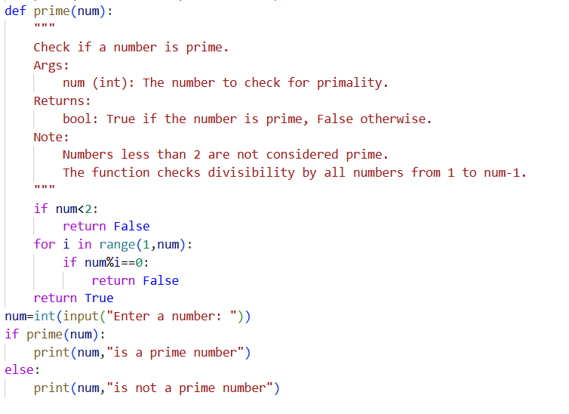
Prompt: Provide a detailed explanation of the code
Code:
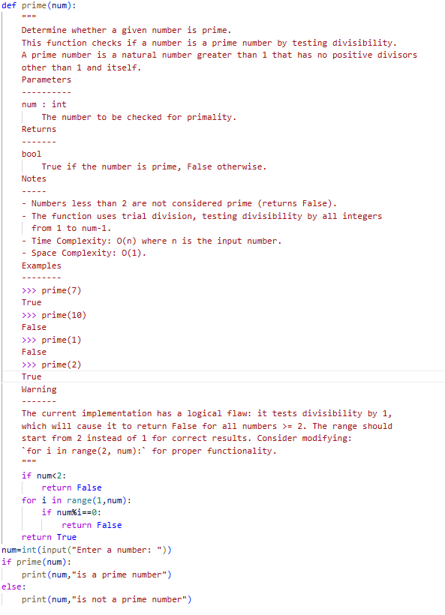

Output:
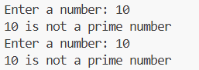
Comparison table:
Aspect | Brief Explanation Code | Detailed Explanation Code
Completeness | Provides a basic overview of the function's purpose. | Offers a comprehensive description including parameters, return values, notes, examples, and warnings.
Clarity | Simple and straightforward, but may lack depth. | Clear and detailed, making it easier to understand the  function's behaviour and edge cases.
Accuracy | Contains a logical flaw in the implementation (checks in divisibility by 1). | Accurately describes the function's intent but also highlights the flaw in the implementation, suggesting a correction.
Usefulness | Useful for quick reference but may lead to misunderstandings due to lack of detail. | Highly useful for developers needing in-depth understanding and correct usage of the function.

