School of Computer Science and Artificial Intelligence

Lab Assignment 6.5

Program : B. Tech (CSE)
Course Title : AI Assisted Coding
Course Code : 23CS002PC304
Semester : III
Academic Session : 2025-2026
Name of Student : Ganesh
Enrollment No. : 2403A51L55
Batch No. : 52
Date : 23-01-2026

Task 1
Prompt 1: Write a Python code to check voting eligibility based on age and citizenship using conditional statements
Code:
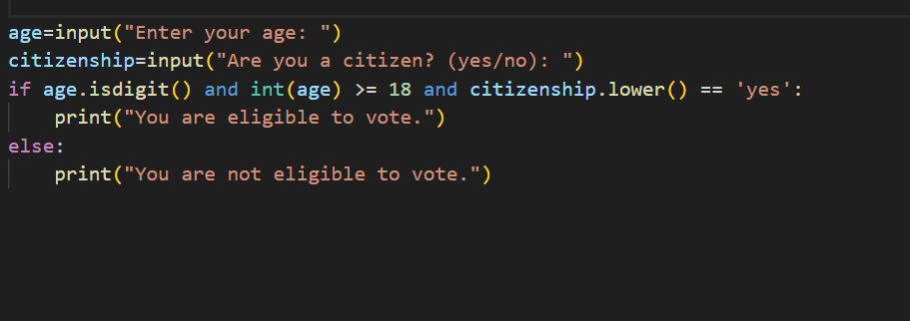

Output:
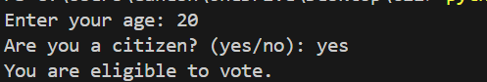

Explanation:
The code first takes the user's age and citizenship status as input.
It then checks if the age is a digit and if it is 18 or older.
Additionally, it checks if the citizenship input is 'yes' .

TASK2
Prompt : Python code to count vowels and consonants in a string using loop

Code:

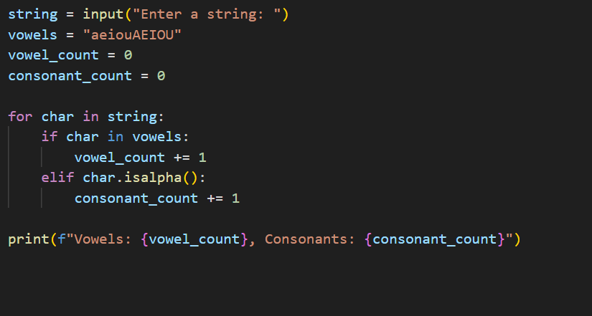
Output:
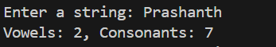

Explanation:
The code takes a string input from the user and initializes counters for vowels and consonants
It then iterates through each character in the string, checking if it is a vowel or consonant,
and increments the respective counter. Finally, it prints the counts of vowels and consonants.

TASK 3:
Prompt: Python program for a library management system using classes, loops, and conditional statements.
Code:

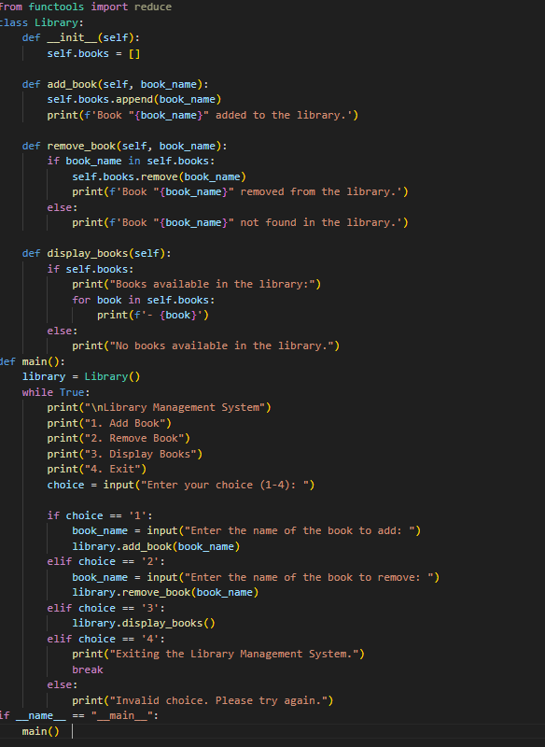

Output:

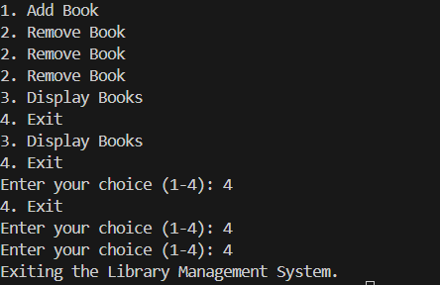

Explaination:
This Python program implements a simple library management system using classes, loops, and conditional statements.
The Library class contains methods to add, remove, and display books in the library.
The main function provides a user interface to interact with the library system through a menu-driven approach
The program runs in a loop until the user chooses to exit, allowing multiple operations on the library.

TASK 4:
Prompt: Python class to mark and display student attendance using loops.
CODE:

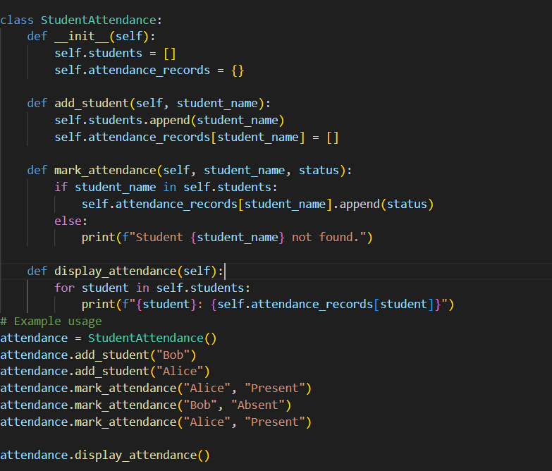
OUTPUT:
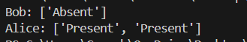

Explanation:
The StudentAttendance class allows you to manage student attendance.
You can add students, mark their attendance as "Present" or "Absent",
and display the attendance records for all students using loops.

TASK5
PROMPT: Python program using loops and conditionals to simulate an ATM menu.
CODE:

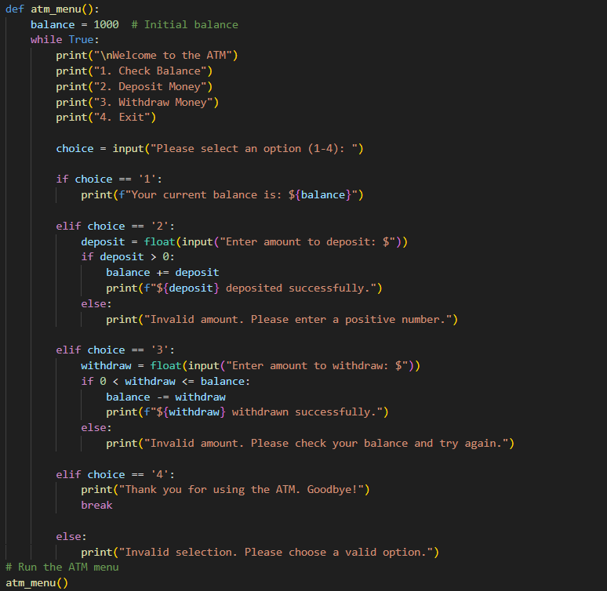

OUTPUT:
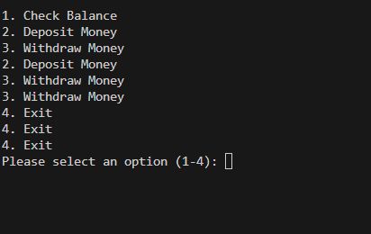

Explanation:

This program simulates a simple ATM menu using a while loop to continuously display options until the
user decides to exit. It uses conditionals to handle different user choices such as checking balance,depositing money, withdrawing money, and exiting program. The balance is updated accordingly based on user actions. on deposits and withdrawals.

