Task-2:
Prompt: Write a python program to generate a is_prime() Python function.
Code :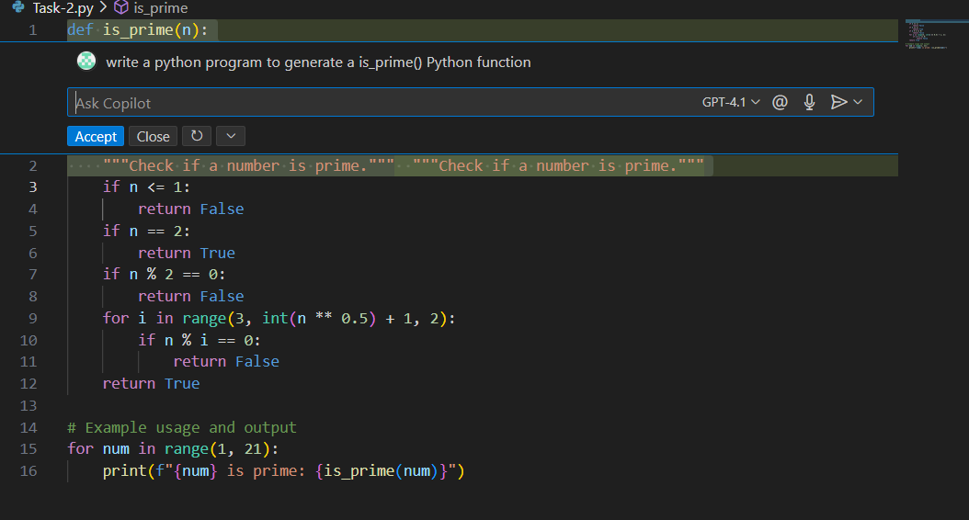

Output:
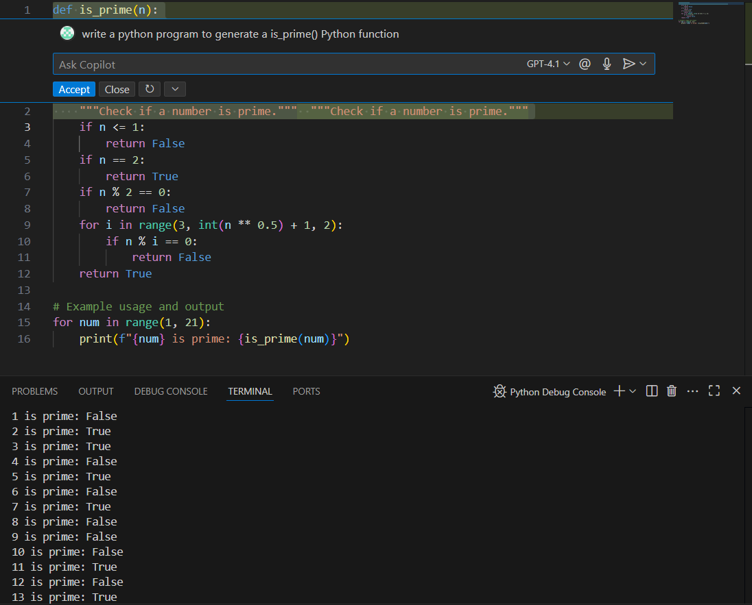
Task-3:
Prompt: Generate a function for function to reverse a string with output.
Code:
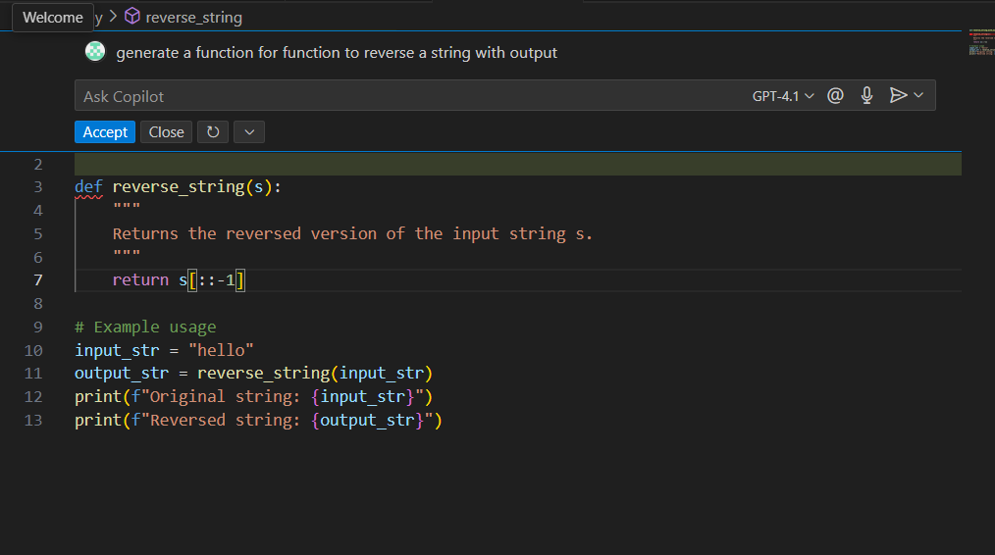

Output:
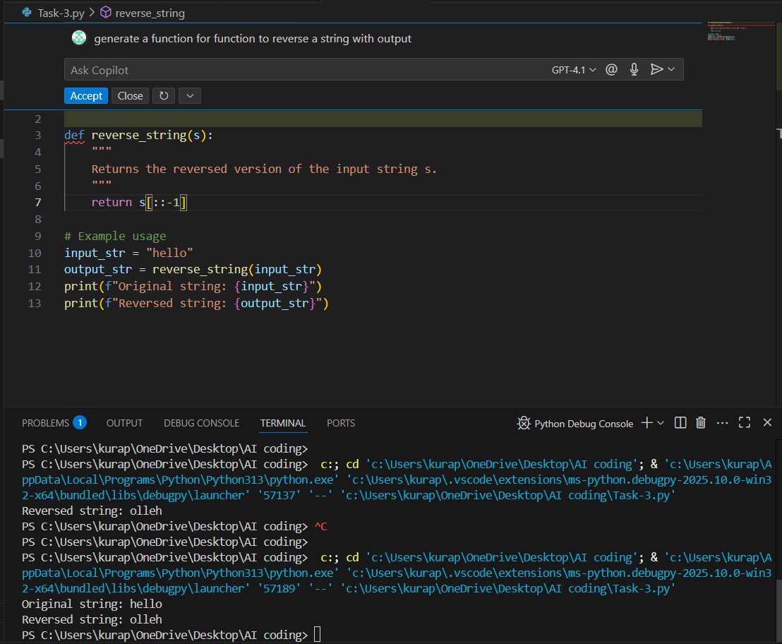

Task-4:
Prompt : Write a python code to generate both recursive and iterative versions of a factorial using comments.
Code:
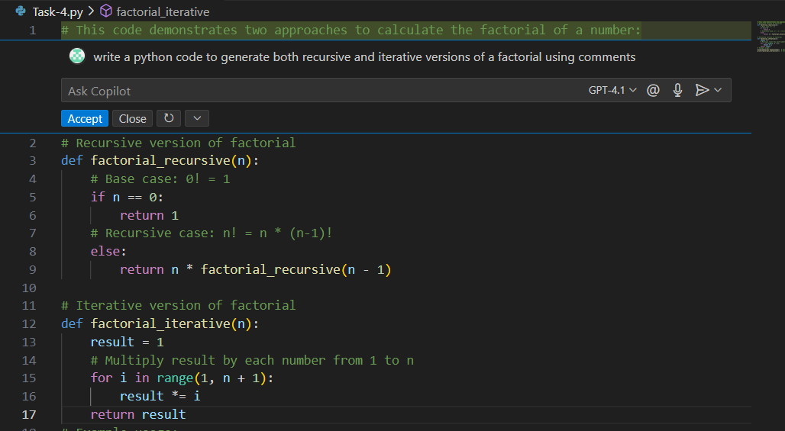

Output:
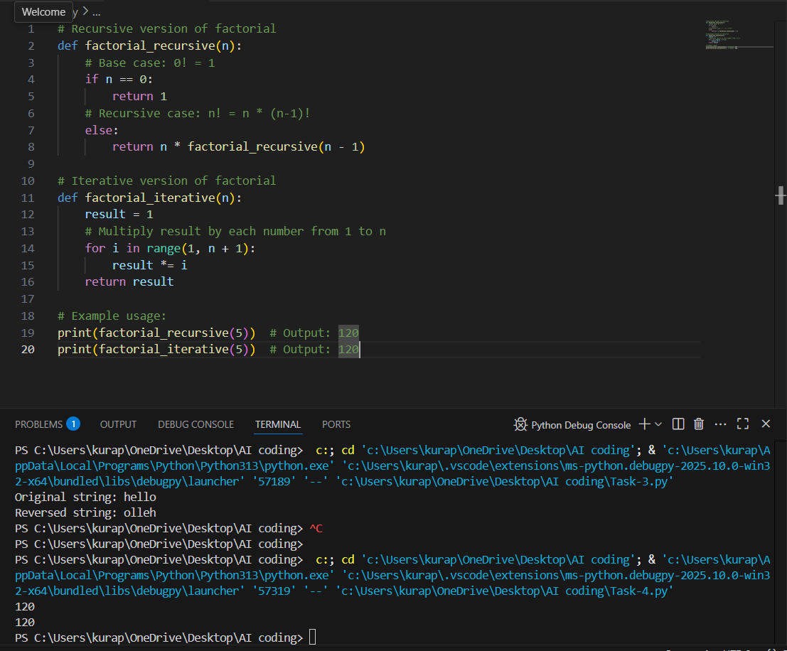

Task-5:
Prompt : write a python program to generate largest number in a list with output.
Code: 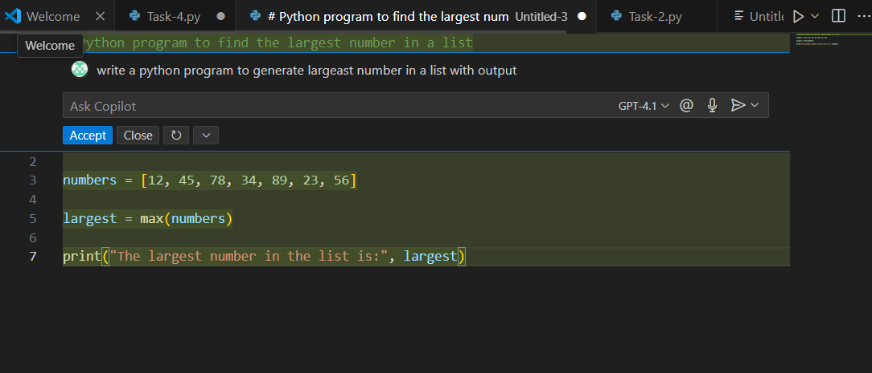

Output:
