AI ASSISTED CODING
ASSIGNMENT – 10.4
NAME : M.SIRI
HALL.NO : 2403A52400
BATCH : AI 14

TASK – 1
CODE:
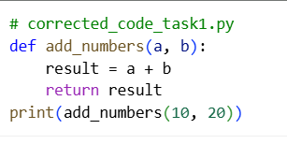
OUTPUT :

CODE EXPLANATION :
- def add_numbers(a, b):: This line defines the function named add_numbers and specifies that it accepts two parameters, a and b.
- result = a + b: Inside the function, this line adds the values of a and b and assigns the sum to a variable named result.
- return result: This line returns the value stored in the result variable, which is the sum of a and b.
- print(add_numbers(10, 20)): This line calls the add_numbers function with the arguments 10 and 20. The function returns 30, which is then printed to the console.

TASK – 2
CODE :
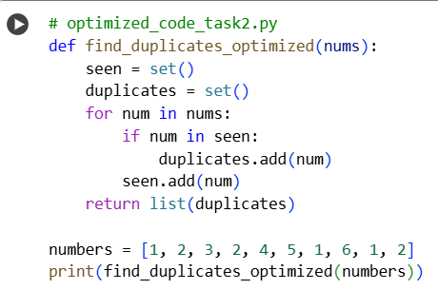

OUTPUT :


CODE EXPLANATION :
- def find_duplicates_optimized(nums):: This line defines the function named find_duplicates_optimized and specifies that it accepts one parameter, nums, which is expected to be a list of numbers.
- seen = set(): This line initializes an empty set called seen. This set will be used to keep track of the numbers encountered so far. Using a set for this purpose allows for very fast lookups.
- duplicates = set(): This line initializes an empty set called duplicates. This set will store the numbers that are found to be duplicates.
- for num in nums:: This line starts a loop that iterates through each number in the input list nums.
- if num in seen:: Inside the loop, this line checks if the current number (num) is already present in the seen set. If it is, it means this is a duplicate number.
- duplicates.add(num): If the number is found in the seen set (i.e., it's a duplicate), this line adds the number to the duplicates set.
- seen.add(num): After checking for duplicates, this line adds the current number (num) to the seen set. This ensures that the next time this number is encountered, it will be identified as a duplicate.
- return list(duplicates): After the loop finishes, this line converts the duplicates set into a list and returns it.
- numbers = [1, 2, 3, 2, 4, 5, 1, 6, 1, 2]: This line creates a list of numbers to be used as input for the function.
10.print(find_duplicates_optimized(numbers)): This line calls the find_duplicates_optimized function with the numbers list and prints the returned list of duplicates to the console.
TASK -3
CODE :
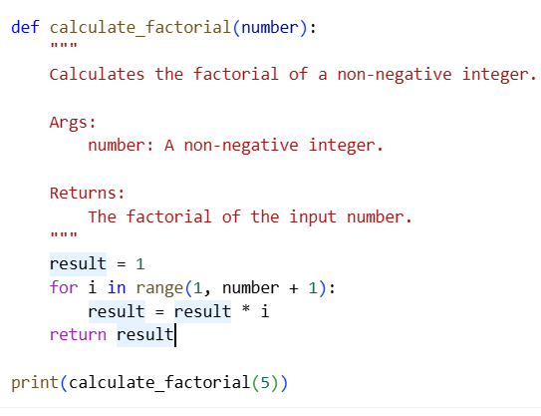
OUTPUT :


CODE EXPLANATION :
- def calculate_factorial(number):: This line defines the function named calculate_factorial and specifies that it accepts one parameter, number, which is expected to be a non-negative integer.
- """ ... """: This is a docstring, which provides a brief explanation of what the function does, its arguments, and what it returns.
- result = 1: This line initializes a variable called result to 1. This is because the factorial of 0 is 1, and it also serves as the starting point for the multiplication in the loop.
- for i in range(1, number + 1):: This line starts a for loop that iterates from 1 up to and including the value of number.
- result = result * i: Inside the loop, this line multiplies the current value of result by the current value of i and updates result with the new value. This repeatedly multiplies result by each integer from 1 up to number.
- return result: After the loop finishes, this line returns the final value of result, which is the factorial of the input number.
- print( calculate_factorial(5)): This line calls the calculate_factorial function with the argument 5 and prints the returned value (which is 120, the factorial of 5) to the console.

TASK – 4
CODE :
# enhanced_code_task4.py
import sqlite3

def get_user_data_enhanced(user_id):
"""
Retrieves user data from the database with enhanced security and error handling.

Args:
user_id: The ID of the user to retrieve.

Returns:
The user data if found, otherwise None.
"""
conn = None # Initialize connection to None
try:
# Input validation: Check if user_id is a digit
if not str(user_id).isdigit():
print("Invalid user ID. Please enter a numeric ID.")
return None

conn = sqlite3.connect("users.db")
cursor = conn.cursor()

# Use parameterized query to prevent SQL injection
query = "SELECT * FROM users WHERE id = ?;"
cursor.execute(query, (user_id,))

result = cursor.fetchall()
return result

except sqlite3.Error as e:
print(f"Database error: {e}")
return None
except Exception as e:
print(f"An unexpected error occurred: {e}")
return None
finally:
if conn:
conn.close()

# Example usage:
# Create a dummy database and table for demonstration
conn = sqlite3.connect("users.db")
cursor = conn.cursor()
cursor.execute("DROP TABLE IF EXISTS users;")
cursor.execute("CREATE TABLE users (id INTEGER PRIMARY KEY, name TEXT);")
cursor.execute("INSERT INTO users (name) VALUES ('Alice');")
cursor.execute("INSERT INTO users (name) VALUES ('Bob');")
conn.commit()
conn.close()

user_input = input("Enter user ID: ")
user_data = get_user_data_enhanced(user_input)

if user_data:
print("User Data:", user_data)
else:
print("User not found or invalid input.")

OUTPUT :
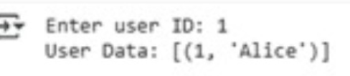
CODE EXPLANATION :
- import sqlite3: This line imports the sqlite3 library, which provides an interface for working with SQLite databases.
- def get_user_data_enhanced(user_id):: This defines the function get_user_data_enhanced that takes one argument, user_id.
- """ ... """: This is a docstring explaining the function's purpose, arguments, and return value.
- conn = None: Initializes the database connection variable conn to None. This is good practice for error handling in the finally block.
- try:: This block starts a try...except...finally block to handle potential errors during database operations.
- if not str(user_id).isdigit():: This performs input validation. It checks if the user_id can be converted to a digit string. If not, it prints an error message and returns None.
- conn = sqlite3.connect("users.db"): This line establishes a connection to the SQLite database file named "users.db". If the file doesn't exist, it will be created.
- cursor = conn.cursor(): This creates a cursor object, which is used to execute SQL commands.
- query = "SELECT * FROM users WHERE id = ?;": This defines the SQL query to select all columns from the users table where the id matches the provided user_id. The ? is a placeholder for a parameterized query, which helps prevent SQL injection.
- cursor.execute(query, (user_id,)): This executes the SQL query. The user_id is passed as a tuple (user_id,) to the execute method, which safely substitutes the placeholder.
- result = cursor.fetchall(): This fetches all rows from the result of the query and stores them in the result variable.
- return result: The function returns the fetched user data (or an empty list if no user is found).
- except sqlite3.Error as e:: This block catches any sqlite3.Error exceptions that occur during the database operations, prints an error message including the specific error, and returns None.
- except Exception as e:: This block catches any other unexpected exceptions, prints a generic error message, and returns None.
- finally:: This block is always executed, regardless of whether an exception occurred or not.
- if conn:: This checks if the conn variable is not None (meaning the connection was successfully established).
- conn.close(): If the connection exists, this line closes the database connection.
- The code outside the function sets up a dummy database and table named users with two entries ('Alice' and 'Bob') for demonstration purposes.
- user_input = input("Enter user ID: "): This line prompts the user to enter a user ID.
- user_data = get_user_data_enhanced(user_input): This calls the get_user_data_enhanced function with the user's input.
- if user_data:: This checks if the function returned any data.
- print("User Data:", user_data): If data is returned, it prints the user data.
- else: print("User not found or invalid input."): If no data is returned (either because the user was not found or the input was invalid), it prints a corresponding message.

TASK – 5
CODE :
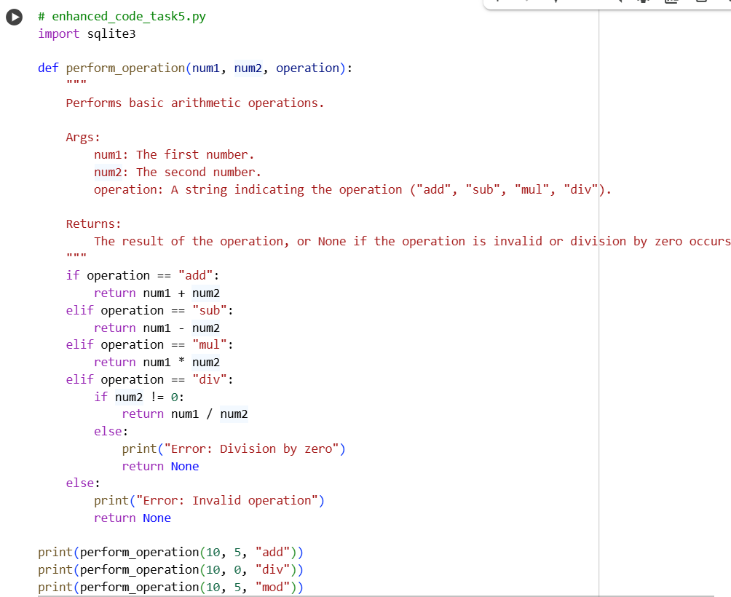

OUTPUT :
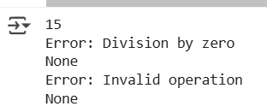

CODE EXPLANATION :
- # enhanced_code_task5.py: This is a comment indicating the filename, though it doesn't affect the code's execution.
- import sqlite3: This line imports the sqlite3 library. While imported, it's not actually used in the perform_operation function itself. It might be leftover from a previous context or intended for future expansion.
- def perform_operation(num1, num2, operation):: This defines the function perform_operation that accepts three arguments: num1 (the first number), num2 (the second number), and operation (a string specifying the operation).
- """ ... """: This is a docstring that explains the function's purpose, arguments, and what it returns.
- if operation == "add":: This is the start of an if-elif-else block that checks the value of the operation string. If it's "add", it proceeds to the next line.
- return num1 + num2: If the operation is "add", this line returns the sum of num1 and num2.
- elif operation == "sub":: If the operation is not "add", this checks if it's "sub".
- return num1 - num2: If the operation is "sub", this line returns the difference between num1 and num2.
- elif operation == "mul":: If the operation is neither "add" nor "sub", this checks if it's "mul".
- return num1 * num2: If the operation is "mul", this line returns the product of num1 and num2.
- elif operation == "div":: If the operation is none of the above, this checks if it's "div".
- if num2 != 0:: Inside the "div" block, this nested if statement checks if the second number (num2) is not equal to 0. This is crucial for preventing division by zero errors.
- return num1 / num2: If the operation is "div" and num2 is not 0, this line returns the result of dividing num1 by num2.
- else:: This else block is executed if the operation is "div" but num2 is 0.
- print("Error: Division by zero"): This line prints an error message to the console indicating division by zero.
- return None: After printing the error, this line returns None to indicate that the division operation could not be completed successfully.
- else:: This else block is executed if the operation string does not match any of the valid operations ("add", "sub", "mul", "div").
- print("Error: Invalid operation"): This line prints an error message indicating that the provided operation is invalid.
- return None: After printing the error, this line returns None to indicate an invalid operation.
- print(perform_operation(10, 5, "add")): These lines demonstrate how to call the perform_operation function with different arguments and print the returned results. The first call performs addition (10 + 5 = 15).
- print(perform_operation(10, 0, "div")): This call attempts division by zero, which triggers the error handling for that case, printing an error message and returning None.
- print(perform_operation(10, 5, "mod")): This call uses an invalid operation ("mod"), which triggers the error handling for invalid operations, printing an error message and returning None.

