AI ASSISTED CODING
ASSIGNMENT-8.1
BATCH NO: 14
HALL TICKET NO:2403A52400
>Lab 8: Test-Driven Development with AI – Generating and Working with Test Cases.
Task Description #1 (Password Strength Validator – Apply AI in Security Context)
- Task: Apply AI to generate at least 3 assert test cases for is_strong_password(password) and implement the validator function.
- Requirements:
Password must have at least 8 characters.
Must include uppercase, lowercase, digit, and character .Must not contain spaces.
CODE AND OUTPUT SCREENSHOT
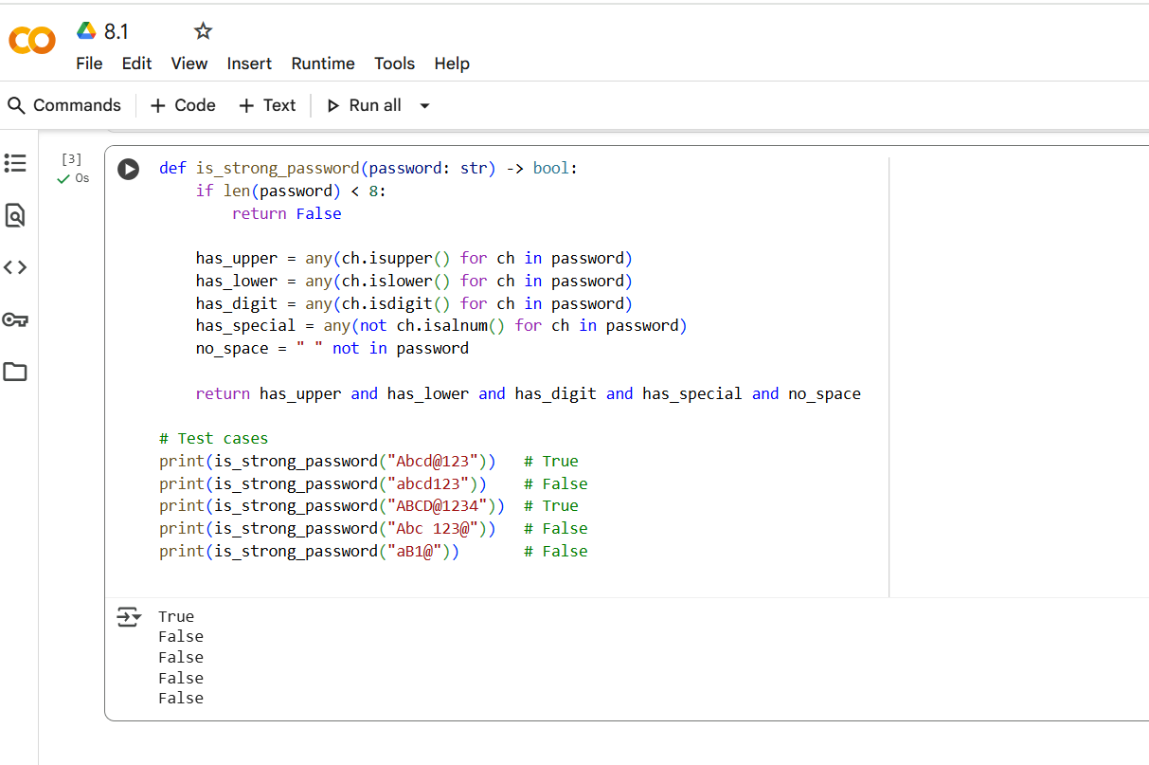
EXPLANTION OF CODE
- Length Check: It first checks if the password is at least 8 characters long. If not, it immediately returns False.
- Character Type Checks: It then uses any() with generator expressions to check for the presence of different character types:
  - has_upper: Checks if there's at least one uppercase letter.
  - has_lower: Checks if there's at least one lowercase letter.
  - has_digit: Checks if there's at least one digit.
  - has_special: Checks if there's at least one character that is not alphanumeric (i.e., a special character).
- Space Check: no_space checks if the password contains any spaces.
- Final Return: Finally, it returns True only if all the checks (has_upper, has_lower, has_digit, has_special, and no_space) are true. Otherwise, it returns False.
The print statements at the end call the function with different passwords and print the resulting boolean value to the console, showing whether each password is considered strong or not based on the function's logic.
Task Description #2 (Number Classification with Loops – Apply AI for Edge Case Handling)
- Task: Use AI to generate at least 3 assert test cases for a classify_number(n) function. Implement using loops.
- Requirements:
  - Classify numbers as Positive, Negative, or Zero.
  - Handle invalid inputs like strings and None.
Include boundary conditions (-1, 0, 1).
CODE AND OUTPUT SCREENSHOT
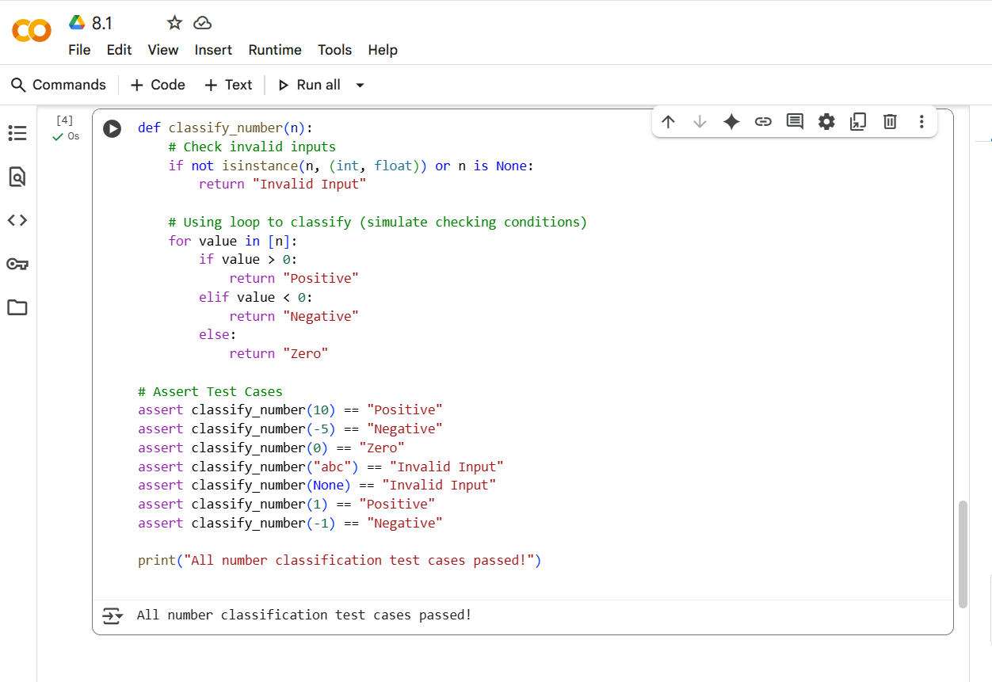
EXPLANTION OF CODE
- Invalid Input Check: It first checks if the input n is not an instance of either int or float, or if it is None. If any of these conditions are true, it returns the string "Invalid Input".
- Classification Loop (Simulated): The code then uses a for loop that iterates over a list containing only the input value n. This loop structure is a bit unusual for this simple case, but it effectively processes the input:
  - If value (which is n) is greater than 0, it returns "Positive".
  - If value is less than 0, it returns "Negative".
  - Otherwise (if value is 0), it returns "Zero".
- Test Cases: The code includes several assert statements that test the function with different inputs (positive, negative, zero, string, and None) to ensure it returns the expected output for each case. If any of these assertions fail, an AssertionError will be raised.
- Success Message: If all the assert statements pass without raising an error, it prints "All number classification test cases passed!" to the console.
Task Description #3 (Anagram Checker – Apply AI for String Analysis)
- Task: Use AI to generate at least 3 assert test cases for is_anagram(str1, str2) and implement the function.
- Requirements:
  - Ignore case, spaces, and punctuation.
  - Handle edge cases (empty strings, identical words).
CODE AND OUTPUT SCREENSHOT
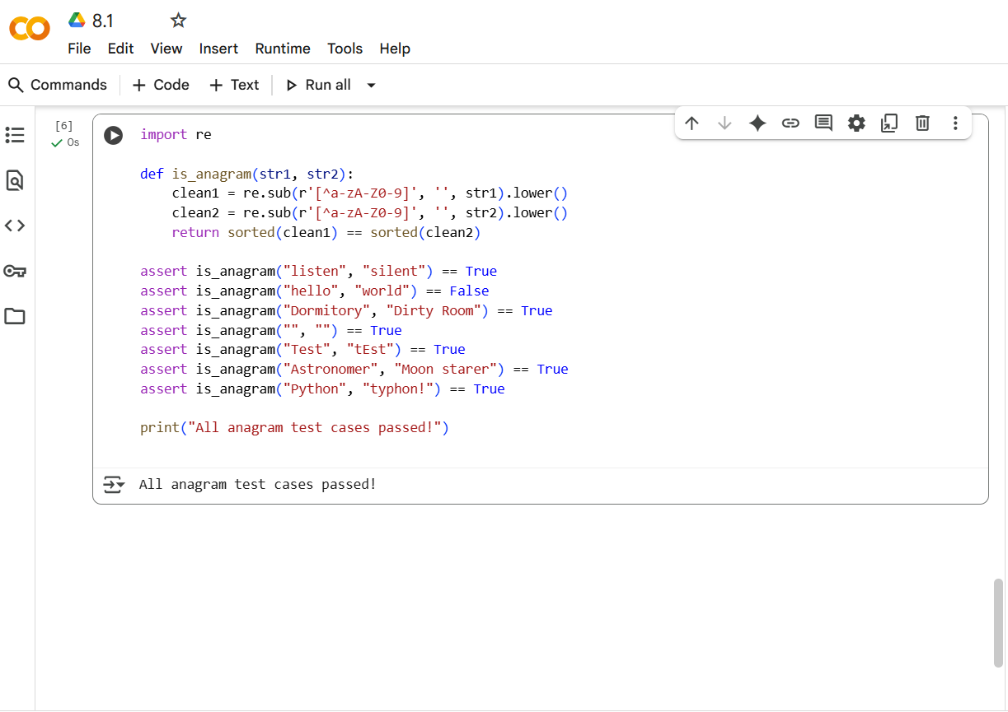
EXPLANTION OF CODE
- Clean Strings:
  - re.sub(r'[^a-zA-Z0-9]', '', str1): This part uses a regular expression to remove any characters that are not alphanumeric (a-z, A-Z, 0-9) from the first input string (str1).
  - .lower(): Converts the cleaned string to lowercase.
  - The same process is applied to the second input string (str2).
  - The results are stored in clean1 and clean2. This step ensures that the comparison is case-insensitive and ignores punctuation and spaces.
- Sort and Compare:
  - sorted(clean1): Converts the clean1 string into a list of its characters and then sorts that list alphabetically.
  - sorted(clean2): Does the same for the clean2 string.
  - return sorted(clean1) == sorted(clean2): Compares the two sorted lists of characters. If the sorted lists are identical, it means the original strings (after cleaning and lowercasing) contained the same characters with the same frequencies, so they are anagrams, and the function returns True. Otherwise, it returns False.
The assert statements at the end are test cases that verify if the function correctly identifies anagrams and non-anagrams. The output "All anagram test cases passed!" indicates that all these tests were successful.
Task Description #4 (Inventory Class – Apply AI to Simulate Real-World Inventory System)
- Task: Ask AI to generate at least 3 assert-based tests for an Inventory class with stock management.
- Methods:
  - add_item(name, quantity)
  - remove_item(name, quantity)
  - get_stock(name)

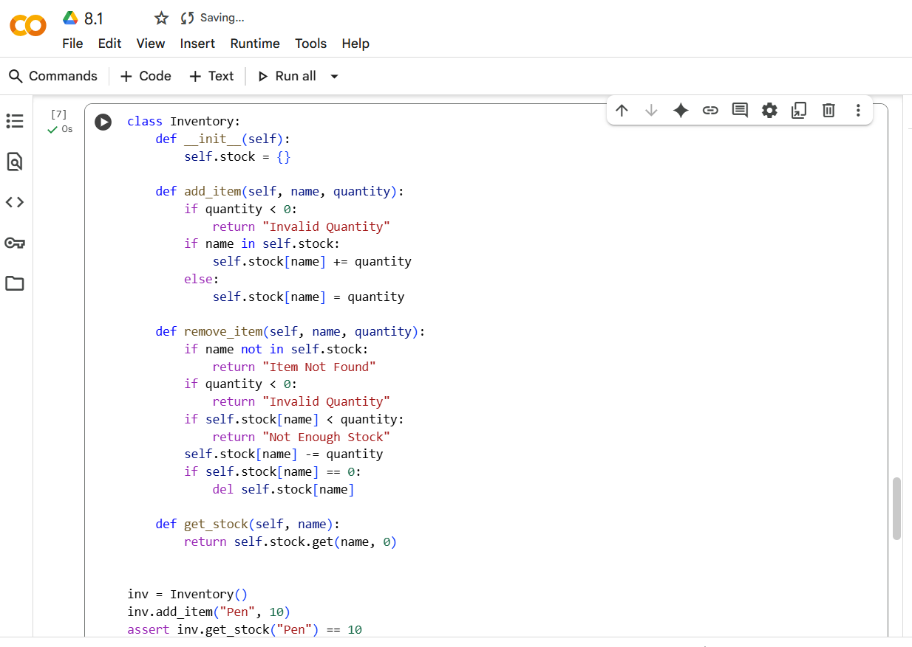
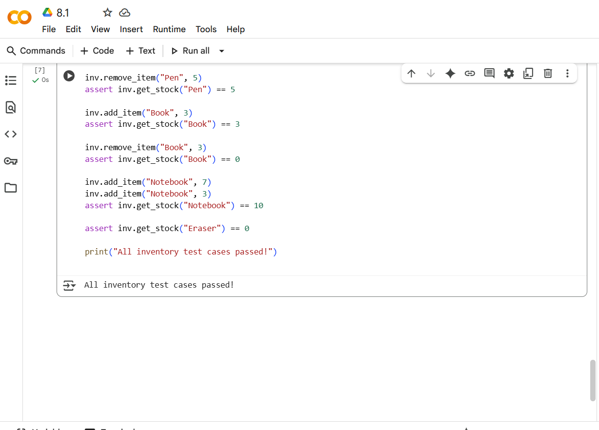

EXPLANTION OF CODE
- __init__(self):
  - This is the constructor of the class.
  - It initializes an empty dictionary called self.stock. This dictionary will store the items in the inventory, with the item name as the key and the quantity as the value.
- add_item(self, name, quantity):
  - This method is used to add a specified quantity of an item with the given name to the inventory.
  - It first checks if the quantity is negative. If it is, it returns "Invalid Quantity".
  - If the name of the item already exists in self.stock, it increases the current quantity by the given quantity.
  - If the name is not in self.stock, it adds the new item to the dictionary with the given quantity.
- remove_item(self, name, quantity):
  - This method is used to remove a specified quantity of an item with the given name from the inventory.
  - It first checks if the name exists in self.stock. If not, it returns "Item Not Found".
  - It then checks if the quantity to be removed is negative. If it is, it returns "Invalid Quantity".
  - It checks if there is enough stock of the item (self.stock[name] < quantity). If not, it returns "Not Enough Stock".
  - If the checks pass, it decreases the quantity of the item in self.stock by the given quantity.
  - If the quantity of the item becomes 0 after removal, it removes the item from the self.stock dictionary using del.
- get_stock(self, name):
  - This method returns the current stock quantity for a given item name.
  - It uses the dictionary's get() method with a default value of 0. This means if the name is found in self.stock, it returns its quantity; otherwise, it returns 0 (indicating the item is not in stock).
The code then creates an instance of the Inventory class called inv and performs several operations (add_item, remove_item, get_stock) with assert statements to test if the methods are working correctly and the inventory state is as expected. The final print statement indicates that all these tests passed.
Task Description #5 (Date Validation & Formatting – Apply AI for Data Validation)
- Task: Use AI to generate at least 3 assert test cases for validate_and_format_date(date_str) to check and convert dates.
Requirements: Validate "MM/DD/YYYY" format.
  - Handle invalid dates.
  - Convert valid dates to "YYYY-MM-DD".
CODE AND OUTPUT SCREENSHOT
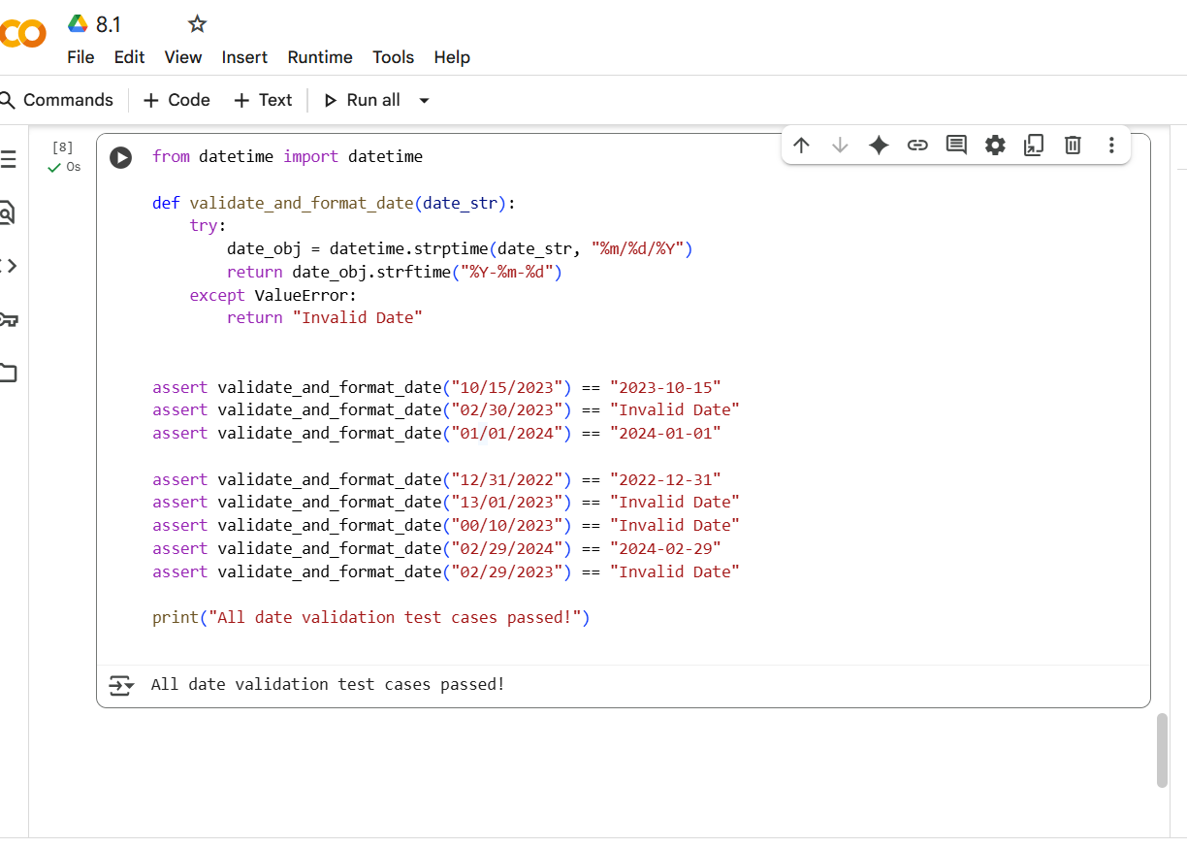
EXPLANTION OF CODE
- Import datetime: It imports the datetime class from the datetime module, which is essential for working with dates and times in Python.
- validate_and_format_date(date_str) function:
  - It takes one argument, date_str, which is the date string to be processed.
  - Error Handling: It uses a try...except ValueError block to handle potential errors that might occur during date parsing.
  - Parsing the Date:
    - datetime.strptime(date_str, "%m/%d/%Y"): This is the core of the validation. strptime (string parse time) attempts to parse the input date_str according to the specified format string "%m/%d/%Y". This format string tells Python to expect the date in the format of month (two digits), day (two digits), and year (four digits), separated by slashes. If the date_str does not match this format or represents an invalid date (like February 30th), a ValueError will be raised.
    - If parsing is successful, a datetime object is created and stored in date_obj.
  - Formatting the Date:
    - date_obj.strftime("%Y-%m-%d"): If parsing was successful, strftime (string format time) is used to format the datetime object (date_obj) into a new string according to the format string "%Y-%m-%d". This format string specifies the output to be year (four digits), month (two digits), and day (two digits), separated by hyphens.
    - The formatted date string is then returned.
  - Handling Invalid Dates:
    - If the strptime call raises a ValueError (because the input string is not in the correct format or is an invalid date), the except block is executed, and the function returns the string "Invalid Date".

