AI ASSISTED CODING

>>ASSIGNMENT: 6.4
HALL TICKET NO:2403A52400
Batch no:14
Task Description #1:
• Start a Python class named Student with attributes name, roll_number, and marks. Prompt GitHub Copilot to complete methods for displaying details and checking if marks are above average.
CODE WITH OUPUT
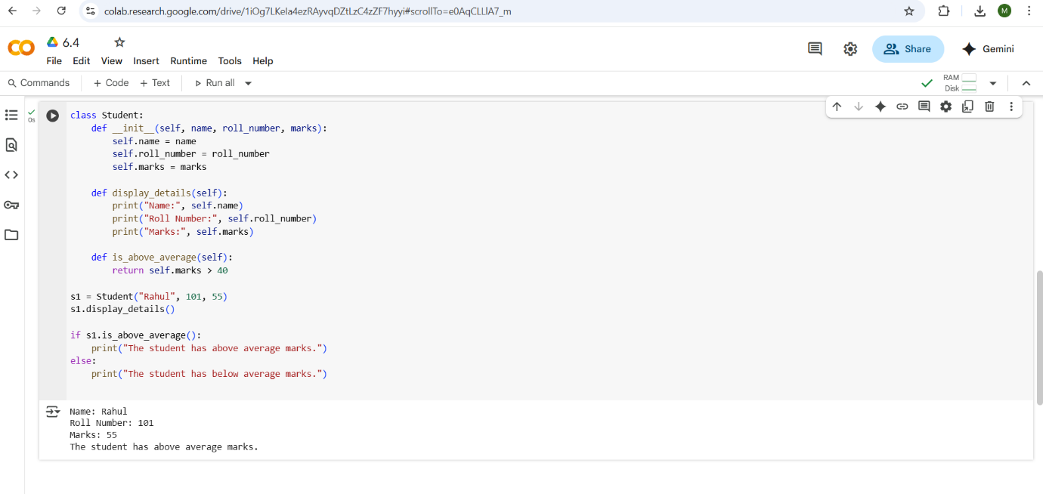
EXPLANATION
- class Student:: This line declares a new class named Student.
- __init__(self, name, roll_number, marks): This is the constructor of the class. It's a special method that gets called when you create a new Student object.
  - self: Refers to the instance of the class itself.
  - name, roll_number, marks: These are parameters that you pass when creating a Student object. They represent the student's name, roll number, and marks.
  - Inside the constructor, self.name = name, self.roll_number = roll_number, and self.marks = marks assign the values passed as arguments to the corresponding attributes of the Student object.
- display_details(self): This method is defined to display the details of a student.
  - It uses an f-string (f"...") to print the name, roll number, and marks of the student in a formatted way.
- is_above_average(self): This method checks if the student's marks are above average.
  - It compares the self.marks attribute with the value 40.
  - It returns True if the marks are greater than 40, and False otherwise.
In essence, this class provides a blueprint for creating Student objects, each with its own name, roll number, and marks, and methods to display their details and check if their marks are above average
--------------------------------------------------------------------------------------------------------------------------------------------------
Task Description #2:
• Write the first two lines of a for loop to iterate through a list of numbers. Use a comment prompt to let Copilot suggest how to calculate and print the square of even numbers only.
CODE WITH OUTPUT
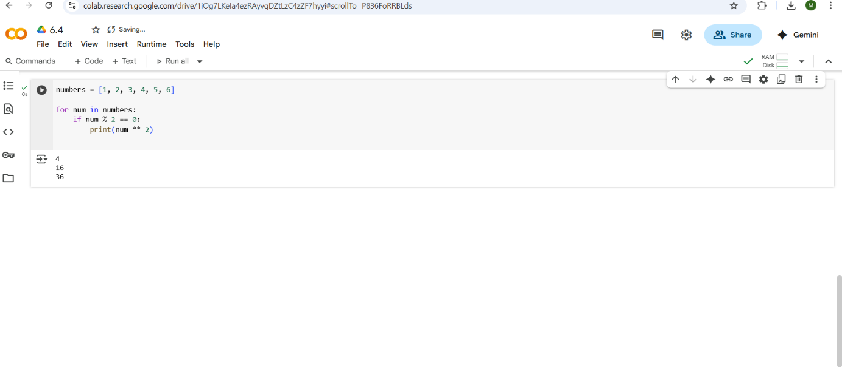
EXPLANATION
- numbers = [1, 2, 3, 4, 5, 6]: This line creates a list named numbers containing the integers from 1 to 6.
- for num in numbers:: This is a for loop that iterates through each element in the numbers list. In each iteration, the current element is assigned to the variable num.
- if num % 2 == 0:: Inside the loop, this is an if statement that checks if the current number (num) is even.
  - The modulo operator (%) returns the remainder of a division. So, num % 2 calculates the remainder when num is divided by 2.
  - If the remainder is 0, it means the number is even, and the condition is True.
- print(num ** 2): This line is inside the if block and is executed only if the if condition is True (i.e., if the number is even).
  - num ** 2 calculates the square of the current number.
  - print() displays the calculated square to the console.
---------------------------------------------------------------------------------------------------------------------------------------------------
Task Description #3:
• Create a class called BankAccount with attributes account_holder and balance. Use Copilot to complete methods for deposit(), withdraw(), and check for insufficient balance.
CODE WITH OUPUT
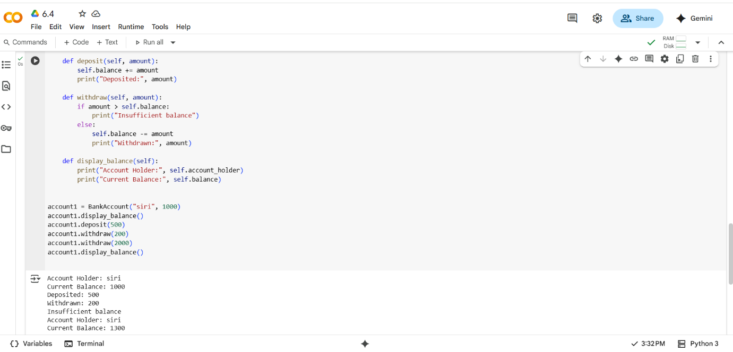
EXPLANATION
- class BankAccount:: This line declares a new class named BankAccount.
- __init__(self, account_holder, balance=0): This is the constructor of the class. It's called when you create a new BankAccount object.
  - self: Refers to the instance of the class.
  - account_holder: A required parameter for the name of the account holder.
  - balance=0: An optional parameter for the initial balance, with a default value of 0.
  - Inside the constructor, the provided account_holder and balance are assigned to the object's attributes self.account_holder and self.balance.
- deposit(self, amount): This method allows depositing money into the account.
  - It adds the specified amount to the self.balance.
  - It then prints a confirmation message.
- withdraw(self, amount): This method allows withdrawing money from the account.
  - It checks if the amount to be withdrawn is greater than the self.balance.
  - If it is, it prints an "Insufficient balance" message.
  - Otherwise, it subtracts the amount from the self.balance and prints a withdrawal confirmation.
- display_balance(self): This method displays the account holder's name and the current balance.
- account1 = BankAccount("siri", 1000): This line creates an instance of the BankAccount class named account1 with "siri" as the account holder and an initial balance of 1000.
- account1.display_balance(): Calls the display_balance method on account1 to show the initial balance.
- account1.deposit(500): Calls the deposit method to add 500 to the balance.
- account1.withdraw(200): Calls the withdraw method to subtract 200 from the balance.
- account1.withdraw(2000): Calls the withdraw method to attempt to subtract 2000. Since the balance is less than 2000, it will print "Insufficient balance".
- account1.display_balance(): Calls the display_balance method again to show the final balance after the operations.
---------------------------------------------------------------------------------------------------------------------------------------------------Task Description #4:
• Define a list of student dictionaries with keys name and score. Ask Copilot to write a while loop to print the names of students who scored more than 75.
CODE WITH OUPUT
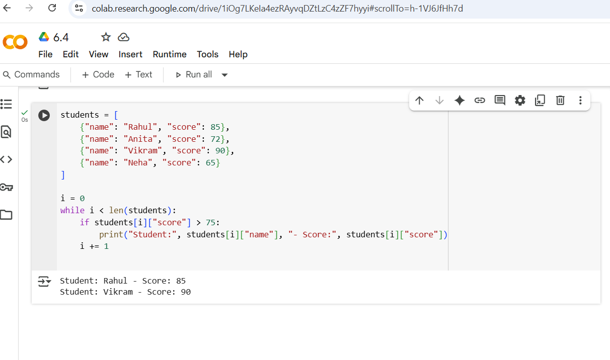
EXPLANATION
- students = [...]: This line creates a list named students. Each element in the list is a dictionary, where each dictionary represents a student with a "name" and a "score".
- i = 0: This line initializes a counter variable i to 0. This variable will be used to keep track of the index of the current student in the list.
- while i < len(students):: This is a while loop that continues as long as the value of i is less than the total number of students in the students list. len(students) returns the number of elements in the list.
- if students[i]["score"] > 75:: Inside the loop, this if statement checks the score of the current student.
  - students[i] accesses the dictionary at the index i in the students list.
  - ["score"] accesses the value associated with the key "score" in that dictionary.
  - The condition checks if this score is greater than 75.
- print("Student:", students[i]["name"], "- Score:", students[i]["score"]): This line is executed only if the if condition is true (i.e., the student's score is above 75).
  - It prints the string "Student:", followed by the student's name (accessed using students[i]["name"]), followed by "- Score:", and finally the student's score.
- i += 1: This line increments the counter i by 1 after each iteration. This ensures that the loop moves to the next student in the list.
---------------------------------------------------------------------------------------------------------------------------------------------------

Task Description #5:
• Begin writing a class ShoppingCart with an empty items list. Prompt Copilot to generate methods to add_item, remove_item, and use a loop to calculate the total bill using conditional discounts.
CODE WITH OUPUT
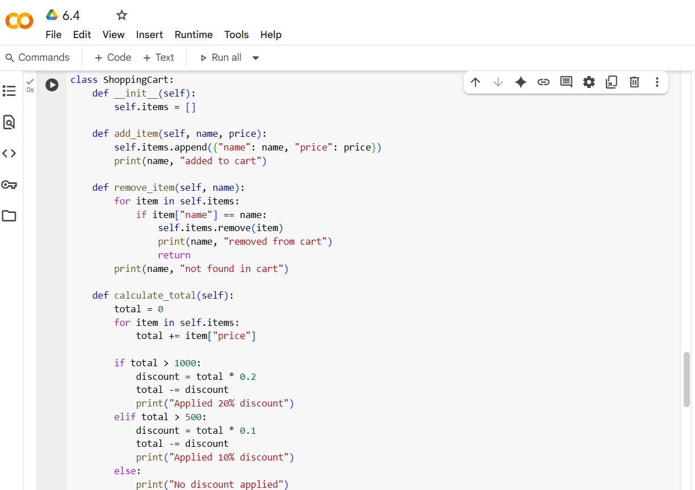
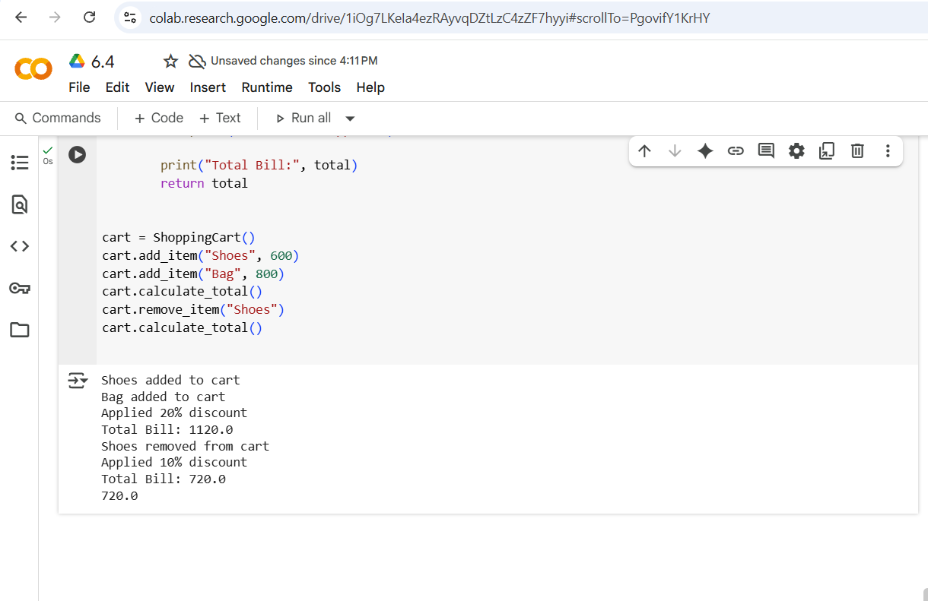
EXPLANATION
- class ShoppingCart:: This line declares a new class named ShoppingCart.
- __init__(self):: This is the constructor of the class. It's called when you create a new ShoppingCart object.
  - self.items = []: Initializes an empty list called items within the ShoppingCart object. This list will store the items added to the cart.
- add_item(self, name, price):: This method adds an item to the shopping cart.
  - It takes name and price as arguments.
  - self.items.append({"name": name, "price": price}): Creates a dictionary with the item's name and price and appends it to the self.items list.
  - It then prints a confirmation message that the item has been added.
- remove_item(self, name):: This method removes an item from the shopping cart based on its name.
  - It iterates through the self.items list.
  - if item["name"] == name:: Checks if the name of the current item in the loop matches the name provided for removal.
  - self.items.remove(item): If a match is found, it removes the item from the list.
  - It prints a confirmation that the item was removed and return exits the method.
  - If the loop finishes without finding the item, it prints a "not found" message.
- calculate_total(self):: This method calculates the total cost of items in the cart, including discounts.
  - total = 0: Initializes a total variable to 0.
  - for item in self.items:: Iterates through the self.items list.
  - total += item["price"]: Adds the price of each item to the total.
  - The code then checks the total amount to apply discounts:
    - If total > 1000, a 20% discount is applied.
    - If total > 500 (and not > 1000), a 10% discount is applied.
    - Otherwise, no discount is applied.
  - It prints messages indicating if a discount was applied and the final total.
  - It returns the calculated total.
- cart = ShoppingCart(): This line creates an instance of the ShoppingCart class named cart.
- cart.add_item("Shoes", 600) and cart.add_item("Bag", 800): These lines add "Shoes" and "Bag" to the cart with their respective prices.
- cart.calculate_total(): Calls the calculate_total method to calculate and display the total bill for the current items.
- cart.remove_item("Shoes"): Calls the remove_item method to remove "Shoes" from the cart.
- cart.calculate_total(): Calls calculate_total again to show the updated total after removing "Shoes".

