AI ASSISTED CODING
ASSIGNMENT:9.3
HALL TICKET NO:2403A52400
BATCH.NO:14
>Task Description#1 Basic Docstring Generation
- Write python function to return sum of even and odd numbers in the given list.
- Incorporate manual docstring in code with Google Style
- Use an AI-assisted tool (e.g., Gemini, Copilot, Cursor AI) to generate a docstring describing the function.
- Compare the AI-generated docstring with your manually written one.
CODE & OUTPUT SCREENSHOT
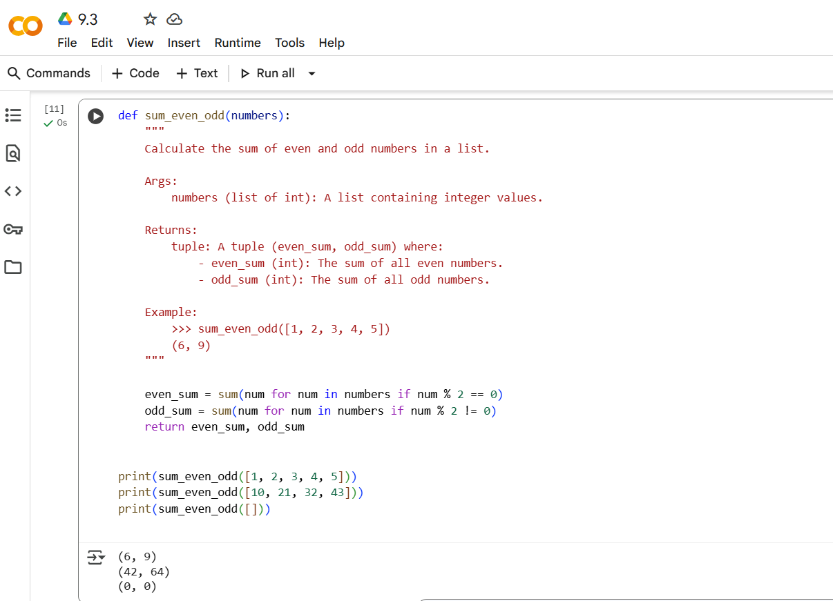
EXPLANATION OF CODE
This code defines a Python function called sum_even_odd that takes a list of integers as input and returns a tuple containing the sum of the even numbers and the sum of the odd numbers in the list.
Here's a breakdown:
- The function uses generator expressions within the sum() function to efficiently calculate the sums.
- sum(num for num in numbers if num % 2 == 0): This part iterates through the input list numbers, and for each num, it checks if it's even using the modulo operator (% 2 == 0). If it's even, it includes the number in the sum.
- sum(num for num in numbers if num % 2 != 0): This part does the same for odd numbers, checking if the number is not divisible by 2 (% 2 != 0).
- Finally, the function returns a tuple containing the calculated even_sum and odd_sum.
>Task Description#2 Automatic Inline Comments
- Write python program for sru_ student class with attributes like name, roll no., hostel_ status and fee_ update method and display_ details method.
- Write comments manually for each line/code block
- Ask an AI tool to add inline comments explaining each line/step.
- Compare the AI-generated comments with your manually written one.
CODE & OUTPUT SCREENSHOT
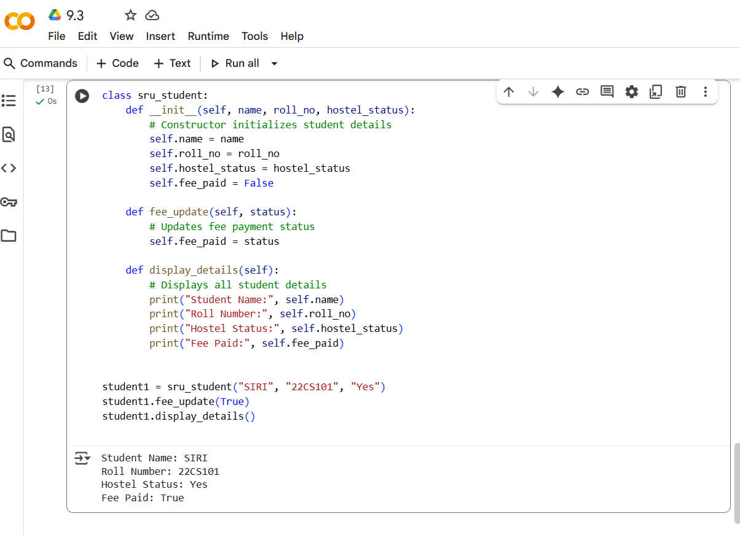
EXPLANATION OF CODE
- __init__(self, name, roll_no, hostel_status): This is the constructor of the class. It's called when you create a new sru_student object. It initializes the object's attributes: name, roll_no, and hostel_status. It also initializes fee_paid to False by default.
- fee_update(self, status): This method allows you to update the fee_paid status of a student object. It takes a boolean value (status) as input and sets the fee_paid attribute to that value.
- display_details(self): This method prints the details of a student object, including their name, roll number, hostel status, and fee payment status.
The code then creates an instance of the sru_student class named student1, updates its fee status to True using the fee_update method, and finally displays the student's details using the display_details method.
> Task Description#3
- Write a Python script with 3–4 functions (e.g., calculator: add, subtract, multiply, divide).
- Incorporate manual docstring in code with NumPy Style
- Use AI assistance to generate a module-level docstring + individual function docstrings.
- Compare the AI-generated docstring with your manually written one.
CODE & OUTPUT SCREENSHOT

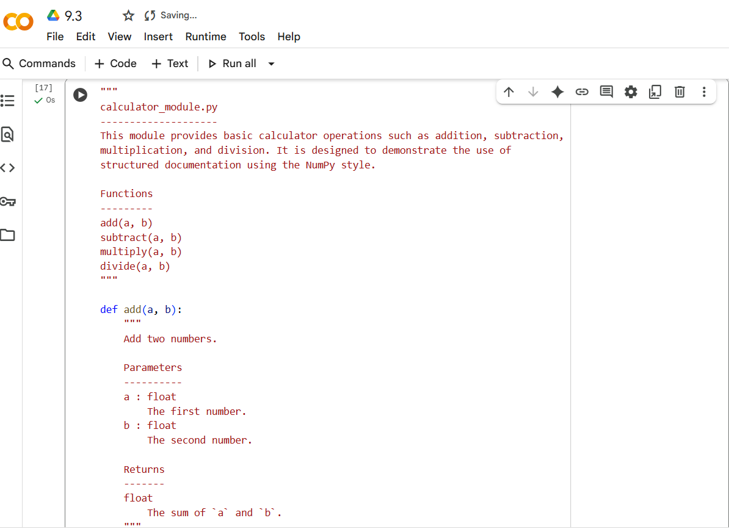
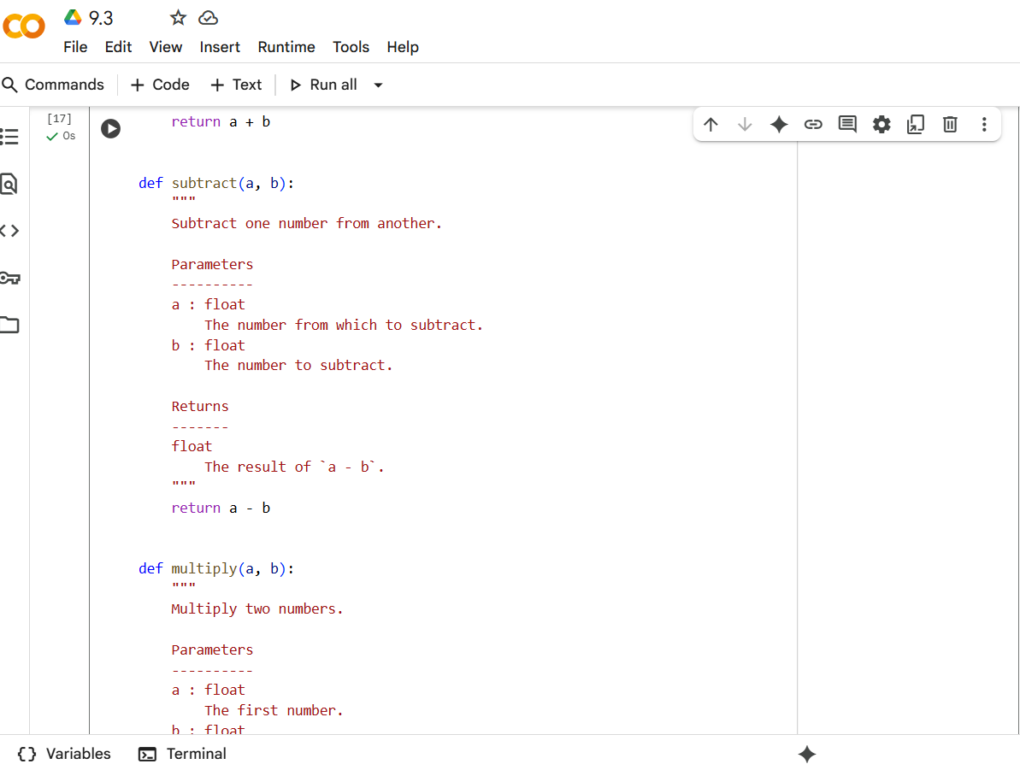
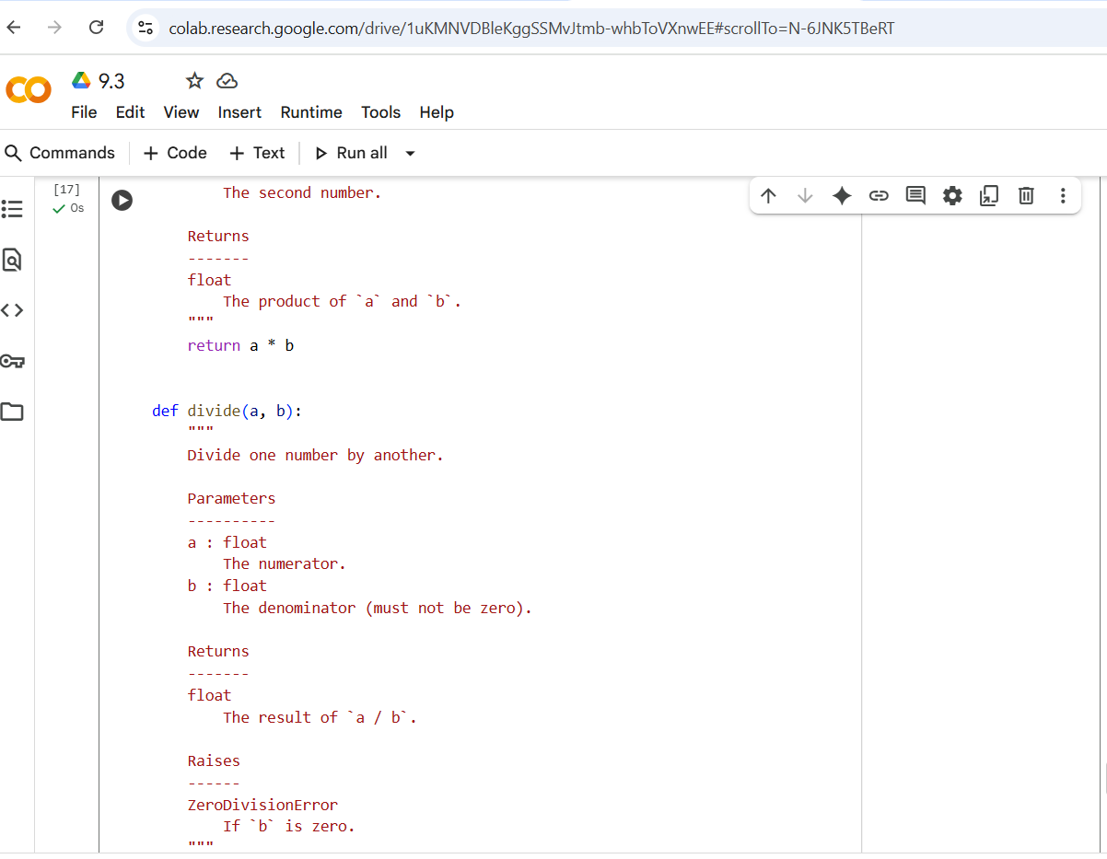
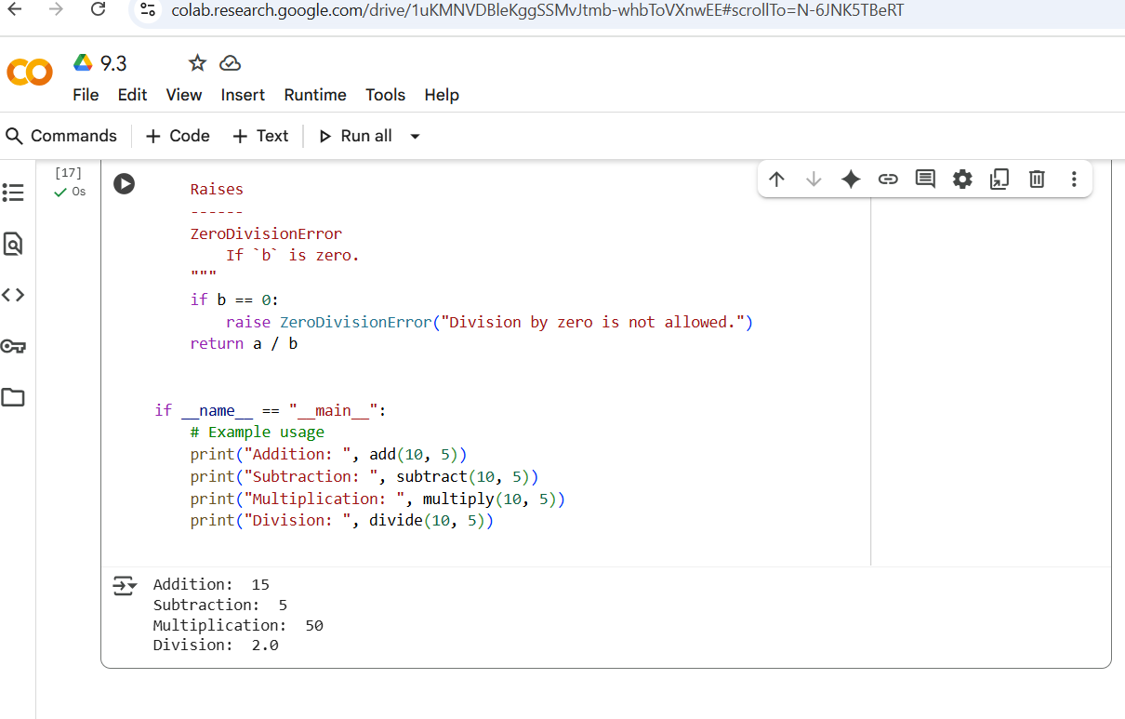
EXPLANATION OF CODE
This code defines a Python module named calculator_module that provides basic arithmetic operations: addition, subtraction, multiplication, and division.
Here's a breakdown:
- Module Docstring: The triple-quoted string at the beginning serves as the module's docstring, explaining its purpose and listing the functions it contains.
- Functions (add, subtract, multiply, divide): Each function performs a specific arithmetic operation and includes a docstring explaining its parameters, return value, and potential exceptions (like ZeroDivisionError for the divide function). The docstrings follow the NumPy style for clear and structured documentation.
- if __name__ == "__main__": block: This block contains example usage of the functions. The code inside this block will only run when the script is executed directly (not when it's imported as a module into another script). It demonstrates how to call each function and prints the results.

