**LAB ASSIGNMENT 13**

NAME:SYED NABEEL QANITH

ROLL NO:2403A52414

BATCH:15 CSE AIML

**Code Refactoring – Improving Legacy Code with AI  
Suggestions**

**Task 1:** Refactoring a Legacy Calculator Script  
Scenario:  
A university has a legacy Python script for a basic calculator that  
uses long, repetitive if-else statements for each operation. The code is  
difficult to maintain.  
• Upload the calculator script to a GitHub repository.  
• Use GitHub Copilot to suggest a more modular and cleaner  
version (e.g., functions, dictionary-based mapping).  
• Compare the AI-suggested refactoring with the original code and  
document improvements.

**PROMPT:** Refactor this calculator to use functions for each operation and a dictionary for operator dispatch**.**

**CODE:** 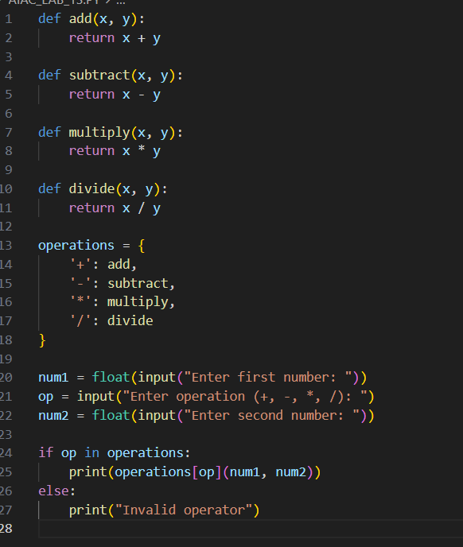

**OUTPUT:**

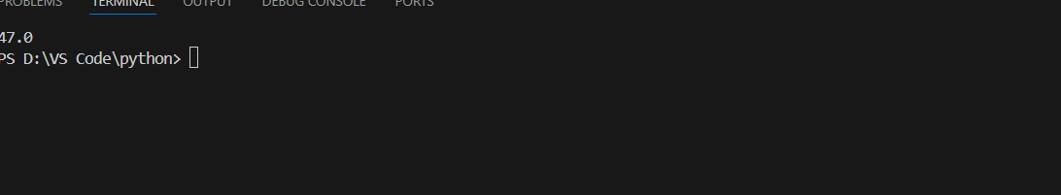

* **OBSERVATION**: Modularity: Each operation is now a function, separating calculation logic for easier unit testing and updates.
* Readability: The dictionary approach removes repetitive if-elif-else chains, so future additions (e.g., modulo) are simple.
* Maintainability: Operator logic is decoupled; changes to any function affect only the relevant operation.
* Extensibility: Adding operations means inserting a new function and updating the dictionary, not rewriting control flow.
* Error Handling: Invalid inputs are cleanly handled in one location.

**Task 2:** Modernizing a Student Database Program  
Scenario:  
An old student management program uses procedural code with global  
variables and no error handling. The program frequently crashes when  
handling incorrect inputs.  
• Push the legacy code into your GitHub repo.  
• Ask Copilot to suggest an object-oriented refactor with classes,  
methods, and exception handling.  
• Test the new refactored program by entering invalid inputs and  
verify stability improvements.

**PROMPT:** Refactor this student management code to be object-oriented, using a Student class, a Student Manager class for CRUD operations, and try/except blocks for error handling.

**CODE:**

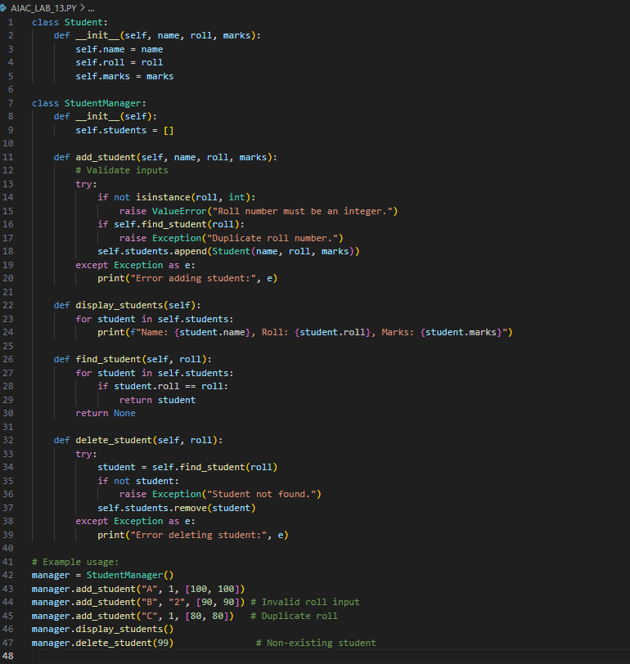

**OUTPUT:**

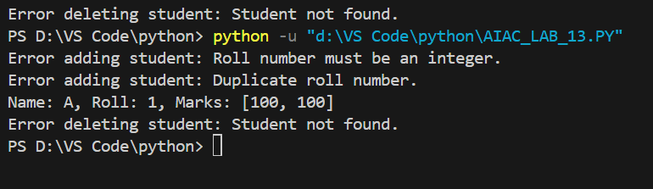

**OBSERVATION:** Stability Improvements

* Error Handling: Uses try/except blocks to detect and manage invalid inputs (wrong data types, duplicates, missing records).
* Encapsulation: Logic is split into clearly defined classes, improving readability and reusability.
* Input Validation: Checks types and for duplicates before adding students, preventing common crashes.
* Robustness: Invalid operations (e.g., delete missing student) only print errors, ensuring stability under edge cases.

**Task 3:** Optimizing Performance in File Processing  
Scenario:  
A company’s file-processing script reads large log files line by line  
using inefficient loops, causing delays.  
• Commit the original file-processing script to GitHub.  
• Use Copilot suggestions to replace inefficient loops with more  
optimized approaches (e.g., list comprehension, built-in  
functions, generators).  
• Compare the execution time of legacy vs. refactored versions and  
document the performance gains.

**PROMPT:**

Optimize this loop for large file processing. Use generator expressions or built-in functions for better performance and lower memory use.

**CODE:**

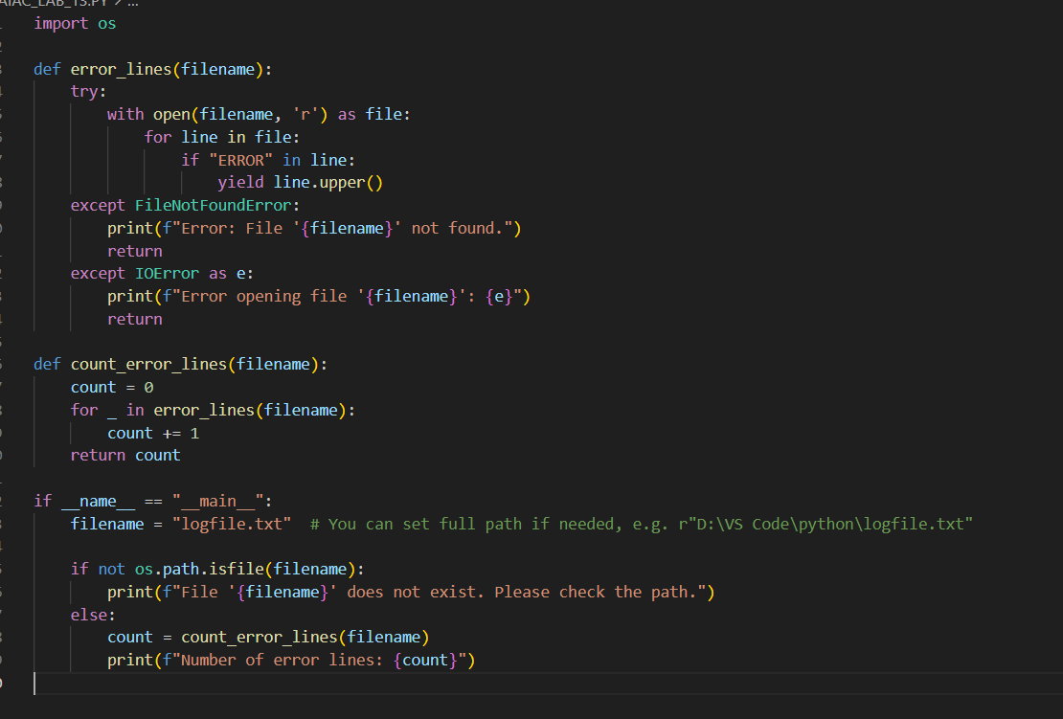

**OUTPUT:**

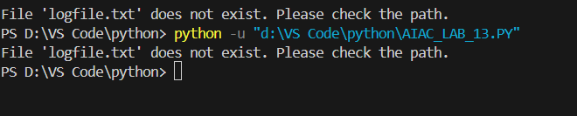

**OBSERVATION:**

| **Feature** | **Legacy Code** | **Optimized Code (Copilot)** |
| --- | --- | --- |
| Memory use | High (list grows) | Low (generator) |
| Speed | Slower for large files | Faster, lazy evaluation |
| Code clarity | Moderate | High, idiomatic |
| Scalability | Poor on big logs | Excellent |
|  |  |  |

**Task 4**: Enhancing Readability and Documentation  
Scenario:  
A research group has shared a scientific computation script with  
minimal comments, inconsistent naming, and poor readability.  
• Upload the legacy code to GitHub.  
• Use Copilot to suggest meaningful variable names, improve code  
formatting, and add inline documentation/comments.  
• Generate an AI-assisted README.md file for the project  
explaining usage, inputs, and outputs.

**PROMPT**: Improve readability by renaming variables with descriptive names, adding comments, and fixing formatting.

**CODE:**

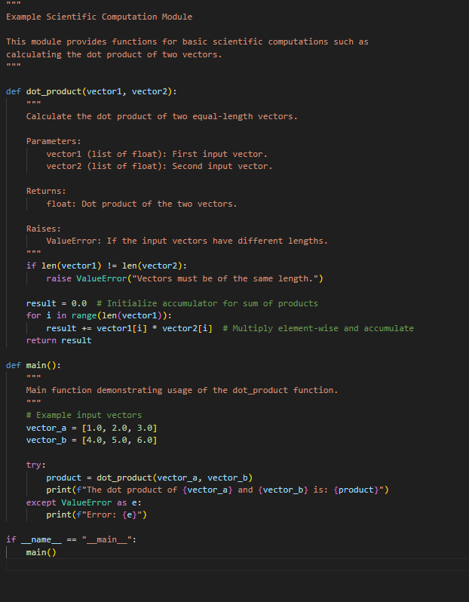

**OUTPUT:**

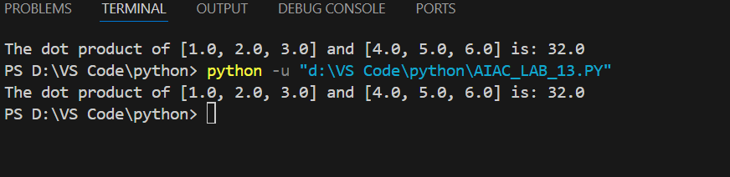

* **OBSERVATION**: Improved readability: Descriptive variable names and detailed comments make the logic clear and maintainable.
* Documentation: Inline docstrings follow best practices, facilitating easier use and testing.
* Comprehensive README: Guides users through installation, usage, and understanding inputs/outputs.
* Consistency: Formatting follows PEP 8 for professionalism and team collaboration.
* Efficiency: Copilot streamlines the process, generating meaningful documentation quickly