Lab Assignment 14.3
ALLAPU SAI CHARAN
2403A52L08-B50
Task1:
Prompt:
Generate a responsive personal portfolio website using HTML, CSS (Flexbox/Grid), and JavaScript.
Include sections: Home, About, Projects, Contact.
Add smooth scrolling and hover effects for project cards.
Code: CSS; HTML and JS
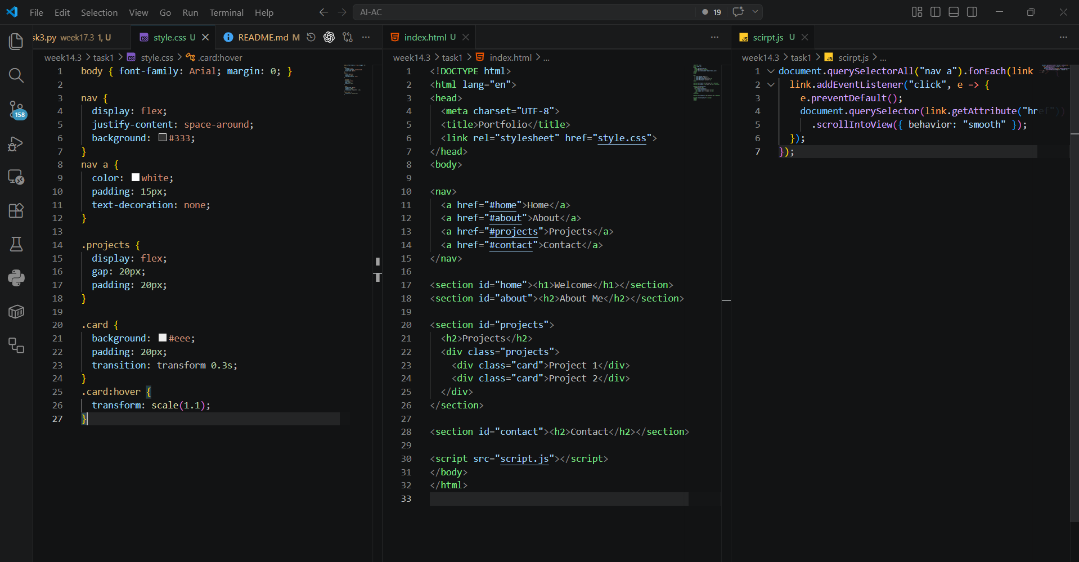
Task2:
Prompt:
Create a restaurant landing page with navbar, menu cards, and an image slider using JavaScript.
Add smooth transitions and responsive design.
Code: HTML
<div class="slider">
<img id="slide" src="img1.jpg">
</div>
JS:
let images = ["img1.jpg", "img2.jpg", "img3.jpg"];
let i = 0;
setInterval(() => {
i = (i + 1) % images.length;
document.getElementById("slide").src = images[i];
}, 2000);
CSS:
.menu {
display: grid;
grid-template-columns: repeat(auto-fit, minmax(200px,1fr));
gap: 20px;
}
.card {
border: 1px solid #ccc;
padding: 15px;
}
Task 3 – Event Registration Form
🔹 Prompt
Generate an HTML form with validation for name, email, phone, department, and event selection.
Add real-time JavaScript validation and styled UI.
Code:
🔹 HTML
<form id="form">
<input type="text" id="name" placeholder="Name" required>
<input type="email" id="email" placeholder="Email">
<input type="text" id="phone" placeholder="Phone">
<button type="submit">Submit</button>
</form>
<p id="msg"></p>

🔹 JS Validation
document.getElementById("form").addEventListener("submit", function(e)
{
e.preventDefault();
let email = document.getElementById("email").value;
let phone = document.getElementById("phone").value;
if (!email.includes("@")) {
alert("Invalid Email");
return;
}
if (phone.length !== 10) {
alert("Phone must be 10 digits");
return;
}
alert("Form submitted successfully!");
});
Task 4 – E-Commerce Product Page
🔹 Prompt
Create a product grid with Add to Cart functionality.
Include cart counter and visual feedback.
Code:
HTML
<h2>Cart: <span id="count">0</span></h2>
<div class="products">
<div class="card">
<p>Product 1</p>
<button onclick="addToCart()">Add</button>
</div>
</div>
🔹 JS
let count = 0;
function addToCart() {
count++;
document.getElementById("count").innerText = count;
alert("Added to cart!");
}

🔹 CSS Grid
.products
{
display: grid;
grid-template-columns: repeat(auto-fit, minmax(200px,1fr));
gap: 20px;
}
Task 5 – Responsive Layout
🔹 Prompt
Create a responsive webpage with header, main content, and footer using Flexbox.
Ensure mobile responsiveness using media queries.
Code:
🔹 HTML
<header>Header</header>
<main>Main Content</main>
<footer>Footer</footer>
🔹 CSS
body {
display: flex;
flex-direction: column;
min-height: 100vh;
}
header, footer {
background: #333;
color: white;
padding: 15px;
text-align: center;
}
main {
flex: 1;
padding: 20px;
}
/* Responsive */
@media (max-width: 600px) {
body {
font-size: 14px;
}
}

