Lab Assignment 16.3
2403A52L08-B50
ALLAPU SAI CHARAN
Task1:
Prompt:
Design a normalized SQL schema for a Hospital Management System with Doctors, Patients, and Appointments tables.
Include primary keys, foreign keys, and constraints.
Generate SQL queries using joins for reporting.
Code:
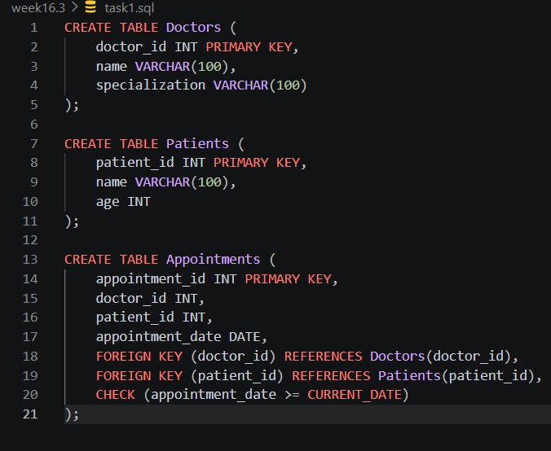

Task2:
Prompt:
Design an e-commerce database schema with Users, Products, Orders, and OrderDetails.
Ensure normalization and generate analytical queries.
Code:
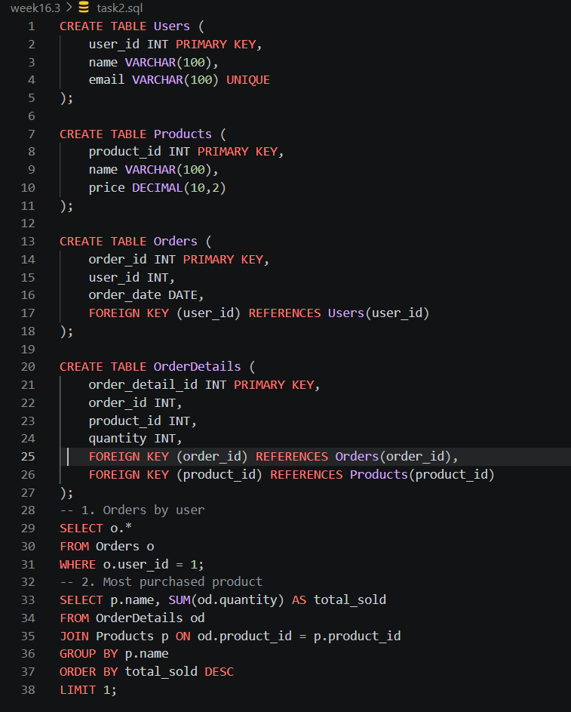
Task3:
Prompt:
Design a library database with Books, Members, and Loans.
Suggest indexing and write queries for issued and overdue books.
Code:
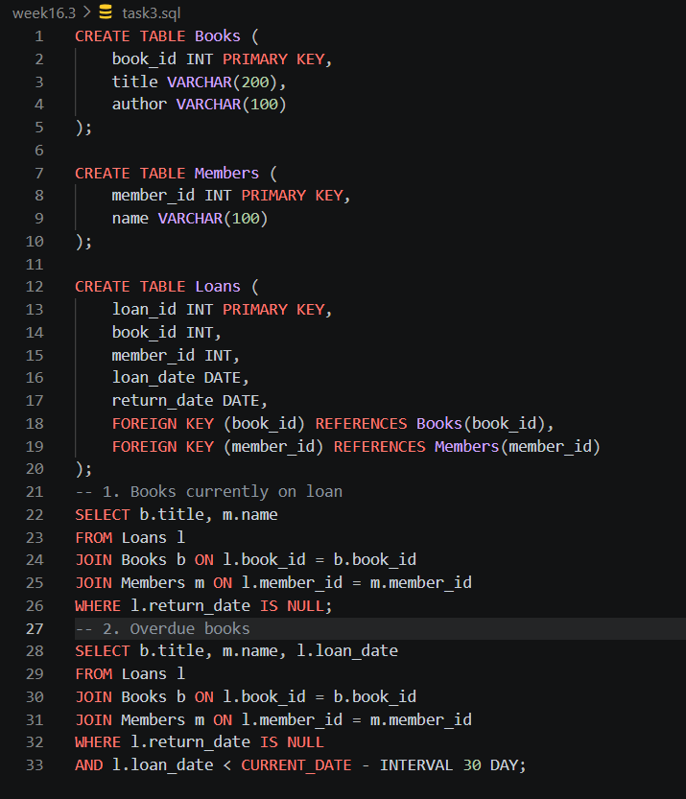

Task 4 – Query Optimization
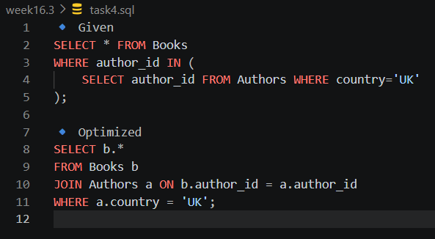
Task 5 – University Course Registration
🔹 Prompt
Design a normalized schema for Students, Courses, Faculty, and Registrations.
Define relationships and write analytical queries.
🔹 SQL
