Lab Assignment 17.5
2403A52L08-B50
ALLAPU SAI CHARAN
Task1:
Code and prompt:
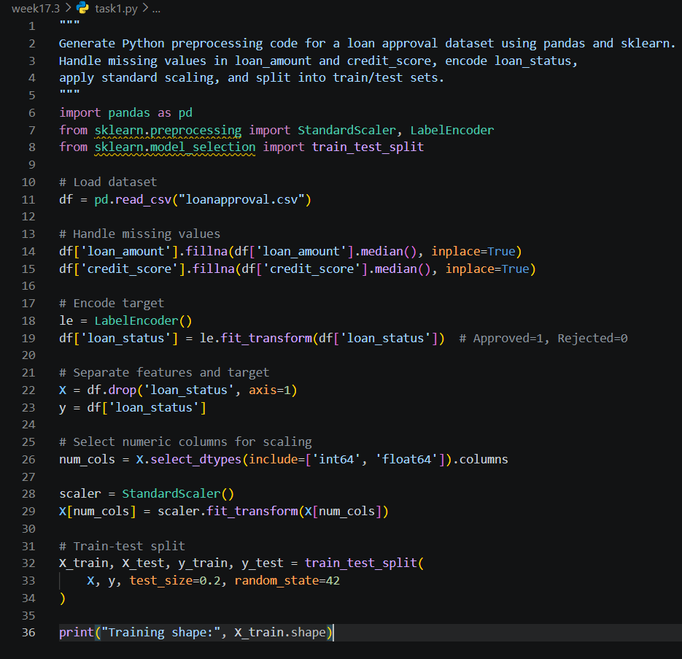

Task2:
Code and prompt:
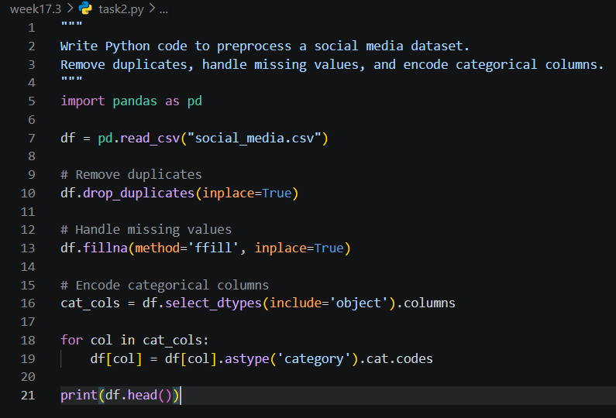
Task3:
Code and prompt:
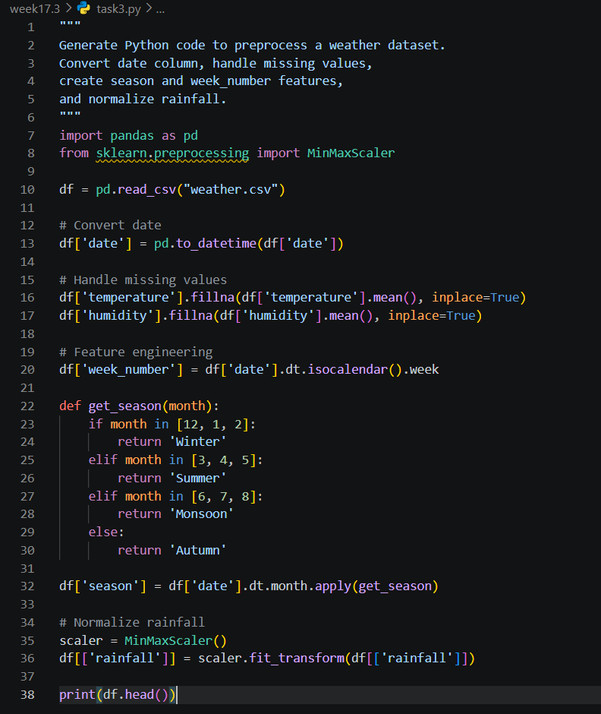
Task4:
Code and prompt:
