Lab Assignment 18.3
240A52L08-B50 ALLAPU SAI CHARAN
Task1:
Code and prompt:
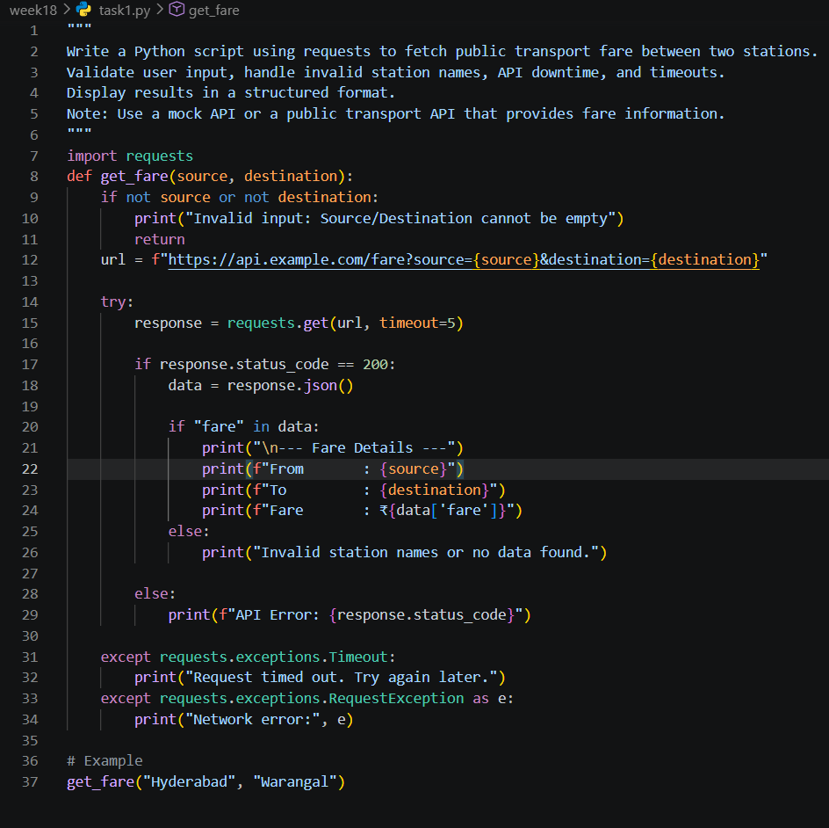

Task2:
Code and prompt:
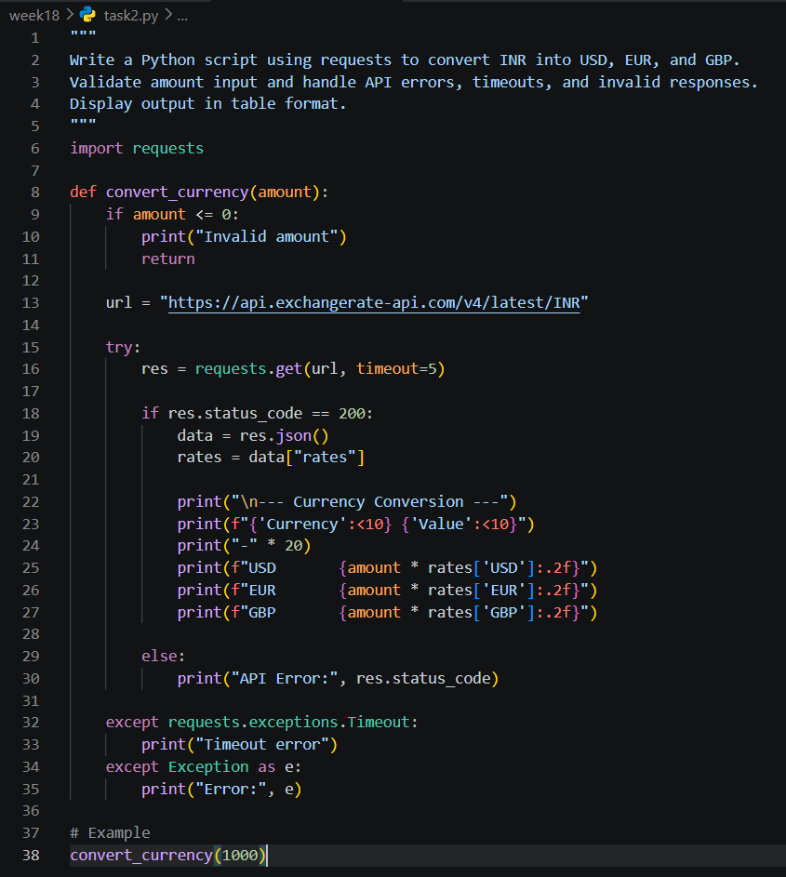

Task3:
Code and prompt:
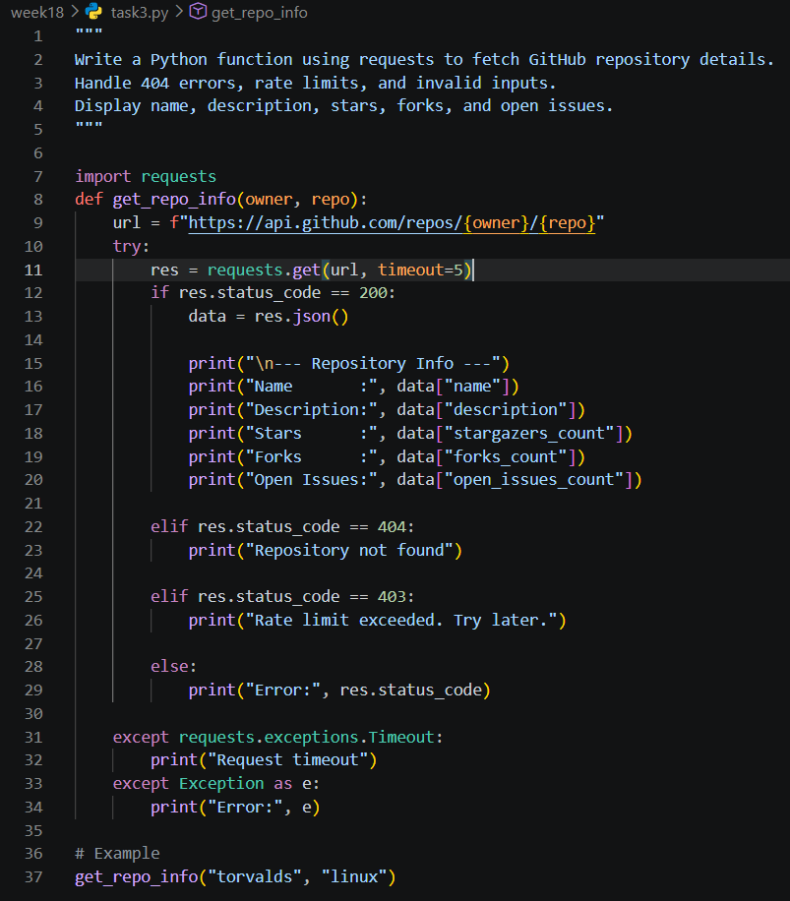

Task4:
Code and prompt:
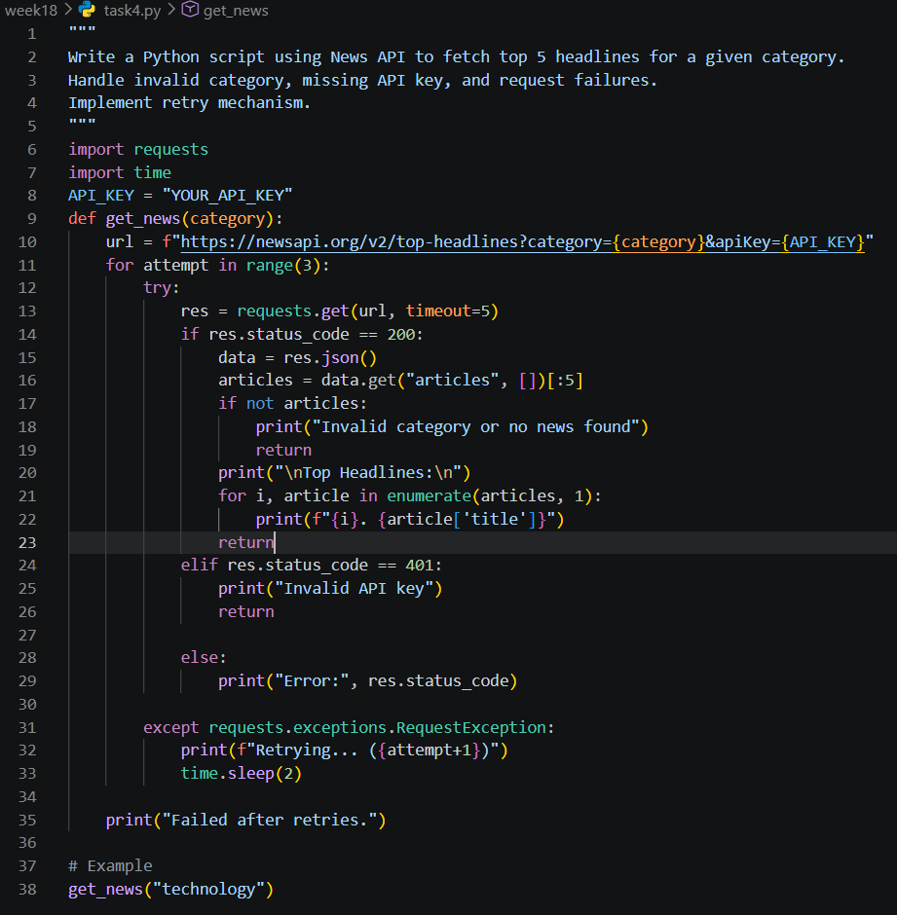

Task5:
Code and prompt:
