Al Assisted Coding Ass-10.3
Code Review and Quality: Using AI to improve code quality and readability
2403A52L08 – B50
ALLAPU SAI CHARAN
Task 1: AI-Assisted Bug Detection
Prompt and code:
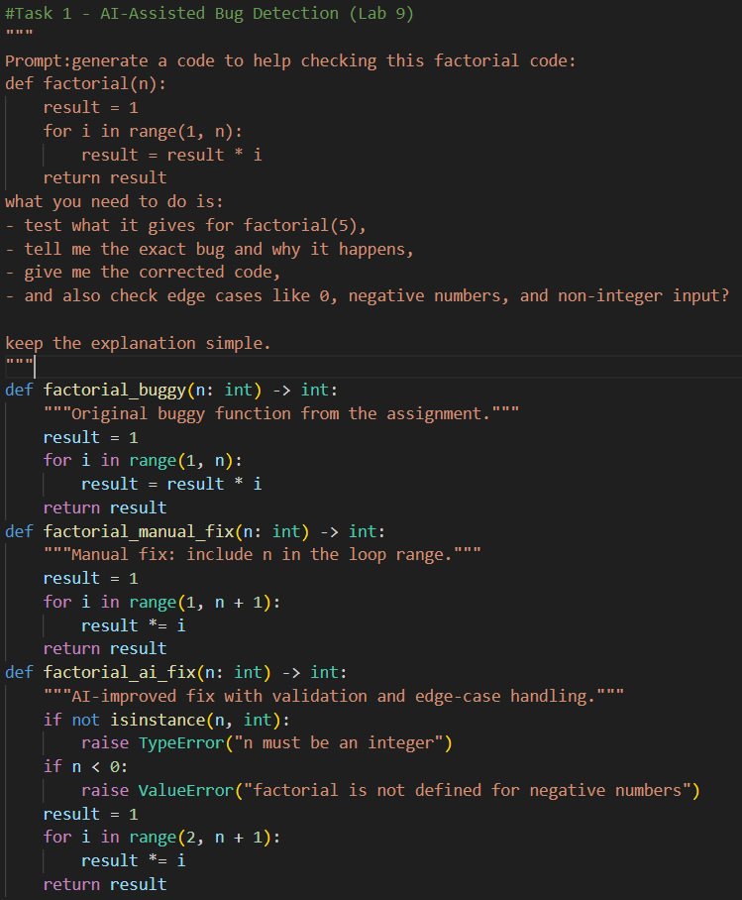
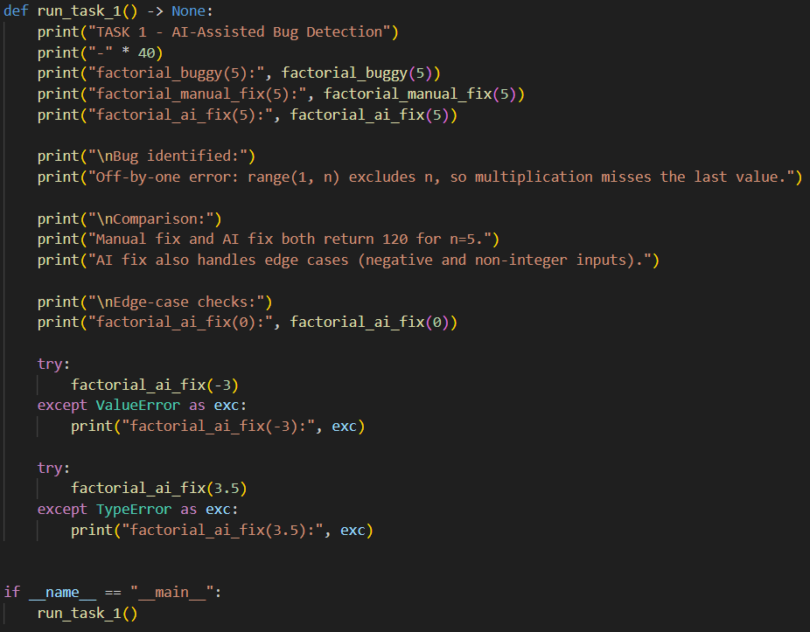
Output:
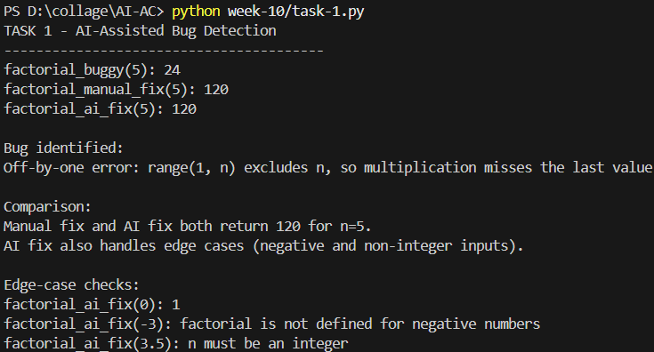

Task 2: Improving Readability & Documentation
Prompt and code:
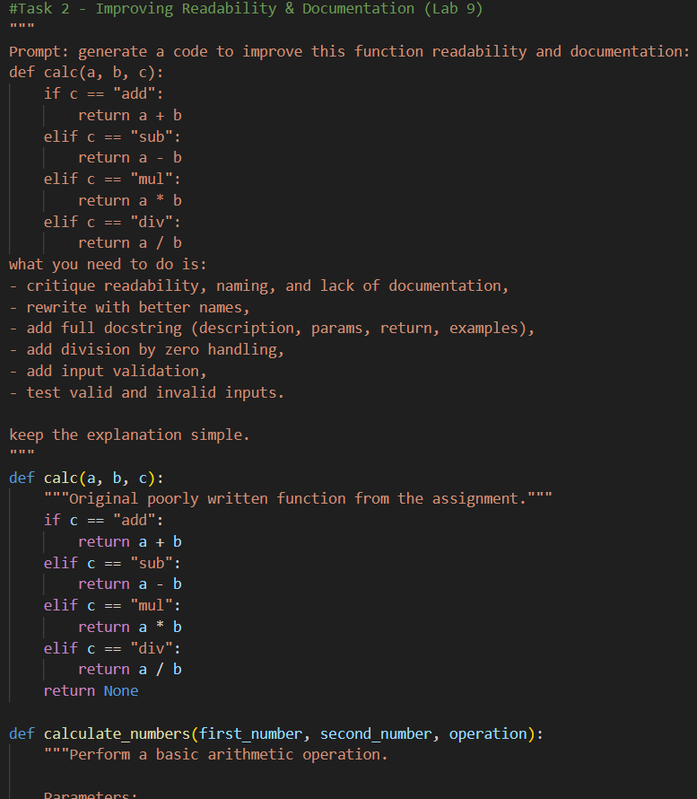

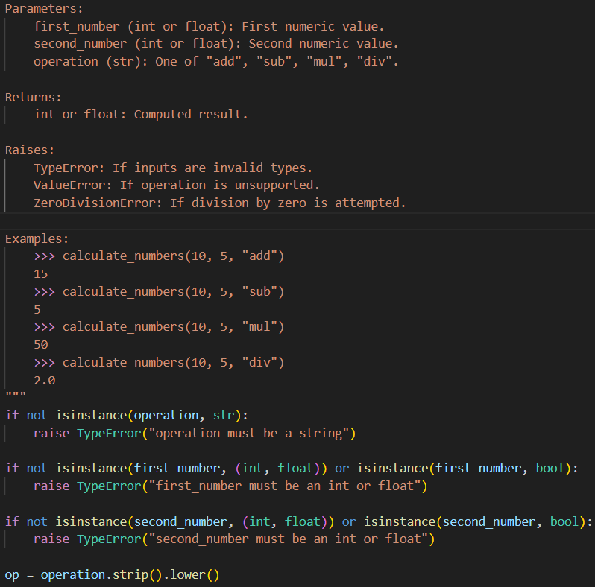

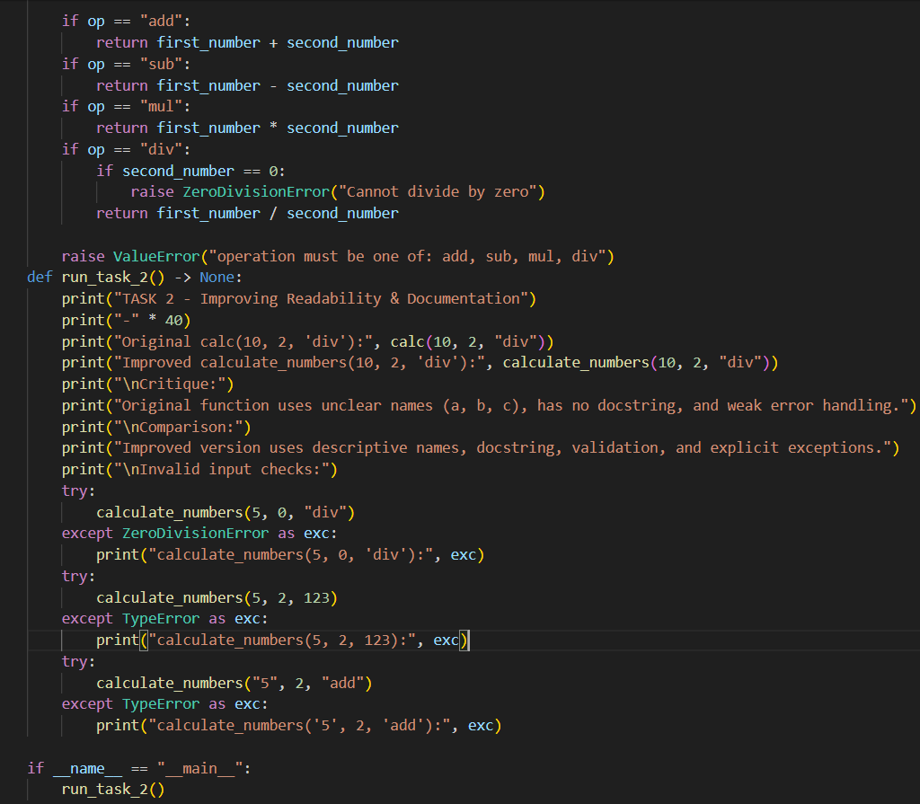
Output:
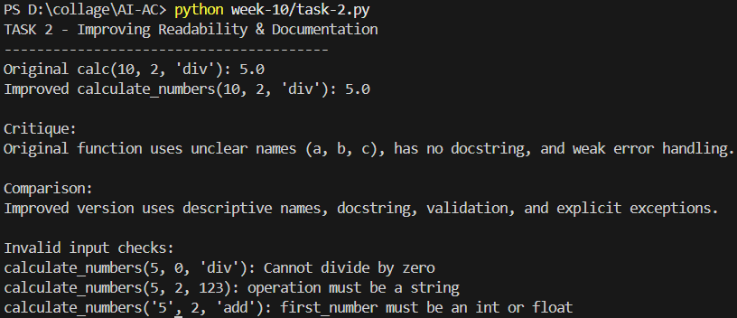

Task 3: Enforcing Coding Standards
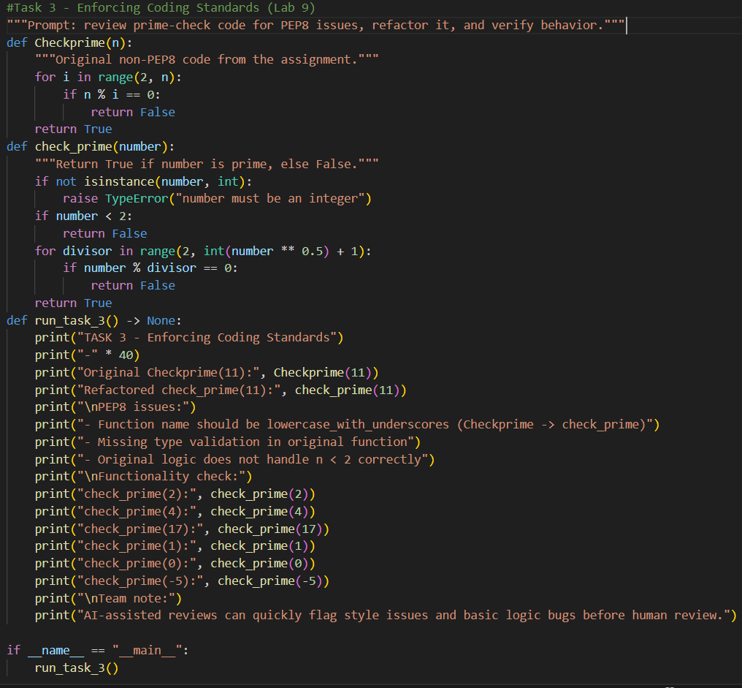
Output:
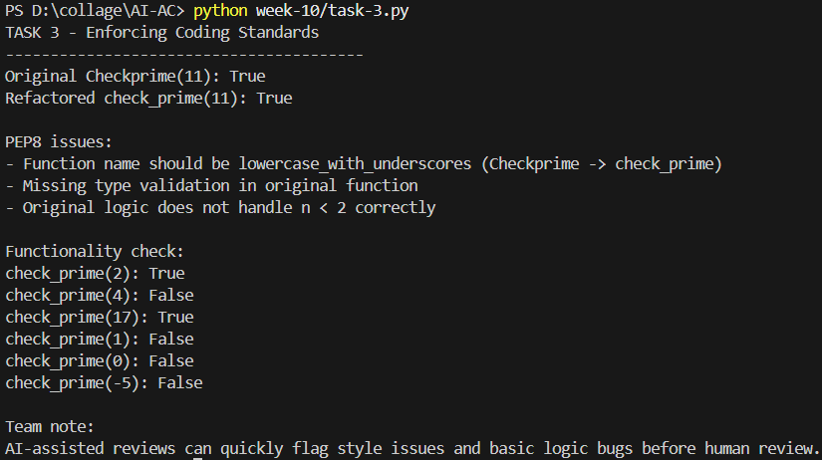
Task 4: AI as a Code Reviewer in Real Projects
Prompt and code:
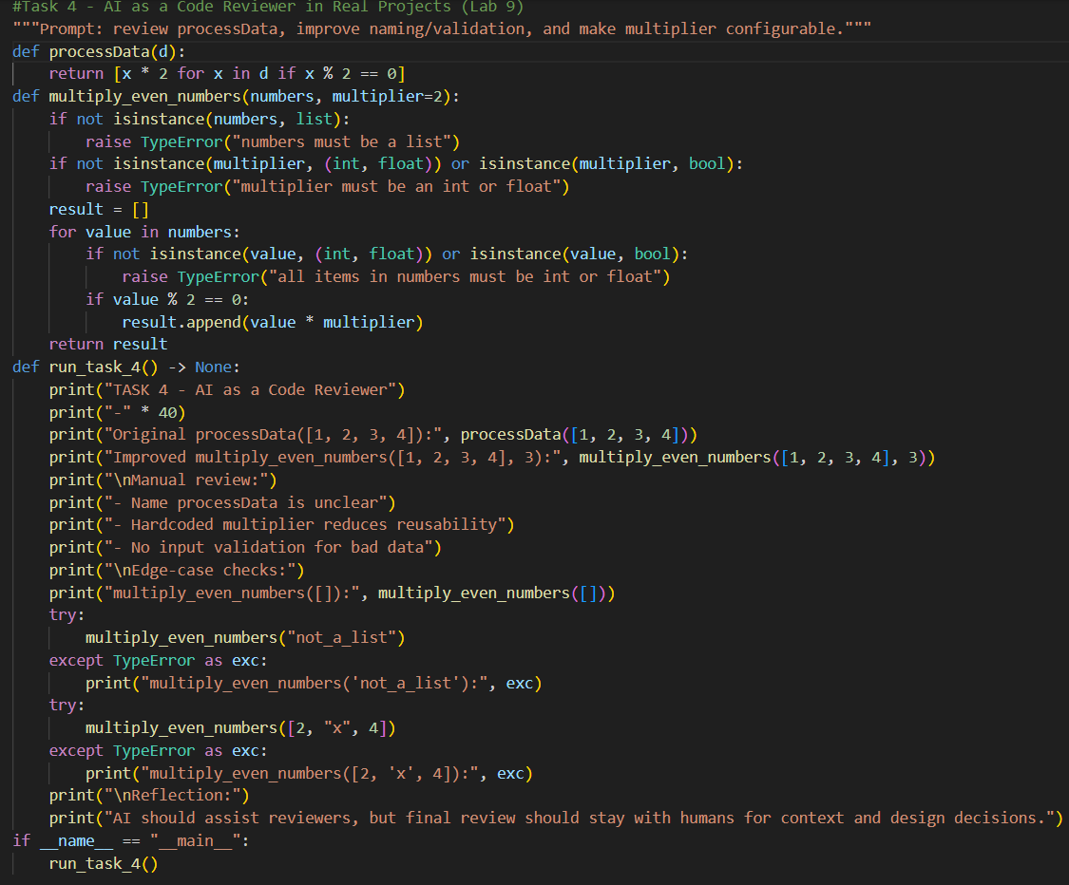
Output:
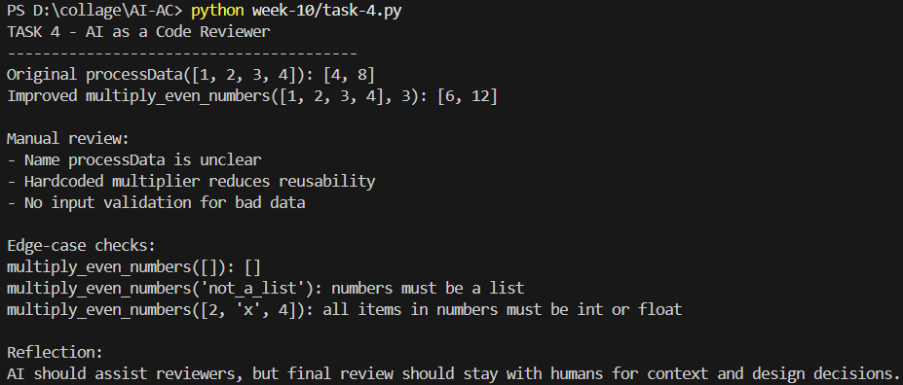

Task 5: AI-Assisted Performance Optimization
Prompt and code:
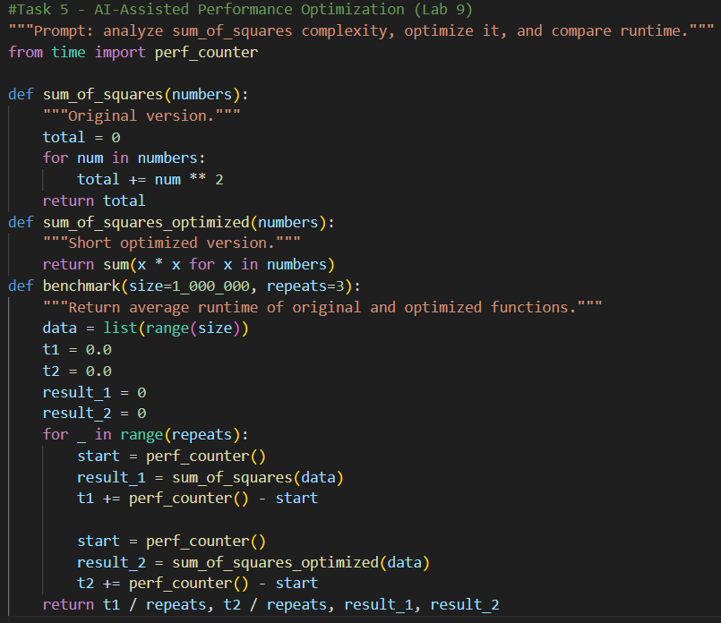
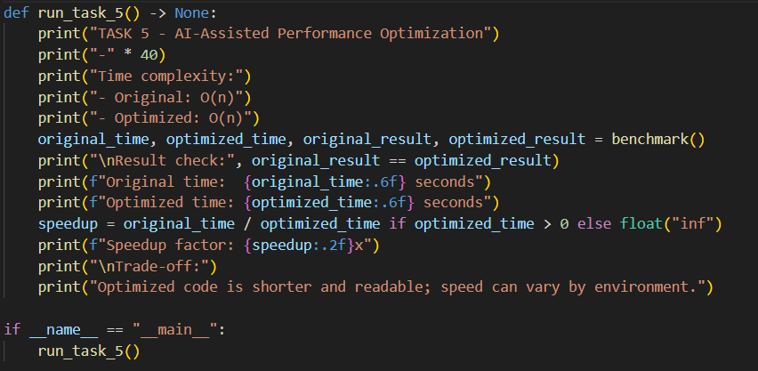

Output:
