ASSIGNMENT-9.5
2403A52L08-B50
ALLAPU SAI CHARAN
Problem 1: String Utilities Function
Consider the following Python function: def reverse_string(text):
return text[::-1]

Task:
- Write documentation in:

  - (a) Docstring
  - (b) Inline comments
  - (c) Google-style documentation
- Compare the three documentation styles.

Recommend the most suitable style for a utility-based string library.

Prompt: # Generate a Docstring Inline comments Google-style documentation to the reversing a string function.
Code:
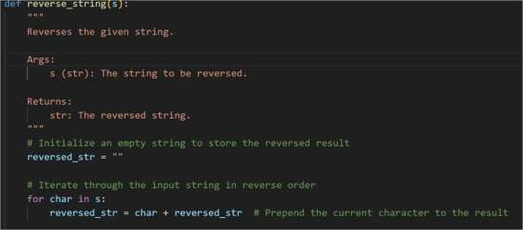
Output:
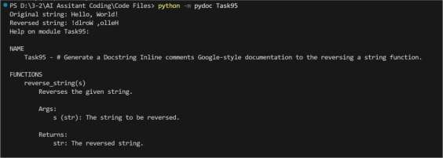
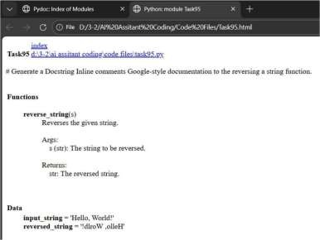

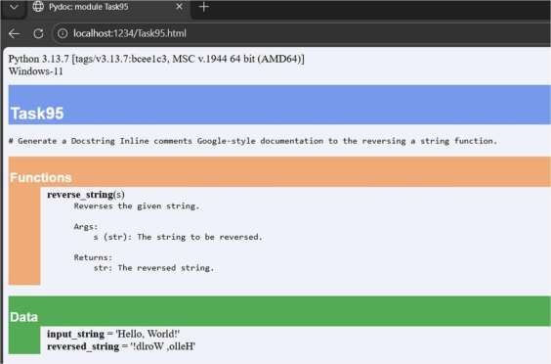

Problem 2: Password Strength Checker
Consider the function:
def
check_strength(password
): return len(password)
>= 8

Task:
- Document the function using docstring, inline comments, and Google style.
- Compare documentation styles for security-related code.
- Recommend the most appropriate style.
Prompt: generate a 1. Document the function using docstring, inline comments, and Google style 2. Compare documentation styles for security-related code. for Password Strength Checker function Code:

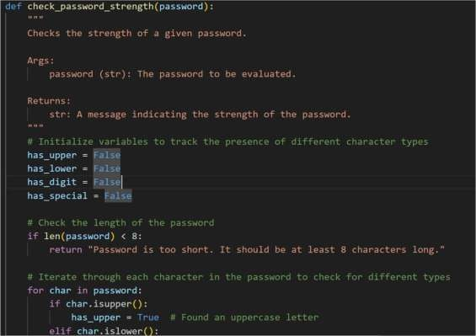
Output:
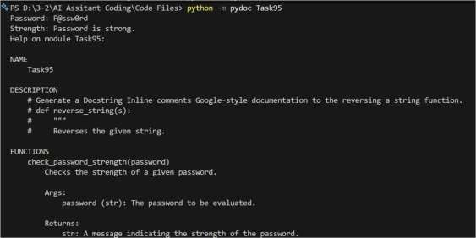

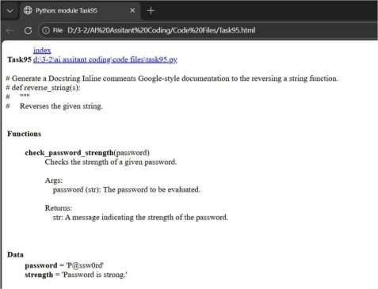

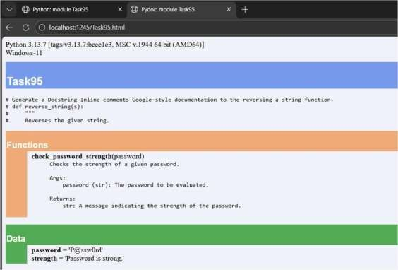

Problem 3: Math Utilities Module Task:
- Create a module math_utils.py with functions:
  - square(n)
  - cube(n)
  - factorial(n)
- Generate docstrings automatically using AI tools.
- Export documentation as an HTML file.
Prompt: # Generate a 1. Create a module math_utils.py with functions:,square(n),cube(n),factorial(n),
# Generate docstrings automatically Code:
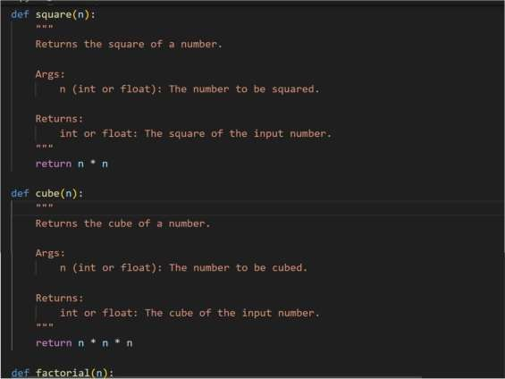
Output:

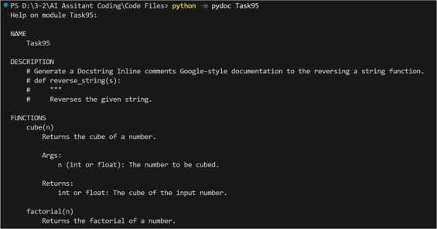
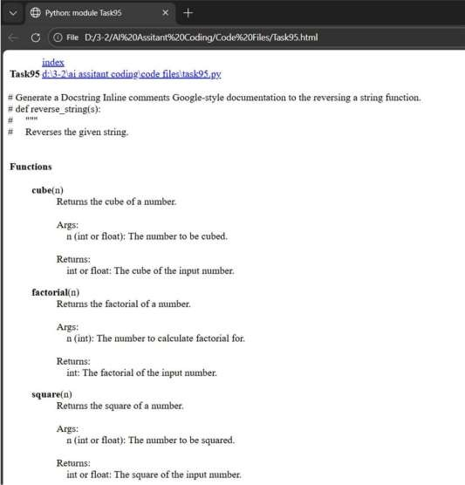

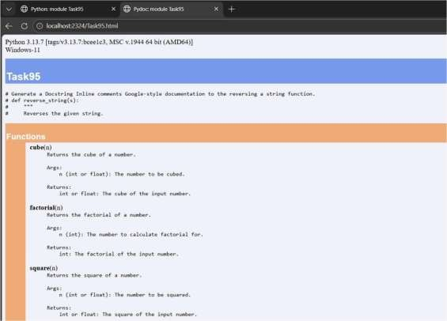

Problem 4: Attendance Management Module Task:
- Create a module attendance.py with functions:
  - mark_present(student)
  - mark_absent(student)
  - get_attendance(student)
- Add proper docstrings.
- Generate and view documentation in terminal and browse Prompt: Generate 1.Create a module attendance.py with functions:mark_present(student),mark_absent(stu dent),
# get_attendance(student) 3.Generate and view documentation

Code:
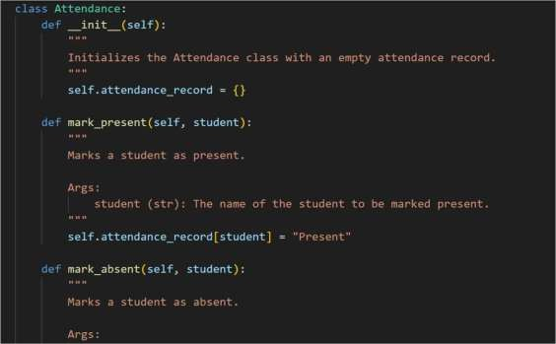
Output:
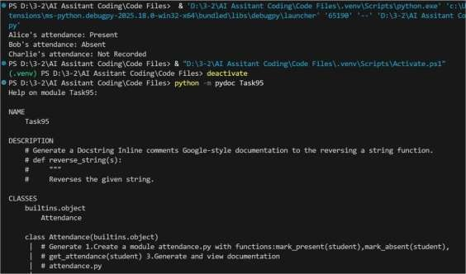

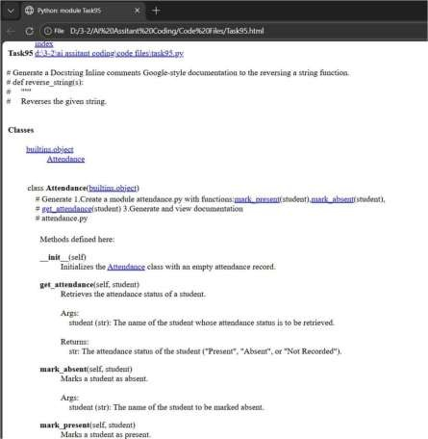
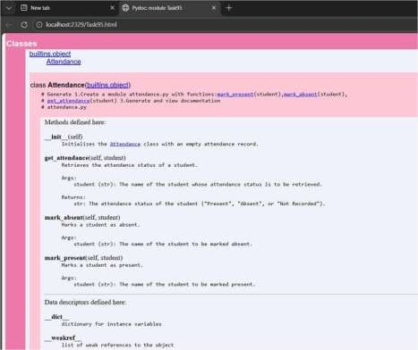

Problem 5: File Handling Function
Consider the function:
def read_file(filename): with open(filename, 'r') as
f: return f.read()

Task:
- Write documentation using all three formats.
- Identify which style best explains exception handling.
- Justify your recommendation.
Prompt: Generate a code with def read_file(filename):,with open(filename, 'r') as f:,return f.read(). Generate documentation using all three formats.2. Identify which style best explains exception handling.
Code:
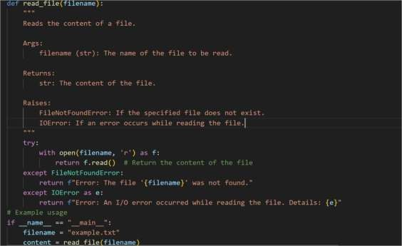
Output:

