AI ASSITANT CODING
ASSIGNMENT - 1.5
NAME- A.Saicharan
H:NO-2403A52L08
BATCH-50
TASK-1
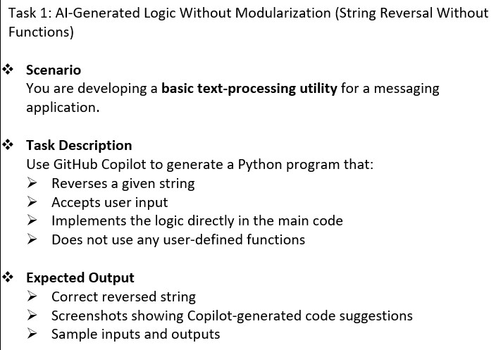

PROMPT:
write a python code to reverse a given string without user defined functions input should be taken from the user.

CODE LOGIC:

string = input("Enter a string: ")
reversed_string = string[::-1]
print("Reversed string:", reversed_string)

OUTPUT:

Enter a string: sai
Reversed string: ias

JUSTIFICATION:

Memory Efficiency: It creates a new string in a single, highly optimized pass.

Readability: For experienced Python developers, this is the "standard" way.
However, for beginners, the [::-1] syntax can look a bit like "magic" code.

TASK-2
Task 2: Efficiency & Logic Optimization (Readability Improvement)

QUESTION:

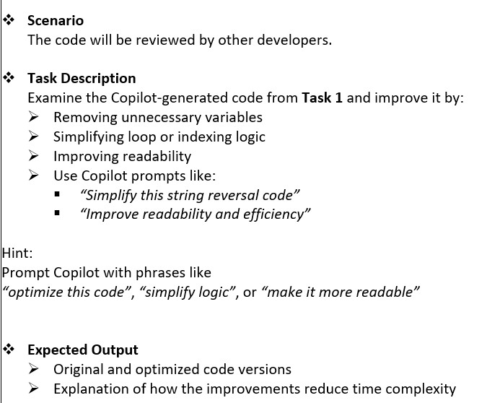

PROMPT:

Make The Code more readable and decrease the time complexityMake The Code
more readable and decrease the time complexity

CODE:

string = input("Enter a string: ") reversed_string = ''.join(reversed(string)) print("Reversed string:", reversed_string)

OUTPUT:

Enter a string: HELLO WORLD
Reversed string: DLROW OLLEH

JUSTIFICATION:

Readability: It is very explicit. A human reading the code knows exactly what is happening: you are reversing the string and then joining the characters back together.
Overhead: Technically, this is slower than slicing. Here is why:
- reversed(string) creates an iterator object.
- .join() then has to loop through that iterator and build the string. These extra steps (creating an object and calling a method) add "overhead" that makes it slower than the direct slicing method.

TASK 3

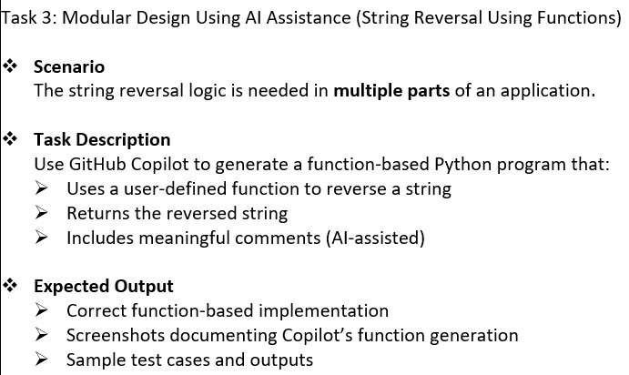

PROMPT:

write a python code that reverse a string with user defined functions that return a reversed string and comments for understand the code.

CODE:

def reverse_string(s):
# This function takes a string as input and returns the reversed string return s[::-1]
# Take input from the user user_input = input("Enter a string: ") # Call the function and store the result result = reverse_string(user_input) # Print the reversed string print("Reversed string:", result)

OUTPUT:

Enter a string: Hello and welcome sai
Reversed string: ias emoclew dna olleH

JUSTIFICATION:

Reusability:
By defining a function, you can reverse strings multiple times throughout a larger program without rewriting the slicing logic.

Modularity:
It separates the core logic (reversing) from the user interface (input/output), making the code cleaner and easier to maintain.

TASK 4 QUESTION:

