AI ASSISTED CODING
ASSIGNMENT - 2.5
NAME-A.Saicharan
H:NO-2403A52L08
BATCH-50
TASK-1
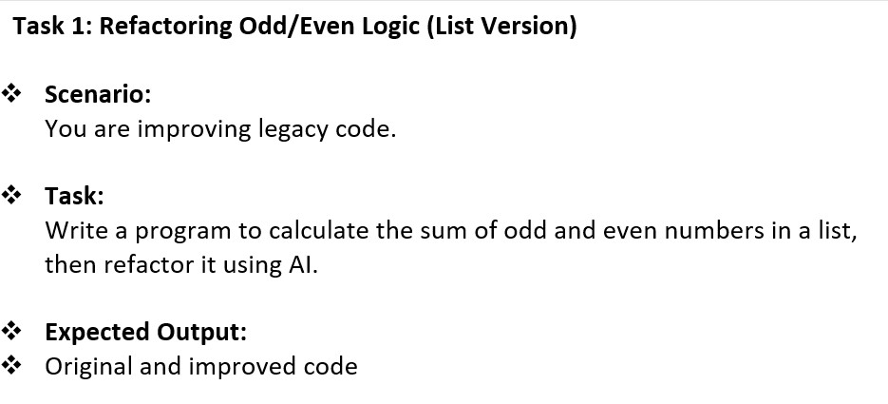
PROMPT:
"Hey, I have this old Python script that uses a basic for-loop and range(len()) to find the sum of odd and even numbers in a list. It feels a bit clunky. Can you refactor this to be more 'Pythonic' using list comprehensions or built-in functions?
Show me the original vs the new version." CODE LOGIC:
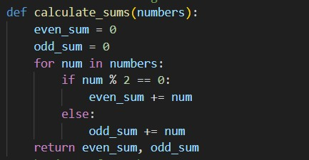
OUTPUT:
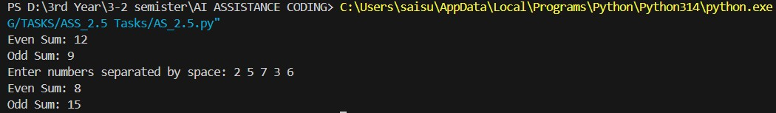
JUSTIFICATION:
This works because it gives the AI a role (cleaner of legacy code) and specifies a target style (Pythonic/List Comprehension). This prevents the AI from just giving you the same code back and forces it to optimize for readability.

TASK-2
QUESTION:
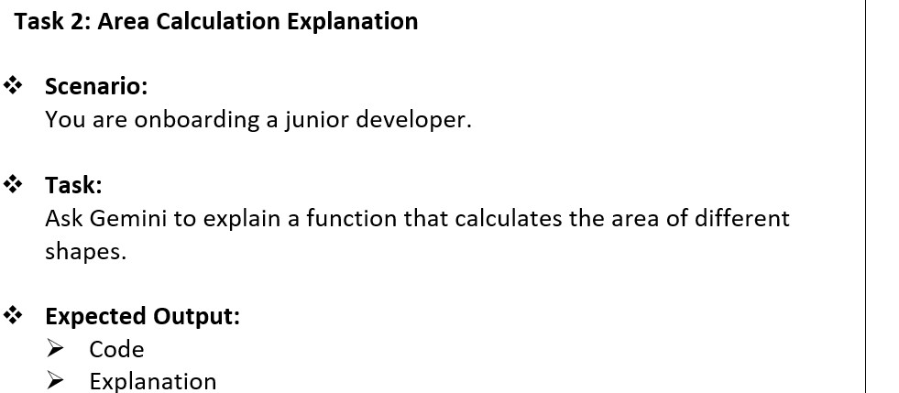
PROMPT:
"I'm onboarding a junior developer today. Can you write a Python function that calculates the area for a circle, rectangle, and triangle? After the code, give a simple, friendly explanation of how it works—especially why we use math.pi and how we handle different inputs—so the junior can follow along easily."
CODE:
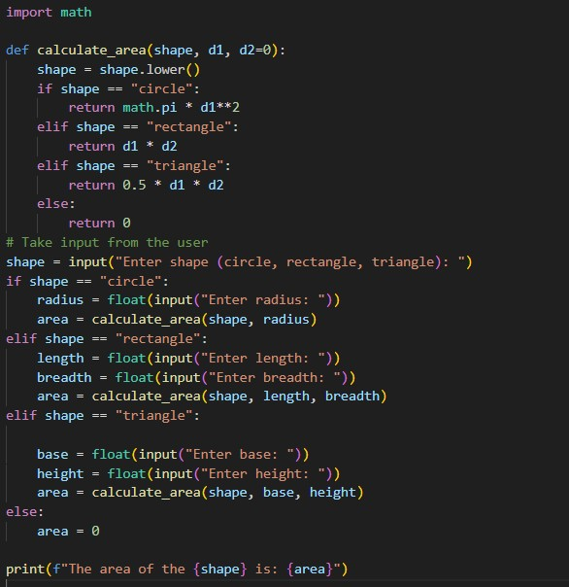
OUTPUT:
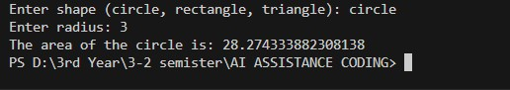
JUSTIFICATION:
By setting a persona (onboarding a junior), you ensure the AI doesn't just give a technical summary. It will use simpler language and focus on the "why" behind the code, which is exactly what your lab task requires.

TASK 3
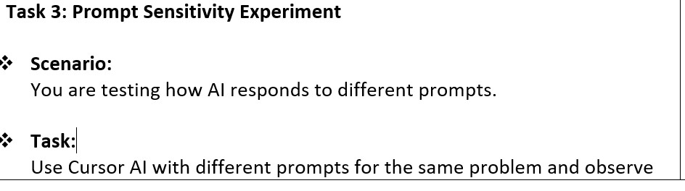
PROMPT:
Prompt A: "Write a function to find the max value in a list."
Prompt B: "Write a function to find the max value in a list, but do it manually using a for-loop and don't use any built-in functions like max()."
CODE:
def get_max(lst):
return max(lst)
JUSTIFICATION:
This is a constraint-based experiment. Prompt A lets the AI be "lazy" and efficient, while Prompt B forces it to show its algorithmic logic. Comparing these shows you how much "control" you have over the AI's output by just changing a few words.
TASK 4 QUESTION:
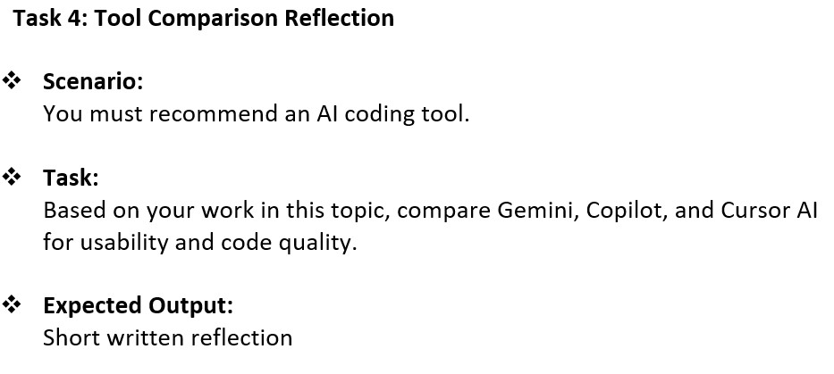
PROMPT:
"I've been using Gemini in Colab, GitHub Copilot, and Cursor AI for these lab tasks. Can you help me summarize the differences? Focus on which one felt best for explaining code to a human and which one was better at refactoring my files. Give me a short paragraph I can use in my lab report."
Justification:
This is a synthesis prompt. It asks the AI to look back at the work you've done and help you verbalize your thoughts into a professional reflection. It's perfect for the "Conclusion" or "Reflection" section of your SRU lab report.

