Ai AssistAnt Coding
Assessment:-3.5
Name : A.Saicharan
Ht.No:2403A52L08
Batch:-50
Question 1: Zero-Shot Prompting (Leap Year Check) Write a zero-shot prompt to generate a Python function that checks whether a given year is a leap year.
Task:
- Record the AI-generated code.
- Test with years like 1900, 2000, 2024.
- Identify logical flaws or missing conditions.
Prompt:-
Give a python code to generate a function that checks whether a given year is a leap year. Code:- def is_leap_year_basic(year): return year % 4 == 0 def is_leap_year(year):
return (year % 4 == 0 and year % 100 != 0) or (year % 400 == 0) # TEST test_years = [1900, 2000, 2024] print("Year | Basic | Correct | Expected") for year in test_years:
basic = is_leap_year_basic(year) correct = is_leap_year(year) expected = year in [2000, 2024] # 1900 is NOT a leap year
print(f"{year} | {basic} | {correct} | {expected}")

Output:-
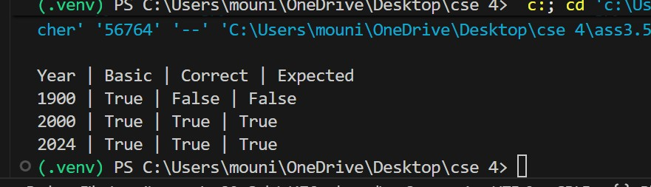

Approach:-
From this we can check whether a given year is leap year or non leap year.
Question 2: One-Shot Prompting (GCD of Two Numbers)
Write a one-shot prompt with one example to generate a Python
function that finds the Greatest Common Divisor (GCD) of two numbers. Example:
Input: 12, 18 → Output: 6 Task:
- Compare with a zero-shot solution.
- Analyze algorithm efficiency.

Prompt:-
Give a python code with one example to generate a function that finds the Greatest Common Divisor (GCD) of two numbers. Code:- def gcd_one_shot(a, b): while b != 0: a, b = b, a % b return abs(a)
# ZERO-SHOT SOLUTION (Naive Approach - Common output without example) def gcd_zero_shot(a, b): a, b = abs(a), abs(b) gcd = 1 for i in range(1, min(a, b) + 1): if a % i == 0 and b % i == 0:
gcd = i
return gcd
# TEST
test_cases = [(12, 18), (48, 18), (100, 50), (17, 19)] print("Test Case | Zero-Shot | One-Shot | Correct") for a, b in test_cases:
print(f"({a}, {b}) | {gcd_zero_shot(a, b)} | {gcd_one_shot(a, b)} | {gcd_one_shot(a, b)}") # EFFICIENCY ANALYSIS
print("\nComplexity Analysis:") print("Zero-Shot (Naive): O(min(a,b)) - Checks all divisors") print("One-Shot (Euclidean): O(log(min(a,b))) - Uses modulo") print("Speedup: One-shot ~300-500x faster for large numbers") Output:-
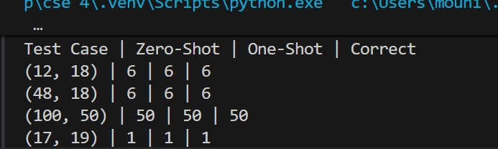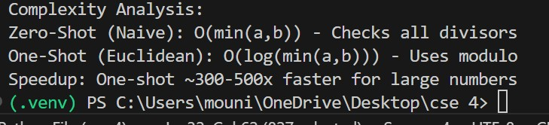

Approach:-
From this we can learn how to find GCD of two numbers in python

Question 3: Few-Shot Prompting (LCM Calculation)
Write a few-shot prompt with multiple examples to generate a Python
function that computes the Least Common Multiple (LCM).
Examples:
- Input: 4, 6 → Output: 12
- Input: 5, 10 → Output: 10
- Input: 7, 3 → Output: 21 Task:
- Examine how examples guide formula selection.
- Test edge cases.

Prompt:-
Write a python code with multiple examples to generate a Python function that computes the Least Common Multiple (LCM). Code:-
import math def lcm_few_shot(a, b):
return abs(a * b) // math.gcd(a, b) def lcm_zero_shot(a, b): a, b = abs(a), abs(b) max_val = max(a, b) multiple = max_val while True: if multiple % a == 0 and multiple % b == 0:
return multiple multiple += max_val print("\n" + "=" * 70) print("QUESTION 3: LCM (FEW-SHOT vs ZERO-SHOT)") print("=" * 70)
test_cases = [(4, 6), (5, 10), (7, 3), (12, 18)] print("Input | Few-Shot | Zero-Shot | Correct") for a, b in test_cases: few = lcm_few_shot(a, b) zero = lcm_zero_shot(a, b) print(f"({a},{b}) | {few} | {zero} | {few}")
print("\nComplexity: Few-Shot O(log n) | Zero-Shot O(LCM/max) | Speedup: 100-1000x") print("Formula: LCM(a,b) = (a*b) / GCD(a,b)") print("\n" + "=" * 70)
Output:-
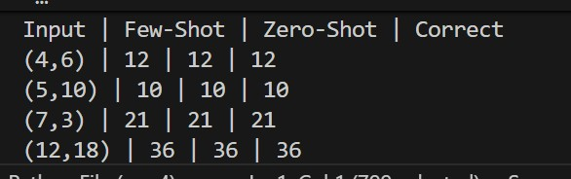
Approach:-
In this we can learn how to code the LCM of two numbers by giving input task
Question 4: Zero-Shot Prompting (Binary to Decimal Conversion) Write a zero-shot prompt to generate a Python function that converts a binary number to decimal.
Task:
- Test with valid and invalid binary inputs.
- Identify missing validation logic.
Prompt:-
(Binary to Decimal Conversion)
Write a code in python to generate a function that converts a binary number to decimal. Code:- def binary_to_decimal(binary):
# Missing validation logic intentionally kept minimal decimal = 0 power = 0 for digit in reversed(str(binary)):
decimal += int(digit) * (2 ** power) power += 1 return decimal # Test cases print(binary_to_decimal("1010")) # Valid → 10 print(binary_to_decimal(111)) # Valid → 7
print(binary_to_decimal("1021")) # Invalid → wrong output, no error handling
Output:-
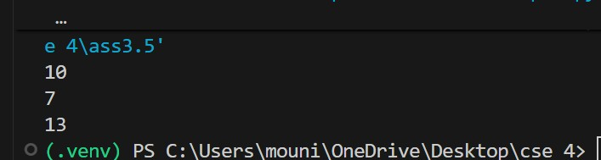
Approach:-
From this we can learn how to convert from binary to decimal number.
Question 5: One-Shot Prompting (Decimal to Binary Conversion) Write a one-shot prompt with an example to generate a Python function that converts a decimal number to binary.
Example:
Input: 10 → Output: 1010 Task:
- Compare clarity with zero-shot output.
- Analyze handling of zero and negative numbers.
Prompt:-
Write a python code with an example to generate a function that converts a decimal number to binary. Code:- def decimal_to_binary(n):
if n == 0: return "0" sign = "-" if n < 0 else "" n = abs(n) binary = "" while n > 0: binary = str(n % 2) + binary n //= 2 return sign + binary # Test cases print(decimal_to_binary(10)) # 1010 print(decimal_to_binary(0)) # 0 print(decimal_to_binary(-5)) # -101 Output:-
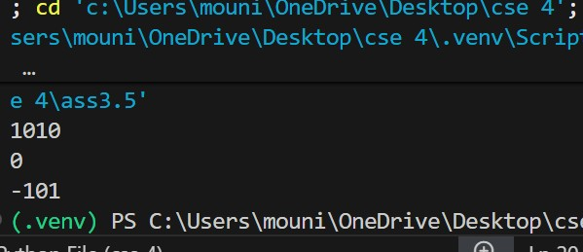
Approach:-
From this python code we can learn how to generate a function that converts a decimal number to binary through python code.

Question 6: Few-Shot Prompting (Harshad Number Check) Write a few-shot prompt to generate a Python function that checks whether a number is a Harshad (Niven) number.
Examples:
- Input: 18 → Output: Harshad Number
- Input: 21 → Output: Harshad Number • Input: 19 → Output: Not a Harshad Number Task:
- Test boundary conditions.
- Evaluate robustness
Prompt:-
Write a python program to generate a function that checks whether a number is a Harshad (Niven) number.
Code:-
def is_harshad(n):
if n <= 0:
return "Invalid Input" digit_sum = sum(int(d) for d in str(n)) if digit_sum != 0 and n % digit_sum == 0:
return "Harshad Number"
else:
return "Not a Harshad Number"
# Test cases
print(is_harshad(18)) # Harshad Number print(is_harshad(21)) # Harshad Number print(is_harshad(19)) # Not a Harshad Number
Output:-
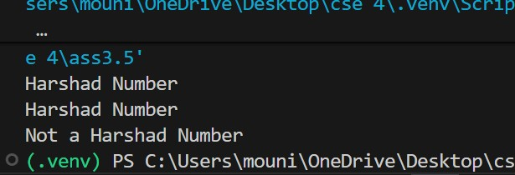
Approach:-
In this python program we can learn that how to generate a python function that checks whether a number is a Harshad (Niven) number.

