Ai Assistant Coding
WEEK 5.5
Name : A.Saicharan
Ht.no:2403A52L08 Batch:50
Task Description #1 (Transparency in Algorithm Optimization) Task: Use AI to generate two solutions for checking prime numbers:
- Naive approach(basic)
- Optimized approach
Prompt:
“Generate Python code for two prime-checking methods and explain how the optimized version improves performance.”
Code:

• Naive approach(basic)
#Naive method import math def is_prime_basic(n):
if n <= 1:
return False for i in range(2, n): if n % i == 0:
return False return True

• Optimized approach
#Optimized version def is_prime_optimized(n): if n <= 1:
return False if n == 2:
return True if n % 2 == 0: return False for i in range(3, int(math.sqrt(n)) + 1, 2): if n % i == 0: return False return True num = int(input("Enter a number: ")) print("Basic method result:", is_prime_basic(num)) print("Optimized method result:", is_prime_optimized(num)) Output:
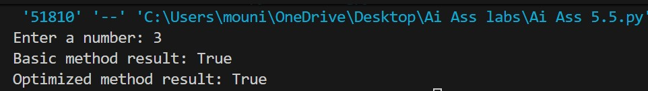
Explanation:
The naive approach code checks whether the given number is prime or nonprime number.
Time Complexity:
O(n) — slow for large numbers.
The optimized version code checks skips even numbers and stops checking after the square root of the number.
Time Complexity:
O(√n) — much faster.

Task Description #2 (Transparency in Recursive Algorithms)
Objective: Use AI to generate a recursive function to calculate
Fibonacci numbers.
Instructions:
- Ask AI to add clear comments explaining recursion.
- Ask AI to explain base cases and recursive calls.
Prompt:
Generate a python code to generate a recursive function to calculate the Fibonacci numbers.
Code:
def fibonacci(n):
# Base case 1:
# If n is 0, Fibonacci value is 0 # This stops further recursive calls if n == 0: return 0
# Base case 2:
# If n is 1, Fibonacci value is 1 # This also stops recursion if n == 1: return 1
# Recursive case:
# The function calls itself to find
# the Fibonacci values of the two
# previous numbers return fibonacci(n - 1) + fibonacci(n - 2)
# Take input from the user n = int(input("Enter a number: "))
# Call the recursive function and print the result print("Fibonacci number is:", fibonacci(n)) Output:
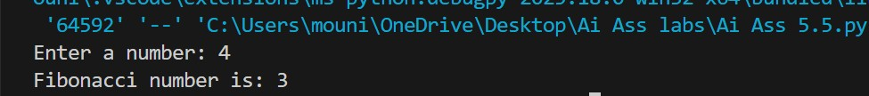
Explanation:
In base cases 1 and 2 we have given value 0 and 1 so it stops the recursive calls and in the recursive case the function calls itself to find the fibonacci values of the two previous numbers.

Task Description #3 (Transparency in Error Handling)
Task: Use AI to generate a Python program that reads a file and processes data.
Prompt:
“Generate code with proper error handling and clear explanations for each exception.”
Code: def calculate_average(filename):
try:
# Step 1: Try to open the file with open(filename, "r") as file: lines = file.readlines() # Step 2: Check if file is empty if not lines:
raise ValueError("File is empty. No data to process.") numbers = []
# Step 3: Convert each line into an integer for line in lines:
numbers.append(int(line.strip()))
# Step 4: Calculate average
average = sum(numbers) / len(numbers) print("Average of numbers:", average) except FileNotFoundError:
# Triggered when file does not exist print("Error: File not found. Please check the file name or path.") except ValueError as ve:
# Triggered for:
# 1) Non-numeric data
# 2) Empty file (manually raised) print("Error:", ve) except ZeroDivisionError:
# Triggered if division by zero occurs print("Error: Cannot divide by zero. No valid numbers found.") except Exception as e:
# Handles any unexpected errors print("Unexpected error occurred:", e) else:
# Runs only if no exception occurs print("File processed successfully.") finally:
# Always executes print("Program execution completed.")
# ---- Program Execution ---- filename = input("Enter file name: ") calculate_average(filename) Output:
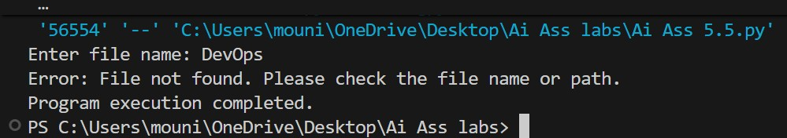
Explanation:
If the file is empty or there is no file with the name we have given,it clearly shows that file not found. If there is the correct file uploaded we will get the average in all cases.

Task Description #4 (Security in User Authentication)
Task: Use an AI tool to generate a Python-based login system. Analyze: Check whether the AI uses secure password handling practices.
Prompt:
Generate a code in python based login system and check whether that the Ai uses secure password handling.
Code:
import hashlib import getpass import re user_db = {} # stores username: hashed_password def hash_password(password):
return hashlib.sha256(password.encode()).hexdigest() def is_strong_password(password):
"""
Password validation rules:
- Minimum 8 characters
- At least 1 uppercase, 1 lowercase, 1 digit
- At least 1 special character
"""
if len(password) < 8: return False if not re.search(r"[A-Z]", password): return False if not re.search(r"[a-z]", password):
return False if not re.search(r"\d", password):
return False if not re.search(r"[!@#$%^&*]", password):
return False return True def register():
username = input("Enter new username: ") if username in user_db:
print("Username already exists. Try login.") return password = getpass.getpass("Enter password: ") if not is_strong_password(password):
print("Weak password! Must be 8+ chars, mix of upper/lower/digit/special.")
return confirm = getpass.getpass("Confirm password: ") if password != confirm:
print("Passwords do not match!") return
user_db[username] = hash_password(password) print(f"User '{username}' registered successfully!") def login():
username = input("Enter username: ") if username not in user_db:
print("User not found. Register first.") return
password = getpass.getpass("Enter password: ") if user_db[username] == hash_password(password): print(f"Welcome, {username}! Login successful.")
else:
print("Incorrect password. Try again.") while True:
choice = input("\n[register/login/exit]: ").lower() if choice == "register":
register() elif choice == "login": login() elif choice == "exit":
break else:
print("Invalid option.")
Output:
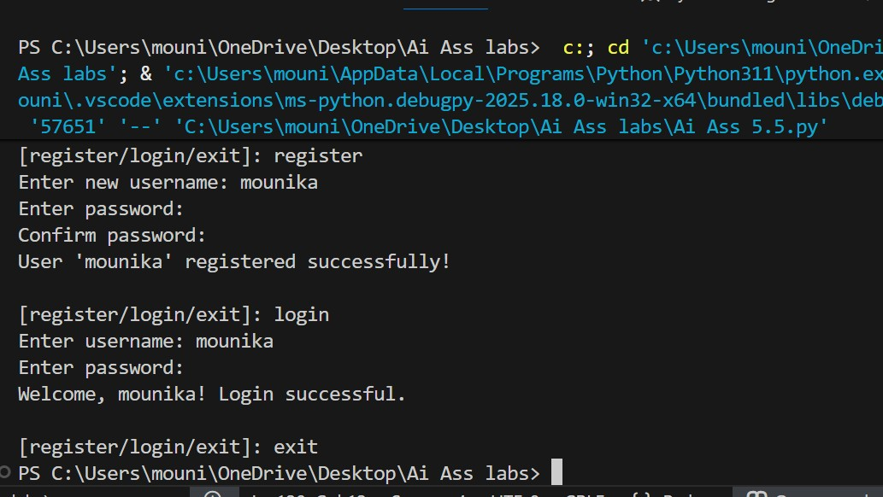
Explanation:
When registering, the program checks if the password is strong and hides input; it shows success only if all checks pass.
During login, it verifies the hashed password and welcomes the user if correct, or shows an error if the username or password is wrong.
Task Description #5 (Privacy in Data Logging)
Task: Use an AI tool to generate a Python script that logs user activity (username, IP address, timestamp).
Analyze: Examine whether sensitive data is logged unnecessarily or insecurely.
Prompt:
Generate a code in python script that logs user activity (username, IP address, timestamp).Examine whether sensitive data is logged unnecessarily or insecurely.
Code:
import logging from datetime import datetime import socket import hashlib # Configure logging logging.basicConfig( filename='user_activity_safe.log', level=logging.INFO, format='%(asctime)s - %(user_id)s - %(ip_masked)s - %(action)s' ) def get_ip_masked():
try:
hostname = socket.gethostname() ip = socket.gethostbyname(hostname)
# Mask last octet for privacy parts = ip.split('.') parts[-1] = 'xxx'
return '.'.join(parts) except:
return "Unknown IP" def anonymize_username(username):
# Hash the username to avoid storing real name return hashlib.sha256(username.encode()).hexdigest()[:8] # first 8 chars def log_activity(username, action): user_id = anonymize_username(username) ip_masked = get_ip_masked()
# Use 'action' instead of 'message' to avoid conflict
logging.info('', extra={'user_id': user_id, 'ip_masked': ip_masked, 'action': action}) print(f"Activity logged: user {user_id} from {ip_masked} - {action}")
# Example usage username = input("Enter username: ") action = input("Enter action performed: ") log_activity(username, action) Output:
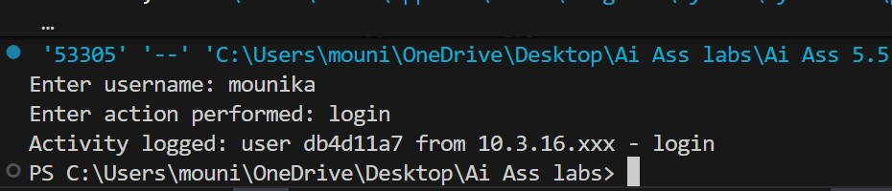
Explanation:
The code logs user activity safely by asking usernames and masking IP addresses, avoiding any direct personal identification. It also fixes a logging error by using a custom key action instead of message.

