AI Assistant Coding
Assignment 19.5
A.Tharun
2403a52L10
B:50

Task 1 – Python to C++ Conversion Task:
Translate a simple Python class into C++ using AI assistance.
Instructions:
- Prompt AI to convert a Python class representing a Student with attributes and methods into equivalent C++ code
- Ensure proper handling of:
o Constructors o Data types o Access specifiers
• Compile and run both versions to verify output consistency Expected Output:
An equivalent working C++ class translated from Python.
#PROMPT
""" convert a Python class representing a Student with attributes and methods into equivalent C++ code
Ensure proper handling of: Constructors, Data types, Access specifiers
Compile and run both versions to verify output consistency"""
#Python CODE
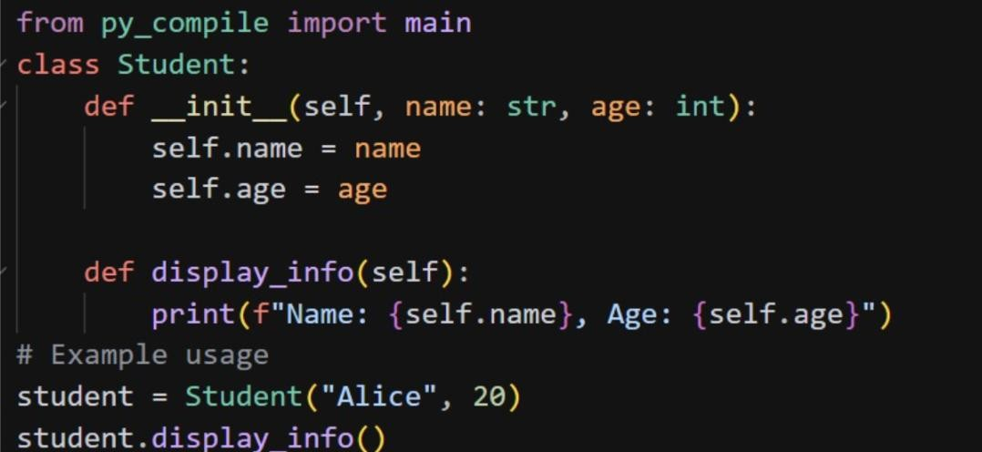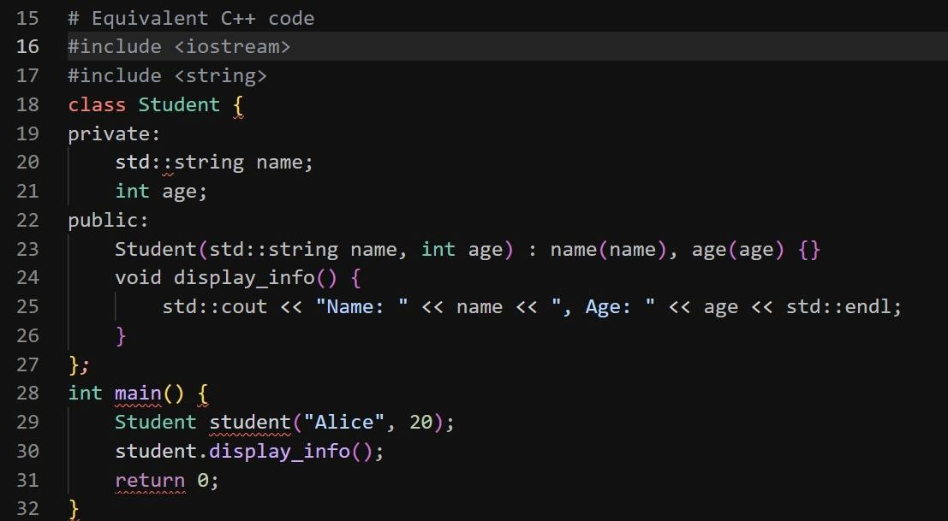
Task 2 – Java to Python Function Conversion Task:
Convert a Java method that checks whether a number is prime into Python.
Instructions:
- Ask AI to translate a Java isPrime() method into Python
- Test the function with multiple inputs
- Ensure the Python version follows Pythonic syntax and logic
Expected Output:
A correct Python function equivalent to the original Java prime- checking method.
#PROMPT
""" Translate a Java isPrime() method into Python Test the function with multiple inputs
Ensure the Python version follows Pythonic syntax and logic for checking prime numbers."""
#CODE
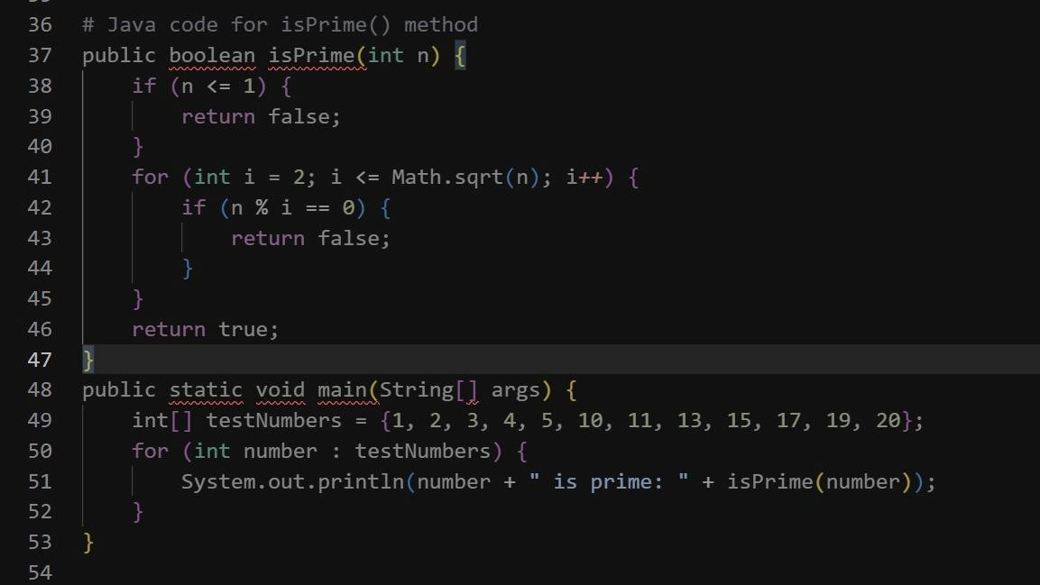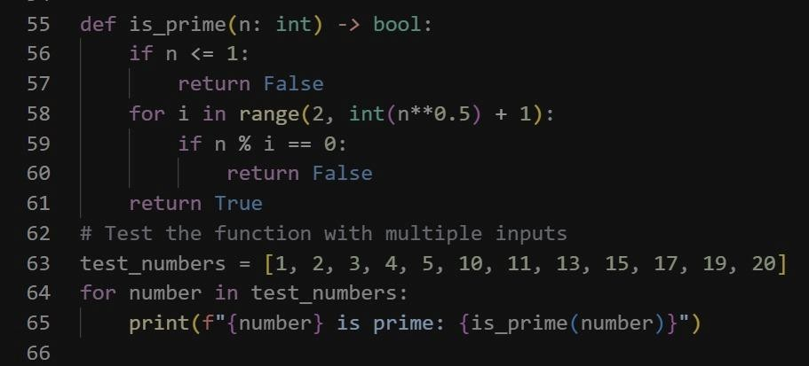

Task 3 – Pseudocode to Python Implementation Task:
Translate a given pseudocode algorithm into Python using AI.
Instructions:
- Provide AI with pseudocode for sorting numbers (e.g., bubble sort or selection sort)
- Ask AI to convert it into executable Python code
- Validate correctness using sample input lists Expected Output:
A working Python program that correctly implements the pseudocode logic.
#PROMPT
""" Translate the given pseudocode for sorting numbers into executable Python code Validate correctness using sample input lists"""
# Pseudocode for sorting numbers """function sortNumbers(list): for i from 0 to length of list - 1: for j from 0 to length of list - i - 2:
if list[j] > list[j + 1]:
swap list[j] and list[j + 1] return list"""
#CODE
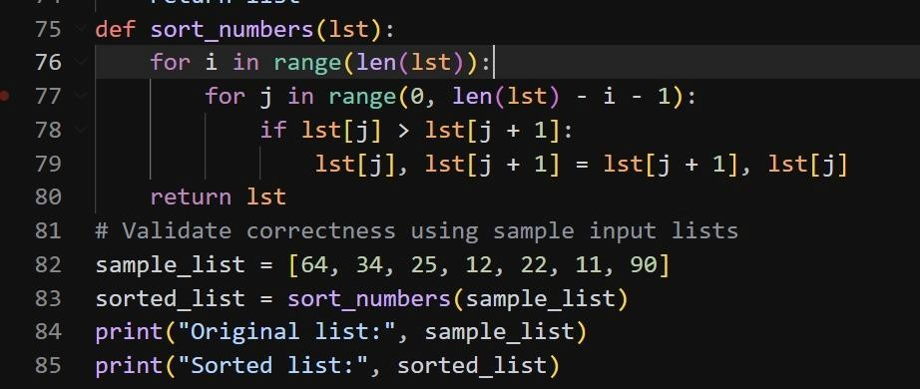
Task 4 – SQL to Pandas Query Task:
Translate a SQL query into a Pandas DataFrame operation in Python.
Instructions:
- Provide AI with a SQL query (e.g., SELECT name, salary FROM employees WHERE salary > 50000).
- Ask AI to generate equivalent Pandas code.
- Test the generated code on a sample DataFrame.
Expected Output:
- Equivalent Pandas query that retrieves the correct subset of data.
#PROMPT
"""Translate a SQL query (e.g., SELECT name, salary FROM employees WHERE salary > 50000)into a Pandas DataFrame operation in Python.Test the generated code on a sample DataFrame."""
#CODE
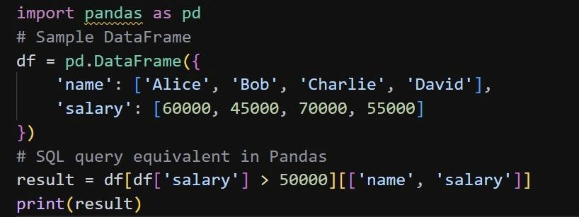
Task Description #5: Smart Hostel Room Allocation System A hostel management system stores student room allocation details including student ID, room number, floor, and allocation date. The system needs to:
- Search allocation details using student ID.
- Sort records based on room number or allocation date.
Student Task
- Use AI to suggest optimized algorithms.
- Justify the selections.
- Implement the solution in Python.
#PROMPT
""" Generate a python program for A hostel management system that stores student room allocation details
including student ID, room number, floor, and allocation date. The system needs to:
- Search allocation details using student ID.
- Sort records based on room number or allocation date. Recommend suitable searching and sorting algorithms.
Justify the selected algorithms."""
#CODE
def merge_sort(arr, key):
if len(arr) <= 1: return arr

mid = len(arr) // 2 left_half = merge_sort(arr[:mid], key) right_half = merge_sort(arr[mid:], key)

return merge(left_half, right_half, key) def merge(left, right, key): merged = [] left_index = right_index = 0

while left_index < len(left) and right_index < len(right): if key(left[left_index]) < key(right[right_index]):
merged.append(left[left_index])
left_index += 1
else:
merged.append(right[right_index])
right_index += 1

# If there are remaining elements in left or right, add them to merged merged.extend(left[left_index:]) merged.extend(right[right_index:])

return merged class Allocation: def _init_(self, student_id, room_number, floor, allocation_date):
self.student_id = student_id
self.room_number = room_number
self.floor = floor
self.allocation_date = allocation_date
class HostelManagementSystem:
def _init_(self):
self.allocations = []

def add_allocation(self, allocation): self.allocations.append(allocation)

def search_allocation_by_student_id(self, student_id):
"""
Searches for allocation details by student ID using linear search.

Time Complexity: O(n) - where n is the number of allocations.
Space Complexity: O(1) - as we are using a constant amount of space for variables.
"""
for allocation in self.allocations: if allocation.student_id == student_id:
return allocation return None

def sort_allocations_by_room_number(self):
"""
Sorts records based on room number using Merge Sort.

Time Complexity: O(n log n) - where n is the number of allocations.
Space Complexity: O(n) - due to the temporary arrays used for merging.
"""
self.allocations = merge_sort(self.allocations, key=lambda x: x.room_number)

def sort_allocations_by_allocation_date(self):
"""
Sorts records based on allocation date using Merge Sort.

Time Complexity: O(n log n) - where n is the number of allocations.
Space Complexity: O(n) - due to the temporary arrays used for merging.
"""
self.allocations = merge_sort(self.allocations, key=lambda x: x.allocation_date)
# Test cases if _name_ == "_main_":
hms = HostelManagementSystem() hms.add_allocation(Allocation("S001", "101", "1st", "2023-09-01")) hms.add_allocation(Allocation("S002", "102", "1st", "2023-09-02")) hms.add_allocation(Allocation("S003", "201", "2nd", "2023-09-03"))

# Test search
allocation = hms.search_allocation_by_student_id("S002")
print(f"Search result for student ID 'S002': {allocation.room_number if allocation else 'Not found'}")

# Test sorting by room number hms.sort_allocations_by_room_number() print("Allocations sorted by room number:") for alloc in hms.allocations:
print(f"Student ID: {alloc.student_id}, Room Number: {alloc.room_number}")

# Test sorting by allocation date hms.sort_allocations_by_allocation_date() print("Allocations sorted by allocation date:") for alloc in hms.allocations:
print(f"Student ID: {alloc.student_id}, Allocation Date: {alloc.allocation_date}")
#OUTPUT
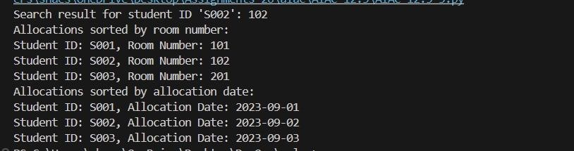
Task Description #6: Online Movie Streaming Platform
A streaming service maintains movie records with movie ID, title, genre, rating, and release year. The platform needs to:
- Search movies by movie ID.
- Sort movies based on rating or release year.
Student Task
- Recommend searching and sorting algorithms using AI.
- Justify the chosen algorithms.
- Implement Python functions.
#PROMPT
"""streaming service maintains movie records with movie ID, title, genre, rating, and release year.
Generate a python program that allows users to perform the following operations:
- Search movies by movie ID.
- Sort movies based on rating or release year. Recommend suitable searching and sorting algorithms. Justify the selected algorithms."""
#CODE
class Movie: def _init_(self, movie_id, title, genre, rating, release_year):
self.movie_id = movie_id
self.title = title
self.genre = genre self.rating = rating
self.release_year = release_year class StreamingService:
def _init_(self): self.movies = []

def add_movie(self, movie): self.movies.append(movie)

def search_movie_by_id(self, movie_id):
"""
Searches for a movie by its ID using linear search.

Time Complexity: O(n) - where n is the number of movies.
Space Complexity: O(1) - as we are using a constant amount of space for variables.
"""
for movie in self.movies: if movie.movie_id == movie_id:
return movie return None

def sort_movies_by_rating(self):
"""
Sorts movies based on rating using Merge Sort.

Time Complexity: O(n log n) - where n is the number of movies.
Space Complexity: O(n) - due to the temporary arrays used for merging.
"""
self.movies = merge_sort(self.movies, key=lambda x: x.rating)

def sort_movies_by_release_year(self):
"""
Sorts movies based on release year using Merge Sort.

Time Complexity: O(n log n) - where n is the number of movies.
Space Complexity: O(n) - due to the temporary arrays used for merging.
"""
self.movies = merge_sort(self.movies, key=lambda x: x.release_year) def merge_sort(arr, key):
if len(arr) <= 1: return arr

mid = len(arr) // 2 left_half = merge_sort(arr[:mid], key) right_half = merge_sort(arr[mid:], key)

return merge(left_half, right_half, key) def merge(left, right, key): merged = [] left_index = right_index = 0

while left_index < len(left) and right_index < len(right): if key(left[left_index]) < key(right[right_index]): merged.append(left[left_index])
left_index += 1
else:
merged.append(right[right_index])
right_index += 1

# If there are remaining elements in left or right, add them to merged merged.extend(left[left_index:]) merged.extend(right[right_index:])

return merged # Test cases if _name_ == "_main_":
streaming_service = StreamingService() streaming_service.add_movie(Movie(1, "Inception", "Sci-Fi", 8.8, 2010)) streaming_service.add_movie(Movie(2, "The Matrix", "Sci-Fi", 8.7, 1999)) streaming_service.add_movie(Movie(3, "Interstellar", "Sci-Fi", 8.6, 2014)) streaming_service.add_movie(Movie(4, "The Godfather", "Crime", 9.2, 1972))

# Search for a movie by ID movie = streaming_service.search_movie_by_id(2)
if movie:
print(f"Movie found: {movie.title} ({movie.release_year}) - Rating: {movie.rating}")
else:
print("Movie not found.")

# Sort movies by rating streaming_service.sort_movies_by_rating() print("\nMovies sorted by rating:")
for movie in streaming_service.movies:
print(f"{movie.title} ({movie.release_year}) - Rating: {movie.rating}")

# Sort movies by release year streaming_service.sort_movies_by_release_year() print("\nMovies sorted by release year:") for movie in streaming_service.movies:
print(f"{movie.title} ({movie.release_year}) - Rating: {movie.rating}")
#OUTPUT
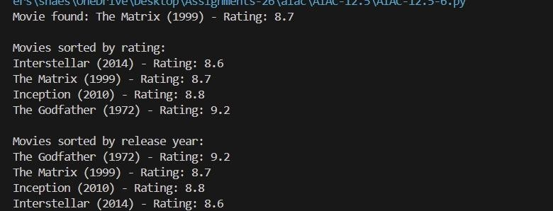

Task Description #7: Smart Agriculture Crop Monitoring System An agriculture monitoring system stores crop data with crop ID, crop name, soil moisture level, temperature, and yield estimate. Farmers need to:
- Search crop details using crop ID.
- Sort crops based on moisture level or yield estimate.
Student Task
- Use AI-assisted reasoning to select algorithms.
- Justify algorithm suitability.
- Implement searching and sorting in Python.

#PROMPT
"""An agriculture monitoring system stores crop data with crop ID, crop name, soil moisture level, temperature, and yield estimate.
Generate a python program that allows users to perform the following operations:
- Search crop details using crop ID.
- Sort crops based on moisture level or yield estimate. Recommend suitable searching and sorting algorithms. Justify the selected algorithms."""
#CODE
class Crop: def __init__(self, crop_id, crop_name, soil_moisture_level, temperature, yield_estimate):
self.crop_id = crop_id
self.crop_name = crop_name self.soil_moisture_level = soil_moisture_level self.temperature = temperature self.yield_estimate = yield_estimate class Agriculture: def __init__(self): self.crops = []

def add_crop(self, crop): self.crops.append(crop)

def search_crop_by_id(self, crop_id):
"""
Searches for crop details by crop ID using linear search.

Time Complexity: O(n) - where n is the number of crops.
Space Complexity: O(1) - as we are using a constant amount of space for variables.
"""
for crop in self.crops: if crop.crop_id == crop_id:
return crop
return None

def sort_crops_by_moisture_level(self):
"""
Sorts crops based on soil moisture level using Merge Sort.

Time Complexity: O(n log n) - where n is the number of crops.
Space Complexity: O(n) - due to the temporary arrays used for merging.
"""
self.crops = merge_sort(self.crops, key=lambda x: x.soil_moisture_level)

def sort_crops_by_yield_estimate(self):
"""
Sorts crops based on yield estimate using Merge Sort.

Time Complexity: O(n log n) - where n is the number of crops.
Space Complexity: O(n) - due to the temporary arrays used for merging.
"""
self.crops = merge_sort(self.crops, key=lambda x: x.yield_estimate) def merge_sort(arr, key):
if len(arr) <= 1: return arr

mid = len(arr) // 2 left_half = merge_sort(arr[:mid], key) right_half = merge_sort(arr[mid:], key)

return merge(left_half, right_half, key) def merge(left, right, key): merged = [] left_index = right_index = 0

while left_index < len(left) and right_index < len(right): if key(left[left_index]) < key(right[right_index]):
merged.append(left[left_index])
left_index += 1
else:
merged.append(right[right_index])
right_index += 1

# If there are remaining elements in left or right, add them to merged merged.extend(left[left_index:]) merged.extend(right[right_index:])

return merged
# Justification for selected algorithms:
# 1. Linear Search: We use linear search for searching crop details by crop ID because it is simple to implement and works well for small datasets. Since the number of crops may not be very large, linear search is efficient enough for this use case.
# 2. Merge Sort: We use merge sort for sorting crops based on soil moisture level and yield estimate because it is a stable sorting algorithm with a time complexity of O(n log n) in the worst case. Merge sort is efficient for sorting large datasets and can handle different types of data, making it suitable for our crop data. Additionally, merge sort does not require additional space for in-place sorting, which can be beneficial when dealing with larger datasets. #Test cases if __name__ == "__main__":
agriculture_system = Agriculture()

# Adding sample crops agriculture_system.add_crop(Crop(1, "Wheat", 30, 25, 100)) agriculture_system.add_crop(Crop(2, "Corn", 40, 28, 150)) agriculture_system.add_crop(Crop(3, "Rice", 20, 22, 120))

# Searching for a crop by ID crop = agriculture_system.search_crop_by_id(2)
if crop:
print(f"Crop found: {crop.crop_name}, Soil Moisture Level: {crop.soil_moisture_level}, Yield Estimate: {crop.yield_estimate}")
else:
print("Crop not found.")

# Sorting crops by soil moisture level agriculture_system.sort_crops_by_moisture_level() print("Crops sorted by soil moisture level:") for crop in agriculture_system.crops:
print(f"{crop.crop_name}: {crop.soil_moisture_level}")

# Sorting crops by yield estimate agriculture_system.sort_crops_by_yield_estimate() print("Crops sorted by yield estimate:") for crop in agriculture_system.crops:
print(f"{crop.crop_name}: {crop.yield_estimate}")
#OUTPUT
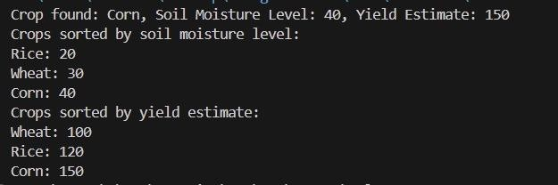
Task Description #8: Airport Flight Management System An airport system stores flight information including flight ID, airline name, departure time, arrival time, and status. The system must:
- Search flight details using flight ID.
- Sort flights based on departure time or arrival time.
Student Task
- Use AI to recommend algorithms.
- Justify the algorithm selection.
- Implement searching and sorting logic in Python.
#PROMPT
""" An airport system stores flight information including flight ID, airline name, departure time, arrival time, and status. Generate a python program that allows users to perform the following operations:
- Search flight details using flight ID.
- Sort flights based on departure time or arrival time""” #CODE
class Flight: def _init_(self, flight_id, airline_name, departure_time, arrival_time, status):
self.flight_id = flight_id
self.airline_name = airline_name self.departure_time = departure_time self.arrival_time = arrival_time self.status = status
class AirportSystem: def _init_(self): self.flights = []

def add_flight(self, flight): self.flights.append(flight)

def search_flight_by_id(self, flight_id):
"""
Searches for flight details by flight ID using linear search.

Time Complexity: O(n) - where n is the number of flights.
Space Complexity: O(1) - as we are using a constant amount of space for variables.
"""
for flight in self.flights: if flight.flight_id == flight_id:
return flight
return None

def sort_flights_by_departure_time(self):
"""
Sorts flights based on departure time using Merge Sort.

Time Complexity: O(n log n) - where n is the number of flights.
Space Complexity: O(n) - due to the temporary arrays used for merging.
"""
self.flights = merge_sort(self.flights, key=lambda x: x.departure_time)

def sort_flights_by_arrival_time(self):
"""
Sorts flights based on arrival time using Merge Sort.

Time Complexity: O(n log n) - where n is the number of flights.
Space Complexity: O(n) - due to the temporary arrays used for merging.
"""
self.flights = merge_sort(self.flights, key=lambda x: x.arrival_time) def merge_sort(arr, key):
if len(arr) <= 1: return arr

mid = len(arr) // 2 left_half = merge_sort(arr[:mid], key) right_half = merge_sort(arr[mid:], key)

return merge(left_half, right_half, key) def merge(left, right, key): merged = [] left_index = right_index = 0

while left_index < len(left) and right_index < len(right): if key(left[left_index]) <= key(right[right_index]):
merged.append(left[left_index])
left_index += 1
else:
merged.append(right[right_index])
right_index += 1

merged.extend(left[left_index:])
merged.extend(right[right_index:])

return merged # Example usage if _name_ == "_main_":
airport_system = AirportSystem()

# Adding some flights airport_system.add_flight(Flight("FL001", "Airline A", "08:00", "10:00", "On Time")) airport_system.add_flight(Flight("FL002", "Airline B", "09:00", "11:00", "Delayed")) airport_system.add_flight(Flight("FL003", "Airline C", "07:30", "09:30", "On Time"))

# Searching for a flight by ID flight = airport_system.search_flight_by_id("FL002")
if flight:
print(f"Flight found: {flight.airline_name}, Departure: {flight.departure_time}, Arrival:
{flight.arrival_time}, Status: {flight.status}")
else:
print("Flight not found.")

# Sorting flights by departure time airport_system.sort_flights_by_departure_time() print("\nFlights sorted by departure time:") for flight in airport_system.flights:
print(f"{flight.flight_id}: {flight.departure_time}")

# Sorting flights by arrival time airport_system.sort_flights_by_arrival_time() print("\nFlights sorted by arrival time:") for flight in airport_system.flights: print(f"{flight.flight_id}: {flight.arrival_time}")

#OUTPUT
