AI ASSISTED CODING
ASSIGNMENT-8.5

2403A52L10-B50
A.Tharun
Task Description #1 (Username Validator – Apply AI in
Authentication Context)
- Task: Use AI to generate at least 3 assert test cases for a function is_valid_username(username) and then implement the function using Test-Driven Development principles.
- Requirements:
- Username length must be between 5 and 15 characters. o Must contain only alphabets and digits.
- Must not start with a digit.
- No spaces allowed. Example Assert Test Cases:
assert is_valid_username("User123") == True assert is_valid_username("12User") == False assert is_valid_username("Us er") == False Expected Output #1:
- Username validation logic successfully passing all AI- generated test cases.

PROMPT:
“Generate assert-based test cases for a function is_valid_username(username) that enforces: length between 5–15 characters, only alphanumeric characters, must not start with a digit, and no spaces allowed”
CODE AND OUTPUT:
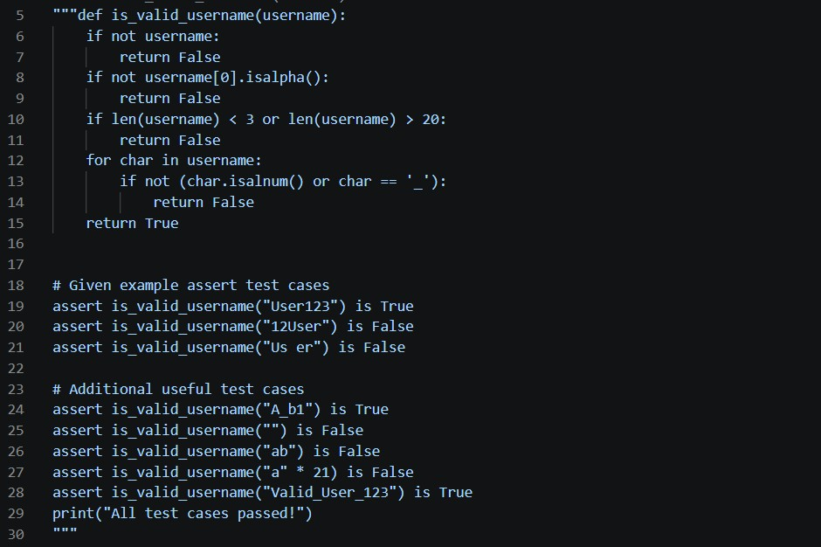

Task Description #2 (Even–Odd & Type Classification – Apply
AI for Robust Input Handling)
- Task: Use AI to generate at least 3 assert test cases for a function classify_value(x) and implement it using conditional logic and loops.
- Requirements:
- If input is an integer, classify as "Even" or "Odd".
- If input is 0, return "Zero".
- If input is non-numeric, return "Invalid Input".
Example Assert Test Cases:
assert classify_value(8) == "Even" assert classify_value(7) == "Odd" assert classify_value("abc") == "Invalid Input" Expected Output #2:
- Function correctly classifying values and passing all test cases.

PROMPT:
“Generate assert-based test cases for a function classify_value(x) that classifies integers as 'Even' or 'Odd', returns 'Zero' for 0, and 'Invalid Input' for non-numeric values."
CODE AND OUTPUT:
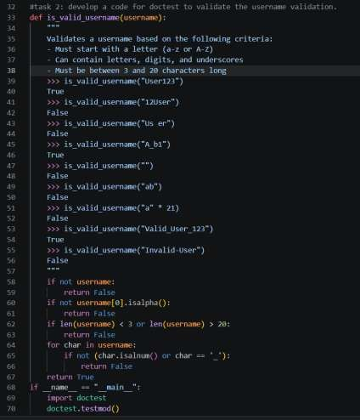

Task Description #3 (Palindrome Checker – Apply AI for
String Normalization)
- Task: Use AI to generate at least 3 assert test cases for a function is_palindrome(text) and implement the function.
- Requirements:
- Ignore case, spaces, and punctuation.
- Handle edge cases such as empty strings and single characters.
Example Assert Test Cases:
assert is_palindrome("Madam") == True
assert is_palindrome("A man a plan a canal Panama") == True
assert is_palindrome("Python") == False Expected Output #3:
• Function correctly identifying palindromes and passing all AI-generated tests.

PROMPT:
“Generate assert-based test cases for a function is_palindrome(text) that ignores case, spaces, and punctuation, and correctly handles empty strings and single characters.
import string”
CODE AND OUTPUT:
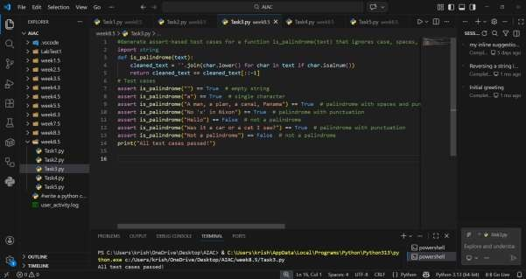

EXPLANATION:
Tests cover case-insensitivity, ignoring spaces/punctuation, empty strings, and single characters. The function normalizes input by removing non-alphanumeric and lowercasing. Then compares string with its reverse. TDD ensures correctness.

Task Description #4 (BankAccount Class – Apply AI for
Object-Oriented Test-Driven Development)
- Task: Ask AI to generate at least 3 assert-based test cases for a BankAccount class and then implement the class.
- Methods:
o deposit(amount) o withdraw(amount) o get_balance()
Example Assert Test Cases: acc = BankAccount(1000) acc.deposit(500)
assert acc.get_balance() == 1500
acc.withdraw(300) assert acc.get_balance() == 1200 Expected Output #4:
• Fully functional class that passes all AI-generated assertions.

PROMPT:
“Generate assert-based test cases for a BankAccount class with methods deposit(amount), withdraw(amount), and get_balance(). Include cases for deposits, withdrawals, overdraft prevention, and fresh accounts.”

CODE AND OUTPUT:
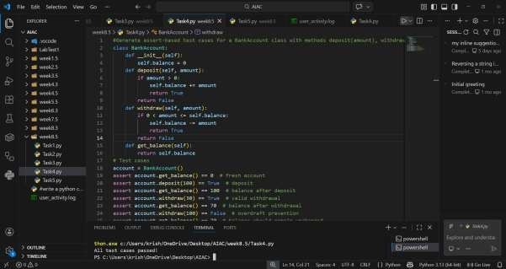
EXPLANATION:
Tests validate deposits, withdrawals, overdraft prevention, and multiple accounts. The class encapsulates balance, with methods to update and retrieve it. Withdraw checks available funds. TDD ensures all behaviors pass.

Task Description #5 (Email ID Validation – Apply AI for Data
Validation)
- Task: Use AI to generate at least 3 assert test cases for a
function validate_email(email) and implement the function.
- Requirements:
o Must contain @ and . o Must not start or end with special characters. o Should handle invalid formats gracefully.
Example Assert Test Cases:
assert validate_email("user@example.com") == True assert validate_email("userexample.com") == False assert validate_email("@gmail.com") == False Expected Output #5:
• Email validation function passing all AI-generated test cases and handling edge cases correctly PROMPT:
“Generate assert-based test cases for a function validate_email(email) that requires '@' and '.', disallows starting/ending with special characters, and handles invalid formats gracefully."
CODE AND OUTPUT:
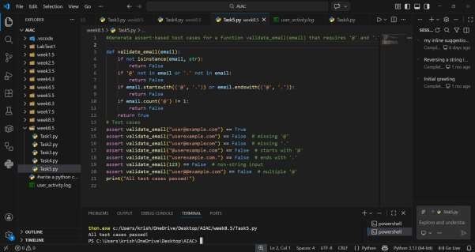
EXPLANATION:
Tests include valid emails, missing symbols, invalid domains, and edge cases. The function checks presence of @ and ., ensures no leading/trailing special characters, and validates format. TDD ensures graceful handling.

